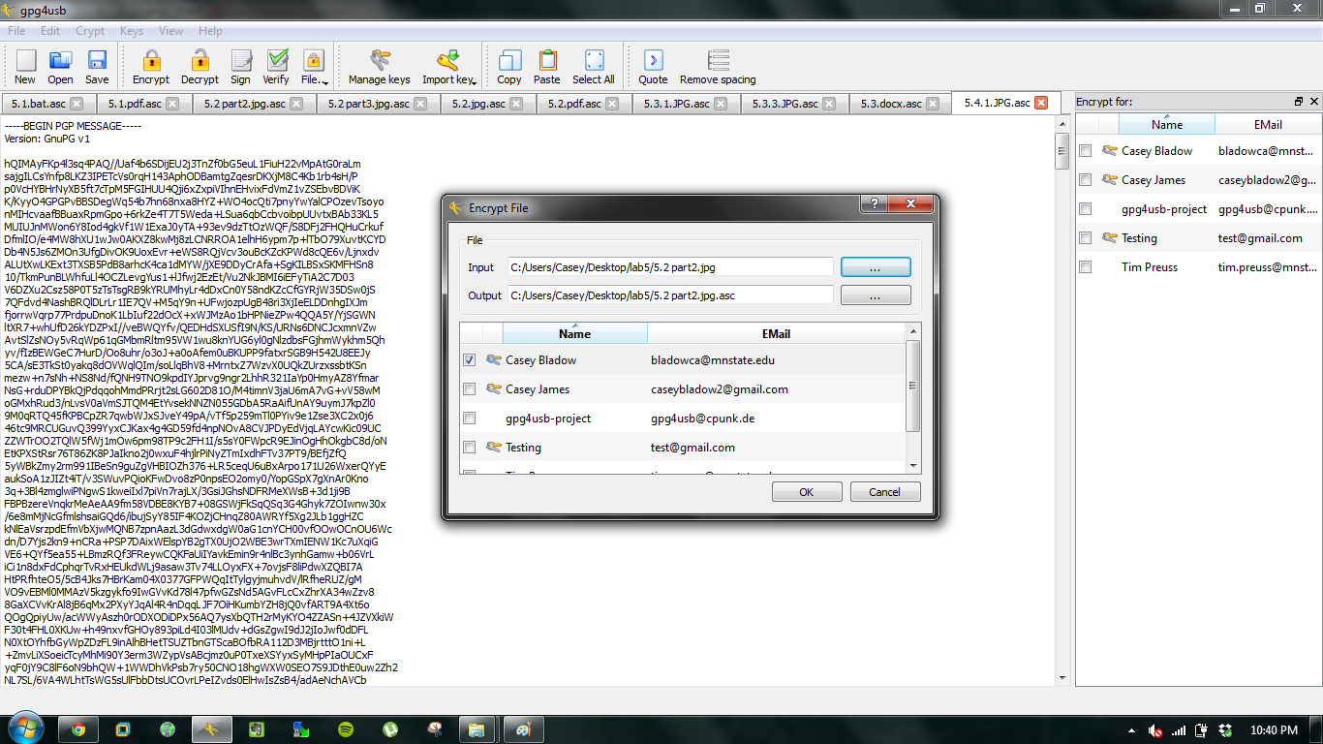

.asc files are encrypted gpg4usb files.



After decrypting they actually stay .asc however, now you can read them. JPG and PDF files aren’t very text friendly.

