5.3.1



5.3.2

To create a backup I simply copied the folder I wished to backup.

Right clicked and selected properties.

Advanced.

Checked “Encrypt contents to secure data”.

Ok, then Apply.

Then you can select “Apply changes to this folder only” or “Apply changes to this folder, subfolders and files”. In almost every circumstance I would recommend choosing the second option.

5.3.3

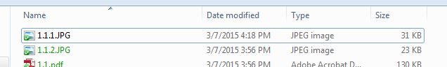

5.3.4

Restoring is the opposite of encrypting. Select the file you wish to restore, right-click, properties, advanced, UNCHECK encrypt, ok, and apply.

5.3.5

If you have lost your password and encryption contact your System Administrator. S/he will have a copy of all employee info and will be able to provide you with the necessary information.