This is will create a small, simple at home network allowing 20 different IP addresses….

Network planning details:  
Which IPv4 class?

We will be using Class C Address.

The first octet of Class C IP address has its first 3 bits set to 110, that is

Class C Addresses

Class C IP addresses range from 192.0.0.x to 192.255.255.x. The default subnet mask for Class B is 255.255.255.x.

Class C gives 2097152 (221) Network addresses and 254 (28-2) Host addresses.

Class C IP address format is **110NNNNN.NNNNNNNN.NNNNNNNN**.HHHHHHHH  
Which subnet mask?

We will be using Class C Subnets.

Class C IP addresses normally assigned to a very small size network because it only can have 254 hosts in a network. Given below is a list of all possible combination of subnetted Class B IP address:

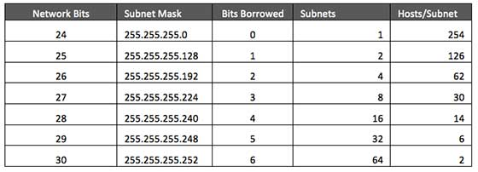

255.255.255.240  
How many routers?

1  
Router IP addresses?

Limited to 14 – 192.168.0.1 to 192.168.0.14  
IP address assignment process  
- managed where?

IP Addresses will be automatically assigned via the PC, Phone, Game system, or whatever else is connecting to the network. Their own NIC should take of this for the user.  
- what happens when exceeded?

When the limited number of IP addresses are exceeded, the user will need to remove one of the machines using the network, thus creating an available IP. In a home network setting, this should never happen. If it does, and one can’t be removed then whoever is trying to connect (#21) won’t be able to connect.  
- do leases expire? How frequently?

Leases expire every 24 hours. However these will be automatically renewed with the same MAC and IP addresses. This shouldn’t create any issues.  
Use of NAT?

Yes, this will allow connection to the outside world (Internet).  
How to determine what has an external IP?

These days everything will be assigned an external IP address. Unless a printer, or something that does not require connection to the Internet, it will be automatically assigned an external IP address.  
IPv6 support?

Since we are using such a simple network setup, IPv6 will not be supported. Although most services will have the capability to use it, we will not. No need to make this anymore complicated for a normal day to day user. IPv6 will wait until it becomes more common and necessary.

Sources-

<http://www.tutorialspoint.com/ipv4/ipv4_address_classes.htm>

<http://www.tutorialspoint.com/ipv4/ipv4_subnetting.htm>

<http://computer.howstuffworks.com/nat.htm>

<https://www.whatismyip.com/how-to-determine-if-your-computer-is-being-assigned-the-external-ip-address/>

<http://en.wikipedia.org/wiki/IPv6>