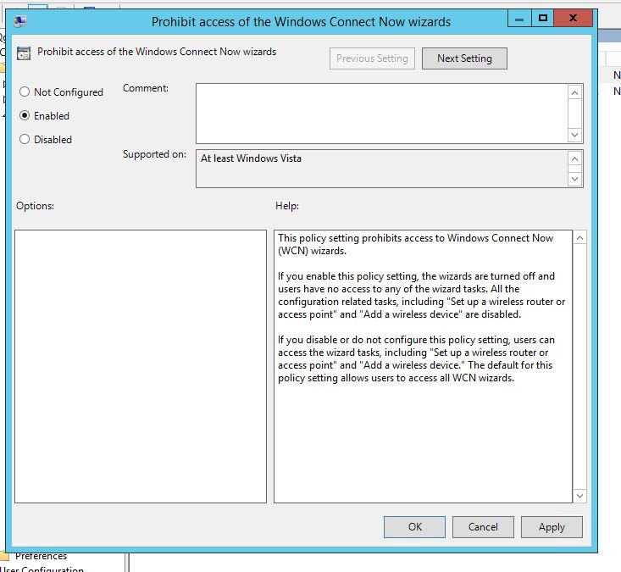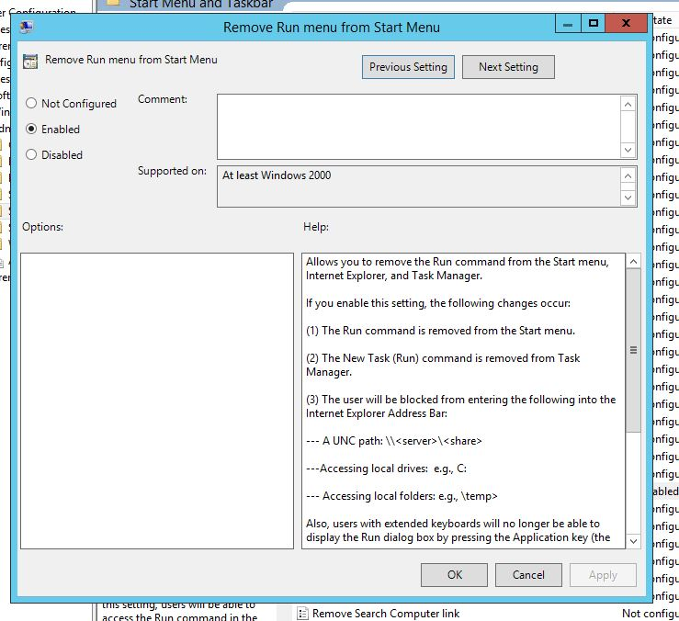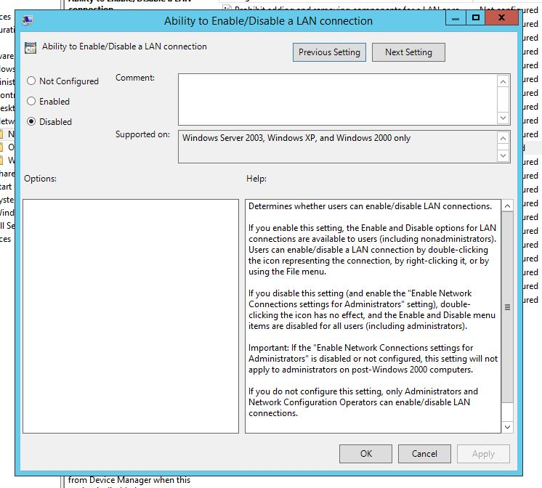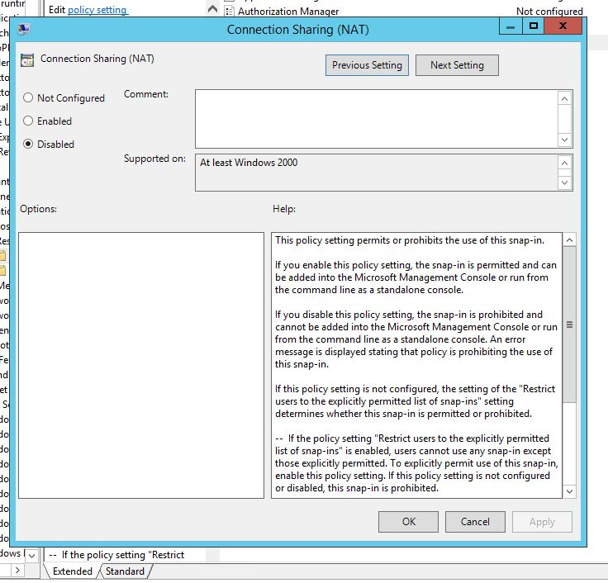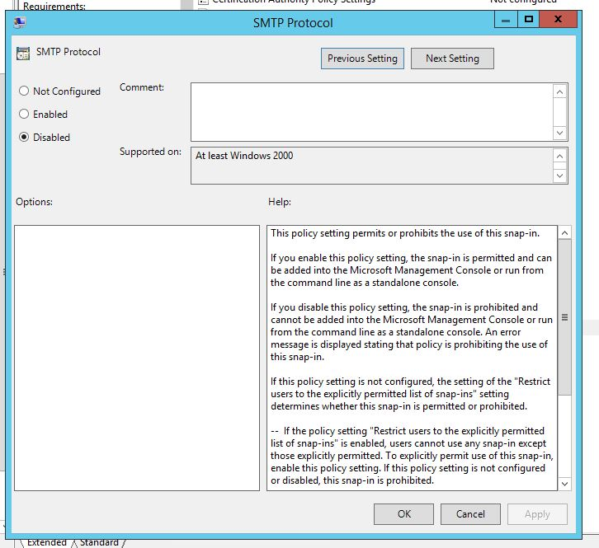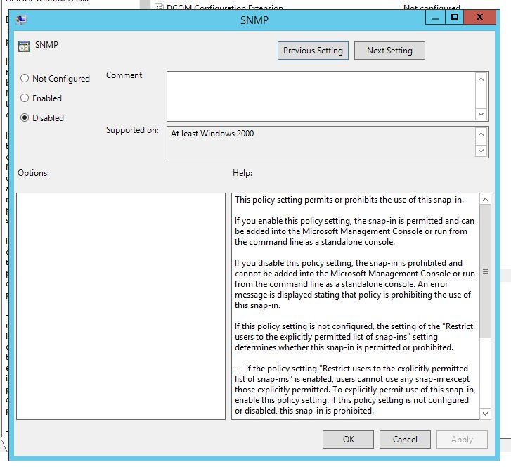

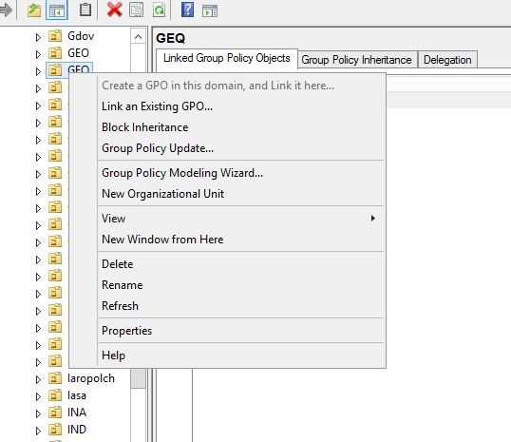

Setting State Comment

AppleTalk Routing Not configured No

Authorization Manager Not configured No

Certification Authority Policy Settings Not configured No

Connection Sharing (NAT) Disabled No

DCOM Configuration Extension Not configured No

DHCP Relay Management Not configured No

Device Manager Not configured No

Event Viewer Not configured No

Event Viewer (Windows Vista) Not configured No

IAS Logging Not configured No

IGMP Routing Not configured No

IP Routing Not configured No

IPX RIP Routing Not configured No

IPX Routing Not configured No

IPX SAP Routing Not configured No

Logical and Mapped Drives Not configured No

OSPF Routing Not configured No

Public Key Policies Not configured No

RAS Dialin - User Node Not configured No

RIP Routing Not configured No

Removable Storage Not configured No

Remote Access Not configured No

Routing Not configured No

SMTP Protocol Disabled No

SNMP Disabled No

Send Console Message Not configured No

Service Dependencies Not configured No

Shared Folders Ext Not configured No

System Properties Not configured No

DFS Management Extension Not configured No

Disk Management Extension Not configured No

File Server Resource Manager Extension Not configured No

Share and Storage Management Extension Not configured No

Storage Manager for SANS Extension Not configured No

Extended View (Web View) Not configured No

Setting State Comment

Prohibit adding and removing components for a LAN or remote access connection Not configured No

Prohibit access to the Advanced Settings item on the Advanced menu Not configured No

Prohibit TCP/IP advanced configuration Not configured No

Prohibit Enabling/Disabling components of a LAN connection Not configured No

Ability to delete all user remote access connections Not configured No

Prohibit deletion of remote access connections Not configured No

Prohibit access to the Remote Access Preferences item on the Advanced menu Not configured No

Enable Windows 2000 Network Connections settings for Administrators Not configured No

Turn off notifications when a connection has only limited or no connectivity Not configured No

Prohibit access to properties of components of a LAN connection Not configured No

Ability to Enable/Disable a LAN connection Disabled No

Prohibit access to properties of a LAN connection Not configured No

Prohibit access to the New Connection Wizard Not configured No

Ability to change properties of an all user remote access connection Not configured No

Prohibit access to properties of components of a remote access connection Not configured No

Prohibit connecting and disconnecting a remote access connection Not configured No

Prohibit changing properties of a private remote access connection Not configured No

Ability to rename all user remote access connections Not configured No

Ability to rename LAN connections or remote access connections available to all users Not configured No

Ability to rename LAN connections Not configured No

Prohibit renaming private remote access connections Not configured No

Prohibit viewing of status for an active connection Not configured No

Setting State Comment

Notifications

Add Search Internet link to Start Menu Not configured No

Clear history of recently opened documents on exit Not configured No

Clear the recent programs list for new users Not configured No

Clear history of tile notifications on exit Not configured No

List desktop apps first in the Apps view Not configured No

Search just apps from the Apps view Not configured No

Add Logoff to the Start Menu Not configured No

Go to the desktop instead of Start when signing in Not configured No

Gray unavailable Windows Installer programs Start Menu shortcuts Not configured No

Turn off personalized menus Not configured No

Lock the Taskbar Not configured No

Start Screen Layout Not configured No

Add "Run in Separate Memory Space" check box to Run dialog box Not configured No

Turn off notification area cleanup Not configured No

Remove Balloon Tips on Start Menu items Not configured No

Prevent users from customizing their Start Screen Not configured No

Remove and prevent access to the Shut Down, Restart, Sleep, and Hibernate commands Not configured No

Remove common program groups from Start Menu Not configured No

Remove Favorites menu from Start Menu Not configured No

Remove Search link from Start Menu Not configured No

Remove frequent programs list from the Start Menu Not configured No

Remove Games link from Start Menu Not configured No

Remove Help menu from Start Menu Not configured No

Turn off user tracking Not configured No

Remove All Programs list from the Start menu Not configured No

Remove Network Connections from Start Menu Not configured No

Remove pinned programs list from the Start Menu Not configured No

Do not keep history of recently opened documents Not configured No

Remove Recent Items menu from Start Menu Not configured No

Do not use the search-based method when resolving shell shortcuts Not configured No

Do not use the tracking-based method when resolving shell shortcuts Not configured No

Remove Run menu from Start Menu Enabled No

Remove Default Programs link from the Start menu. Not configured No

Remove Documents icon from Start Menu Not configured No

Remove Music icon from Start Menu Not configured No

Remove Network icon from Start Menu Not configured No

Remove Pictures icon from Start Menu Not configured No

Do not search communications Not configured No

Remove Search Computer link Not configured No

Remove See More Results / Search Everywhere link Not configured No

Do not search for files Not configured No

Do not search Internet Not configured No

Do not search programs and Control Panel items Not configured No

Remove programs on Settings menu Not configured No

Prevent changes to Taskbar and Start Menu Settings Not configured No

Remove Downloads link from Start Menu Not configured No

Remove Homegroup link from Start Menu Not configured No

Remove Recorded TV link from Start Menu Not configured No

Remove user's folders from the Start Menu Not configured No

Remove Videos link from Start Menu Not configured No

Force classic Start Menu Not configured No

Remove Clock from the system notification area Not configured No

Prevent grouping of taskbar items Not configured No

Do not display any custom toolbars in the taskbar Not configured No

Remove access to the context menus for the taskbar Not configured No

Hide the notification area Not configured No

Prevent users from uninstalling applications from Start Not configured No

Remove user folder link from Start Menu Not configured No

Remove user name from Start Menu Not configured No

Remove links and access to Windows Update Not configured No

Change Start Menu power button Not configured No

Show QuickLaunch on Taskbar Not configured No

Remove the "Undock PC" button from the Start Menu Not configured No

Show the Apps view automatically when the user goes to Start Not configured No

Show "Run as different user" command on Start Not configured No

Add the Run command to the Start Menu Not configured No

Show Start on the display the user is using when they press the Windows logo key Not configured No

Remove Logoff on the Start Menu Not configured No

Pin Apps to Start when installed Not configured No

Remove the Action Center icon Not configured No

Remove the networking icon Not configured No

Remove the battery meter Not configured No

Remove the volume control icon Not configured No

Turn off feature advertisement balloon notifications Not configured No

Do not allow pinning Store app to the Taskbar Not configured No

Do not allow pinning items in Jump Lists Not configured No

Do not allow pinning programs to the Taskbar Not configured No

Do not display or track items in Jump Lists from remote locations Not configured No

Turn off automatic promotion of notification icons to the taskbar Not configured No

Show Windows Store apps on the taskbar Not configured No

Lock all taskbar settings Not configured No

Prevent users from adding or removing toolbars Not configured No

Prevent users from rearranging toolbars Not configured No

Do not allow taskbars on more than one display Not configured No

Turn off all balloon notifications Not configured No

Remove pinned programs from the Taskbar Not configured No

Prevent users from moving taskbar to another screen dock location Not configured No

Prevent users from resizing the taskbar Not configured No

Turn off taskbar thumbnails Not configured No

Setting State Comment

Prohibit access of the Windows Connect Now wizards Enabled No

Configuration of wireless settings using Windows Connect Now Not configured No