Product Note
Cash Mobile – Notification Management CMS
Change Request | CR-CM-2026-001 | Version 1.5
Prepared by: Ali Ibrahim
Signature: __________________ Date: __________________
Verified by: __________________________
Signature: __________________ Date: __________________
Name | Designation | Date | Signature

Table of contents:
1. Purpose of Document
2. Specific Objectives
3. Technical Requirements
4. Document History
Scope: Cash Mobile notification campaigns, confirmed transaction notifications, an in-app notification history, and notification-only reporting.

1. PURPOSE OF DOCUMENT
• Enable MTN to send and manage Cash Mobile notifications from one controlled CMS.
• Let customers access their own notification history directly inside Cash Mobile.
2. SPECIFIC OBJECTIVES
• Provide simple, timely notifications for financial operations, system messages, reminders and offers.
• Support secure campaign targeting, scheduling, automatic alerts and notification reporting.
3. TECHNICAL REQUIREMENTS
3.1 Notification Center in Cash Mobile App
Path: Cash Mobile Home Page and Main/Sup Categories Pages → Bell Icon (top bar) → Notifications / الإشعارات.
• Add a bell icon in the home-page and in the and Main/Sup categories pages top bar. Show the unread-notification count on the icon.
• Open a customer-specific history sorted newest first, with notification title, short text, time and unread indicator.
• Provide five tabs: All / الكل, Transactions / المعاملات, System / النظام, Reminders / التذكيرات, Offers / العروض. “All” is a filter, not a fifth notification type.
• Allow customers to open notification details and mark notifications as read, including “Mark all as read / تحديد الكل كمقروء”.
• Store history against the signed-in customer in the backend, avoid duplicates and keep read status consistent across devices.
Notification types:
Type / النوع | Examples
Transactions / المعاملات | Successful transfers, bill payments, top-ups, refunds and final failures.
System / النظام | App updates, maintenance and approved account/security notices.
Reminders / التذكيرات | Due bills and scheduled payment reminders.
Offers / العروض | Promotions and marketing campaigns (only for eligible customers).

3.2 Notification Details Screen
• Show title, complete message and date/time. For financial events, display authorized transaction amount, masked wallet/account and reference when available.
• “View Transaction Details / عرض تفاصيل العملية” opens the existing secure payment screen only after login and ownership verification.

3.3 Notification CMS
• Use CMS pages for Dashboard, Campaigns, Automated Notifications, Customers, Notification Analytics, Users & Roles, Audit Logs and Settings.
• Create push campaigns with title, message, language, notification type and destination; choose all eligible customers, selected numbers/lists or validated CSV/XLSX files.
• Support Send Now, scheduled sending, cancellation before dispatch and controlled resend with preserved history.
• Create automatic alerts only from confirmed payment-backend events. The primary event is an incoming transfer to its actual recipient.
3.4 Security and Reporting
• Link each notification to the verified customer ID; respect device permissions, marketing consent and customer access controls.
• Track campaign counts and notification outcomes (queued, accepted, failed, unknown), with opened/received evidence only where available.
• Report notification performance only. Do not track general app usage, visited pages or user journeys.
• Support Arabic RTL and English LTR. Distinguish push delivery from saved in-app notification history.
3.5 Acceptance Criteria
• Bell icon, unread badge, All filter and four category tabs are available as shown in the reference screens.
• Every notification opens its correct detail screen, and only the account owner can access financial details.
• Notification history remains available even when push permission is disabled; repeated events do not create duplicate history records.
Reference screenshots:
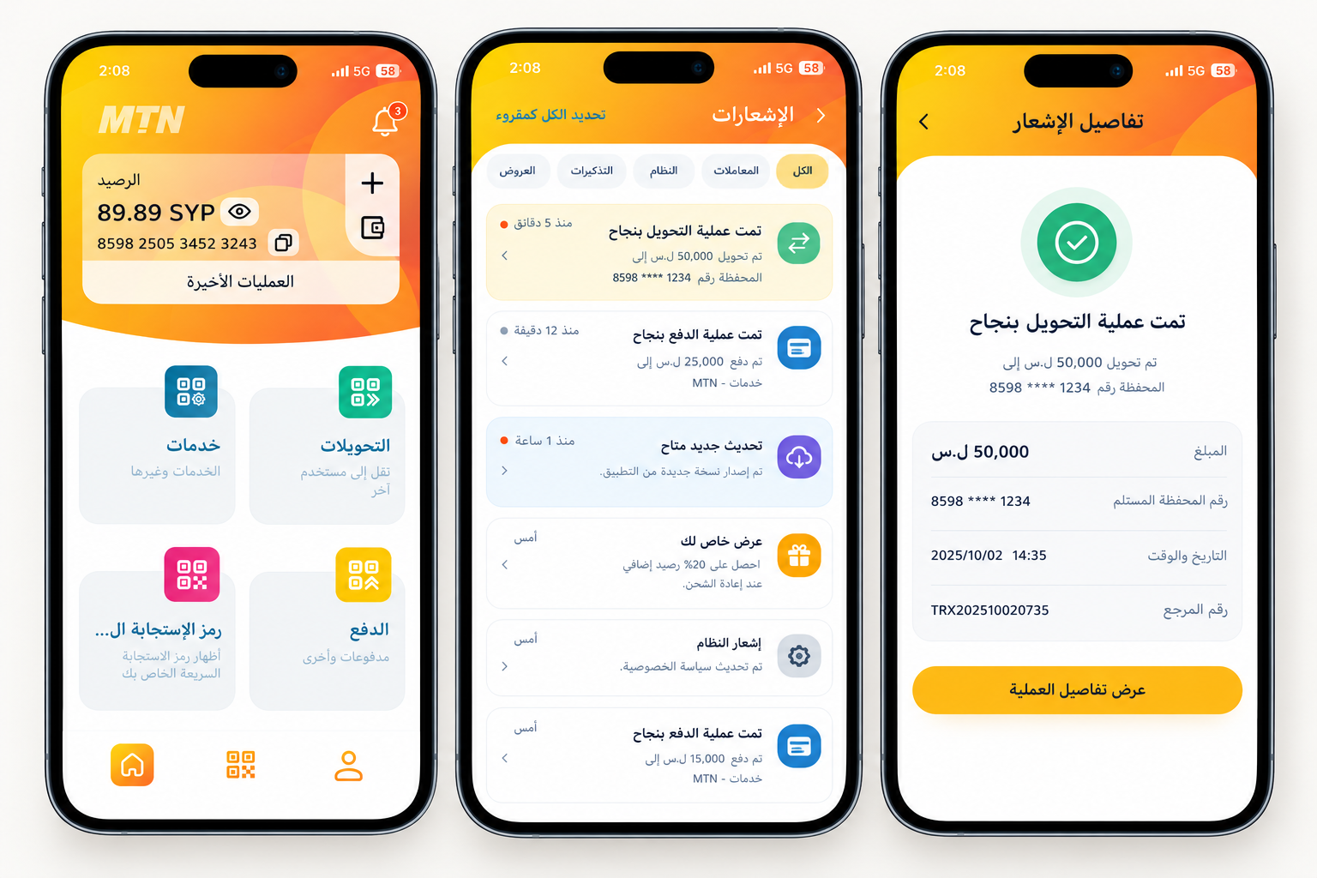
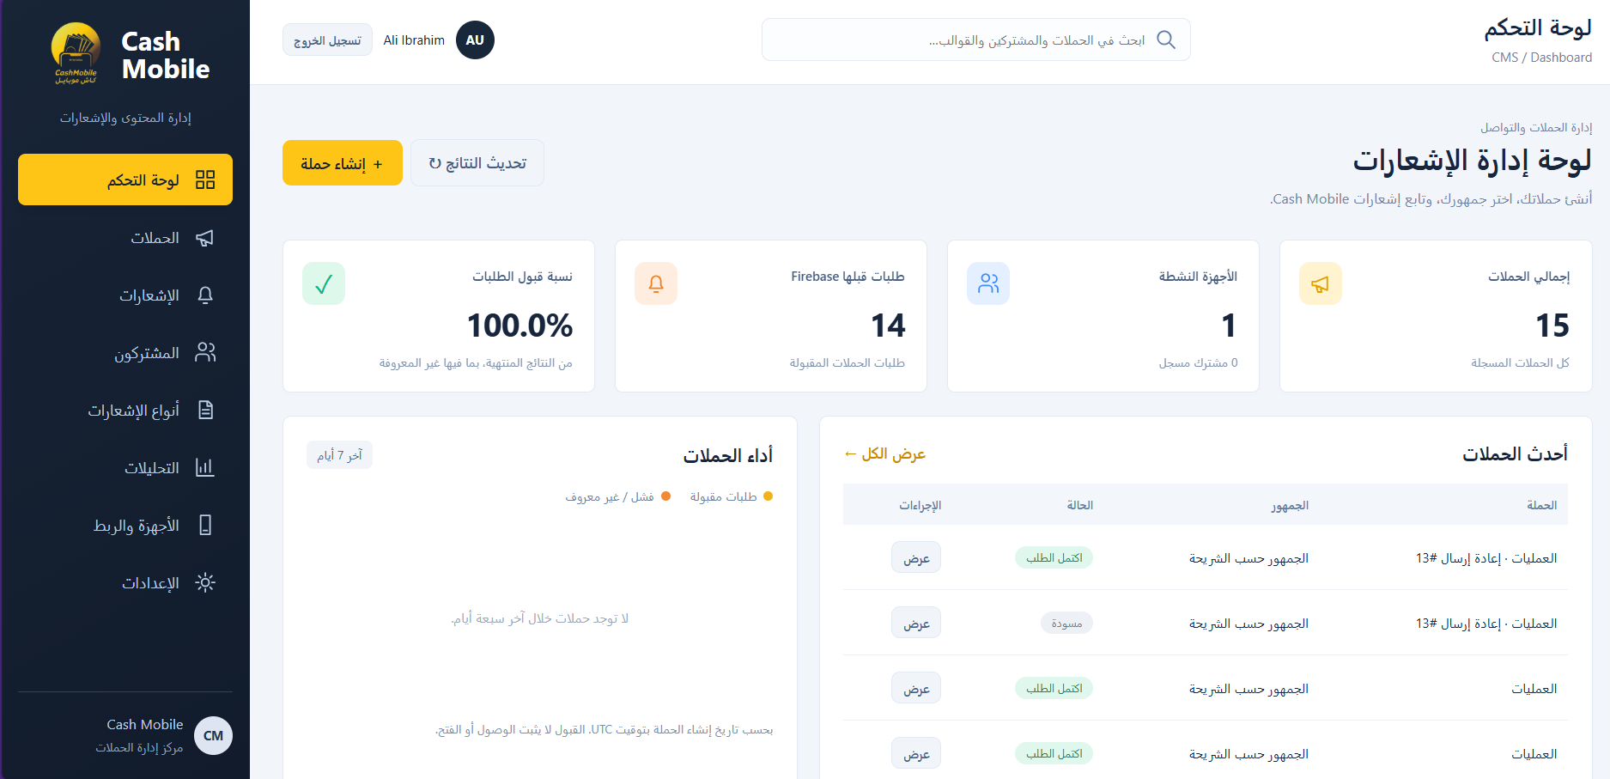
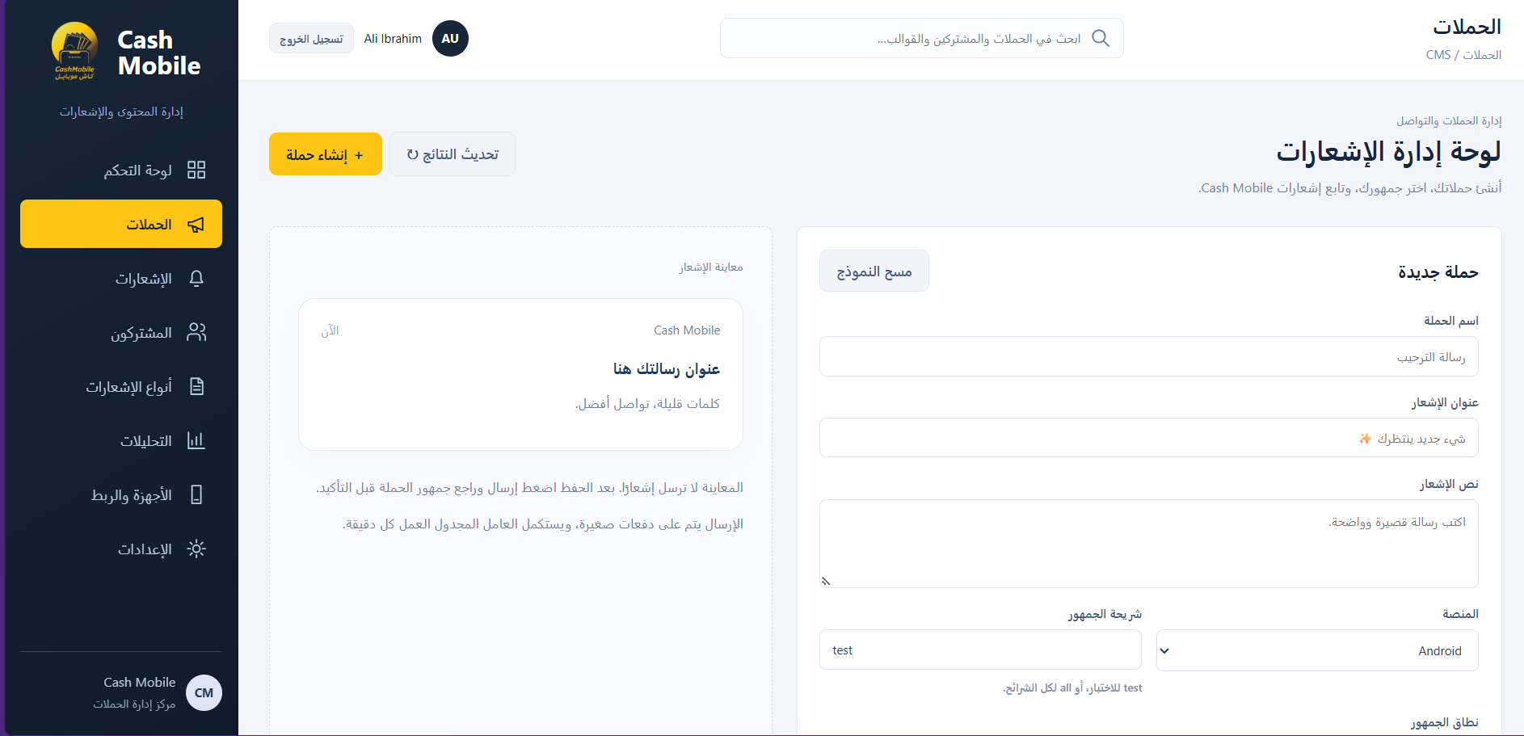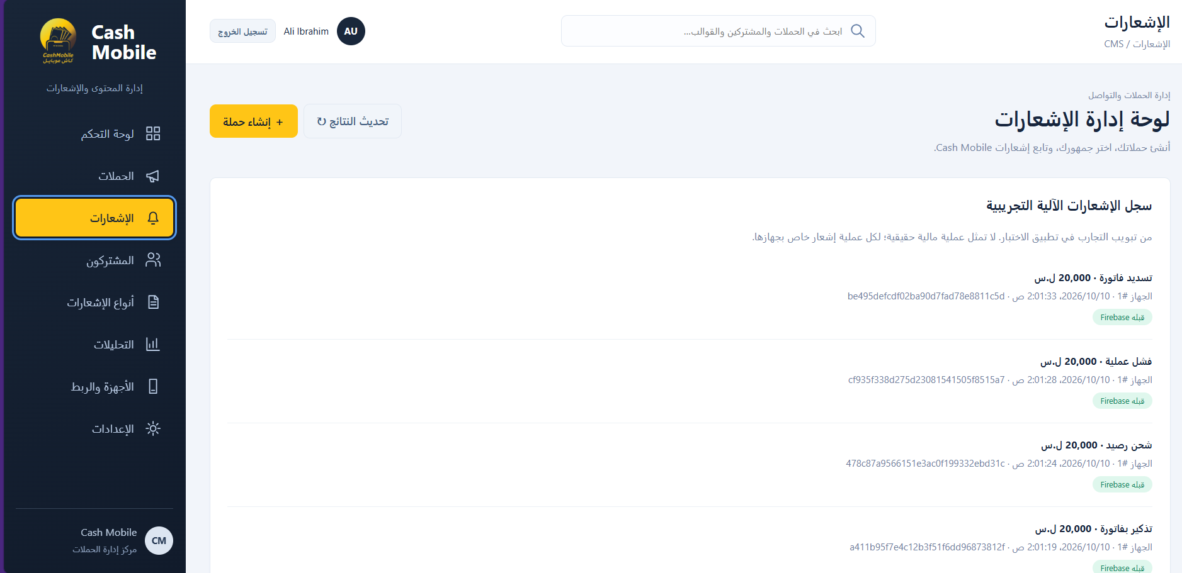
4. DOCUMENT HISTORY
Version | Date | Modification / Validation
1.1 | 27-Oct-2026 | Earlier CMS requirements draft.

