‘ACE_2_1’

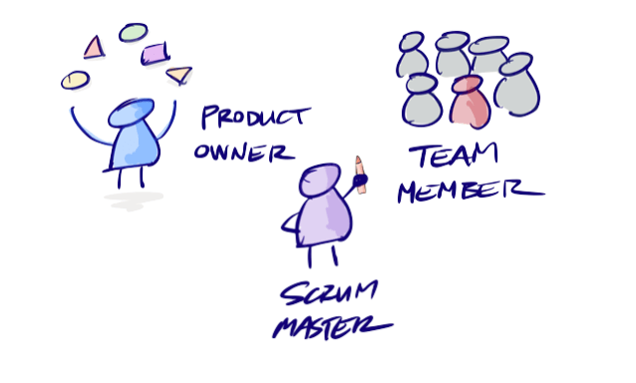

1. Write a single document for the team that explains the team’s plans for determining additional requirements beyond the project requirements handout.
2. Daily/ monthly/ Annually graph of sales for each service
3. Possibly including a rescheduling option for patrons unable to attend date of reservation (taking into account proper cancellation, and no overlap of scheduled times for specific services)
4. A how to use page for employees to refer to
5. A customer details (contact info, attendance, payment history) page with notes for employees to write about customer’s care

**Project Requirements Summary:**

The project is to create software for “Mud in Your Eye” (MiYE), a new, small hot spring health spa, located in a remote, scenic part of the US. The MiYE is a full-time resort spa facility[[1]](https://cgu.instructure.com/courses/9791/assignments/119283#_ftn1), but it has just one front desk clerk on duty at any time. Front desk clerks are local people, hired primarily for their friendliness, not their computer skills—one can’t assume any sophistication in the use of computer software.

**Mud In Your Eye Project Requirements Breakdown:**

|  |  |  |
| --- | --- | --- |
| **Requirements** | **Description** |  |
| service reservations usage | front desk clerk see what appointments are available at any particular day/time |  |
| statements of service | lists reservations made, reservations canceled (if any), the amount charged for each service, and a total of service-related charges before taxes. |  |
| Services: | mineral baths: 60 / 90 min @$2.50/min  massages (Swedish, shiatsu, or deep tissue) : 30/ 60 min @ $3.00/mi.  facials (normal or collagen): 30/ 60 min @ $2.00/min  specialty treatments (hot stone, sugar scrub, herbal body wrap, or botanical mud wrap) : 60/90 min @ $3.50/min. |  |
| Hours of Operation | M-S from 8 am to 8 pm *service ends at 8pm |  |
| Client Unique ID | assigned at check-in allows, among other things, the looking-up of the beginning and end of the guest’s stay at the spa  To reserve / receive services |  |
| Reservation | Services can only be scheduled during the guest’s stay—no reservations for future stays are allowed. |  |
| Charge | every service requested |  |
| Payment Process | a separate manual process at checkout  Charges include: rooms, food, and other things besides services. |  |
| Reservation Statement | obtain a printed copy of the statement of services used for any guest  reservations canceled (if any)  the amount charged for each service,  total of service-related charges before taxes.  Neither multi-user nor network capabilities wanted |  |
| Cancelation Policy | 10 minutes of making the reservation  **or**  at least 90 minutes before the reservation time |  |
| Restrictions | no service reservations overlap--no guest may have two reservations at the same time and day -- except mineral bath services, which have no limit  Consecutive services are permitted  1) the guest has no overlapping reservation already booked,  2) there is no other reservation for the service at that time and day,  3) the reservation would begin no earlier than 8 am and end no later than 8 pm. |  |
| User experience | easily accommodate changes in the number, types, times, and prices of services  software must be maintainable by management or their designees |  |
| Interfaces | interface for operation by front desk clerks  maintenance by management |  |

**Roles - Timeline:**

|  |  |  |  |
| --- | --- | --- | --- |
| **Date** | **Product Owner** | **Scrum Master** | **Team Member** |
|  |  |  |  |
|  |  |  |  |
|  |  |  |  |
|  |  |  |  |