‘ACE_2_1’

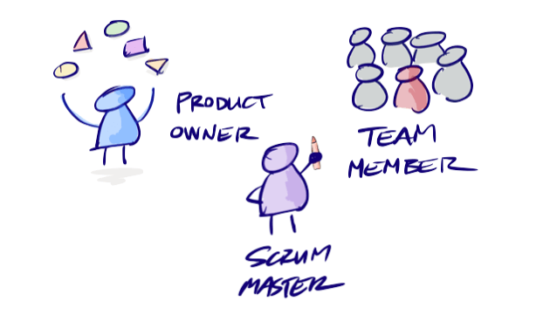

1. Write a single document for the team that explains the team’s plans for determining additional requirements beyond the project requirements handout.