

# Return your Raspberry Pi to “Normal”

# Objective

The Raspberry Pis on the tables have had some minor modifications made to them in order to enable a quick connection to the hotel network. These are instructions that will help return them to their standard, out of the box, Raspbian os setup.

# Enable Raspbian GUI

The systems were configured to boot up in a command line only configuration. This was not strictly required, but we wanted to conserve memory just to be on the safe side. To re-enable the GUI, do the following:

* At the command line, enter: sudo raspi-config  
  This will start the text based Raspbian config tool. There is also a GUI based config tool that you can use later, after the GUI has been re-enabled.
* In the raspi-config tool, do the following:  
  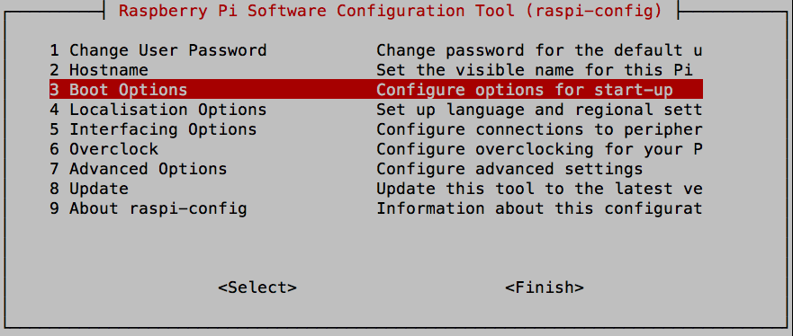  
  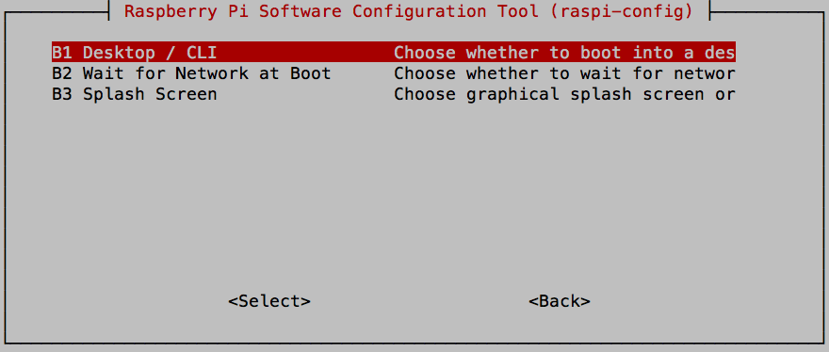  
  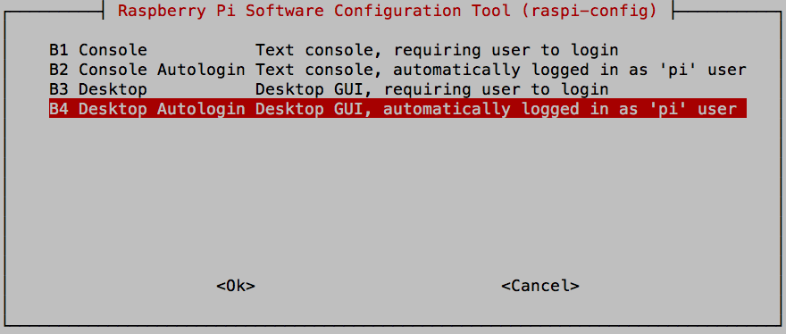  
  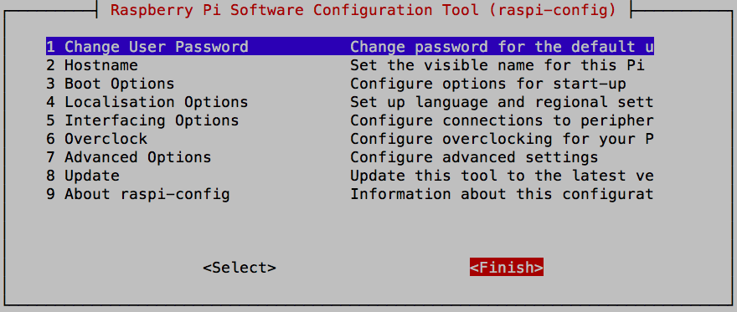  
  ***Note****: Use the tab key to move to the <Finish> button.*  
  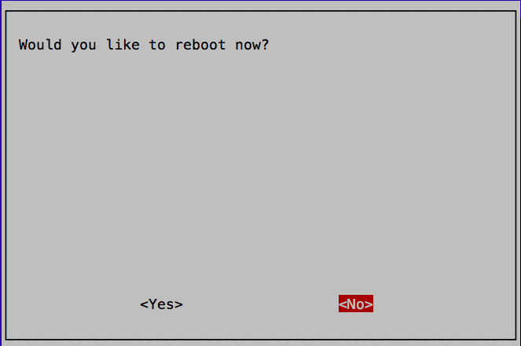  
  ***Note****: No need to reboot now, there are still more changes.*

# Return to dhcp addressing

In order to ensure that everyone connected to the correct Raspberry pi, we set them up to use statically assigned IP addresses. In order to return them to dhcp assigned addressing, do the following:

* Edit the file /etc/dhcpcd.conf. The instructions here will use the nano editor so enter:  
  sudo nano /etc/dhcpcd.conf
* At the bottom of this file you will see the following four lines that need to be deleted.  
  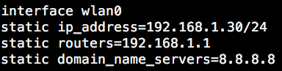  
  ***Note****: In nano, you can use Ctrl-k to delete the line that the cursor is on.*
* Enter Ctrl-x to exit the editor.
* Answer Y to save the file.

# Set your WiFi network

The Pis were set up to use a specific WiFi network. While you can also accomplish this step after booting into the GUI and using the fancy GUI network tool, you might want to know where this is set so that you can work in a remote/client environment.

* Edit the file /etc/wpa_supplicant/wpa_supplicant.conf. The instructions here will use the nano editor so enter:  
  sudo nano /etc/wpa_supplicant/wpa_supplicant.conf
* In this file, you will clearly see the WiFi SSID and the Pre Shared Key (PSK). You can set these to the values you use in your home network and the Pi will connect. You need to have your entries inside quotes.
* You can also create multiple network definitions and they will be attempted in the order they appear.
* Enter Ctrl-x to exit the editor.
* Answer Y to save the file.

***Note****: In order to connect to the certificate based IBM internal WiFi networks, additional work wil be required that is beyond the scope of this guide.*

# Don’t autostart node-red (optional)

If you do not want node-red to start automatically when the system boots, just issue the following command:

sudo systemctl disable nodered.service