选课系统的设计与实现

一、设计概述

项目内容：当今社会，学生需要全面提高自身，除了专业课与公共课外，还需要选择选修课选课系统主要面向广大师生，着眼于选课的管理，可以方便学生快速了解选课的信息与及选择，同时也将学生的信息反馈给老师，从而达到方便，易管理的效果。
二、系统分析与设计
1、功能分析
项目功能：
学生：查看可选课程、选择课程、查询已选课程、退选课程、修改密码
老师：发布课程、查询已发布课程、查询选课学生信息、修改密码
管理员：管理学生信息、管理教师信息、修改密码，管理班级信息，审核注册的账号
注册账号

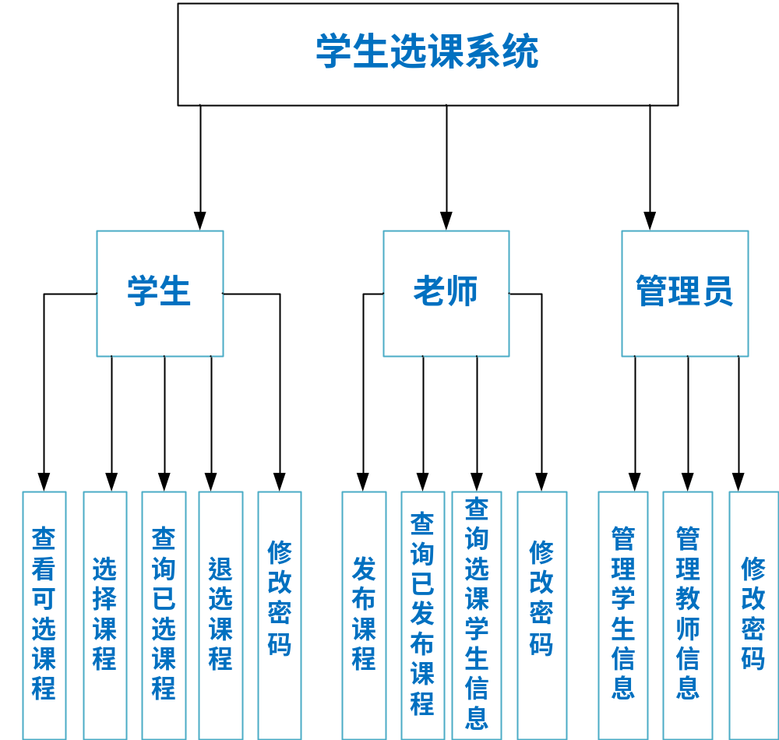
注册账号
管理班级信息
审核注册帐号
2、架构设计
18.1.2 系统架构设计
本系统根据功能的不同，项目结构可以划分为以下几个层次。
●持久对象层(也称持久层或持久化层):该层由若干持久化类(实体类)组成。
●数据访问层(DAO层): 该层由若干DAO接口和MyBatis映射文件组成。接口的名称统一以Dao结尾，且MyBatis的映射文件名称要与接口的名称相同。
●业务逻辑层(Service层): 该层由若干Service接口和实现类组成。在本系统中，业务逻辑层的接口统一使用Service结尾，其实现类名称统一在接 口名后加Impl。该层主要用于实现系统的业务逻辑。
●Web表现层:该层主要包括Spring MVC中的Controller类和JSP页面。Controller类主要负责拦截用户请求，并调用业务逻辑层中相应组件的业务逻辑方法来处理用户请求，然后将相应的结果返回给JSP页面。
为了让读者更清晰地了解各个层次之间的关系，下面通过一张图来描述各个层 次的关系和作用，如图18-2所示。
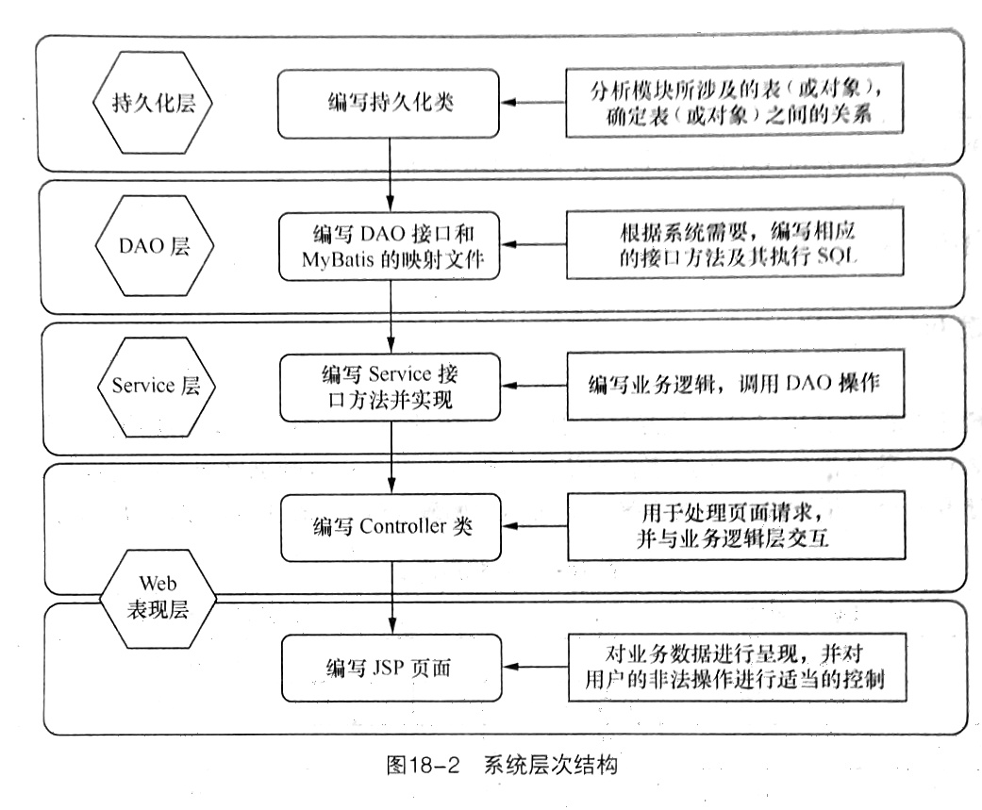
三、文件组织结构
（这是maven项目是我在idea做的，为了方便教室电脑运行转移到eclipse，所以目录有所不同）

总目录：
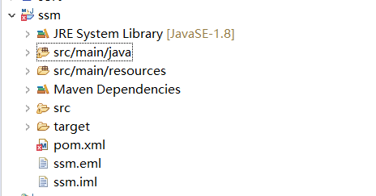
分目录:
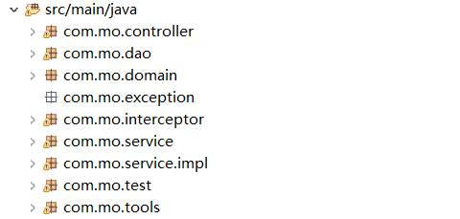
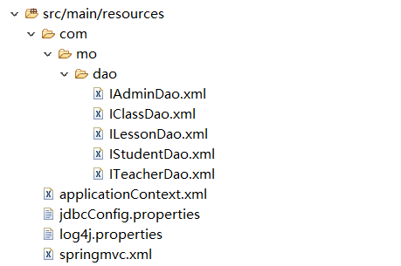
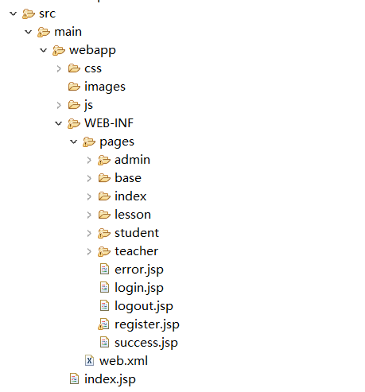
四、开发及运行环境
18.1.4 :系统开发及运行环境
选课系统开发环境如下。
●操作系统: Windows
●Web服务器: Tomcat 8.0
●Java开发包: JDK8
●开发工具: Eclipse Java EE IDE for Web Developers
/ IntelliJ IDEA 2018.1.5
●数据库: sqlserver2008
●浏览器:火狐或谷歌
五、团队组织及分工
姓名 | 负责内容
莫钡先 | 负责系统的实现
陆胤霖 | 负责文档的编写，数据库的设计
描述团队组成及分工。重点描述自己在团中的角色和承担的工作

六、相关技术介绍
Spring框架技术简介：Spring是一个轻量级控制反转(IoC)和面向切面(AOP)的容器框架。
MyBatis框架技术简介：MyBatis 是一款优秀的持久层框架，它支持定制化 SQL、存储过程以及高级映射。MyBatis 避免了几乎所有的 JDBC 代码和手动设置参数以及获取结果集。MyBatis 可以使用简单的 XML 或注解来配置和映射原生信息，将接口和 Java 的 POJOs(Plain Ordinary Java Object,普通的 Java对象)映射成数据库中的记录。
Spring MVC框架技术简介：SpringMVC是一种基于Java的实现MVC设计模式的请求驱动类型的轻量级Web框架，使用了MVC架构模式的思想，将web层进行职责解耦，基于请求驱动指的就是使用请求-响应模型，框架的目的就是帮助我们简化开发。

Sqlserver2008数据库技术简介：SQL Server是由Microsoft开发和推广的关系数据库管理系统（DBMS）
过滤器：过滤器放在web资源之前，可以在请求抵达它所应用的web资源(可以是一个Servlet、一个Jsp页面，甚至是一个HTML页面)之前截获进入的请求，并且在它返回到客户之前截获输出请求。Filter：用来拦截请求，处于客户端与被请求资源之间，目的是重用代码。Filter链，在web.xml中哪个先配置，哪个就先调用。在filter中也可以配置一些初始化参数。
Java中的Filter 并不是一个标准的Servlet ，它不能处理用户请求，也不能对客户端生成响应。 主要用于对HttpServletRequest 进行预处理，也可以对HttpServletResponse 进行后处理，是个典型的处理链。

拦截器：Spring MVC中的拦截器（Interceptor）类似于Servlet中的过滤器（Filter），它主要用于拦截用户请求并作相应的处理。例如通过拦截器可以进行权限验证、记录请求信息的日志、判断用户是否登录等。
要使用Spring MVC中的拦截器，就需要对拦截器类进行定义和配置。通常拦截器类可以通过两种方式来定义。
1.通过实现HandlerInterceptor接口，或继承HandlerInterceptor接口的实现类（如HandlerInterceptorAdapter）来定义。
2.通过实现WebRequestInterceptor接口，或继承WebRequestInterceptor接口的实现类来定义。

事务管理器: Spring框架支持事务管理的核心是事务管理器抽象，对于不同的数据访问框架（如Hibernate）通过实现策略接口PlatformTransactionManager，从而能支持各种数据访问框架的事务管理

七、系统实现
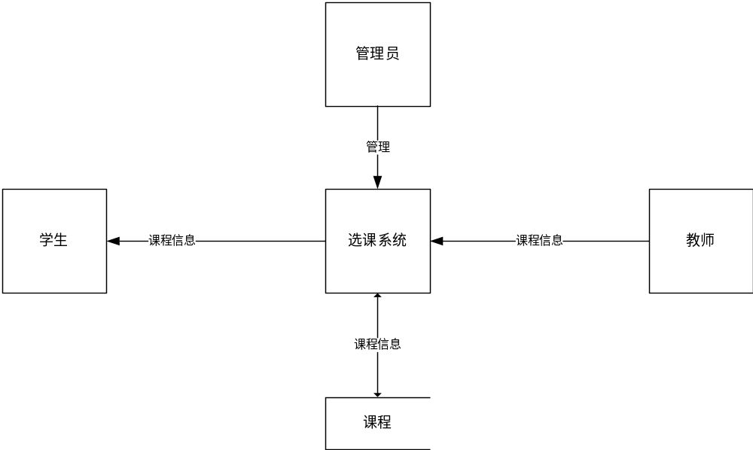

AdminController.java
package com.mo.controller;
import com.mo.domain.Admin;
import com.mo.domain.Class_;
import com.mo.domain.Student;
import com.mo.domain.Teacher;
import com.mo.service.IAdminService;
import com.mo.service.IClassService;
import com.mo.service.IStudentService;
import com.mo.service.ITeacherService;
import com.mo.tools.Jump;
import com.mo.tools.Page;
import org.springframework.beans.factory.annotation.Autowired;
import org.springframework.stereotype.Controller;
import org.springframework.ui.Model;
import org.springframework.util.DigestUtils;
import org.springframework.web.bind.annotation.GetMapping;
import org.springframework.web.bind.annotation.PathVariable;
import org.springframework.web.bind.annotation.RequestMapping;
import org.springframework.web.bind.annotation.SessionAttributes;
import javax.servlet.http.HttpServletRequest;
import javax.servlet.http.HttpServletResponse;
import javax.servlet.http.HttpSession;
import java.util.List;
/**
* Created by IntelliJ IDEA.
* User: PeiHsien Mo
* Date: 2019/11/6
* Time: 19:49
*/
@Controller
@SessionAttributes(value = {"admin"})
@RequestMapping("/admin")
public class AdminController {
@Autowired
private IAdminService adminService;
@Autowired
private ITeacherService teacherService;
@Autowired
private IStudentService studentService;
@Autowired
private IClassService classService;
@RequestMapping("/index")
public String index() {
return "admin/index";
}
@RequestMapping("/info")
public String info(HttpSession session, Model model) {
Admin admin = adminService.findById((String) session.getAttribute("userId"));
admin.setPassword(null);
model.addAttribute("admin", admin);
return "admin/info";
}
@RequestMapping("/update/{id}")
public String update(Model model, String verifyInput, HttpSession session, @PathVariable(name = "id") String id, Admin admin, String oldPassword, String rePassword, HttpServletResponse response, HttpServletRequest request) throws Exception {
if (!verifyInput.toLowerCase().equals(((String) session.getAttribute("verifyCode")).toLowerCase())) {
return Jump.success(model, "验证码不正确");
}
if (!rePassword.equals(admin.getPassword())) {
return Jump.success(model, "两次输入密码不一致");
}
if (admin.getPassword().equals(oldPassword)) {
return Jump.success(model, "不可以和原密码相同");
}
if (!adminService.findById(admin.getAdmin_id()).getPassword().equals(DigestUtils.md5DigestAsHex(oldPassword.getBytes()))) {
return Jump.success(model, "原密码不正确");
}
admin.setAdmin_id(id);
admin.setPassword(DigestUtils.md5DigestAsHex(admin.getPassword().getBytes()));
adminService.updateAdmin(admin);
return Jump.success(model, "修改成功");
}
@RequestMapping("/edit/{id}")
public String edit(@PathVariable(name = "id") String id, Model model) throws Exception {
Admin admin = adminService.findById(id);
model.addAttribute("admin", admin);
return "admin/edit";
}
@GetMapping("/teachers")
public String getAllTeacher(Integer page, Model model) {
// p.setTotal(teacherService.AllTeacher().size());
// p.setCurrentPage(page);
// p.setPageSize(2);
// p.setLink();
Page p = new Page(model, page, teacherService.AllTeacher().size(), 10, "/ssm/admin/teachers");
List<Teacher> teachers = teacherService.AllTeacherByPage(p.getPageSize(), (p.getCurrentPage() - 1) * p.getPageSize());
// List<Teacher> teachers = teacherService.AllTeacherByPage(2,2*2);
model.addAttribute("teachers", teachers);
return "admin/teachers";
}
@GetMapping("/students")
public String getAllStudent(Integer page, Model model) {
Page p = new Page(model, page, studentService.findAll().size(), 10, "/ssm/admin/students");
List<Student> students = studentService.findStudentByPage(p.getPageSize(), (p.getCurrentPage() - 1) * p.getPageSize());
model.addAttribute("students", students);
return "admin/students";
// ModelAndView modelAndView = new ModelAndView();
// modelAndView.setViewName("admin/students");
// modelAndView.addObject("students",students);
// modelAndView.addObject("page",p);
// return modelAndView;
}
@RequestMapping("/deleteUser/{id}")
public String deleteUser(@PathVariable(name = "id") String id, Model model) {
String result = adminService.deleteUser(id);
return Jump.success(model, result);
}
// @RequestMapping("/allClass")
// public String AllClass(){
// List<Class_> classes = classService.findAll();
// for(Class_ class_:classes){
//
// System.out.println(class_);
// }
// return "success";
//
// }
// @RequestMapping("/addClass")
// public String AddClass(){
// Class_ class_ = new Class_();
// class_.setClass_id("171005");
// class_.setName("17本计算机科学与技术5班");
// class_.setDepartment("数据科学学院");
// Integer result = classService.addClass(class_);
// System.out.println(result);
// return "success";
//
// }
// @RequestMapping("/deleteClass/{id}")
// public String deleteClass(@PathVariable(name = "id") String id,Model model){
// String result = classService.deleteClass(id);
// return Jump.success(model,result);
// }
@GetMapping("/studentTemps")
public String findAllStudentTempByPage(Integer page, Model model) {
Page p = new Page(model, page, studentService.findAllStudentTemp().size(), 10, "/ssm/admin/studentTemps");
List<Student> students = studentService.findAllStudentTempByPage(p.getPageSize(), (p.getCurrentPage() - 1) * p.getPageSize());
model.addAttribute("students", students);
return "admin/studentTemps";
}
@GetMapping("/teacherTemps")
public String AllTeacherTempByPage(Integer page, Model model) {
// p.setTotal(teacherService.AllTeacher().size());
// p.setCurrentPage(page);
// p.setPageSize(2);
// p.setLink();
Page p = new Page(model, page, teacherService.AllTeacherTemp().size(), 10, "/ssm/admin/teacherTemps");
List<Teacher> teachers = teacherService.AllTeacherTempByPage(p.getPageSize(), (p.getCurrentPage() - 1) * p.getPageSize());
// List<Teacher> teachers = teacherService.AllTeacherByPage(2,2*2);
model.addAttribute("teachers", teachers);
return "admin/teacherTemps";
}
@RequestMapping("/addToStudent/{id}")
public String addToStudent(@PathVariable(name = "id") String id, Model model) {
String result = studentService.addToStudent(id);
return Jump.success(model, result);
}
@RequestMapping("/deleteStudentTemp/{id}")
public String deleteStudentTemp(@PathVariable(name = "id") String id, Model model) {
Integer result = studentService.deleteStudentTemp(id);
if (result > 0) {
return Jump.success(model, "删除成功");
} else {
return Jump.success(model, "删除失败");
}
}
@RequestMapping("/addToTeacher/{id}")
public String addToTeacher(@PathVariable(name = "id") String id, Model model) {
String result = teacherService.AddToTeacher(id);
return Jump.success(model, result);
}
@RequestMapping("/deleteTeacherTemp/{id}")
public String deleteTeacherTemp(@PathVariable(name = "id") String id, Model model) {
Integer result = teacherService.deleteTeacherTemp(id);
if (result > 0) {
return Jump.success(model, "删除成功");
} else {
return Jump.success(model, "删除失败");
}
}
@RequestMapping("/class")
public String findAll(Model model, Integer page) {
Page p = new Page(model, page, classService.findAll().size(), 10, "/ssm/admin/class");
List<Class_> classes = classService.findAllClassByPage(p.getPageSize(), (p.getCurrentPage() - 1) * p.getPageSize());
model.addAttribute("classes", classes);
return "admin/class";
}
@RequestMapping("/deleteClass/{id}")
public String deleteClass(Model model, @PathVariable(name = "id") String id) {
String result = classService.deleteClass(id);
return Jump.success(model, result);
}
@RequestMapping("/classEdit/{id}")
public String classEditById(Model model, @PathVariable(name = "id") String id) {
Class_ class_ = classService.findById(id);
List<Class_> departments = classService.findAllDepartment();
model.addAttribute("departments", departments);
model.addAttribute("class_", class_);
return "admin/classEdit";
}
@GetMapping("/addClass")
public String classEdit(Model model, String id) {
List<Class_> departments = classService.findAllDepartment();
model.addAttribute("departments", departments);
return "admin/addClass";
}
@RequestMapping("/saveClass")
public String addClass(Model model, Class_ class_, String verifyInput, HttpSession session) {
if (!verifyInput.toLowerCase().equals(((String) session.getAttribute("verifyCode")).toLowerCase())) {
return Jump.success(model, "验证码不正确");
}
Integer result = classService.addClass(class_);
if (result > 0) {
return Jump.success(model, "添加成功", "/ssm/admin/class");
} else {
return Jump.success(model, "添加失败", "/ssm/admin/class");
}
}
@RequestMapping("/updateClass")
public String updateClass(Model model, Class_ class_, String verifyInput, HttpSession session) {
if (!verifyInput.toLowerCase().equals(((String) session.getAttribute("verifyCode")).toLowerCase())) {
return Jump.success(model, "验证码不正确");
}
Integer result = classService.update(class_);
if (result > 0) {
return Jump.success(model, "修改成功", "/ssm/admin/class");
} else {
return Jump.success(model, "修改失败", "/ssm/admin/class");
}
}
}

RegisterController.java
package com.mo.controller;
import com.mo.domain.Student;
import com.mo.domain.Teacher;
import com.mo.service.IClassService;
import com.mo.service.IStudentService;
import com.mo.service.ITeacherService;
import com.mo.tools.Jump;
import org.springframework.beans.factory.annotation.Autowired;
import org.springframework.stereotype.Controller;
import org.springframework.ui.Model;
import org.springframework.util.DigestUtils;
import org.springframework.web.bind.annotation.ModelAttribute;
import org.springframework.web.bind.annotation.RequestMapping;
import org.springframework.web.bind.annotation.SessionAttributes;
import javax.servlet.http.HttpServletRequest;
import javax.servlet.http.HttpServletResponse;
import javax.servlet.http.HttpSession;
import java.io.IOException;
/**
* Created by IntelliJ IDEA.
* User: PeiHsien Mo
* Date: 2019/11/20
* Time: 18:04
*/
@Controller
@SessionAttributes(value = {"msg"})
public class RegisterController {
@Autowired
private IClassService classService;
@Autowired
private IStudentService studentService;
@Autowired
private ITeacherService teacherService;
@RequestMapping("/register")
public String register(Model model){
model.addAttribute("pageTitle","注册");
model.addAttribute("departmentList",classService.findAllDepartment());
return "register";
}
@RequestMapping("/studentCheck")
public String studentCheck(Model model,String verifyInput, HttpSession session,Student student,String password2,HttpServletRequest request, HttpServletResponse response) throws Exception {
if(!verifyInput.toLowerCase().equals(((String)session.getAttribute("verifyCode")).toLowerCase())){
return Jump.success(model,"验证码不正确");
}
if(student.getStu_id().length() <6){
return Jump.success(model,"账户长度必须长于6位");
}else if(student.getPassword().length() <6){
return Jump.success(model,"密码长度必须长于6位");
} else if(!password2.equals(student.getPassword()) ){
return Jump.success(model,"两次输入密码不一致");
}else if(student.getClass_id() == null || student.getClass_id() ==" "){
return Jump.success(model,"没有选择班级");
}else{
student.setPassword(DigestUtils.md5DigestAsHex(student.getPassword().getBytes()));
String result = studentService.addStudent(student);
return Jump.success(model,result);
}
}
@RequestMapping("/teacherCheck")
public String teacherCheck(Model model, Teacher teacher, String password2, HttpServletRequest request, HttpServletResponse response) throws Exception {
if(teacher.getTeach_id().length() <6){
return Jump.success(model,"账户长度必须长于6位");
}else if(teacher.getPassword().length() <6){
return Jump.success(model,"密码长度必须长于6位");
} else if(!password2.equals(teacher.getPassword()) ){
return Jump.success(model,"两次输入密码不一致");
}else{
teacher.setPassword(DigestUtils.md5DigestAsHex(teacher.getPassword().getBytes()));
String result = teacherService.addTeacher(teacher);
return Jump.success(model,result);
}
}
}

StudentController.java
package com.mo.controller;
import com.mo.domain.Admin;
import com.mo.domain.Lesson;
import com.mo.domain.Student;
import com.mo.domain.Teacher;
import com.mo.service.IAdminService;
import com.mo.service.ILessonService;
import com.mo.service.IStudentService;
import com.mo.service.ITeacherService;
import com.mo.tools.Jump;
import com.mo.tools.Page;
import org.springframework.beans.factory.annotation.Autowired;
import org.springframework.stereotype.Controller;
import org.springframework.ui.Model;
import org.springframework.util.DigestUtils;
import org.springframework.web.bind.annotation.GetMapping;
import org.springframework.web.bind.annotation.PathVariable;
import org.springframework.web.bind.annotation.RequestMapping;
import javax.servlet.http.HttpServletRequest;
import javax.servlet.http.HttpServletResponse;
import javax.servlet.http.HttpSession;
import java.util.List;
/**
* Created by IntelliJ IDEA.
* User: PeiHsien Mo
* Date: 2019/11/7
* Time: 19:56
*/
@Controller
@RequestMapping("/student")
public class StudentController {
@Autowired
private IStudentService studentService;
@Autowired
private ILessonService lessonService;
@RequestMapping("/index")
public String index(){
return "student/index";
}
@RequestMapping("/findAll")
public String findAll(){
List<Student> all = studentService.findAll();
for(Student student:all){
System.out.println(student);
}
return "index/success";
}
@RequestMapping("/selected")
public String findStuIdSelectedLessonById(Model model,HttpSession session){
Student student = studentService.findStuIdSelectedLessonById((String)session.getAttribute("userId"));
// Student student = studentService.findStuIdSelectedLessonById("417240335");
model.addAttribute("student",student);
return "student/selected";
}
@RequestMapping("/update/{id}")
public String update(Model model, String verifyInput, HttpSession session, @PathVariable(name = "id") String id, Student student, String oldPassword, String rePassword, HttpServletResponse response, HttpServletRequest request) throws Exception {
if(!verifyInput.toLowerCase().equals(((String)session.getAttribute("verifyCode")).toLowerCase())){
response.sendRedirect(request.getContextPath()+"/login");
}
if(!rePassword.equals(student.getPassword())){
return Jump.success(model,"两次输入密码不一致");
}
if(student.getPassword().equals(oldPassword)){
return Jump.success(model,"不可以和原密码相同");
}
if(!studentService.findById(student.getStu_id()).getPassword().equals(DigestUtils.md5DigestAsHex(oldPassword.getBytes()))){
return Jump.success(model,"原密码不正确");
}
student.setStu_id(id);
student.setPassword(DigestUtils.md5DigestAsHex(student.getPassword().getBytes()));
studentService.update(student);
return Jump.success(model,"修改成功");
}
@RequestMapping("/edit/{id}")
public String edit(@PathVariable(name = "id") String id, Model model) throws Exception {
Student student = studentService.findById(id);
model.addAttribute("student",student);
return "student/edit";
}
@RequestMapping("/lesson")
public String lesson(Model model,HttpSession session,Integer page){
Page p = new Page(model, page, lessonService.findByStuId((String) session.getAttribute("userId")).size(), 10, "/ssm/student/lesson");
List<Lesson> lessons = lessonService.findByStuIdByPage((String)session.getAttribute("userId"),p.getPageSize(), (p.getCurrentPage() - 1) * p.getPageSize());
model.addAttribute("lessons",lessons);
return "student/lesson";
}
@GetMapping("/selectLesson")
public String selectLesson(String stuId,String lessonId,Model model){
String result = lessonService.selectLesson(stuId, lessonId);
return Jump.success(model,result,"/ssm/student/lesson");
}
@GetMapping("/unSubLesson")
public String unSubLesson(String stuId,String lessonId,Model model){
String result = lessonService.unSubLesson(stuId, lessonId);
return Jump.success(model,result,"/ssm/student/selected");
}
}
TeacherController.java
package com.mo.controller;
import com.mo.domain.*;
import com.mo.service.*;
import com.mo.tools.Jump;
import org.springframework.beans.factory.annotation.Autowired;
import org.springframework.stereotype.Controller;
import org.springframework.ui.Model;
import org.springframework.util.DigestUtils;
import org.springframework.web.bind.annotation.GetMapping;
import org.springframework.web.bind.annotation.PathVariable;
import org.springframework.web.bind.annotation.RequestMapping;
import javax.servlet.http.HttpServletRequest;
import javax.servlet.http.HttpServletResponse;
import javax.servlet.http.HttpSession;
import java.util.List;
/**
* Created by IntelliJ IDEA.
* User: PeiHsien Mo
* Date: 2019/11/11
* Time: 0:06
*/
@Controller
@RequestMapping("/teacher")
public class TeacherController {
@Autowired
private IClassService classService;
@Autowired
private ITeacherService teacherService;
@Autowired
private ILessonService lessonService;
@RequestMapping("/index")
public String index(){
return "teacher/index";
}
@RequestMapping("/update/{id}")
public String update(Model model, String verifyInput, HttpSession session, @PathVariable(name = "id") String id, Teacher teacher, String oldPassword, String rePassword, HttpServletResponse response, HttpServletRequest request) throws Exception {
if(!verifyInput.toLowerCase().equals(((String)session.getAttribute("verifyCode")).toLowerCase())){
return Jump.success(model,"验证码不正确");
}
if(!rePassword.equals(teacher.getPassword())){
return Jump.success(model,"两次输入密码不一致");
}
if(teacher.getPassword().equals(oldPassword)){
return Jump.success(model,"不可以和原密码相同");
}
if(!teacherService.findById(teacher.getTeach_id()).getPassword().equals(DigestUtils.md5DigestAsHex(oldPassword.getBytes()))){
return Jump.success(model,"原密码不正确");
}
teacher.setTeach_id(id);
teacher.setPassword(DigestUtils.md5DigestAsHex(teacher.getPassword().getBytes()));
teacherService.update(teacher);
return Jump.success(model,"修改成功");
}
@RequestMapping("/edit/{id}")
public String edit(@PathVariable(name = "id") String id, Model model) throws Exception {
Teacher teacher = teacherService.findById(id);
model.addAttribute("teacher",teacher);
return "teacher/edit";
}
@RequestMapping("/lesson")
public void lesson(Model model,HttpSession session) {
Teacher teacher = teacherService.findByTeachId((String) session.getAttribute("userId"));
model.addAttribute("teacher",teacher);
}
@RequestMapping("/deleteLesson/{id}")
public String deleteLesson(Model model,@PathVariable(name = "id") String id){
String result = lessonService.deleteLesson(id);
return Jump.success(model,result,"/ssm/teacher/lesson");
}
@RequestMapping("/editLesson/{id}")
public String editLesson(@PathVariable(name = "id") String id,Model model,HttpSession session){
List<Class_> departments = classService.findAllDepartment();
List<Class_> classes = classService.findAll();
Lesson lesson = lessonService.findLessonInfoByLessonIDAndTeachId((String)session.getAttribute("userId"),id);
model.addAttribute("departments", departments);
model.addAttribute("classes",classes);
model.addAttribute("lesson",lesson);
return "teacher/editLesson";
}
@RequestMapping("/updateLesson/{id}")
public String updateLesson(Model model, String verifyInput, HttpSession session, @PathVariable(name = "id") String id, Lesson lesson) throws Exception {
if(!verifyInput.toLowerCase().equals(((String)session.getAttribute("verifyCode")).toLowerCase())){
return Jump.success(model,"验证码不正确");
}
lesson.setLesson_id(id);
Integer result = lessonService.updateLesson(lesson);
if(result>0){
return Jump.success(model,"修改成功");
}else {
return Jump.success(model,"修改失败");
}
}
@RequestMapping("/addLesson")
public void addLesson(Model model,HttpSession session){
List<Class_> departments = classService.findAllDepartment();
List<Class_> classes = classService.findAll();
model.addAttribute("departments", departments);
model.addAttribute("classes",classes);
}
@RequestMapping("/saveLesson")
public String saveLesson(Model model, String verifyInput, HttpSession session, Lesson lesson) throws Exception {
if(!verifyInput.toLowerCase().equals(((String)session.getAttribute("verifyCode")).toLowerCase())){
return Jump.success(model,"验证码不正确");
}
String result = lessonService.saveLesson(lesson);
return Jump.success(model,result);
}
@GetMapping("/findLessonSelectedByLessonIDAndTeachId")
public String findLessonSelectedByLessonIDAndTeachId(Model model,HttpSession session,String lesson_id){
Teacher teacher = teacherService.findByTeachId((String) session.getAttribute("userId"));
if(lesson_id!=null){
Lesson lesson = lessonService.findLessonSelectedByLessonIDAndTeachId((String) session.getAttribute("userId"),lesson_id);
model.addAttribute("students",lesson.getStudents());
}
model.addAttribute("lessons",teacher.getLessons());
return "teacher/findLessonSelectedByLessonIDAndTeachId";
}
}

IadminDao.java
package com.mo.dao;
import com.mo.domain.Admin;
import com.mo.domain.Student;
import org.apache.ibatis.annotations.*;
import org.springframework.stereotype.Repository;
import java.util.List;
/**
* Created by IntelliJ IDEA.
* User: PeiHsien Mo
* Date: 2019/11/6
* Time: 19:38
*/
public interface IAdminDao {
public void updateAdmin(Admin admin);
public Admin find(@Param(value = "id") String id, @Param(value = "password")String password);
public Admin findById(@Param(value = "id") String id);
public String deleteUser(@Param(value = "id") String id);
}
ICLassDao.java
package com.mo.dao;
import com.mo.domain.Class_;
import org.apache.ibatis.annotations.*;
import org.springframework.stereotype.Repository;
import java.util.List;
/**
* Created by IntelliJ IDEA.
* User: PeiHsien Mo
* Date: 2019/11/7
* Time: 18:09
*/
@Repository
public interface IClassDao {
@Select("select * from class")
public List<Class_> findAll();
@Select("select department from class group by department")
public List<Class_> findAllDepartment();
@Select("select name,class_id from class where department =#{department}")
public List<Class_> findByDepartment(String department);
@Insert("insert into class(class_id,name,department) values(#{class_id},#{name},#{department})")
public Integer addClass(Class_ class_);
@Select("DECLARE @result varchar(20) EXEC Proc_DeleteClass @id = #{id},@result = @result OUTPUT SELECT @result as N'@result'")
public String deleteClass(String id);
@Select("select top ${pageSize} * from class where class_id not in (select top ${preTotal} class_id from class)")
public List<Class_> findAllClassByPage(@Param(value = "pageSize") Integer pageSize, @Param(value = "preTotal")Integer preTotal);
@Select("select * from class where class_id = #{id}")
public Class_ findById(String id);
@Update("update class set name=#{name},department=#{department} where class_id = #{class_id}")
public Integer update(Class_ class_);
}
IlessonDao.java
package com.mo.dao;
import com.mo.domain.Lesson;
import org.apache.ibatis.annotations.Param;
import org.apache.ibatis.annotations.Select;
import org.apache.ibatis.annotations.Update;
import java.util.List;
/**
* Created by IntelliJ IDEA.
* User: PeiHsien Mo
* Date: 2019/11/7
* Time: 18:10
*/
public interface ILessonDao {
public List<Lesson> findAll();
public List<Lesson> findByStuId(String stuId);
public List<Lesson> findByTeachId(String teachId);
public Lesson findLessonSelectedByLessonIDAndTeachId(@Param(value = "teachId") String teachId,@Param(value = "lessonId") String lessonId);
public Lesson findLessonInfoByLessonIDAndTeachId(@Param(value = "teachId") String teachId,@Param(value = "lessonId") String lessonId);
@Select("DECLARE @result varchar(100) EXEC Proc_SelectCourse @stu_id = #{stu_id},@lesson_id = #{lesson_id},@result = @result OUTPUT SELECT @result as N'@result' ")
public String selectLesson(@Param(value = "stu_id") String stu_id,@Param(value = "lesson_id") String lesson_id);
@Select("DECLARE @result varchar(20) EXEC Proc_DeleteCourse @stu_id = #{stu_id},@lesson_id = #{lesson_id},@result = @result OUTPUT SELECT @result as N'@result'" )
public String unSubLesson(@Param(value = "stu_id") String stu_id,@Param(value = "lesson_id") String lesson_id);
public List<Lesson> findByStuIdByPage(@Param(value = "stu_id") String stu_id,@Param(value = "pageSize") Integer pageSize,@Param(value = "preTotal") Integer preTotal);
@Select("DECLARE @result varchar(20) EXEC Proc_DeleteLesson @id =#{lesson_id},@result = @result OUTPUT SELECT @result as N'@result'")
public String deleteLesson(String lesson_id);
@Update("update lesson set name=#{name},teach_time = #{teach_time},teach_id=#{teach_id},teach_place = #{teach_place},class_id=#{class_id},limit=#{limit} where lesson_id = #{lesson_id}")
public Integer updateLesson(Lesson lesson);
public String saveLesson(Lesson lesson);
}
IstudentDao.java
package com.mo.dao;
import com.mo.domain.Student;
import org.apache.ibatis.annotations.Delete;
import org.apache.ibatis.annotations.Param;
import org.apache.ibatis.annotations.Select;
import org.springframework.stereotype.Repository;
import java.util.List;
/**
* Created by IntelliJ IDEA.
* User: PeiHsien Mo
* Date: 2019/11/7
* Time: 18:10
*/
@Repository
public interface IStudentDao {
public List<Student> findAll();
public Student find(@Param(value = "id") String id, @Param(value = "password")String password);
public void update(Student student);
public Student findById(String id);
public Student findStuIdSelectedLessonById(String stuId);
public String addStudent(Student student);
public List<Student> findStudentByPage(@Param(value = "pageSize") Integer pageSize,@Param(value = "preTotal")Integer preTotal);
public List<Student> findAllStudentTemp();
public List<Student> findAllStudentTempByPage(@Param(value = "pageSize") Integer pageSize,@Param(value = "preTotal")Integer preTotal);
@Select("DECLARE @id varchar(10) DECLARE @result varchar(30) EXECUTE Proc_AddToStudent #{id},@result OUTPUT")
public String addToStudent(String id);
@Delete("delete from studentTemp where stu_id =#{id}")
public Integer deleteStudentTemp(String id);
}
IteacherDao.java
package com.mo.dao;
import com.mo.domain.Teacher;
import org.apache.ibatis.annotations.Delete;
import org.apache.ibatis.annotations.Param;
import org.apache.ibatis.annotations.Select;
import org.springframework.stereotype.Repository;
import java.util.List;
/**
* Created by IntelliJ IDEA.
* User: PeiHsien Mo
* Date: 2019/11/7
* Time: 18:09
*/
@Repository
public interface ITeacherDao {
public Teacher find(@Param(value = "id") String id, @Param(value = "password")String password);
public Teacher findById(String id);
public void update(Teacher teacher);
public Teacher findByTeachId(String teach_id);
public List<Teacher> AllTeacher();
@Select("DECLARE @result varchar(30) EXEC Proc_AddTeacher @id = #{teach_id},@name = #{name},@password = #{password},@sex = #{sex},@result = @result OUTPUT SELECT @result as N'@result'")
public String addTeacher(Teacher teacher);
@Select("select top ${pageSize} * from teacher where teach_id not in (select top ${preTotal} teach_id from teacher)")
public List<Teacher> AllTeacherByPage(@Param(value = "pageSize") Integer pageSize,@Param(value = "preTotal")Integer preTotal);
@Select("select top ${pageSize} * from teacherTemp where teach_id not in (select top ${preTotal} teach_id from teacherTemp)")
public List<Teacher> AllTeacherTempByPage(@Param(value = "pageSize") Integer pageSize,@Param(value = "preTotal")Integer preTotal);
@Select("select * from teacherTemp")
public List<Teacher> AllTeacherTemp();
@Select("DECLARE @id varchar(10) DECLARE @result varchar(20) EXECUTE Proc_AddToTeacher #{id},@result OUTPUT")
public String AddToTeacher(String id);
@Delete("delete from TeacherTemp where teach_id = #{id}")
public Integer deleteTeacherTemp(String id);
}

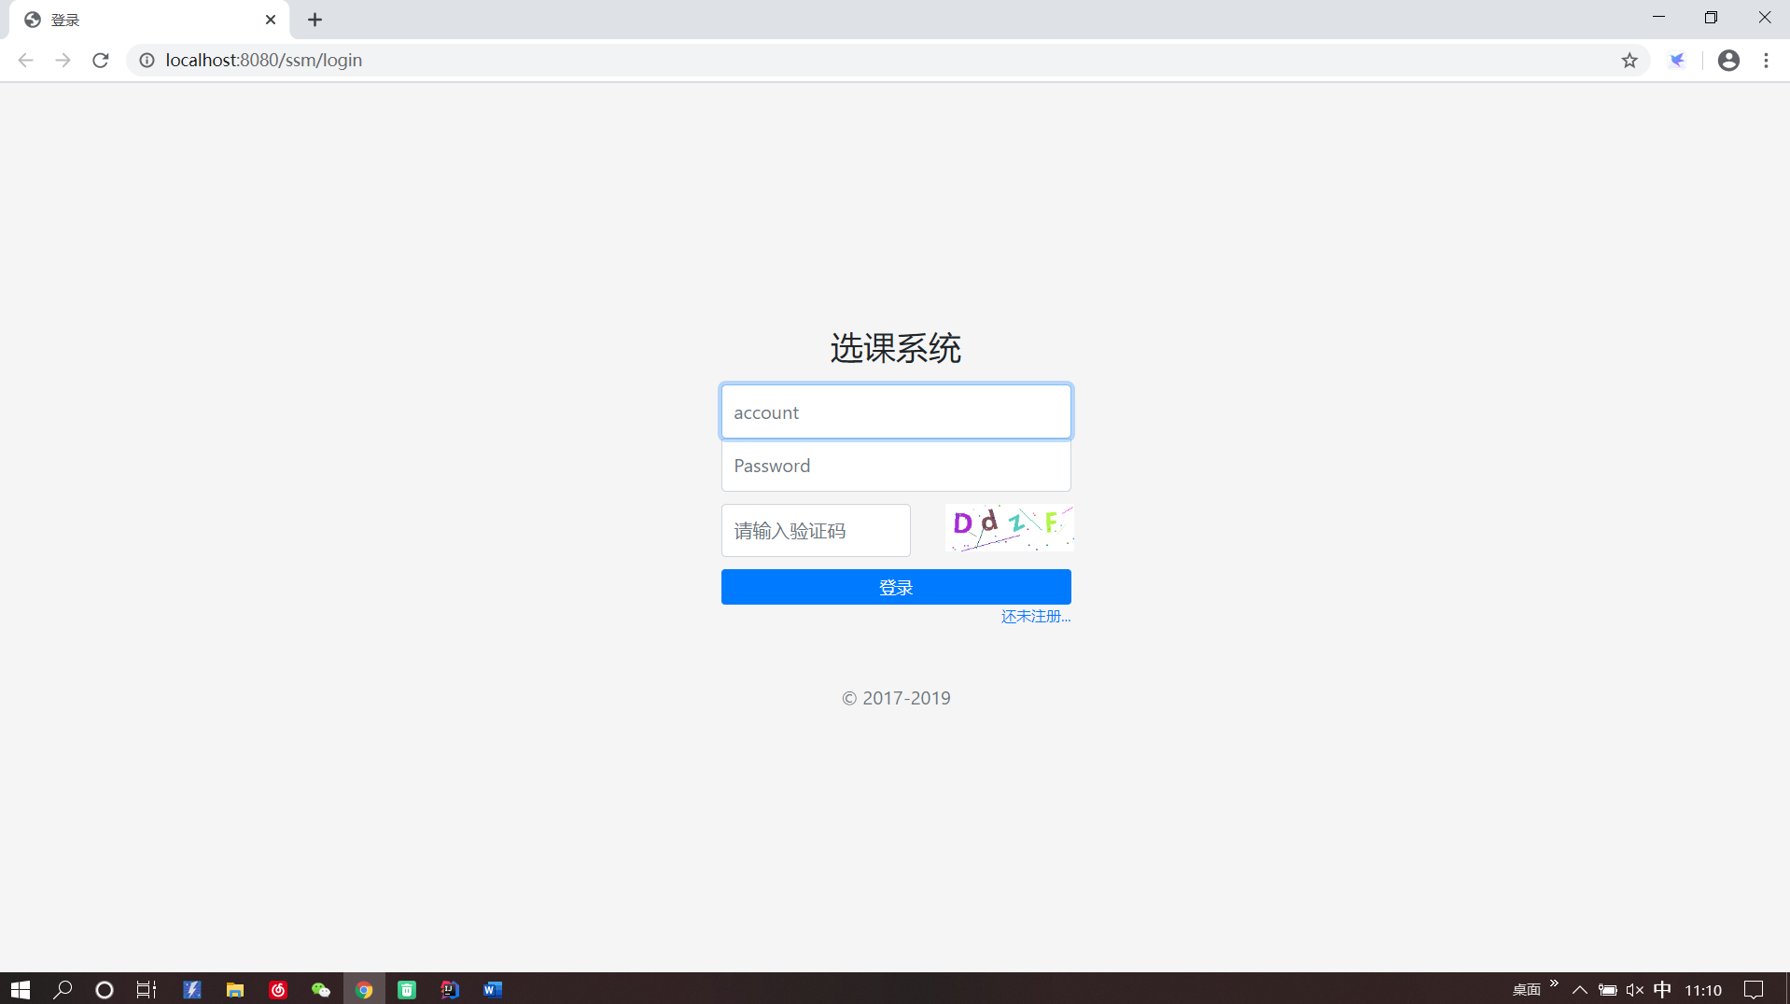
登录界面

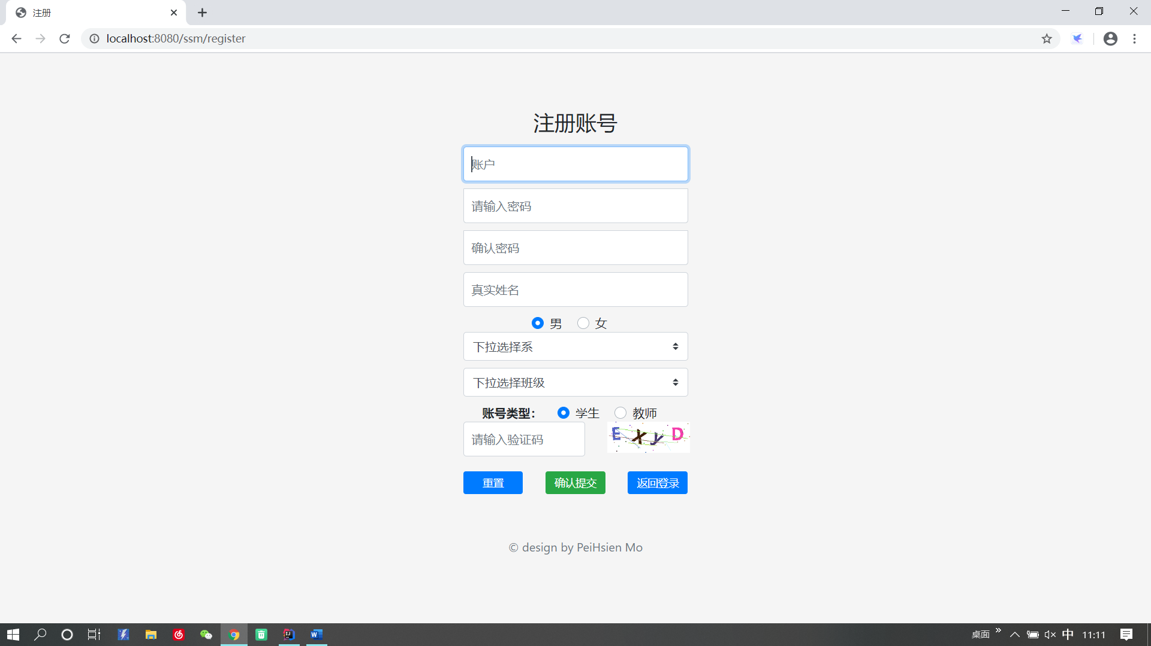
注册页面
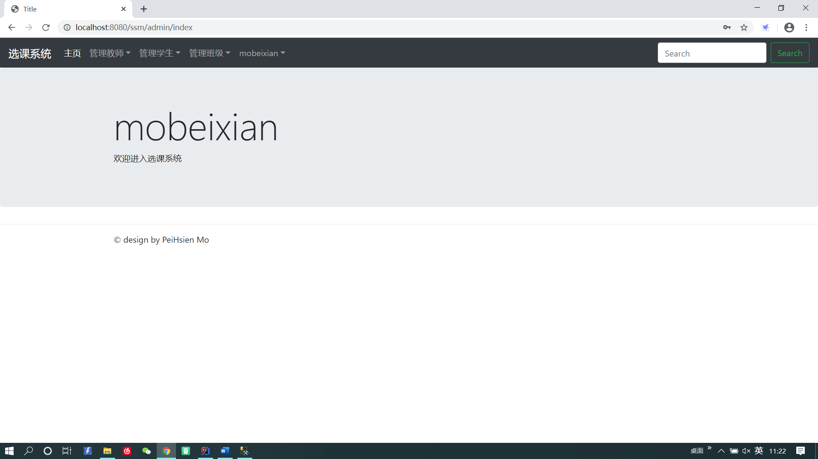
主页

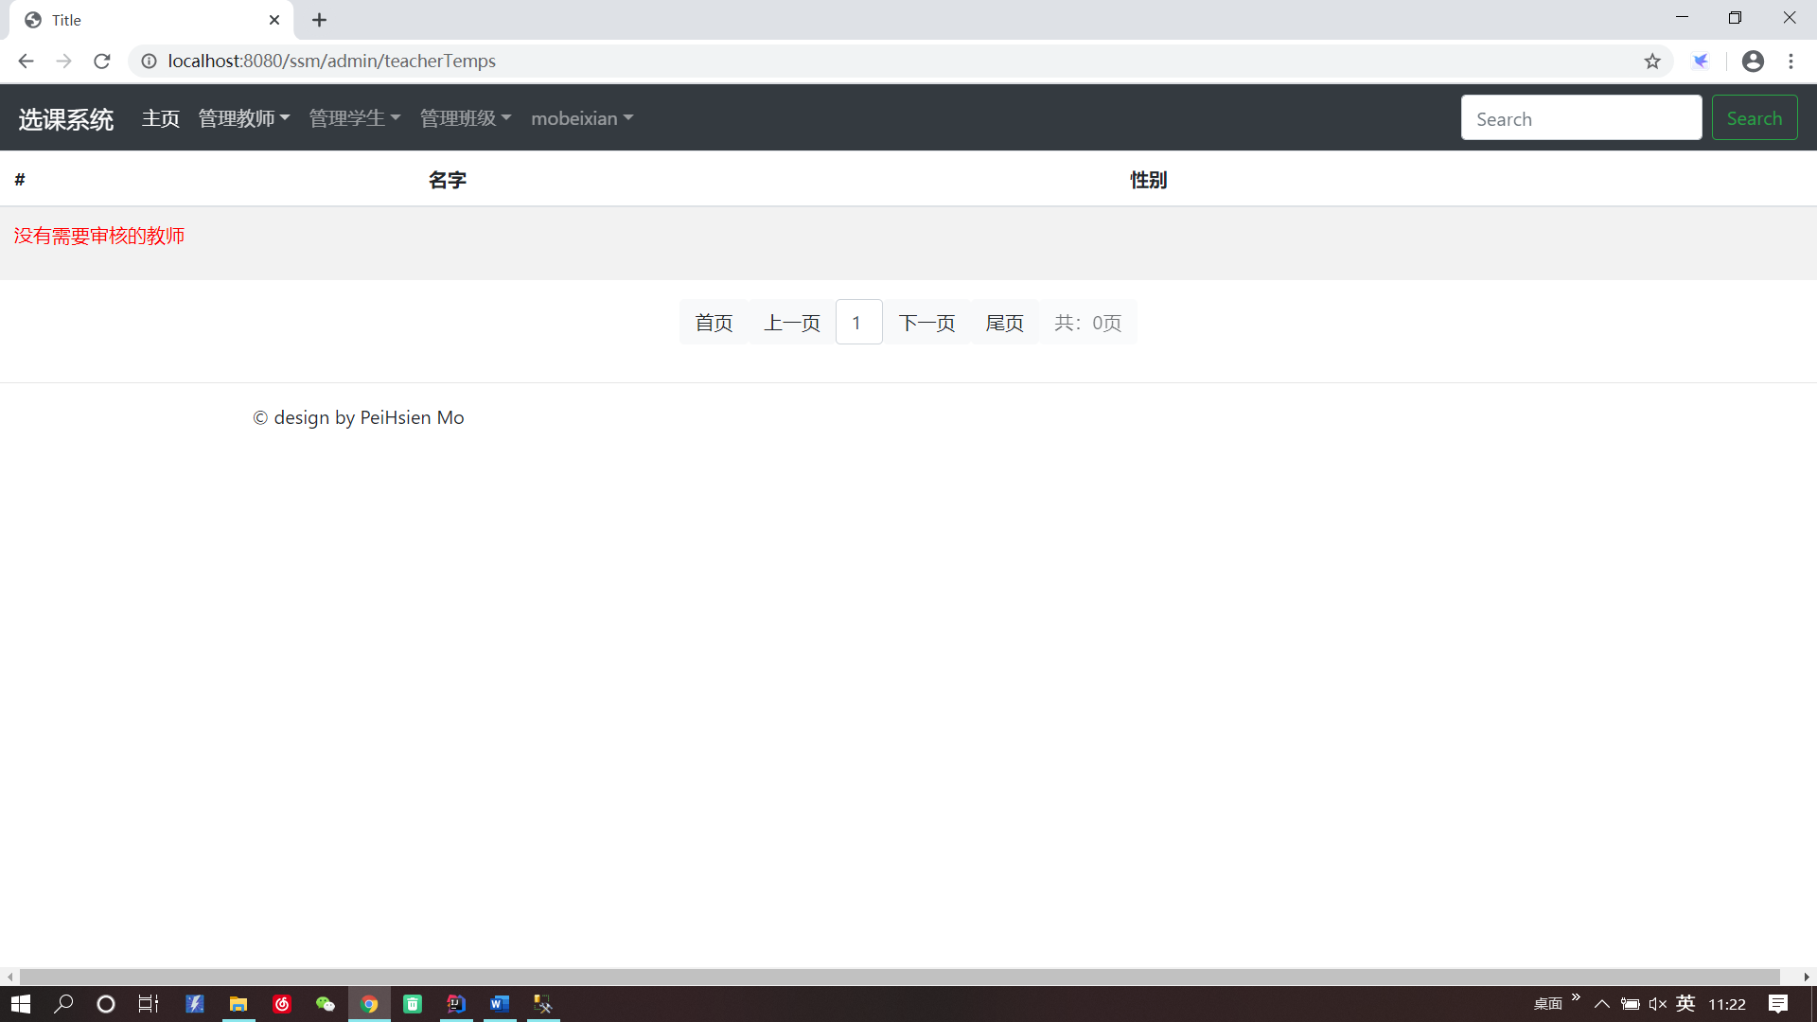
审核教师

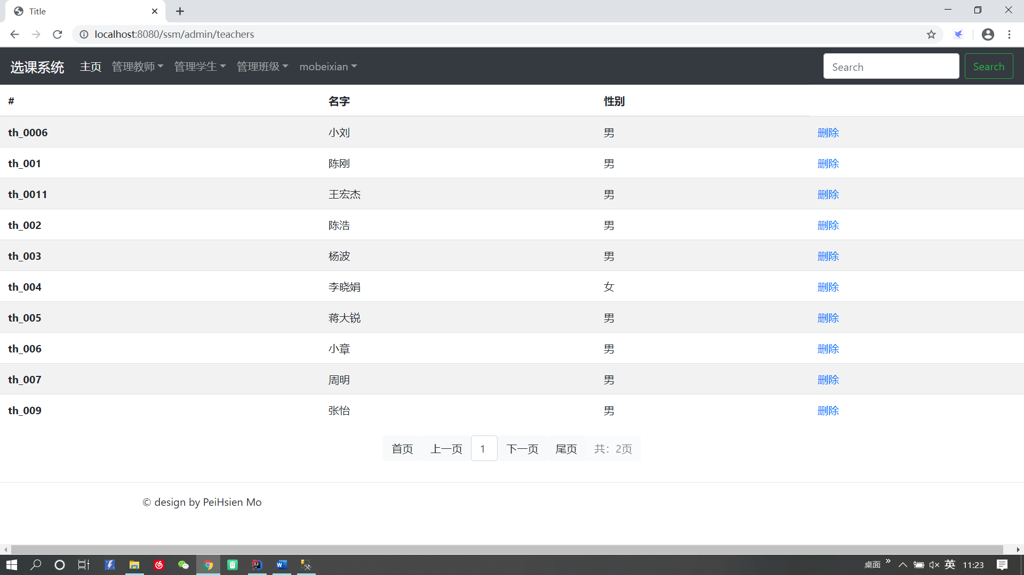
管理教师

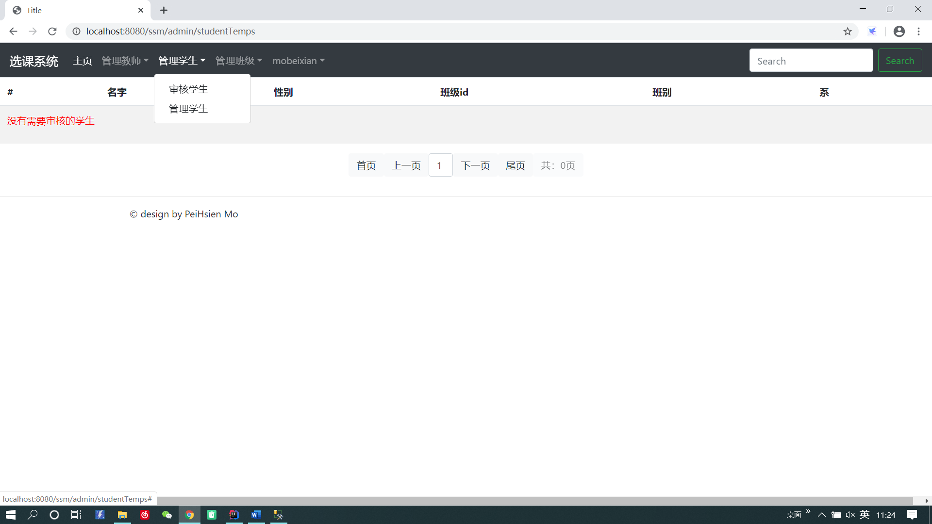
审核学生
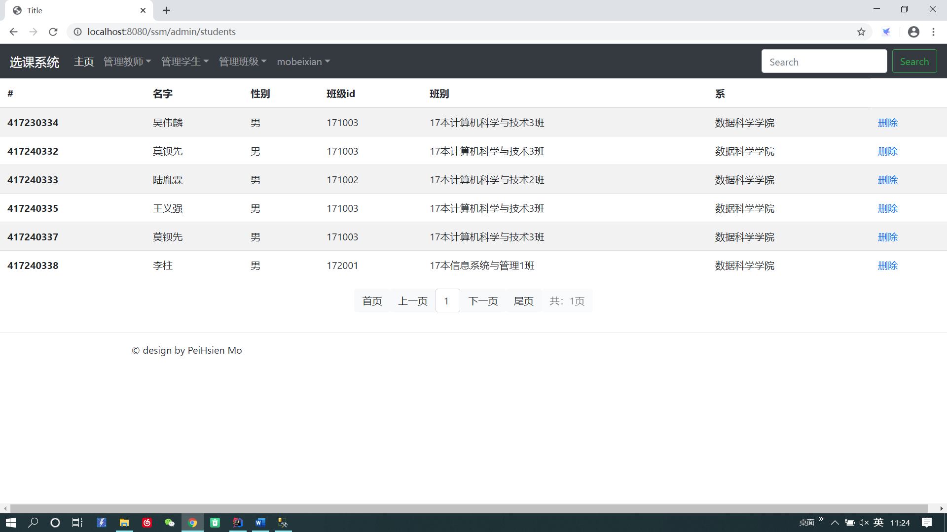
管理学生

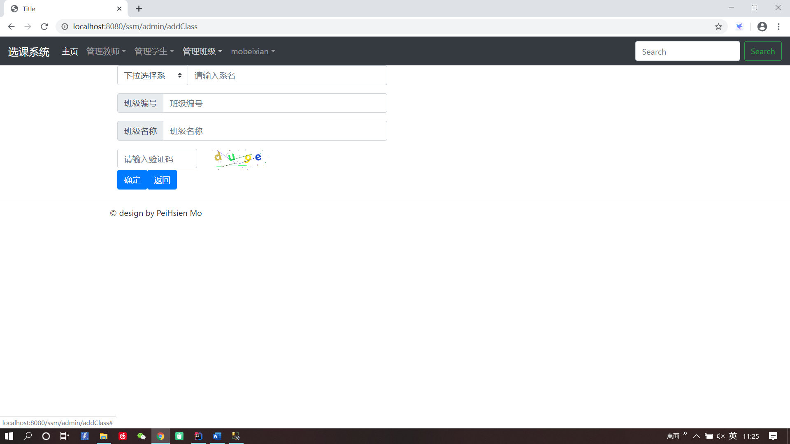
添加班级
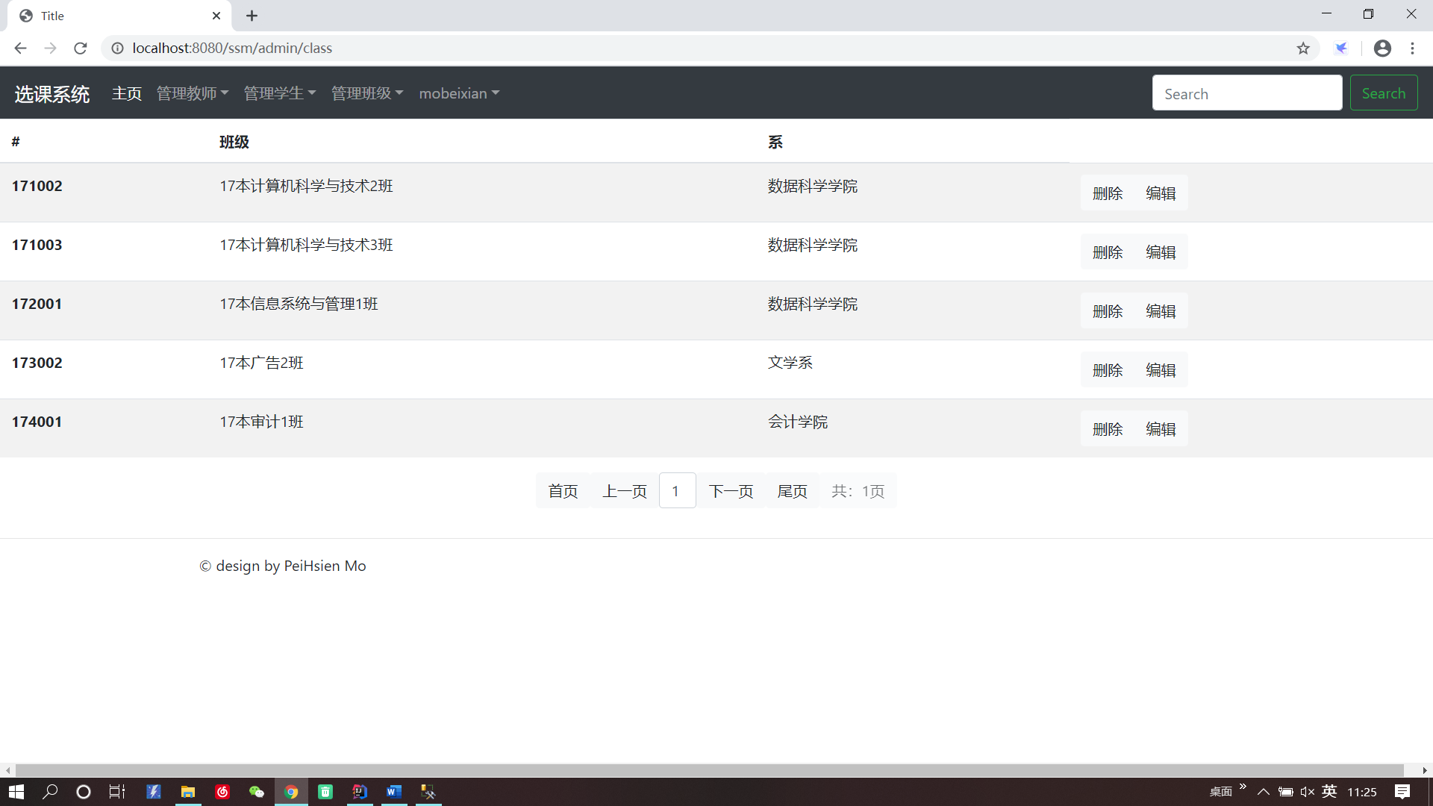
管理班级

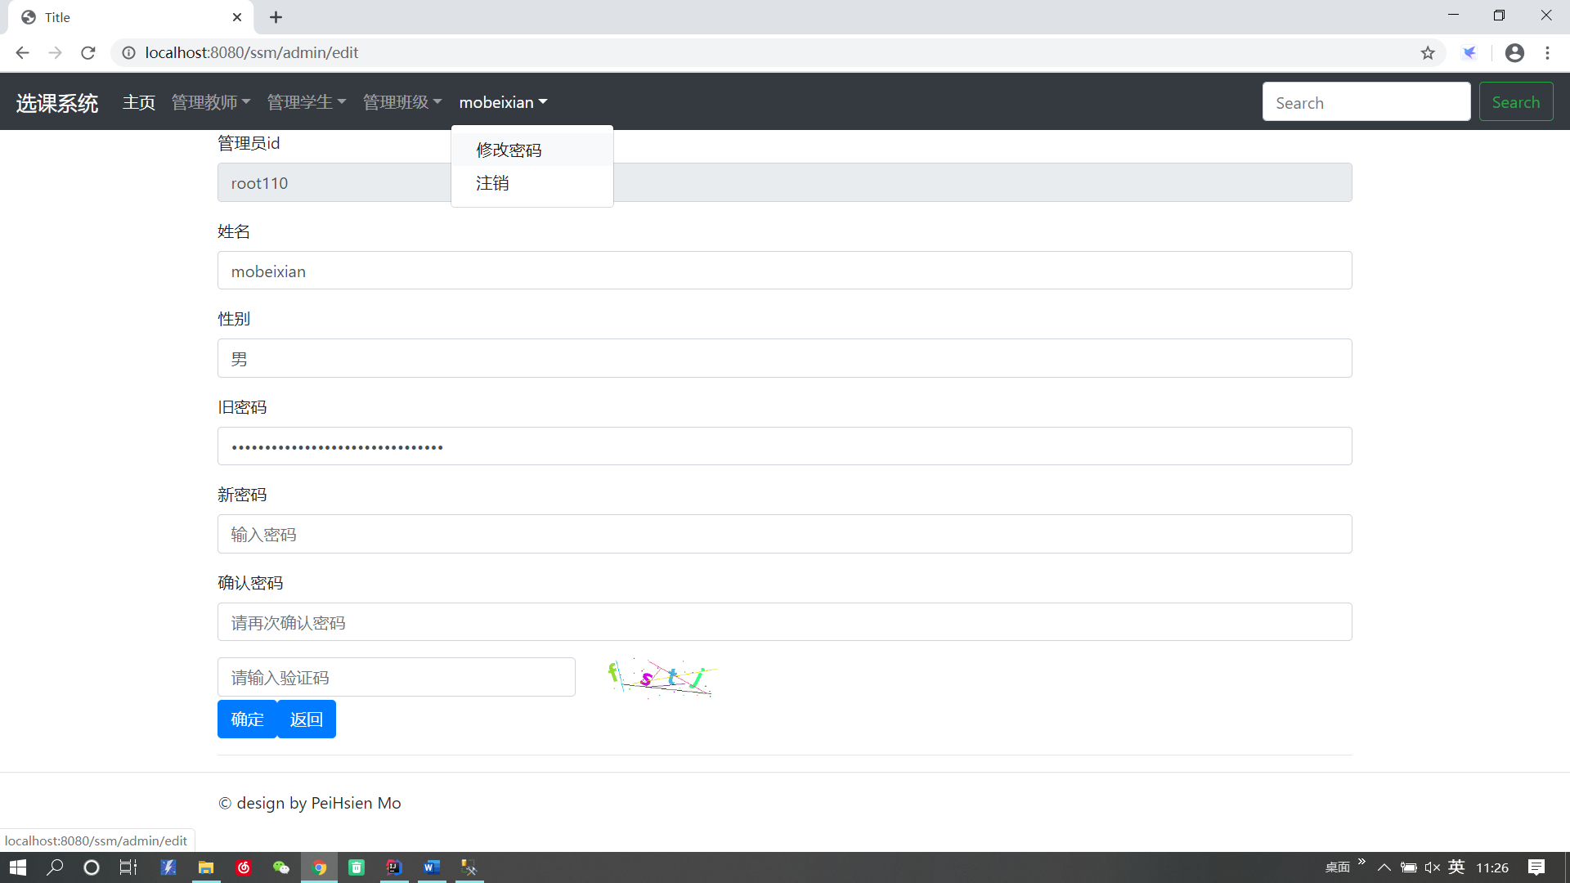
修改密码

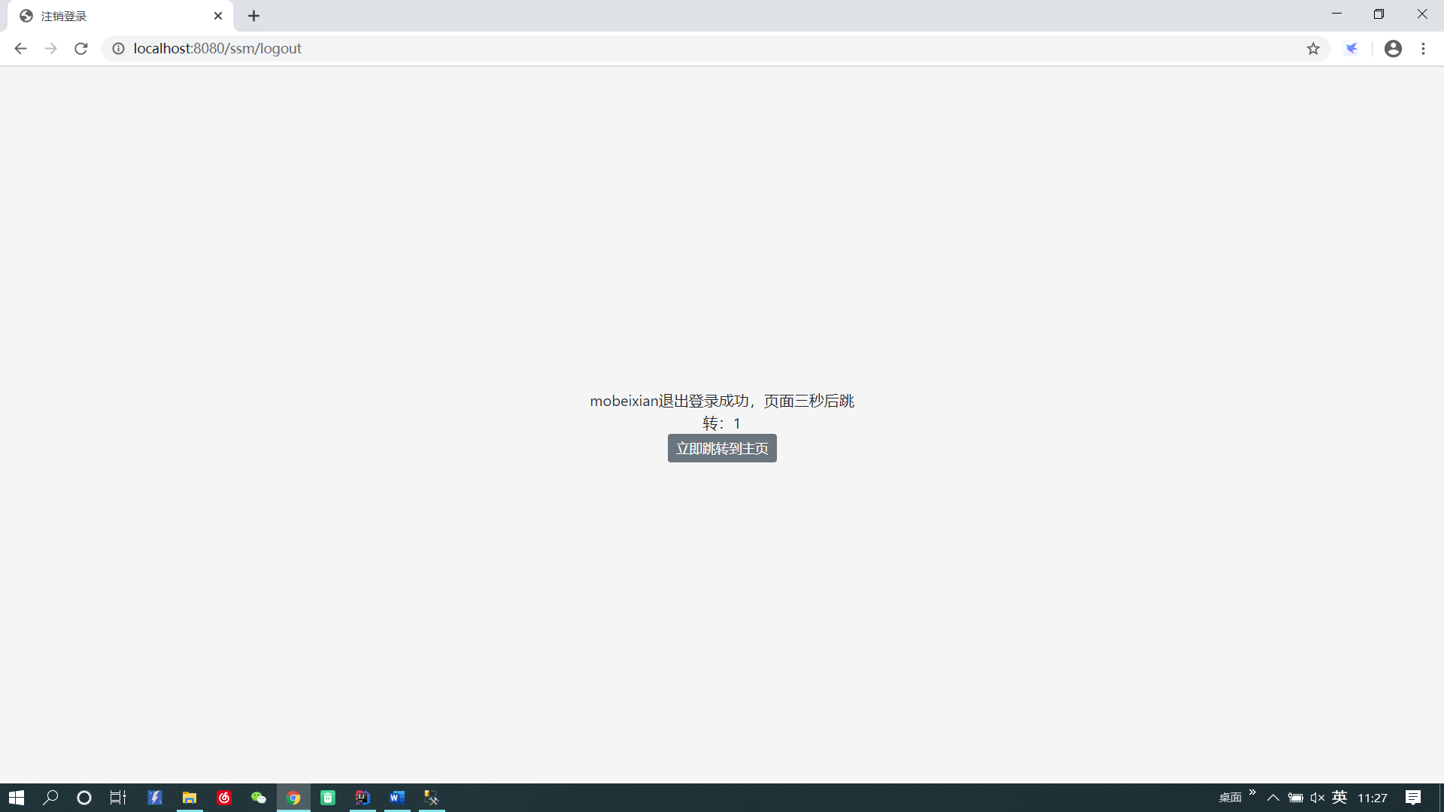
注销

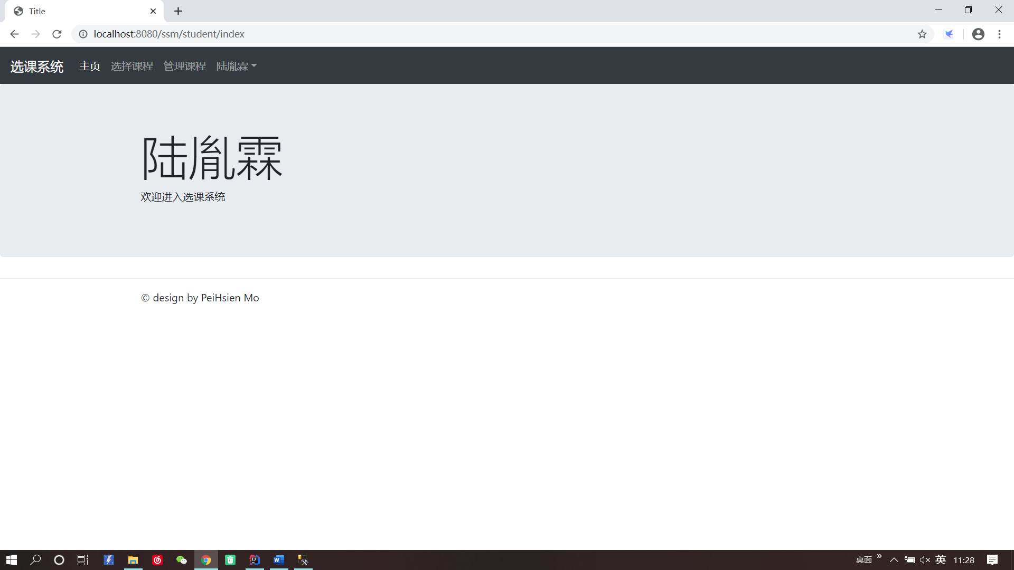
学生主页

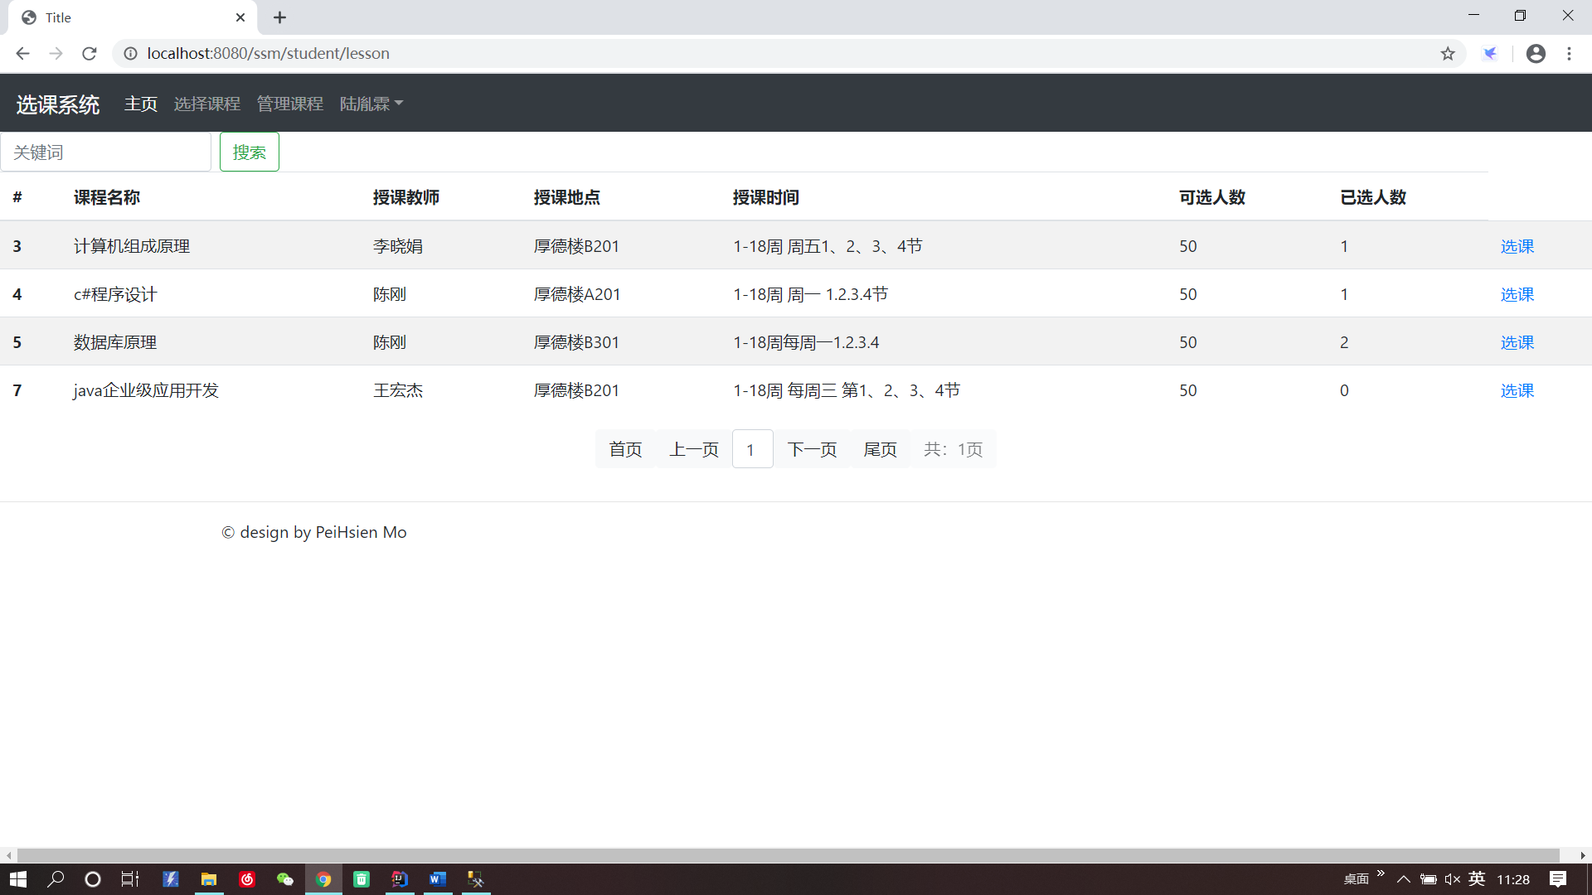
学生选择课程

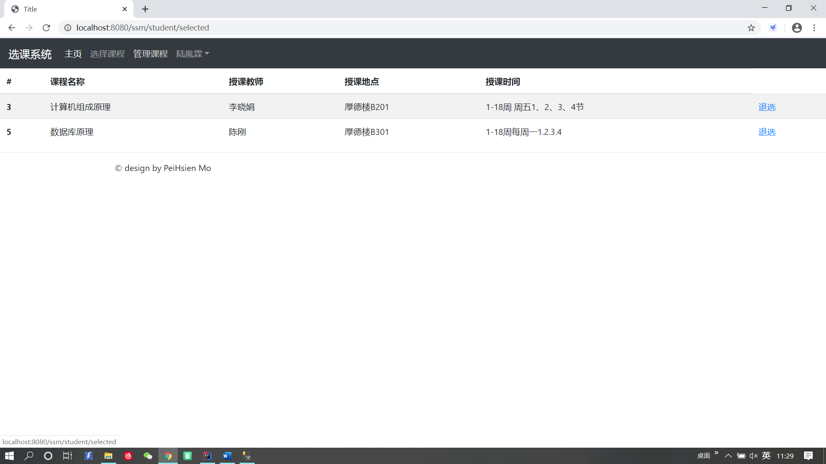
管理课程

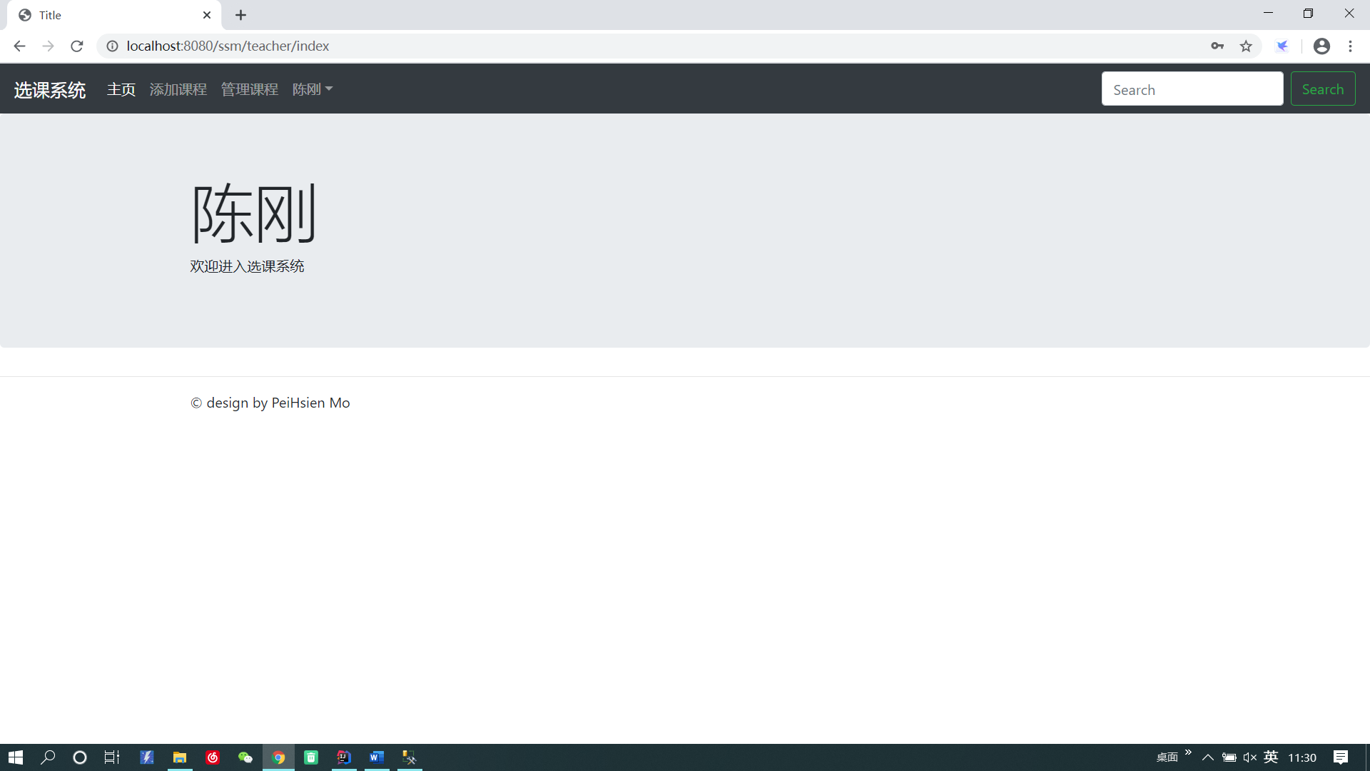
教师主页

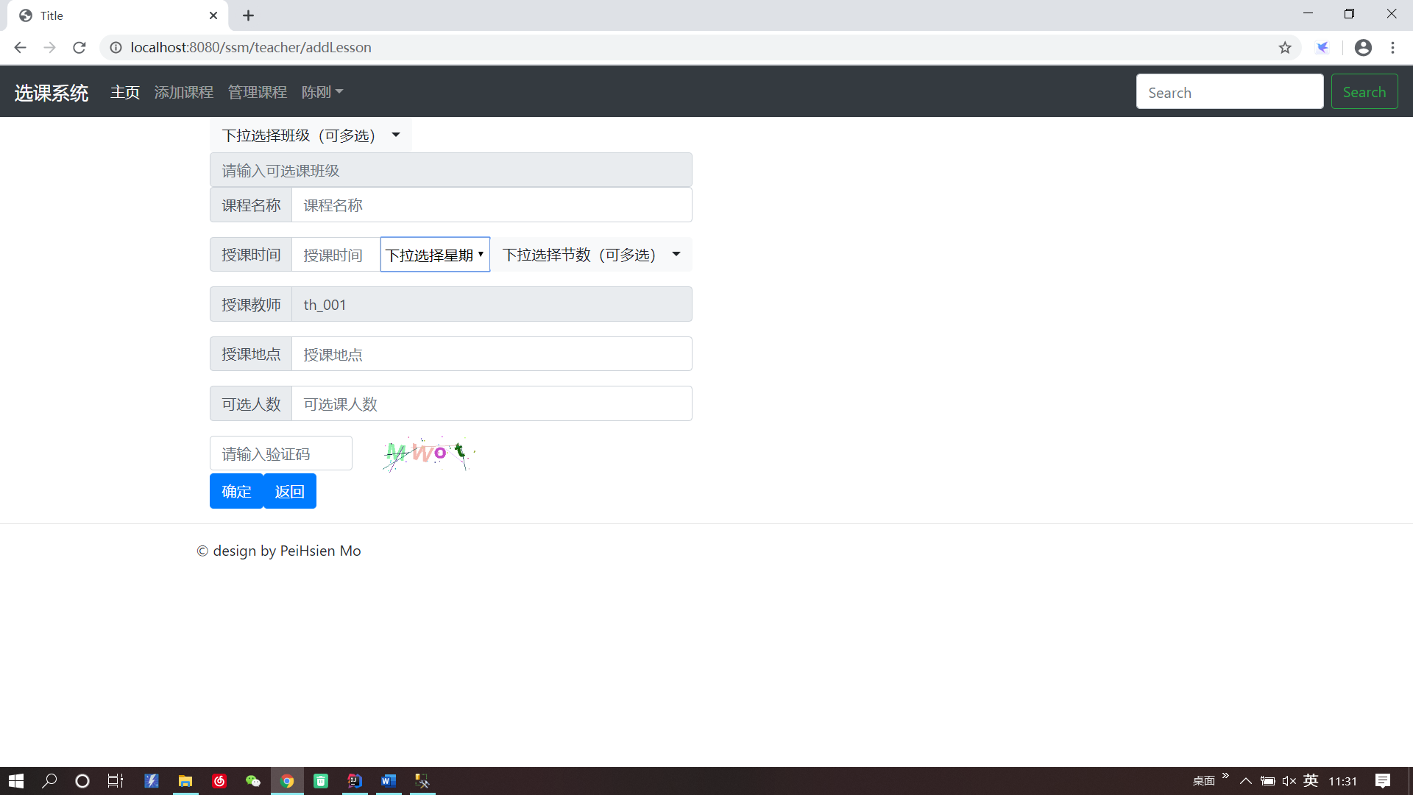
教师添加课程
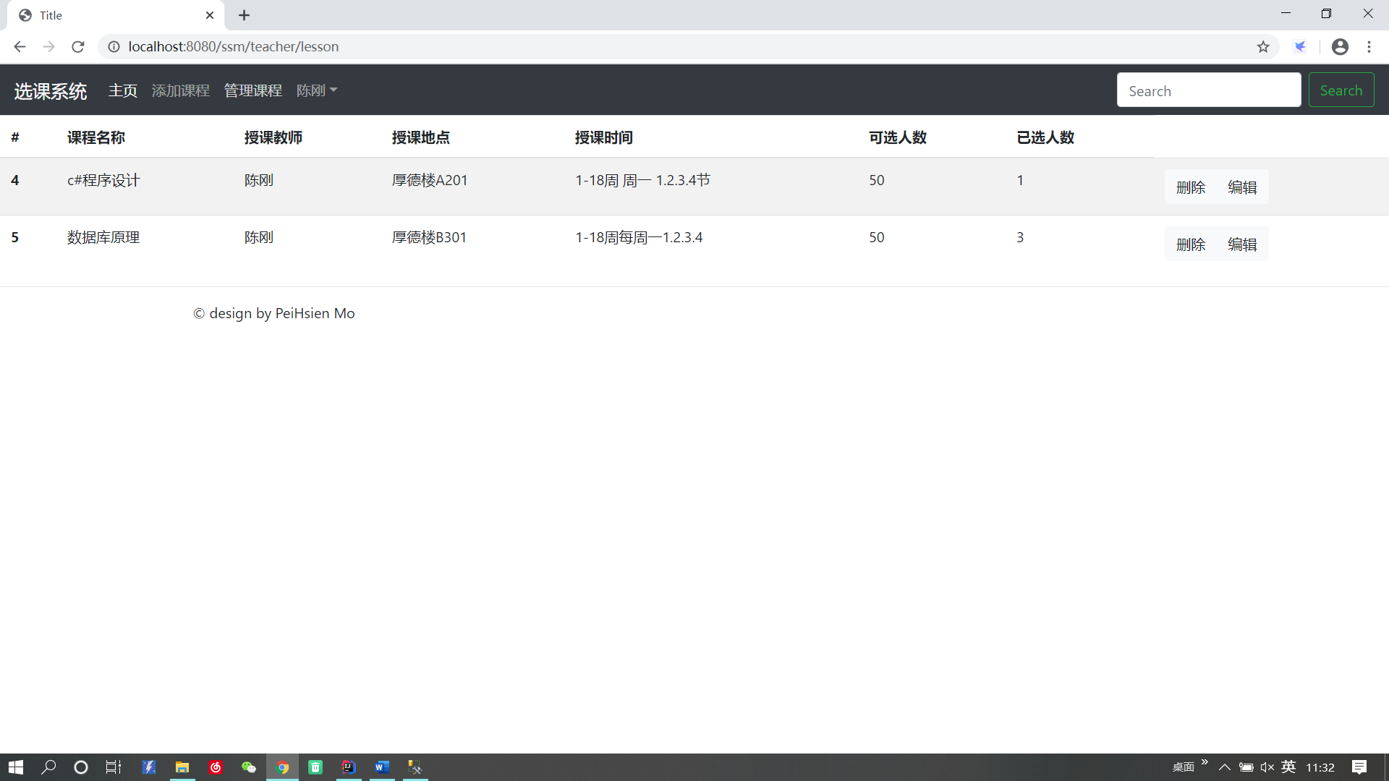
教师管理课程

注册账号
管理班级信息
审核注册帐号
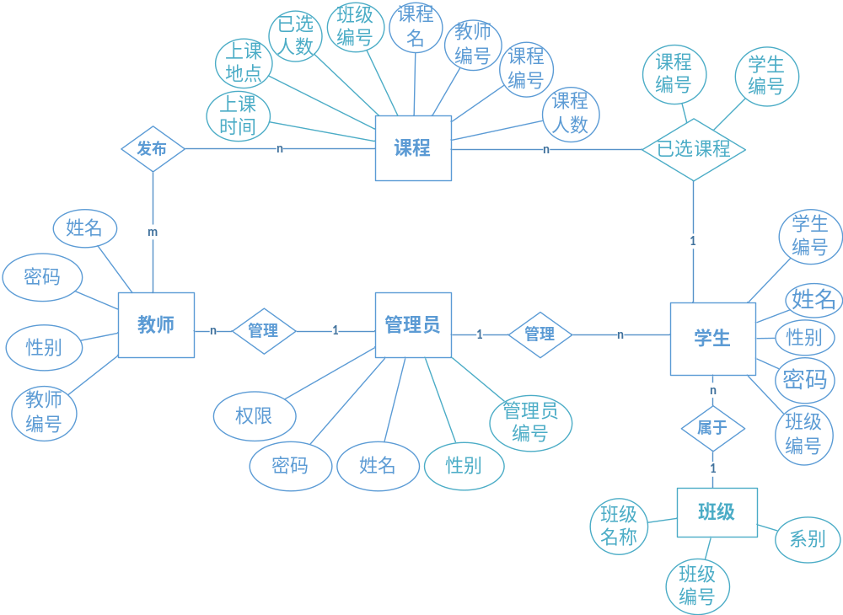
图3全局ER图

逻辑结构设计
3.1 ER图转换为关系模式

学生（学生编号，姓名，性别，密码，班级编号）
教师（教师编号，姓名，性别，密码）
课程（课程编号，课程名，教室编号，教师编号，上课地点，上课时间，课
程人数，已选人数）
管理员（管理员编号，姓名，性别，密码，权限）
班级（班级编号，班级名称，系别）
选课（课程编号，学生编号）
发布（教师编号，课程编号）
管理（管理员编号，教师编号，学生编号）

3.2 关系模式规范化

在关系模式学生（学生编号，姓名，性别，密码，班级编号）中，每一个属性都不能再分，故属于1NF；
在关系模式学生（学生编号，姓名，性别，密码，班级编号）中，主键为学号，所以，姓名，性别，专业，出生日期，班级都是非主属性。根据候选键定义可知，学号完全决定姓名，姓名，性别，专业，出生日期，班级，即每一个非主属性完全依赖于候选键，故该关系模式属于2NF；
在关系模式学生（学生编号，姓名，性别，密码，班级编号）中，姓名、性别、出生日期、班级、专业，都是非主属性，且每一个非主属性不传递函数依赖于候选键学号，即，学号决定姓名，但姓名不决定性别，不决定出生日期、班级、专业。故该关系模式属于3NF。
在关系模式学生（学生编号，姓名，性别，密码，班级编号）中，候选键为学函数依赖为学号→姓名，学号→性别，学号→密码，学号→班级编号，故该关系模式属BCNF；
由于在关系模式学生（学生编号，姓名，性别，密码，班级编号）中不存在多值依赖，故该关系模式不属于4NF。
综上所述，关系模式学生（学生编号，姓名，性别，密码，班级编号）为BCNF。

物理结构设计
4.1 设计表结构

学生表（student）
列名 | 数据类型 | 是否为空/主键 | 说明
stu_id | char(9) | not null/PK | 学生的学号
name | varchar(10) | not null | 学生的姓名
password | varchar(30) | not null | 学生的密码
sex | varchar(10) | not null | 学生的性别
class_id | varchar(10) | not null | 学生的教室编号

教师表（teacher）
列名 | 数据类型 | 是否为空/主键 | 说明
teach_id | char(9) | not null/PK | 教师的编号
name | varchar(10) | not null | 教师的姓名
password | varchar(30) | not null | 教师的密码
sex | varchar(10) | not null | 教师的性别

课程表（lesson）
列名 | 数据类型 | 是否为空/主键 | 说明
lesson_id | char(1) | not null/PK | 课程编号
name | varchar(10) | not null | 课程名
limit | int | not null | 课程人数
selected | int | not null | 课程已选人数
teach_id | varchar(10) | not null | 教师编号
teach_place | varchar(20) | not null | 上课地点
course_class_id | varchar(10) | not null | 班级编号
teach_time | varchar(30) | not null | 上课时间

班级表（class）
列名 | 数据类型 | 是否为空/主键 | 说明
class_id | char(10) | not null/PK | 班级编号
department | varchar(50) | not null | 系别
name | Varchar50) | not null | 课程名字

管理员表（admit）
列名 | 数据类型 | 是否为空/主键 | 说明
admin_id | char(10) | not null/PK | 管理员编号
name | varchar(10) | not null | 管理员姓名
password | varchar(30) | not null | 管理员密码
sex | varchar(10) | not null | 管理员性别
Root | int | not null | 管理员权限

八、总结
在这几个星期，我们用数据库做了一个学生选课系统，在这次试验中，我们都很用心的去做这次试验，但是，这次试验也中出现了许多的问题，最大的问题就是对数据库软件的不熟悉，在实现与数据库的连接时，经常会出现一些不同的错误。
回顾实习生活，感触很深，收获颇丰。经过实习我更加认识到实践是检验真理的唯一标准，只学不实践，那么所学的就等于零，理论应当与实践相结合。另一方面，实践可为以后找工作打基础。我感觉实践是大学生活的第二课堂，是知识常新和发展的源泉，是检验真理的试金石，也是大学生锻炼成长的有效途径。一个人的知识和本事仅有在实践中才能发挥作用，才能得到丰富、完善和发展。大学生成长，就要勤于实践，将所学的理论知识与实践相结合一齐，在实践中继续学习，不断总结，逐步完善，有所创新，并在实践中提高自我的各方面知识、本事、技术等因素融合成的综合素质和本事，为自我事业的成功打下良好的基础。
本次项目实践中，不仅是温习了大二下学期学习的java的学习，还学习到了非常多的专业知识，因为在真正的实现某些功能时，必须要做很多检查，必须要给用户舒适的反馈，为了避免错误，必须要在存储过程中设置很多的判断语句，对用户输入的内容进行判断，减少了造成系统错误的隐在祸患，而在这些操作中，也非常的考验javaweb设计人员的思维逻辑，如何创建表，如何使表与表的信息进行交互，如何设计页面，如何设计控制层。我也在实践中发现了自己的很多问题，对ssm框架并不是很熟悉，很多都要通过查询才可以完成操作，不过在这是项目实践中，牢牢的记住了很多关于ssm框架的知识，温故而知新。

