REPUBLIC OF THE PHILIPPINES

SURIGAO DEL NORTE STATE UNIVERSITY

Narcisso Street, Surigao City 8400, Philippines

Caspe,Mark Angelo J

BSECE-3A

Laboratory Activity no.1

Getting Started:(Blinking LED**)**

**Introduction:**

LEDs (light emitting diodes) are used in all sorts of clever things which is why we have included them in this kit. We will start off with something very simple, turning one on and off, repeatedly,producing a pleasant blinking effect.

**Objectives:**

The objective of creating the activity to blink the LED is to introduce learners to basic programming and circuitry concepts, providing hands-on experience with microcontrollers and electronic components, while utilizing Proteus to simulate and visualize circuit behavior.

**Materials:**

1.) Atmega328P 2.) Crystal 3.) 10mm LED x1

4.) 22pf Capacitor 5.) 150 Ohm Resistor

**Schematic Diagram:**

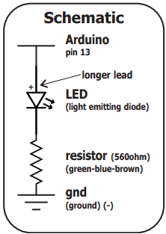

**Procedure:**

* Start by opening Proteus and creating a new project.
* Next, identify the materials required for our assembly activity.
* Then, refer to the schematic diagram to understand the guidelines for connecting components.
* After identifying the schematic diagram, proceed to create a program in the Arduino IDE to make the LED blink.Save the code in the Arduino IDE.Return to Proteus and select the Atmega328p component.Locate the file name of the code, select the .hex file, and run the simulation in Proteus.

**Results and Discussion:**

The simulation results in Proteus indicate that the LED is blinking as expected. Learners can adjust the blinking speed by modifying the delay in the code. This demonstrates the practical application of programming concepts in controlling circuit behavior, providing a customizable learning experience.

**Circuits:**

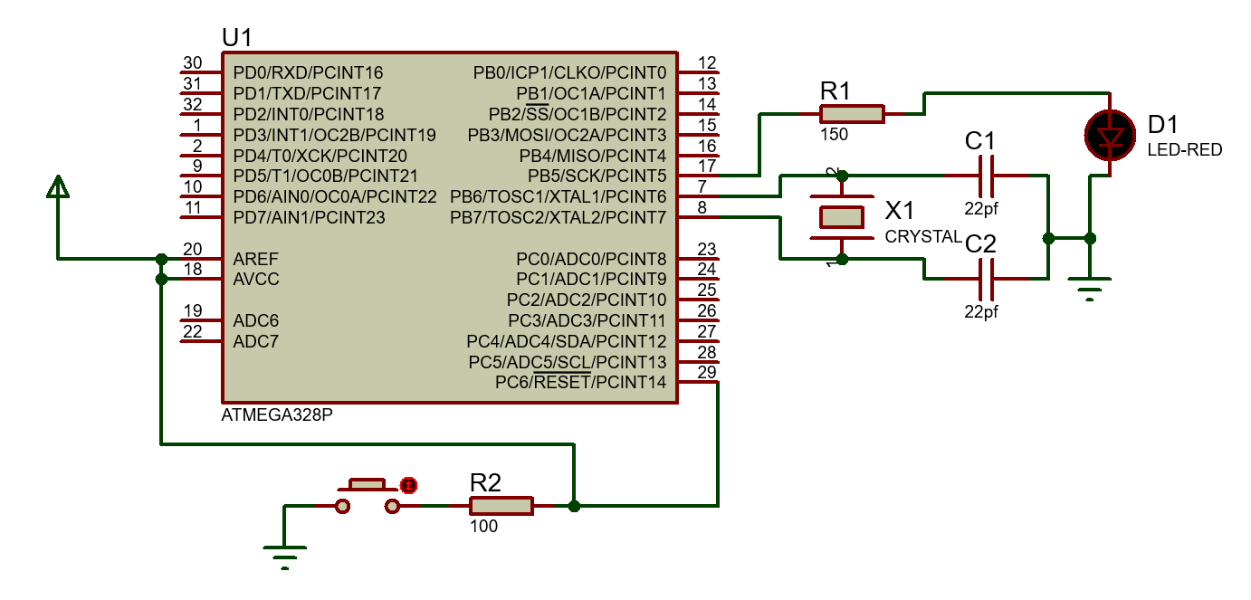

**Program:**

int ledPin = 13;

void setup()

{

pinMode(ledPin, OUTPUT);

}

void loop() {

digitalWrite(ledPin, HIGH);

delay(500);

digitalWrite(ledPin, LOW);

delay(500);

}

**Findings:**

* The LED blinked as expected.
* Learners successfully adjusted blinking speed by changing the code delay.

**Recommendations:**

Try simulating a traffic light system in Proteus. This project builds on the blinking activity, helping you practice programming and simulating LED sequences to mimic real traffic lights.

**Conclusions:**

In conclusion, the LED blinking activity in Proteus provided valuable hands-on experience in microcontroller programming and circuit simulation. Learners successfully controlled the LED's blinking speed by adjusting the code delay, establishing a strong foundation for future projects.