REPUBLIC OF THE PHILIPPINES

SURIGAO DEL NORTE STATE UNIVERSITY

Narcisso Street, Surigao City 8400, Philippines

Caspe,Mark Angelo J

BSECE-3A

Laboratory Activity no.2

8 LED Fun: Multiple LED’s

**Introduction:**

We have caused one LED to blink, now its time to up the stakes. Lets connect eight. We'll also have an opportunity to stretch the Arduino a bit by creating various lighting sequences. This circuit is also a nice setup to experiment with writing your own programs and getting a feel for how the Arduino works.

**Objectives:**

Simulating the connection of eight LEDs to an Arduino in Proteus allows for hands-on learning of programming and hardware control. It's a practical way to experiment with lighting sequences and programming concepts without physical components.

**Materials:**

1.) Atmega328p 2.) Crystal 6.)Push Button

3.) 5mm Green LED x8 4.) 22pf Capacitor 5.) 150 Ohm Resistor

**Schematic Diagram:**

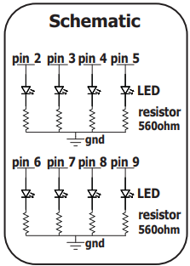

**Procedure:**

* Open Proteus and locate the necessary components for this activity based on the schematic diagram.
* Follow the guidelines to assemble the circuit accordingly.
* Then, open the Arduino IDE and write a program to control the eight LEDs in your preferred style.
* Compile the code and save it as a .hex file. Return to Proteus, click on Atmega328p, and select the .hex file you saved.
* Finally, run the simulation in Proteus to observe the behavior of the LEDs controlled by your Arduino program.

**Results and Discussion;**

The LED lights looked nice in the simulation. We could easily change the patterns using the code. This shows how flexible the Arduino board is for making different lighting effects.

**Circuit:**

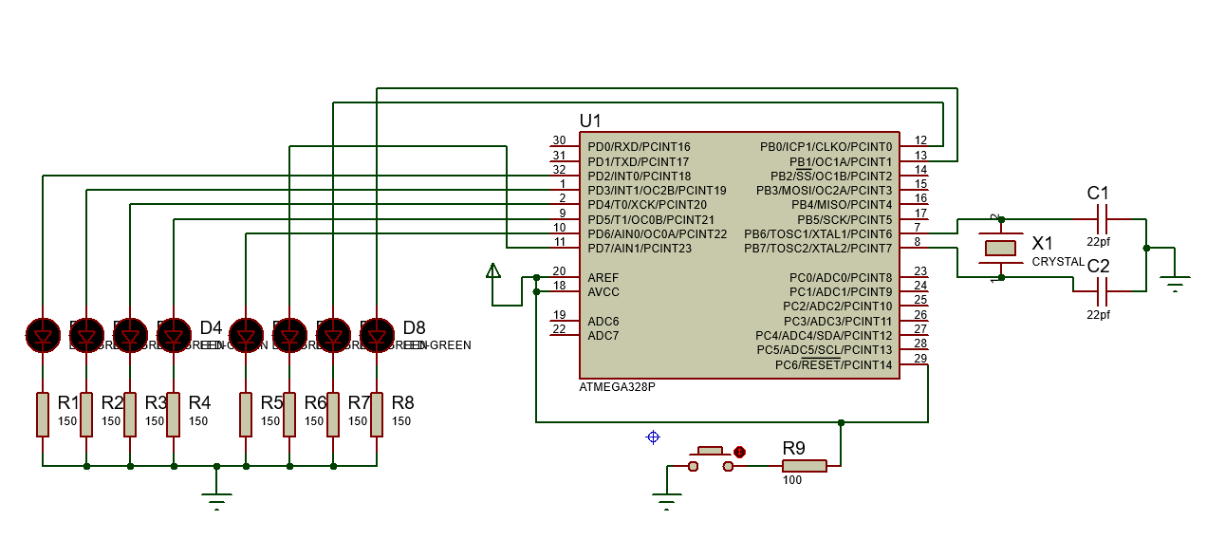

**Program:**

int ledPins[] = {2,3,4,5,6,7,8,9};

void setup()

{

  for(int i = 0; i < 8; i++) {

    pinMode(ledPins[i],OUTPUT);

  }

}

void loop(){

  inAndOut();

  oneAfterAnotherLoop();                                   }

void inAndOut(){

  int delayTime = 100;

  int offLED1 = 2;

  int offLED2 = 5;

  for(int i = 3; i >= 0; i--) {

    int onLED2 = 7 - i;

    digitalWrite(ledPins[offLED1], LOW);

    digitalWrite(ledPins[offLED2], LOW);

    digitalWrite(ledPins[i], HIGH);

    digitalWrite(ledPins[onLED2], HIGH);

    offLED1 = i;

    offLED2 = onLED2;

    delay(delayTime);

  }

  for(int i = 0; i <= 3; i++) {

    int onLED2 = 7 - i;

    digitalWrite(ledPins[offLED1], LOW);

    digitalWrite(ledPins[offLED2], LOW);

    digitalWrite(ledPins[i], HIGH);

    digitalWrite(ledPins[onLED2], HIGH);

    offLED1 = i;

    offLED2 = onLED2;

    delay(delayTime);

  }

}

void oneAfterAnotherLoop()

{

  int delayTime = 100;

  for(int i = 0; i <= 7; i++){

    digitalWrite(ledPins[i], HIGH);

    delay(delayTime);

  }

 for(int i = 7; i >= 0; i--) {

    digitalWrite(ledPins[i], LOW);

    delay(delayTime);

  }

}

**Findings:**

The 8 LED lighting appears pleasing due to the patterns generated by the code. Adjusting the delay adds to its appeal, as it allows for slower or faster lighting patterns based on personal preference.

**Recommendations:**

Try different delays, mix patterns, write down favorites, and share with others to inspire creativity.

**Conclusions:**

In conclusion, the activity in Proteus allowed for the exploration of 8 LED lighting patterns, showcasing the flexibility of the Arduino platform. By adjusting the delay in the code, users could personalize the lighting sequences, from slow to fast-paced patterns. Moving forward, further experimentation within Proteus, such as trying different delay values and pattern combinations, can lead to the discovery of unique LED lighting designs. This activity highlights the practicality of using Proteus for learning and experimentation in electronics and programming, offering a dynamic platform for innovation and creativity.