REPUBLIC OF THE PHILIPPINES

SURIGAO DEL NORTE STATE UNIVERSITY

Narcisso Street, Surigao City 8400, Philippines

Caspe,Mark Angelo J

BSECE-3A

Laboratory Activity no.5

8 More LEDs:74HC595 Shift Register

**Introduction:**

Time to start playing with chips. Or integrated circuits (ICs) as they like to be called. The external packaging of a chip can be very deceptive for example the chip on the Arduino board (a micro controller) and the one we will use in this circuit (a shift register) look very similar but are in fact rather different, for example the price of the Atmega chip on the arduino board is a few dollars while the 74hc595 is a couple dozen cents. It's a good introductory chip, and once your comfortable playing around with it and its datasheet (available online http://ardx.org/74HC595 ) the world of chips will be your oyster. The shift register (also called a serial to parallel converter), will give you an additional 8 outputs (to control LEDs and the like) using only three arduino pins. They can also be linked together to give you a nearly unlimited number of outputs using the same four pins.

**Objectives:**

The objective of simulating the shift register (74HC595) in Proteus is to understand how it works and how it can expand the output capabilities of the Arduino using only a few pins. By interfacing the shift register with the Arduino and controlling it via serial communication, you can effectively control multiple outputs (such as LEDs) with just a few Arduino pins, thus optimizing the utilization of the microcontroller's resources. This activity helps in gaining hands-on experience with integrated circuits, understanding datasheets, and expanding your knowledge of electronics and microcontroller programming.

**Materials:**

1.) Atmega328P 2.) Crystal 3.) Shift Register 74HC595 x1 4.) 22pf Capacitor

5.) Red LED x8 6.) 150 Ohm Resistor 7.)Push Button

**Schematic Diagram:**

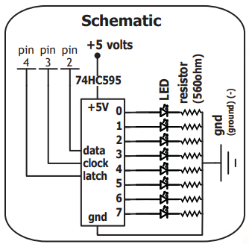

**Procedure:**

* Open Proteus and create a new project.
* Find the components needed for your activity in Proteus.
* Refer to the schematic diagram for guidance on connecting the components.
* Open the Arduino IDE and create the code for your project.
* Save the code.Go back to Proteus, click on the ATmega328P microcontroller.
* Find the file you saved in step 5 (the .hex file) and choose it.
* Simulate or run the simulation in Proteus to see your project in action.

**Results and Discussion;**

The simulation successfully demonstrated how the Arduino communicates with the 74HC595 shift register to control multiple LEDs, providing a foundation for understanding integrated circuit interfacing and enabling further experimentation with microcontroller projects..

**Circuit:**

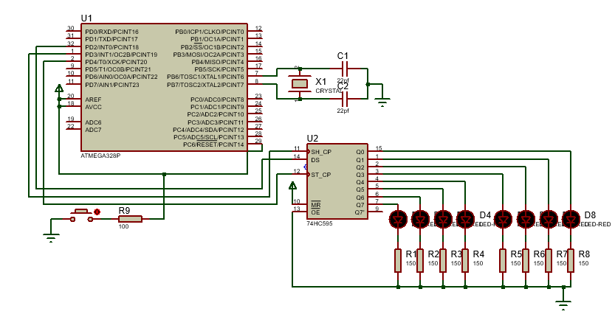

**Program:**

int data = 2;

int clock = 3;

int latch = 4;

void setup()

{

  pinMode(data, OUTPUT);

  pinMode(clock, OUTPUT);

  pinMode(latch, OUTPUT);

}

void loop()

{

  int delayTime = 100; //the number of milliseconds to delay between LED updates

  for(int i = 0; i < 256; i++){

   updateLEDs(i);

   delay(delayTime);

  }

}

void updateLEDs(int value){

  digitalWrite(latch, LOW);

  shiftOut(data, clock, MSBFIRST, value);

  digitalWrite(latch, HIGH);

}

**Findings:**

We successfully simulated the interaction between an Arduino board and a 74HC595 shift register in Proteus, ensuring accurate component connection and code implementation. This allowed us to observe how the Arduino controls the shift register's outputs, turning on 8 LED lights with different patterns, and paving the way for further experimentation and learning.

**Recommendations:**

Experiment with different LED patterns and behaviors to explore the full capabilities of the shift register and deepen your understanding of microcontroller-based systems.

**Conclusions:**

In conclusion, simulating the interaction between the Arduino board and the 74HC595 shift register in Proteus helped us understand how to control multiple LED lights with minimal pin usage, paving the way for further exploration in microcontroller project.