REPUBLIC OF THE PHILIPPINES

SURIGAO DEL NORTE STATE UNIVERSITY

Narcisso Street, Surigao City 8400, Philippines

Caspe,Mark Angelo J.

BSECE-3A

Laboratory Activity no.9

Light:Photo Resistors

**Introduction:**

Whilst getting input from a potentiometer can be useful for human controlled experiments, what do we use when we want an environmentally controlled experiment? We use exactly the same principles but instead of a potentiometer (twist based resistance) we use a photo resistor (light basedresistance). The Arduino cannot directly sense resistance (it senses voltage) so we pin is calculable, but for our purposes (just sensing relative light) we can experiment with the values and see what works for us. A low value will occur when the sensor is well lit while a high value will occur when it is in darkness.

**Objectives:**

The objective of this activity in simulation with Proteus is likely to demonstrate the functionality and application of using a photoresistor as a sensor in an environmentally controlled experiment. It allows users to understand how to interface such sensors with an Arduino using a voltage divider circuit, and how the varying resistance of the photoresistor can be translated into voltage changes to detect light levels. This hands-on simulation likely helps users grasp the practical aspects of sensor interfacing and environmental monitoring using Arduino.

**Materials:**

1.) Atmega328P 2.) Crystal 3.) Photo-Resistor x1 4.) 22pf Capacitor

5.) 10k Ohm Resistor 6.) 150 Ohm Resistor 7.) Green LED x1

**Schematic Diagram:**

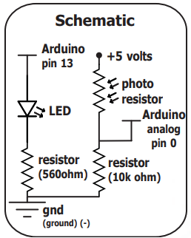

**Procedure:**

* **Proteus Setup:** - Open Proteus and create a new project. - Search for the following components: ATmega328P microcontroller (Arduino Uno), photoresistor, resistors for the voltage divider circuit, and wires to connect the components. - Refer to a schematic diagram for guidance on connecting the components. Ensure the connections match the schematic for proper functionality.
* **Arduino Code:\*** - Open the Arduino IDE. - Write the code for your project, including the logic to read the analog input from the photoresistor and output the results. - Verify that your code compiles without errors. - Save the code to your desired location on your computer.
* **Loading Code onto ATmega328P:\*** - In Proteus, click on the ATmega328P microcontroller. - Find the file you saved earlier in the Arduino IDE (the .hex file) and choose it to load onto the microcontroller.
* **Simulation:\*** - Run the simulation in Proteus to observe how your circuit behaves based on the code you wrote. - Observe the behavior of the photoresistor and ensure that it responds correctly to changes in light levels.

**Results and Discussion:**

The simulation results demonstrate that the photoresistor (LDR) reacts to changes in light levels. When sunlight is adjusted, the LDR responds accordingly, causing the LED to light up. This indicates that the circuit successfully senses changes in light intensity and triggers the LED based on the input received from the photoresistor. This observation confirms the functionality of the circuit in responding to environmental changes, showcasing how the Arduino can effectively interface with sensors like the photoresistor to create responsive systems. Additionally, it highlights the practical application of using photoresistors in environmental monitoring and control systems.

**Circuit:**

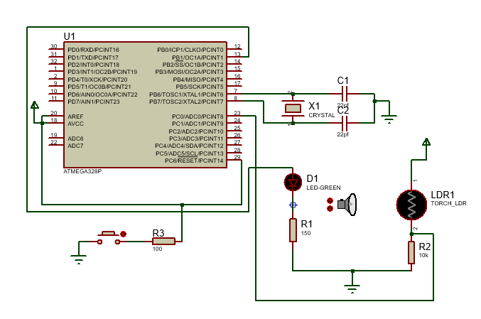

**Program:**

//PhotoResistor Pin

int lightPin = 0;

int ledPin = 9;

void setup()

{

  pinMode(ledPin, OUTPUT); //sets the led pin to output

}

void loop()

{

  int lightLevel = analogRead(lightPin);

  lightLevel = map(lightLevel, 0, 900, 0, 255);

  lightLevel = constrain(lightLevel, 0, 255);

  analogWrite(ledPin, lightLevel);

}

**Findings:**

The experiment found that the circuit effectively detects changes in light levels using a photoresistor. Adjusting sunlight causes the photoresistor to change resistance, altering voltage at the Arduino pin, and lighting the LED accordingly. This demonstrates the photoresistor's sensitivity to light changes and its usefulness in environmental sensing and control.

**Recommendations:**

Based on the experiment results, it's recommended to ensure the sensor is well-placed, calibrated accurately, and free from obstacles to optimize its performance in detecting light changes.

**Conclusions:**

In conclusion, the simulation experiment effectively demonstrated the functionality of the light sensing circuit using a photoresistor and Arduino. The circuit accurately detected changes in light levels by adjusting the resistance of the photoresistor, triggering the LED accordingly. This highlights the practical application of photoresistors in environmental monitoring and control systems, showcasing their sensitivity to light changes and their potential for various projects requiring light sensing capabilities.