Nickname: Breezy (Chris Brown)

Desired Income: $300,000.00

Ok, @Jimmy Robertson. Your battle buddy is @Dré Noisin. Your group members are @Kyle Baker, @Christopher Brown, @Ahmad Khalid Qadafi, @Jay Herrera. Guys can you please get with Jimmy. I need you guys to connect with one another.

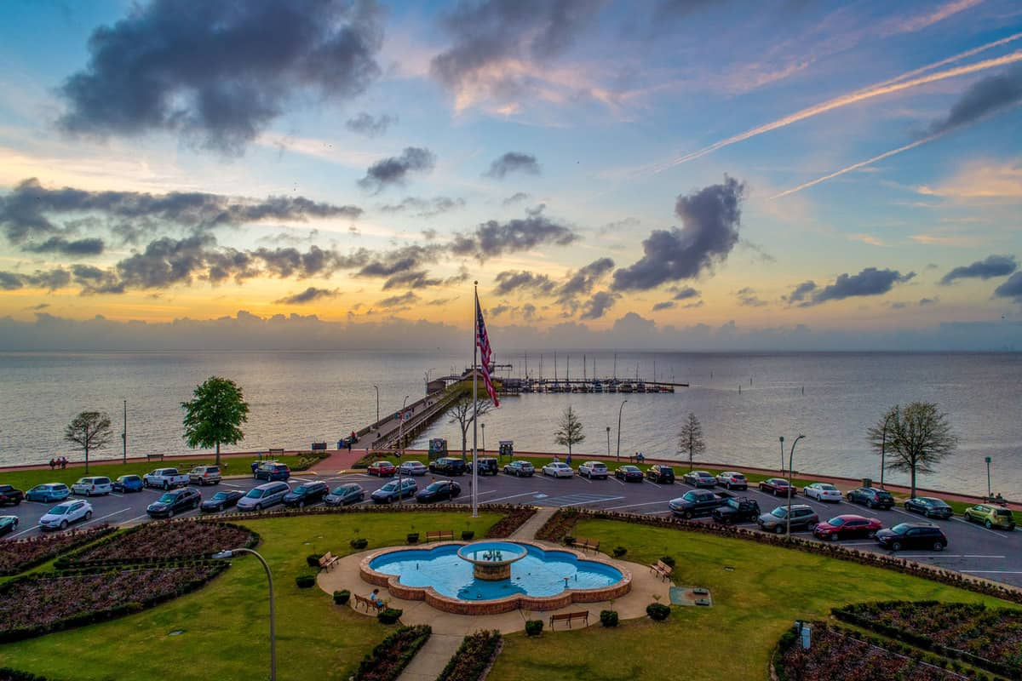

Happy Place:

Fairhope, AL

Fairhope Pier

Hobby:  Reading and enjoying Smooth Jazz Music