POA Internship

**KICAD 6 information Health Concept Lab**

**Student:** Casper R. Tak

**Studentnumber:** 657313

**Client**: Rudie van den Heuvel

**Coach:** Jeroen Veen

**High School:** HAN Arnhem

**Education:** Embedded Systems Engineering

**Date:** 12-12-2022

# Why KiCad6?

The Rastaban project requires a printed circuit board (PCB) so it can be used and moved safely from one point to another. Later a PCB is the only viable way to produce this product in larger quantities.

The reasons that made me choose KICAD 6 are as follows. KICAD is open-source, free, widely used by many hobbyists and also some professionals and apart from that it’s good software to start learning how to design PCB’s.

I used to design my PCB’s with EasyEda, which is proprietary. This isn’t a problem on its own, but it does mean that your CAD software is loaded with EasyEda’s ads, they put their own components first and they really want you to use their online servers, which also makes you more vulnerable to your designs being lost or stolen. Apart from this, you are not allowed to install any useful plugins like an interactive BOM file for assembly, 3D model archiver, fabrication toolkits, which could’ve saved you time or made your designs and workflow even better. These are the main reasons why I stopped using EasyEda. It is, however, to be noted that by using the parts from EasyEda’s library that you most likely gain the fastest (and also probably cheapest) way to produce a fully assembled PCB. Something to keep in mind. If you are going to assemble your PCBs yourself, than this is no longer an argument. Apart from that, there are plugins for KICAD6 that give you the ability back to relatively easily get LCSC part numbers that are required by JLCPCB for PCB assembly.

# Plugins

To create an even better PCB and make my workflow easier, I downloaded a few plugins. The plugins I downloaded are as follows:

|  |  |  |
| --- | --- | --- |
| Name | Function | Download location |
| KiCAD JLCPCB tools | This plugin allows you to search the JLCPCB parts database, assign LCSC article numbers to your parts, generate production files for JLCPCB and much more. | <https://github.com/Bouni/kicad-jlcpcb-tools> |
| Interactive HTML BOM | This plugin generates convenient BOM listing with ability to visually correlate and easily search for components and their placements on the pcb. | Build into KICAD6 |
| PCB action tools | Annular Ring Checker, Snap Selected Footprint(s) to Grid, Fabrication Footprint Position, Move Selected Drawings to chosen Layer, Export pcb technical layers to DXF, Checking 3D missing models | Build into KICAD6 |
| Archive 3D models | Copies footprint models to the project local subfolder and remaps all the links within the used footprints. | Build into KICAD6 |
| Place Footprints | Arrange sequentially numbered footprints or footprints from multiple hierarchical sheets in linear, circular or matrix arrangement. This plugin works on footprints already present in the layout, so that layout and schematics stay in sync. | Build into KICAD6 |
| Round Tracks | Algorithmically smooth tracks in a predictable manner. Useful for flex PCBs, or just because it looks cool. | Build into KICAD6 |
| Length matching | Track Length Calculator | Build into KICAD6 |
| Freerouting | Auto router for Kicad. It draws all the connections between components for you. Be warned: Auto routing should never be used carelessly, always check the results. | Build into KICAD6 (requires Java) |

# How to learn KICAD6

I learned KICAD6 by following [an online course.](https://techexplorations.com/so/kicad-like-a-pro-3rd-edition/) But I could also have used tutorials on YouTube or read books on it. KICAD itself is not difficult to use, but there are a lot of buttons, some of which are important, some are a bit redundant, which can be confusing. The best way to learn KICAD is to just start creating a schematic with some (maybe 4) parts and connecting them together. Then you can start creating a PCB in the “PCBNEW” section.

# The design approach

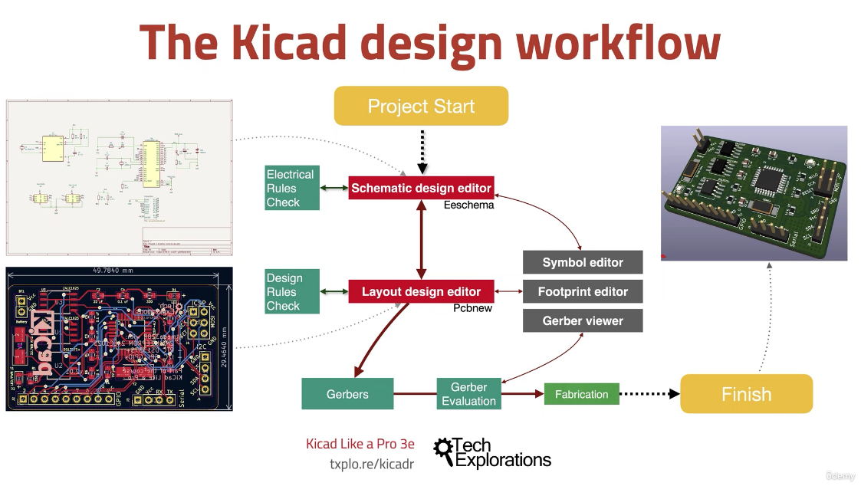  
Creating a PCB is always following trough 2 stages (as shown in the picture right)

1. Create the schematic
2. Create the PCB

After having done this, your design is finished. Of course there are more details to both design stages an those are described in the following pictures.

