**Aylmer Britto R**

**Technocrat’s summer vacation task report-I**

**Serial Communication:**

Is adopted in most of the cases because it is cheap, serves its purpose efficiently. The job can be done with a single wire itself. And most commonly it takes four wires in maximum. Here the data is transmitted bit by bit. Serial communication has two different classifications (asynchronous and synchronous).

**Synchronous:**

In Synchronous serial interface the devices share a common clock unlike asynchronous serial interface.

**Asynchronous:**

Asynchronous devices do not have a common external clock. However this reduces the requirement of wire and the I/O pins it increases the effort put to make it work.

To eschew the external clock technology there are several other substitutes to be taken care of (baud rate, Data bits, synchronisation bits, data bits and parity). The primary thing is to make sure that both the devices in the serial bus are configured to work on the same protocol. Baud rate is something that tells you how fast the data bits are being transferred from the transmitter to the receiver. If the baud rate is inverted, it tells us the time taken to transfer one single bit. It is also gonna tell you how long a serial line will transmit data. The most common baud rate is 9600 and the largest known baud rate is 115200. Faster the baud rate, higher the transmission speed. But when the baud rate goes high there are chances of errors as the transmitter and the receiver can’t cope up the speed. Framing the data is a term to refer when data is sent in packets usually in byte. Frames are created by appending synchronisation and parity to our data. Chunk is the real data that is to be transmitted. Usually it varies from 5-9 bits. But conventionally we use 8-bit cycle. But a 7-bit data chunk can be more efficient. Now the character length is sent. Then you should be sure whether the data is sent from most significant bit (MSB) to least significant bit (LSB). If not specified assume the transfer is made from LSB to MSB. Synchronisation bits comprises of one single start bit and either one or two stop based on their configurations. Start bit is indicated by the idle data line going from 1-0 and in stop bit the data line will come back from its place to 1. Parity is a low level error checking mechanism.

**Serial peripheral Interface:**

The advantages are the data are sent without any interruptions regardless of the number of bits unlike UART and I2C where data is transferred in packets. The devices in SPI are in Master-Slave relationship. There exists one master and any number of slaves. Mainly SPI has 4 Wires for MOSI->(Master output and slave input), MISO->(Master Input and Slave output), SCLK->(Clock), SS/CS->(Slave Select or chip select).The slave select line is kept in high voltage when not in use and when kept in low it is denoted that it is in use.

In multiple-slave system the slaves can share the clock, MISO and MOSI cables in parallel connection but all the slaves should have an independent ss on their own.

**Advantages**:

1) High transmission rate

2) No need of start and stop bits and data transfer is done without any interruption.

3) Full Duplex mode since it has MOSI and MISO cables.

**Disadvantage:**

1) Uses four wires

2) Only one master

3) No error checking

**UART:**

Universal Asynchronous receiver/transmitter. As the name says it has no external clock to synchronise the transfer instead it has start bit and stop bits.

It has a ground line, UX (master) to TX(slave), TX(master) to RX(slave).

**Advantage**:

1. Requires no external clock

**Disadvantage**:

1. But very hard to setup in software level
2. Requires at-least 10 bit data to transfer 8 bits. Those 2 bits are the start bit and the end bit.

**I2C:**

Inter integrated circuit. The two major issues of UART (many wires and no error checking facility) and SPI (more data occupation and only between two devices) were sorted out and I2C was developed. The new I2C technology can have any number of slaves and masters depending on the circuit (based on the addressing system). It has only two signals. One of them is the clock signal and the other one is the data signal. Now coming to the data signal part it has address bit followed by acknowledging bit then data bits and finally the stop bit.

**Advantages:**

1. Can have any number of slaves and masters
2. Uses only two wire i.e. two signals.

**ZIGBee and XCTU:**

Xbee is a technology that can used to have a wireless connection between your micro-controller and your device say sensor. There is a gateway between your board and Xbee called XCTU (software). It communicates over two wires only RX and TX. It has signal strength indicator and a power indicator.

Xbee is an open source software that helps you the communication between the devices connected in the network. It helps you organise the topology in which the devices are connected. It allows you to control the hubs and the nodes in the mesh.

**Colour Mark Sensor:**

Colour mark sensors are something that senses the colour of the target by comparing the contrasts between the base and the mark. The mark here refers to the target colour. Contrast is the difference in luminescence that makes the object distinguishable. Contrast is the difference in colour and brightness of the object and the other object within the same field of view. Light amount ratio is the ratio between the contrasts between the mark and the base. The base here is the non-base area.

**Panasonic LX-100:**

This colour mark sensor is capable of detecting stable marks. The sensor can be operated in two different modes (Mark mode and colour mode).

**Mark mode:**

The sensor has three LED (Red, Blue, Green). The one among the three is selected by "Automatic optimal LED selection function". This function automatically selects the appropriate LED for contrast manipulation. It comes up with the optimal LED by comparing the light amount ratio of all the three colours. Since the function itself chooses the right LED for mark detection based on the target this mode is used for high speed detection.

**Colour Mode:**

We go for this mode when the result obtained has to be more precise. Unlike the mark mode in colour mode all the three LED light up and the reflective ratio is compared.

In this colour mark sensor there is a 12 bit ADC (analog to digital converter). The 12 bit signifies the resolution (the least change to which the system can respond). It says that it has precision upto $\frac{1}{2^{12}}$.

There is a digital display attached that assists you throughout the setup process and also during run-time.

There are 6 different navigation modes.

1. RUN (In mark mode it displays the light entering amount and in colour mode it gives the colour consistency)
2. TEACH button
3. ADJ mode
4. COLOR button (switch between color mode and mark mode)
5. TIMER (for timer type selection)
6. PRO button (for choosing key lock and timer mode).

The four digit digital display gives you the direct code which tells you everything about the operation mode. The display shows us the 4 digit code where each digit has its significance for different modes.

Next comes the teaching button. Teaching is nothing but initialising the sensor according to our need. Keeping straight to the mark press the on button enclosed within the rectangle named teach. And then move to the base part and then press the off button. This is the two level teaching method (simple teaching). Two level teaching is for mark mode. For color mode one level teaching is done. External teaching is done when the sensor is aligned in a hard to reach spot. When this is done to prevent the mistakes the key lock function is used which can accessed from the "PRO" button. Other options like RUN adjust and RUN teaching is used to adjust the threshold value and teaching respectively while in RUN mode itself.

ECO mode is associated with power consumption (turning off the display when not in use)

It comes in two models (cable type and plug-in connector type).

Specification:

|  |  |  |
| --- | --- | --- |
| Characteristic | NPN | PNP |
| Range | 10mm (+/-3)mm | |
| Supply Voltage | 12-24 V | |
| Output Voltage | 1.5 V or less @ 50mA sink current(cable type) | |
| 1.5 V or less @100mA sink current(plug-in converter type) | |
| Teaching | LOW | HIGH |
| Cable | Cabtyre type | |

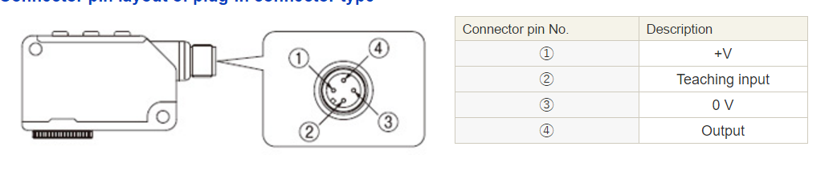

**PCB Fabrication:**

First the sketch of the circuit was made

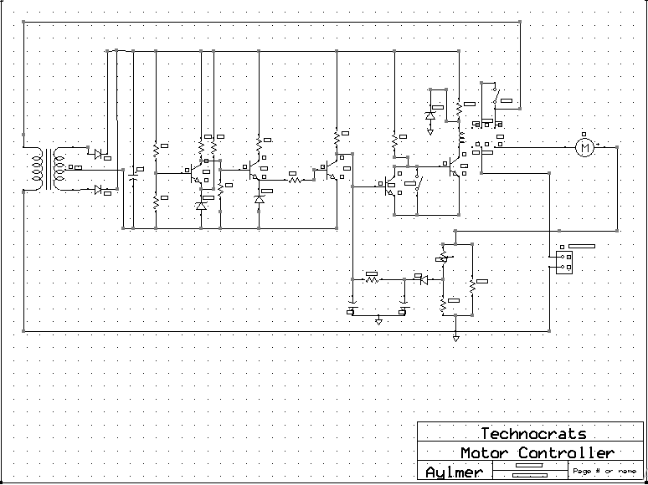

Then the PCB layout.

