**Assignment 1, Mobile Development**

**Madi Khassenov, 23MD0450**

**Exercise 1: Kotlin Syntax Basics**

**1. Variables and Data Types:**

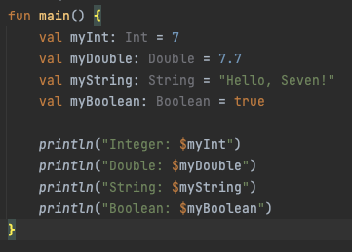



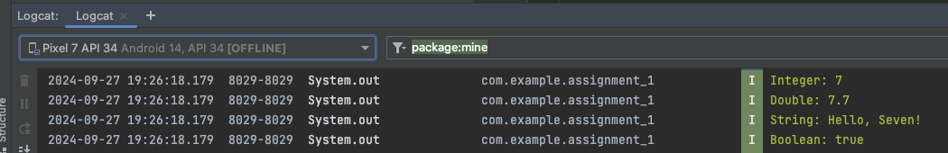

**2. Conditional Statements:**

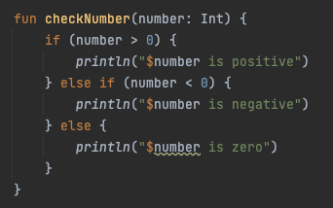





**3. Loops:**

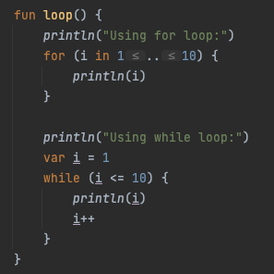



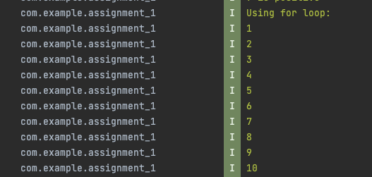

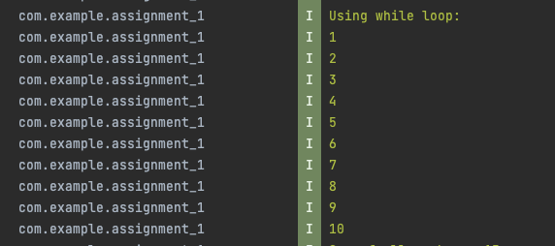

4. **Collections:**

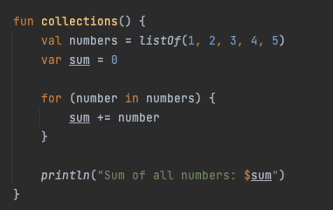





**Exercise 2: Kotlin OOP (Object-Oriented Programming)**

**1. Create a Person class:**

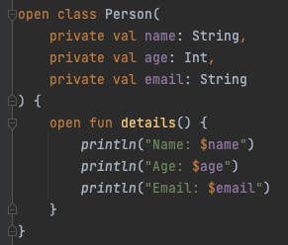





**2. Inheritance:**

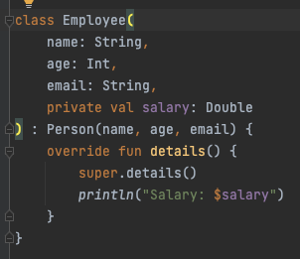



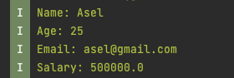

**3. Encapsulation:**

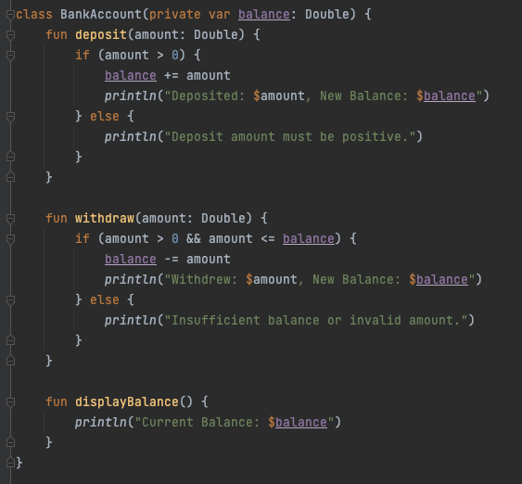

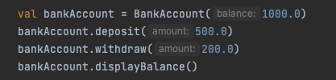

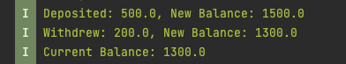

**Exercise 3: Kotlin Functions**

**1. Basic Function:**

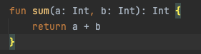





**2. Lambda Functions:**







**3. Higher-Order Functions:**

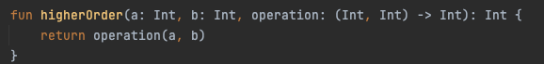





**Exercise 4: Android Layout in Kotlin (Instagram-like Layout)**

**1. Set Up the Android Project:**

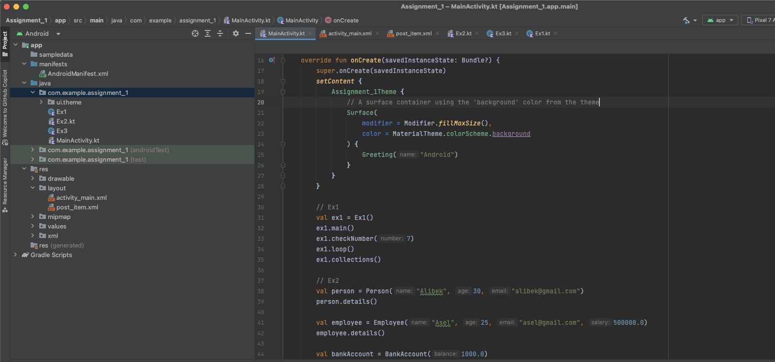

**2. Design the Layout:**

