**Assignment 1, Web Application Development**

**Madi Khassenov, 23MD0450**

**Intro to Containerization: Docker**

**Exercise 1: Installing Docker**

Steps:

1. 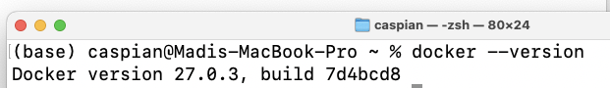
2. 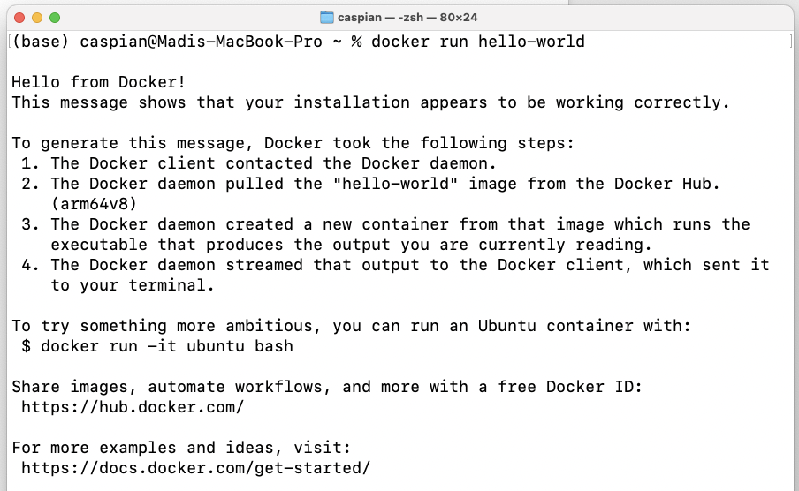

Questions:

1. What are the key components of Docker (e.g., Docker Engine, Docker CLI)?

Key components of Docker are:

1. Docker Engine – the core of Docker which includes Server (Docker Daemon), REST API, and CLI.
2. Docker Images – lightweight read-only files that contain everything needed to run an application.
3. Dockerfile – a script with instructions on how to make a Docker Image. Contains information about OS, languages, environment variables, ports etc.
4. Docker Hub – a cloud-based archive of Docker images that allows users to push and pull images either publicly or privately.
5. Docker Volumes – allows users to preserve and store data across containers and mount it to new ones.
6. Docker Compose – allows users to run multi-container Docker applications using a YAML file.
7. Docker Desktop – a GUI application used for interacting with Docker.
8. Docker Containers – active instances of Docker Images that allow interaction.
9. How does Docker compare to traditional virtual machines?

Docker uses the host OS’ kernel where each container runs as an isolated process, whereas each VM uses a full OS and a hypervisor. This makes Docker more lightweight, resource efficient, and portable.

1. What was the output of the docker run hello-world command, and what does it signify?

The output was:



Which means that Docker is correctly installed and functions correctly. The output also described what exactly happened after the command was run.

**Exercise 2: Basic Docker Commands**

Steps:

1. 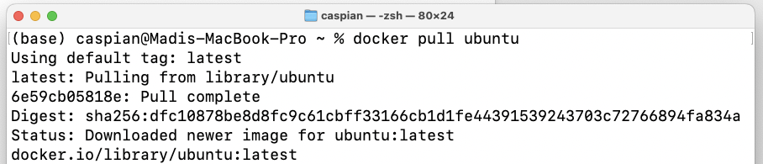
2. 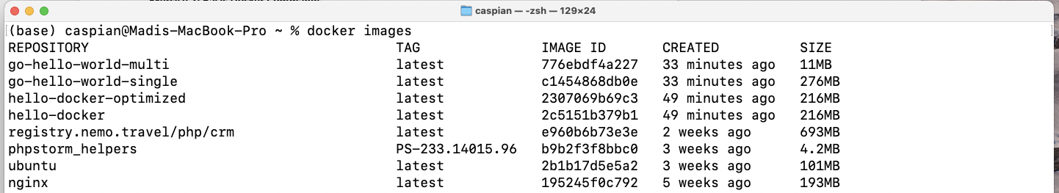
3. 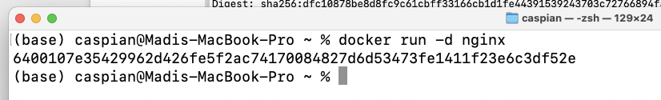
4. 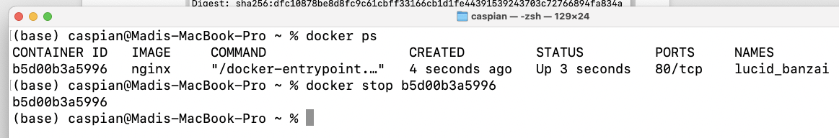

Questions:

1. What is the difference between docker pull and docker run?

docker pull just pulls the image without running the container, while docker run does both.

1. How do you find the details of a running container, such as its ID and status?

Using the docker ps command.

1. What happens to a container after it is stopped? Can it be restarted?

When a container is stopped its processes are terminated and its status is changed to ‘stopped’, the container’s resources are released. Yes, it can be restarted.

**Exercise 3: Working with Docker Containers**

Steps:

1. 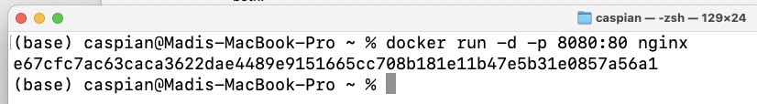
2. 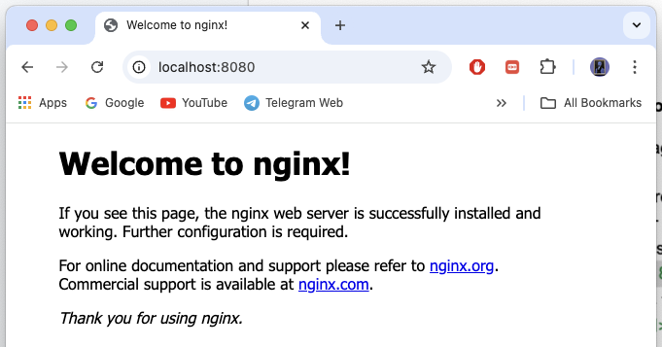
3. 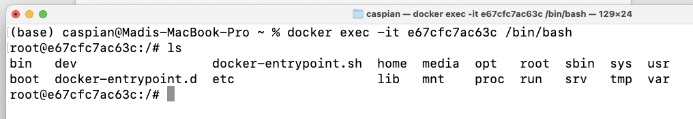
4. 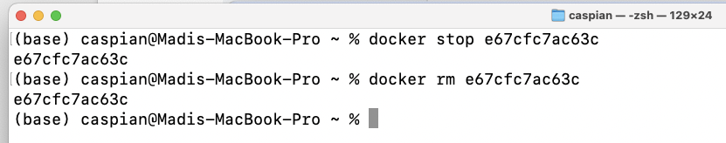

Questions:

1. How does port mapping work in Docker, and why is it important?

Port mapping works by exposing the container services to the host machine, it is done using the -p or –publish option in the docker run command. It is important to make services accessible from outside the container or to run multiple containers.

1. What is the purpose of the docker exec command?

Using the docker exec commands we can run commands inside of a running container.

1. How do you ensure that a stopped container does not consume system resources?

We can remove the container.

**Dockerfile**

**Exercise 1: Creating a Simple Dockerfile**

Steps:

1. 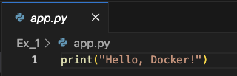
2. 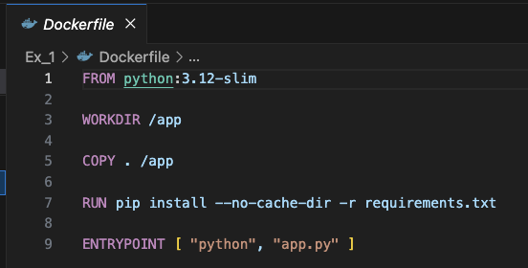
3. 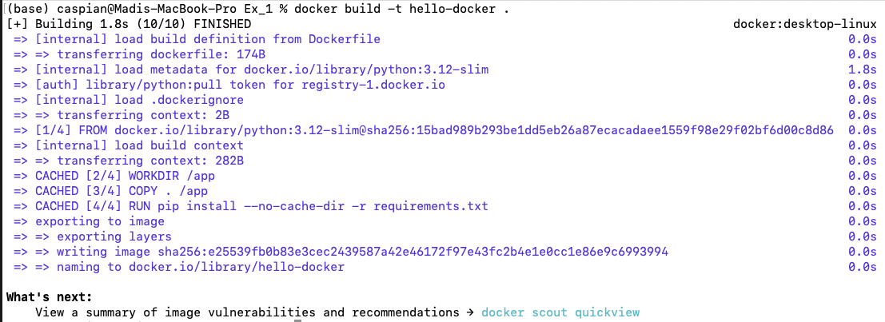
4. 

Questions:

1. What is the purpose of the FROM instruction in a Dockerfile?

The FROM instruction is used to specify the base image of our own image.

1. How does the COPY instruction work in Dockerfile?

The COPY instruction is used to copy files and directories from our host machine to the image’s filesystem during the build.

1. What is the difference between CMD and ENTRYPOINT in Dockerfile?

Both will run when we start our container, however CMD can be overriden.

**Exercise 2: Optimizing Dockerfile with Layers and Caching**

Steps:

1. 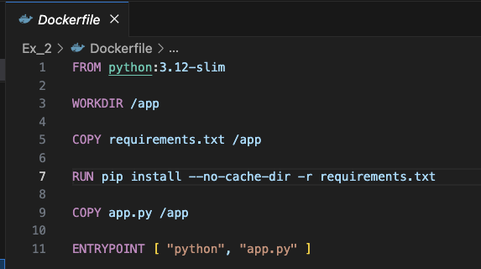
2. 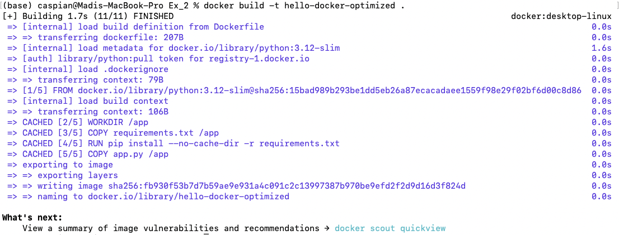
3. 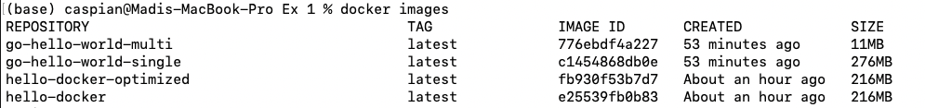

Questions:

1. What are Docker layers, and how do they affect image size and build times?

Docker Layers represent a set of system changes and instructions, they are stacked on top of each other. Each layers adds to the size of the image. Layers can be cached if they haven’t been changed, which helps in reducing the built time of the image.

1. How does Docker's build cache work, and how can it speed up the build process?

Basically if layers haven’t been changed then Docker just reuses them.

1. What is the role of the .dockerignore file?

The .dockerignore file specifies the files that must be excluded from the build context, thus reducing the image size.

**Exercise 3: Multi-Stage Builds**

Steps:

1. 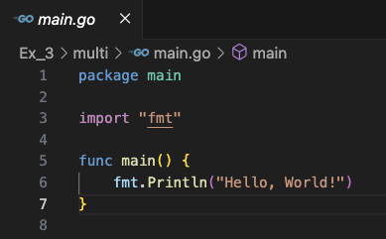
2. 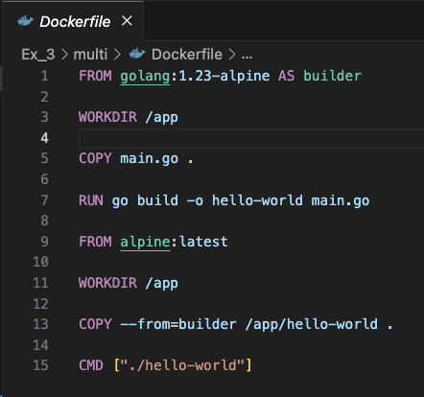
3. 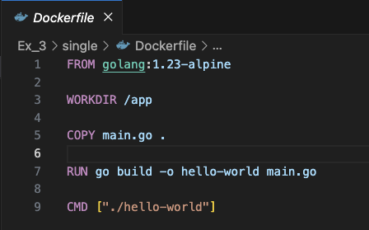

Questions:

1. What are the benefits of using multi-stage builds in Docker?

The benefits of using multi-staged builds in Docker are smaller final image size, cleaner builds, separation of concerns, optimized build times.

1. How can multi-stage builds help reduce the size of Docker images?

We can avoid using heavy dependencies by using separate base images for building our application and running it.

1. What are some scenarios where multi-stage builds are particularly useful?

When our application is compiled, when we need to reduce the final image size, when we are building for different environments.

**Exercise 4: Pushing Docker Images to Docker Hub**

Steps:

1. 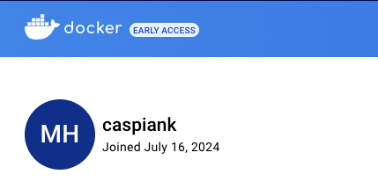
2. 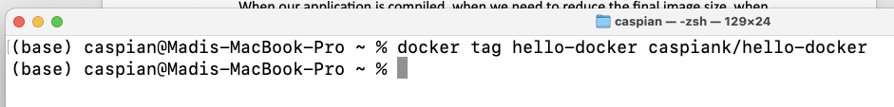
3. 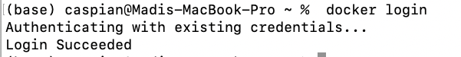
4. 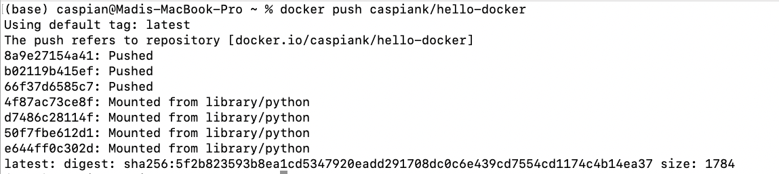
5. 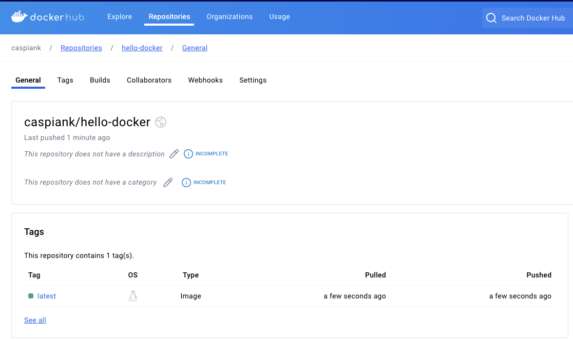

Questions:

1. What is the purpose of Docker Hub in containerization?

Docker Hub allows image sharing and collaboration, provides access to official images, simplifies cloud deployments, has CI/CD integration.

1. How do you tag a Docker image for pushing to a remote repository?

Using the docker tag command.

1. What steps are involved in pushing an image to Docker Hub?

Tagging the image and pushing it.

docker tag SOURCE_IMAGE TARGET_IMAGE

docker push TARGET_IMAGE