Cassandra Doll
Professor Adjei
DSC 200
10 December 2025

Data Wrangling Final Project
Introduction and Instructions
The project chosen was the second project available, or the issue of urban housing integration by region. The objective is to procure and clean datasets which were focused on housing trends and demographics based on a particular state or city, as long as it had a suitable amount of publicly available data to sift and clean through. Several datasets were to be chosen, such as excel files which contained demographics data for the chosen region from the United States Census Bureau (USCB), information on housing prices for homes from Zillow, information on rental prices for homes from Kaggle, using web scraping to extract more information on rental listings from either Apartments.com or Craigslist for the selected area, using some sort of publicly available API service which tracked the housing market trends for the chosen area (Zillow once again was chosen for this part), and the extraction of data from PDF files from the Office of Policy Development and Research (OPD&R), specifically a housing policy report. After acquiring these several datasets it would then be necessary to standardize names and columns across the datasets, handle any missing or null data entries, convert numerical data into a consistent format, resolve any inconsistencies around date or time formats in the datasets, and remove any duplicate data from the datasets. After properly cleaning the datasets it would then be necessary to merge them together on some sort of similar feature such as zip code, dates or times, neighborhood, state or city, etc. It was also necessary to include fields that calculated some sort of total, such as the price to income ratio, the average rental cost per square foot, any average of demographics data, etc. For the area chosen it was decided on that data would be taken for specifically the state of Wisconsin, the city of Milwaukee would be chosen as the representative in case datasets were county or city specific. The datasets chosen were all already almost given by the project instructions, but the following were the specific ones chosen:
- An excel file from the USCB, a quarter-yearly report of cities all around the country which collected a large amount of data on the general housing trends of the area.
- A csv file from Zillow that contained info for both housing and rental costs for the chosen area.
- A PDF of a housing policy report from OPD&R which contained information on income brackets for every single city in the area chosen, specifically giving the limits and incomes of the average person.
- There was a csv chosen which gave significant insight into racial and other demographic information for the area chosen, having several hundred categories such as the population of children split up into under 5, 5-9, 10-14, and 15-19, along with every other age available in a 5 year range. In addition to this it had all of these datapoints for several races, along with even including information such as the median voter age given race and sex.
- The Zillow API was chosen for gathering more data on housing market trends for the area
- It was decided to use Apartments.com for web scraping rather than Craigslist.

Processes Performed
The processes performed were all rather simple due to unforeseen circumstances (please see Outstanding Issues), but it is still important to go over what was done to each of the datasets which were able to be formatted and combined.
Firstly, the Excel file had the issue of being extremely large and containing rather large swaths of data which were not about Wisconsin whatsoever, this is without mentioning the fact that it sampled each area quarterly, boosting up the amount of data by 4 times as much. In the code (refer to figure 1) the first step was to convert the file into a csv as for better viewing, PyCharm itself only makes CSV files and JSON files into neat, organized tables which allow for seeing what is being done more efficiently instead of having to search through what was essentially a large string. The second and most important step was the removal of any and all references to any locations not within Milwaukee-Waukesha, Wisconsin, the chosen area as it was organized by city instead of by state.
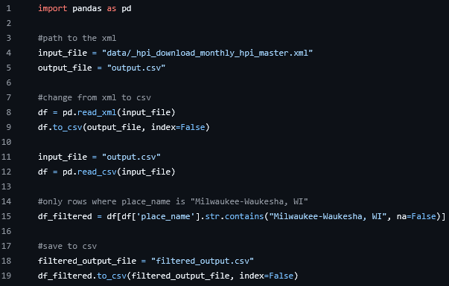Figure 1.

Secondly, the CSV with the demographics data was both flipped the incorrect way (the columns were where the rows were meant to be and the brown were where the columns were meant to be), so flipping it was the first order of business using the transpose function with Pandas with the help of a lambda function to properly format it (figure 2). It was then decided to remove the entries which calculated the margin of error, as it seemed unnecessary to keep.
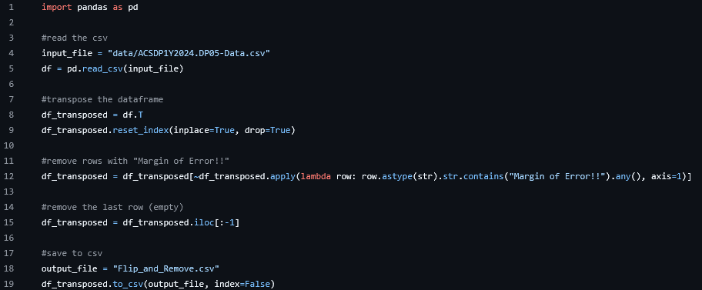
Figure 2.

Third, the Zillow housing and rental prices data file was all mostly well formatted. However, like the demographics data, it contained data for every single city in the United States. As a result, it was decided to simply remove all entries that were not in Wisconsin, leading to a much smaller and easier to manage file.
Finally, due to lack of time (read Outstanding Issues) it was decided to just combine the files in a basic merge using Pandas built in concatenate function to simply combine the files together (figure 4). A strange issue popped up that I myself had never encountered that seemed to result from merging together files without matching headers, wherein the files would align starting from the bottom right of the previous file, leading to the total file having significantly more rows compared to what was expected.
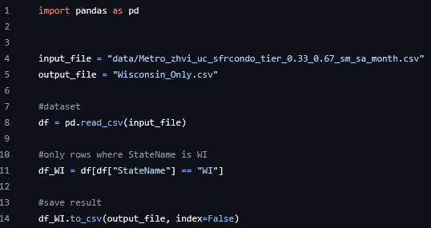
Figure 3.

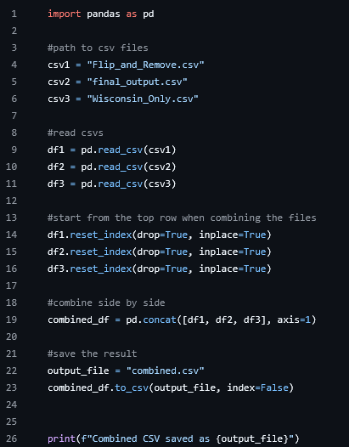
Figure 4.

Outstanding Issues
There are many glaring outstanding issues to cover in terms of this project, almost all of which being caused by the device they were being stored on automatically deleting files it determines to be “old and unused” without telling the user which files it is deleting. The Friday before the project was due my computer told me it required an update immediately, but that it needed to delete some files (not chosen by me) in order to do so. At this point I had already more than completed the actual data grabbing from every source and was just working on cleaning. I had decided not to upload it to the github page beforehand as if there were any bugs that came up or any changes I wished to make then I would rather not forget to update the github and turn in something non-functional. From my best estimation, what happened was that the only user generated files on my computer were from the PyCharm application itself, this combined with the fact that I kept all of my projects in the same folder (it was very bad practice admittedly as it quite frequently led to things being lost) it had seen that several files were from months ago and had made the sweeping decision to delete all user-generated files from PyCharm along with my downloads folder as a whole in an effort to save space. While it admittedly did so, it came at the cost of my entire final project and a smaller assignment for another class. While I would like to go on about the difficulties of the web scraping, or having to learn how to use an API which requires an access key, or having to learn how to scrape PDF files again after not doing so for months, it was rendered simply impossible for me to be able to prove I had done or could do any of these things, as having the entire project deleted presented a dilemma of what exactly to focus on given the extreme time constraints imposed onto my entirely by misfortune. As for what is missing, roughly half of the datasets required were either not able to be converted correctly, or they were deemed too much of a time sink to justify spending the limited time I had on them. In addition data cleaning was almost entirely given up on just so I would be able to have something to turn in. If I had more time I would have removed roughly a fourth of the data from the demographics dataset by only keeping the data from the first quarter of the year. Additionally I would actually convert the PDF file, which I was able to get partially done but sadly had to be dropped for time. Additionally I would also very much like to get the APIs and web scraping working, but they took significantly longer than any other part of the project due to the slowness of my computer and the strangely stringent nature of web scraping they have, banning your IP if you send too many requests.

Lessons Learned
The number one thing I have learned from this project is to absolutely back up everything possible if there is even a slim margin for all of it to be deleted. Freak accidents always seem so far off until you’re the one who’s being hit with them. The API and web scraping almost were given up on the first time, as I had never used an API key and could not figure out how to actually connect to the Zillow server, and Apartments.com would ban my IP for a day or so if I attempted to try and scrape their website too often. Each test of either one of these could take upwards of twenty minutes just to end up with an empty CSV, between that, several infinite loading glitches, and being banned for 24 hours at a time after doing 3 tests, it was shocking to me I was able to get it done once. Judging it from the perspective of someone with 5 days to get as much done as possible (not including work or studying or taking the other final exams) I would count this as an overall success with the extreme crunch.

