Questions

1. Plot your data in a spreadsheet with time in seconds on the y-axis and the size of n on the x-axis (plots should be in the pdf you turn). Make sure the sorts are clearly labeled

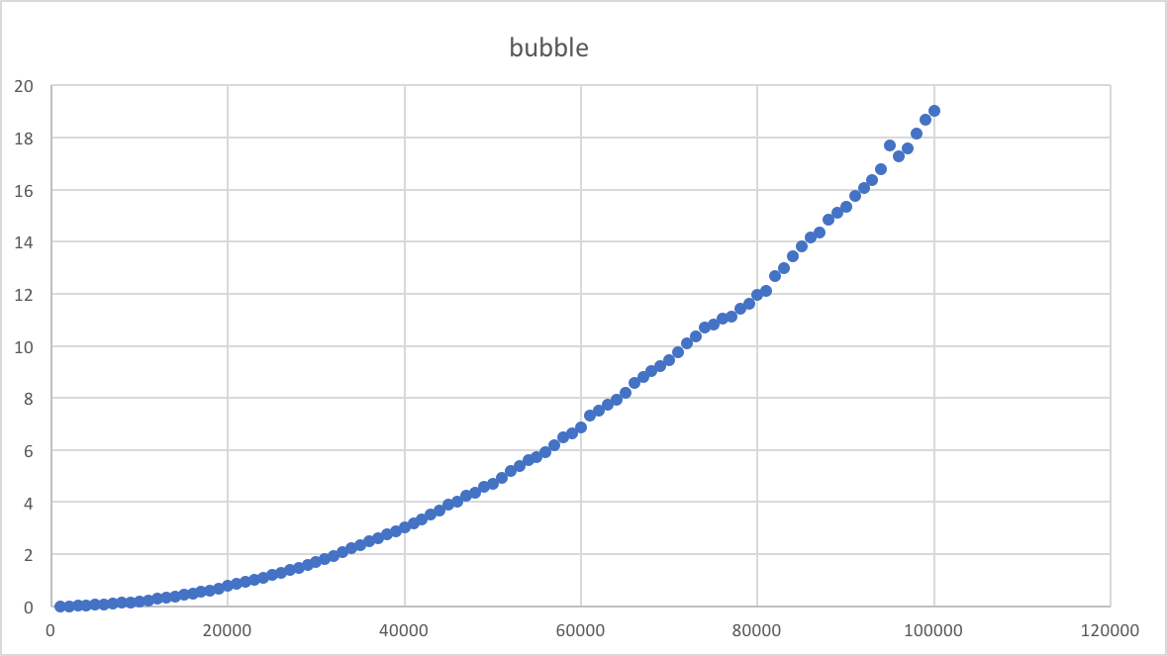

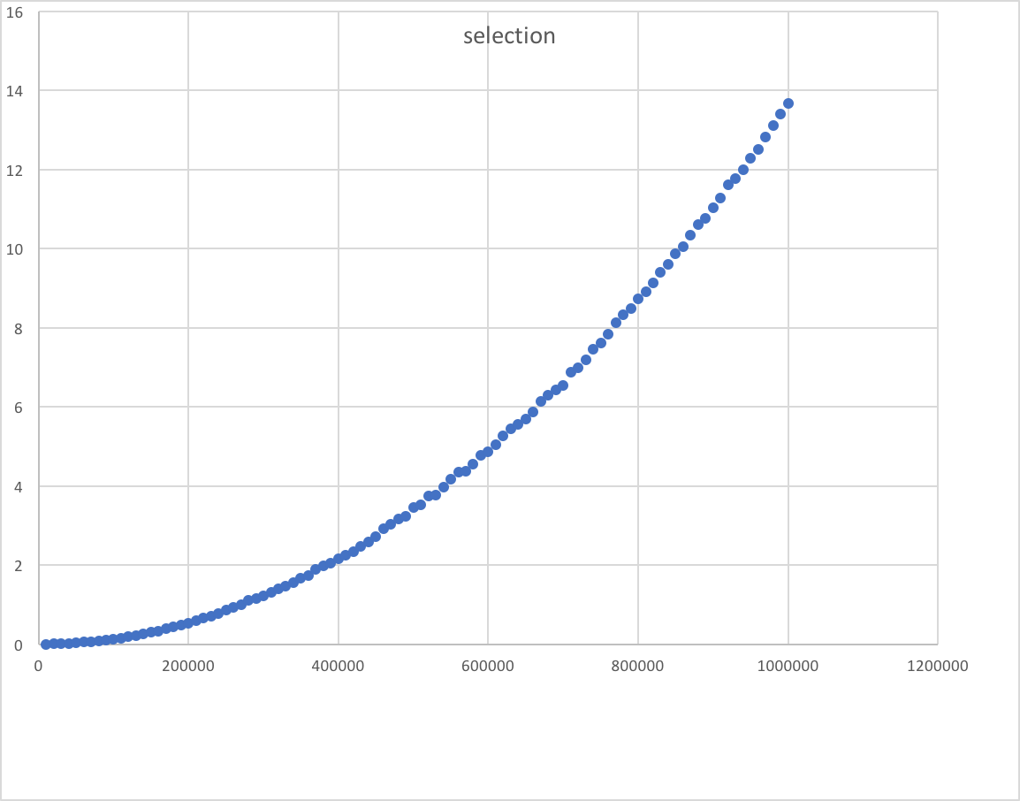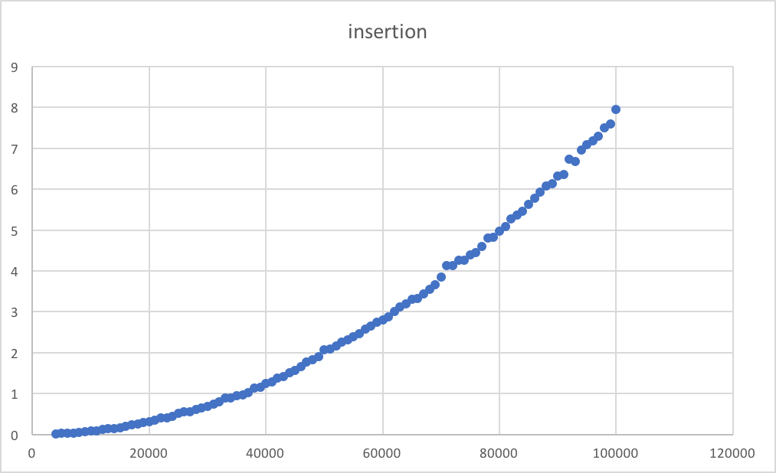

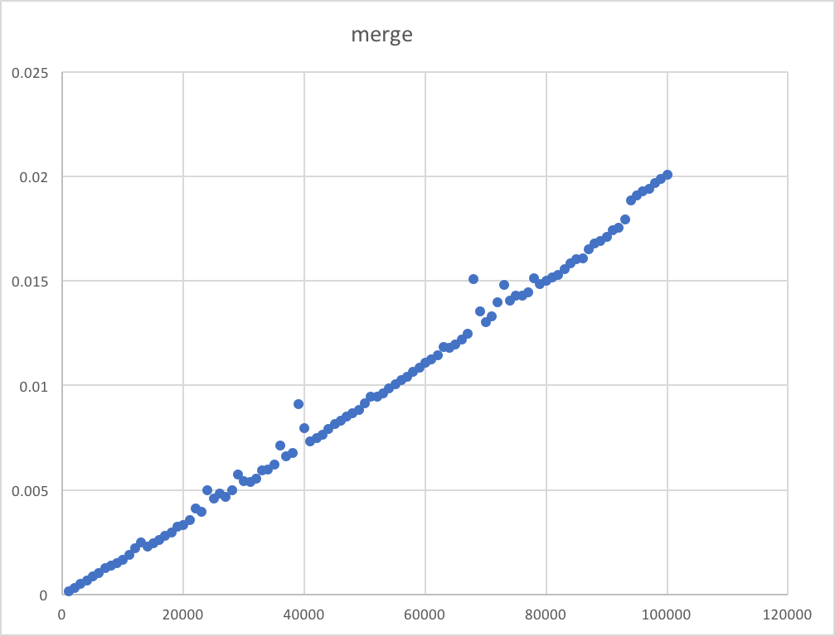

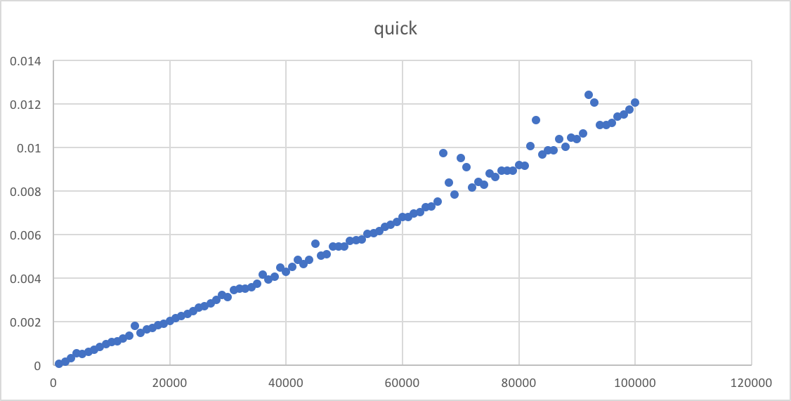

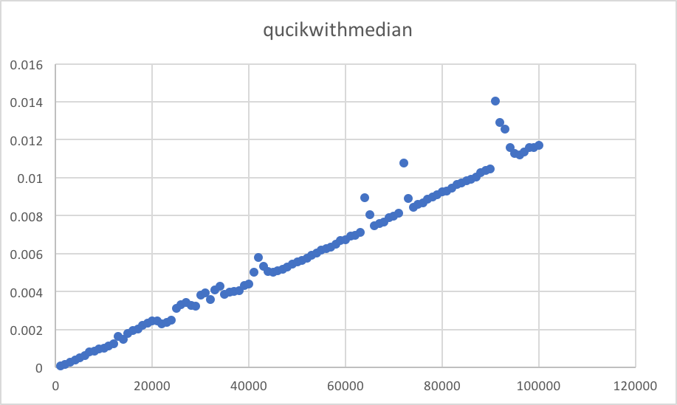

1. Do the sorts we know to be of O(n^2) complexity demonstrate this behavior? (The iterative sorts)

Yes, take bubble, selection, and insertion sorts as examples, according to the trend of showing graph, their O(n^2) is illustrated.

1. Do the sorts we know to be of O(n\*lg(n)) complexity demonstrate this behavior? (The recursive sorts)

Yes, quick, merge, and quick with median sorts are O(n\*lg(n)) complexity, as the graphs shows aboved.

1. For any plot points that are outliers (far away from the rest of the curve), how do you explain them?

Since the numbers are random numbers, sometimes the numbers have some order, it costs less time to reorder them. However, other random number are messy, it will take longer time to sort them.