Cassandra Lundberg

09/02/21

Lab 2 Assignment Part 1:

Question A)

/home/clundberg3

Question B)

Before the file csc3320 was created the current working directory had no file listed so the command ls did not list any files. After the file was created the ls command listed the csc3320 file.

Question C)

To display the current working directory the command pwd should be typed.

Question D)

To create a new folder called lab2 in the csc3320 file the command mkdir should be used so the command mkdir lab2 should be typed.

Question E)

To go to the new folder called lab2 the command cd should be used so the line cd lab2 should be typed.

Question F) The special character “>” in between “cat” and “myLab2.txt” allows the user to type and concatenate the typed text into the file. The command Ctrl-D at the end of the input represents the end of the typed text.

Question G)

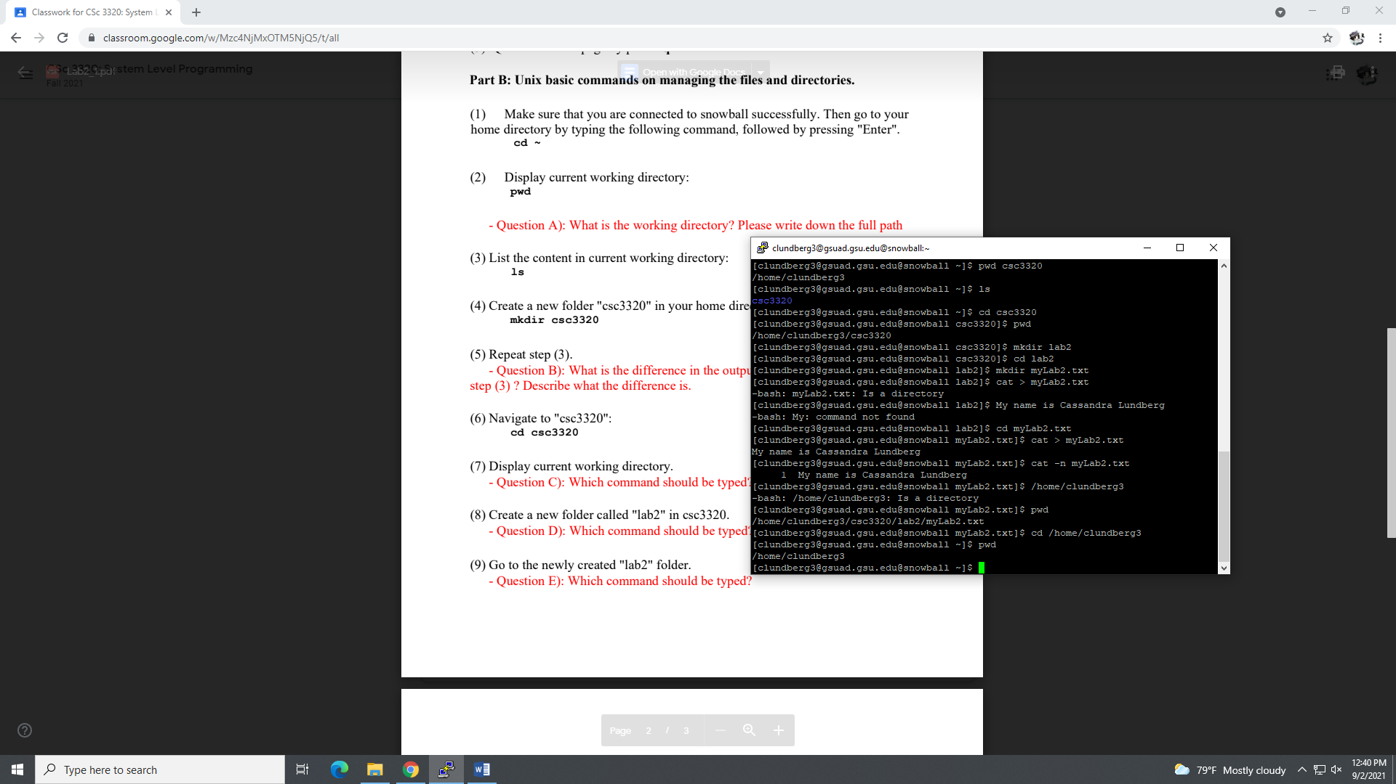

Question H)

