Cassandra Lundberg

10/15/21

Lab Assignment# 7

1. getPhoneNumber.c

Source code screenshot:

Output:

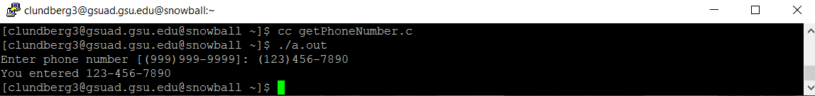

1. calcPrice.c

Source code screenshot:

Output:

