# INFO ENTRY

ENTRY NOTES:

* green = does not need to be editted
* yellow = info for the inputter
* ref_id = “refs_glossary_2024-08-09.xls > “references” tab
  + if the reference not present, either add it (if you’re confident that you can follow the format), or add a comment in this doc with the info and I will adjust
* **images – file name in** “refs_glossary_2024-08-09.xls > “references” tab
* Ignore everything in the “POPULATE MARKDOWN” section
* Size of columns in tables and text format do not matter; see note on bold and italize below
* Any content with “glue}`` prefix or surrounded by “{{ “ / “ }}” indicates where text will be inserted from the keys
* You may see “<br>” throughout, you can ignore these
* additional formatting notes (optional)
  + \*\***bold**\*\*
  + \**italics*\*
* **Topic Info**
  + If the topic is NOT related to a question, you can leave “question” as NULL
  + “question” here is more for your reference
* **Assumptions, Pros, Cons**
  + Only for modelling approaches; can ignore otherwise (leave table here)
  + [WILL BE HERE, BUT INSERTED DIRECTLY FROM CSV FILE (THUS NO INPUT NEEDED)]
* **Advanced**
  + If the topic doesn’t warrant inclusion, you can leave as NULL
* **Figures**
  + Placeholders here as “filename” can leave in if not <5 images
* **Video**
  + no “<” before the URL text and a “>” after URL in this case
  + ref_id in this example is not correct, just for illustrative purposes
* **Analytical tools & resources**
  + The ref_id should be included in the reference column (and the full text reference in the master reference file). If you aren’t sure if the reference is in the master doc, add the full text ref as a comment.
  + Please add a “<” before the URL text and a “>” after (e.g., <http://www.somesitelink.com>)
  + Type can be something similar to: Article, App/Program, R package
* **References / Glossary** 
  + items in-text above (IGNORE FOR NOW)
* **Notes**
  + (future ref / not included in markdown conversion)

## Topic Info

|  |  |
| --- | --- |
| **info_id** | cam_strat_covar |
| **question** | Do you plan to strategically place camera locations to include multiple differing categories (e.g., different land cover types, near vs. far from a disturbance, etc.)  If so, how many covariates? (e.g., 5 different habitat types would be 5 covariates)  Relates to:  OBJECTIVES - relative abundance, species diversity & richness, behaviour   |  |  | | --- | --- | |  | num_cams | | mod_divers_rich | If stratified, 20-50 per stratum | | mod_behaviour | If stratified, > 20 per stratum | | mod_rai | If stratified, 20-50 per stratum | |

## Overview

Do you plan to strategically place camera locations to include multiple habitats or otherwise differing categories (e.g., different land cover types, or near vs. far from a disturbance)

If so, how many covariates? (e.g., 5 different habitat types would be 5 covariates)

[OBJECTIVES- relative abundance, species diversity & richness, behaviour]

Cassie – suggestions for above red text for consistency and simplicity/clarity: be consistent – use either “habitat types” or “land cover” not both for simplicity and clarity; use strata vs. covariates. Also 5 different habitat types = 1 covariate and 5 strata. I use “covariate” at the beginning and then strata for means to address confounding variable…

Refs need to be added and things put in correct format which I can do. Need feedback first on content.

--------------------------------------------------------------------------------------------------------------------------------------------------------------------**Overview**

How does that work?

This question relates to the number of cameras you might need, since this will depend on the number of different “covariates” you might hope to include (if you are “stratifying” locations).

A \*\***covariate**\*\* is either an independent variable (i.e., a variable you manipulate or change in your study because it isof direct interest), or an unwanted, “confounding” variable that, if not accounted for, can lead to biased, and/or result in inaccurate conclusions. [[ Something about the fact that we might stratify because we are interested in assessing the affect of some var, OR because we need to account for it, --- yes, alludes to it above, but need to reiterate more directly in remote cam context,]]. In remote camera studies, potential confounding factors that affect the ability to detect wildlife are especially important to address to help ensure that your results are reliable and robust

[ADD something about sample size issues for analysis, but keep it simple.

Maybe too in the weeds, but there might be a way to use these to say what could happen if you didn’t account for a confound, using an example – im not sure)

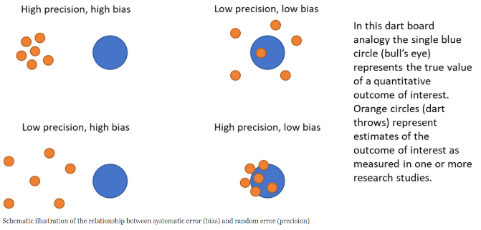

frampton_et_al_2022_fig2.png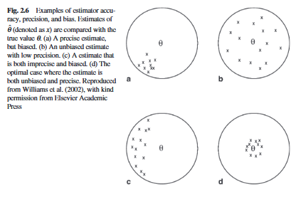

morrison_et_al_2008_fig2_6.png

Put in advanced / not clear how it ties in – maybe under sub category?

Several factors impact the ability of cameras to detect wildlife, including animal characteristics (e.g., home range size), environmental variables (e.g., landscape features), set-up protocols (e.g., camera height and density), and camera specifications (e.g., trigger speed) (Hofmeester et al., 2018). The Survey Objectives, spatial scale, and target species will determine the most influential factors. For example, when estimating density for multiple species, differences in species traits and environments (e.g., habitats) may lead to variation in imperfect detection, the inability to tease apart detection probability from other factors (e.g., habitat preference), and erroneous estimates of occurrence and abundance (Burton et al., 2015; Dénes et al., 2015; Kays et al., 2021). Careful consideration of factors that may cause detection bias when designing studies can be an effective and efficient way to partially avoid detection biases. It can also prevent the need to try to subsequently correct the variable of direct interest (e.g., relative abundance) or use covariates in an advanced statistics framework.

Study Design - Stratification

Camera locations and their spatial arrangements are integral components of any study design and strongly influence detection probability and likelihood of species occurrence. In a stratified design, the study area is divided into smaller strata according to distinct features (e.g., habitat types, disturbance classes). Cameras can be then randomly or strategically placed across the study area according to these strata. Generally, a random placement is recommended for species diversity and richness, relative abundance, and behaviour objectives; however, the optimal design for a given study will be influenced by the expected variation in detection probabilities, available resources, and the relative importance of the pros and cons for each design. For example, an optimal study design may be considered that that provides the greatest precision for the lowest cost. Stratification in general can help minimize detection bias, optimize sampling effort, and ultimately result in more precise estimates.

In a stratified random study design, the different strata are sampled in proportion to their availability in the study area. For example, if the study area consists of 75% coniferous forest, 75% (or close to) of randomly selected sites should occur within coniferous forest, on average. Camera placement is independent of animal distribution. This approach helps ensure representation of across the range of habitat types (or other strata categories) in the entire study area but may result in fewer overall detections relative to other study designs. A simple random design may also not adequately address some biases in detection probability due to environmental factors (e.g., vegetation denseness) and require subsequently correcting for these biases in a statistical framework. Standardizing other sampling components (e.g., camera set-up protocols) as much may help reduce some other study-specific biases.

In a stratified non-random study design, the different strata are sampled in proportion to specific criteria, as determined by the study objective (e.g., behaviour). For example, more cameras may be strategically placed in strata known or suspected to have higher activity, that are more common, and/or that have higher expected variance within a stratum. By allocating sampling effort in strata that have higher likelihood of detection, are larger, and/or more variable, overall effort may be reduced and precision of estimates improved. However, there are several important disadvantages to using a non-random study design, including the possibility of missing individuals/species/behaviours entirely, and the inability to make inferences to the entire study area.

Number of Strata

The number (and selection of) strata appropriate for a given study area will depend on the study’s objectives, heterogeneity, spatial scale, target species, and available resources. For example, a study estimating abundance of a wide-ranging species that is patchily distributed across a study area with a diversity of habitat types will typically have more strata than that for the same species in a more homogenous environment, or homogenous distribution. Sampling effort (e.g., number of cameras, camera days) will increase with the number of strata. Wearn & Glover-Kapfer (2017) recommended at least 20 camera locations, and ideally 50 locations, per strata (or covariate) for reasonably precise estimates of species diversity, richness, relative abundance, and behaviours.

## Advanced

It may not always be possible to address biases of confounding variables in the study design phase (e.g., using stratification, complex hierarchically structured designs) or by using standardized field and reporting protocols over time and space. Examples of these instances include when collecting data on multiple species concurrently across seasons (but see ___), or when using data from different studies and sampling protocols. To address these situations, one needs to either correct for the metric of interest (e.g., relative abundance) or using use covariates in an advanced statistics framework to address known or suspected confounding variables. A common approach to correct for detection biases when estimating relative abundance, for instance, is to quantify effective detection range for example (e.g., Hofmeester et al. 2017a, Rowcliffe et al. 2011). Alternatively, covariates can be used in simple multiple linear regression models and/or much more complex hierarchal (or structured) models. For example, detection probability can be modeled with covariates to obtain separate estimates for different study-specific factors introducing detection biases (e.g., habitat type, season, sex). Regression models have the limitation of only addressing single processes, and therefore are unable to differentiate between detection and ecological processes (e.g., movement versus abundance), while interpretation of hierarchal models may be complicated. Refer to ___ for examples of applying covariates or hierarchal models, respectively to species diversity and richness, relative abundance, and behaviour, respectively. See Esteveo et al. (2017) for fitting of habitat covariates in co-occurrence models to estimate occupancy and detection of one species in the presence of another [3, 4, 13, 14, 17].

## Figures

Hofmeester et al. 2018 – Table 1 – “when to control for” field relative to animal characteristics that influence detection. Species, season, site. Table 4 – environmental variables of CT location that influence detection. Fig 2 – questions that lead to selection of covariates.

|  |  |  |  |
| --- | --- | --- | --- |
| **Image** | **file_name** | **Caption (if applicable)** | **ref_id** |
|  | figure1_filename.png | figure1_caption | figure1_ref_id |
|  | figure2_filename.png | figure2_caption | figure2_ref_id |
|  | figure3_filename.png | figure4_caption | figure3_ref_id |
|  | figure4_filename.png | figure4_caption | figure4_ref_id |
|  | figure5_filename.png | figure5_caption | figure5_ref_id |
|  | figure6_filename.png | figure6_caption | figure6_ref_id |

Messy pasting some potetuals here, you choose which are best

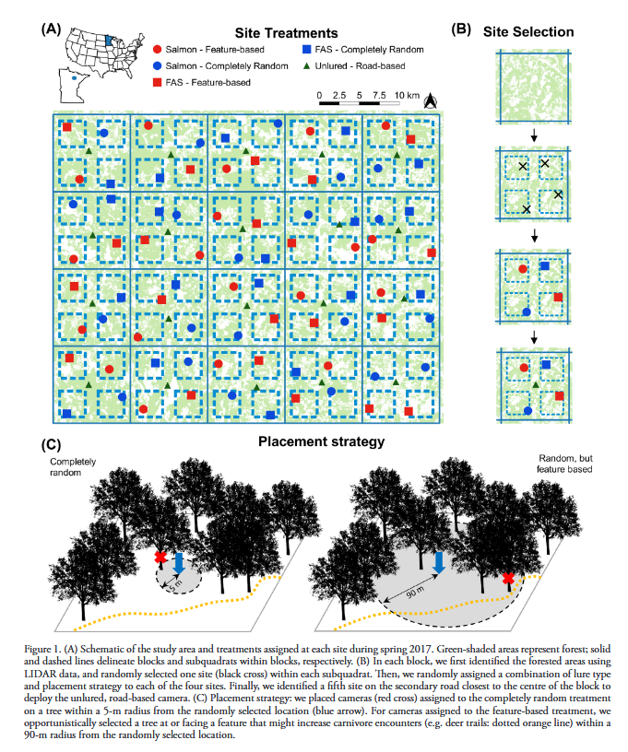

iannarilli_et_al_2021_fig1.png

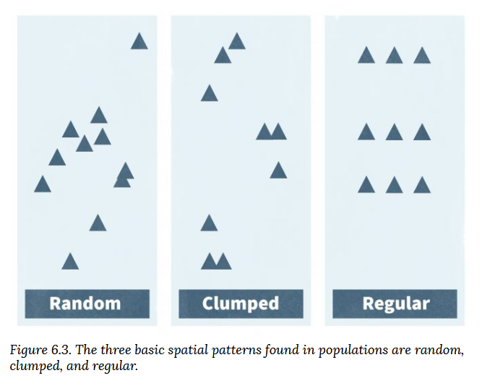

mccomb_et_al_2010_fig6_3.png

## Video

|  |  |  |
| --- | --- | --- |
| **caption** | **URL (no < / > before/after URL** | **ref_id** |
| vid1_caption | vid1_url | vid1_ref_id |
| vid2_caption | vid2_url | vid2_ref_id |
| vid3_caption | vid3_url | vid3_ref_id |
| vid4_caption | vid4_url | vid4_ref_id |
| vid5_caption | vid5_url | vid5_ref_id |
| vid6_caption | vid6_url | vid6_ref_id |

## Shiny

Shiny name = shiny_name

Shiny caption = shiny_caption

Shiny URL = shiny_url

## Analytical tools & resources

|  |  |  |  |  |
| --- | --- | --- | --- | --- |
| **Type** | **Name** | **Note** | **URL** | **ref_id** |
| resource1_type | resource1_name | resource1_note | resource1_url | resource1_ref_id |
| resource2_type | resource2_name | resource2_note | resource2_url | resource2_ref_id |
| resource3_type | resource3_name | resource3_note | resource3_url | resource3_ref_id |
| resource4_type | resource4_name | resource4_note | resource4_url | resource4_ref_id |
| resource5_type | resource5_name | resource5_note | resource5_url | resource5_ref_id |
| resource6_type | resource6_name | resource6_note | resource6_url | resource6_ref_id |
| resource7_type | resource7_name | resource7_note | resource7_url | resource7_ref_id |
| resource8_type | resource8_name | resource8_note | resource8_url | resource8_ref_id |
| resource9_type | resource9_name | resource9_note | resource9_url | resource9_ref_id |
| resource10_type | resource10_name | resource10_note | resource10_url | resource10_ref_id |
| resource11_type | resource11_name | resource11_note | resource11_url | resource11_ref_id |
| resource12_type | resource12_name | resource12_note | resource12_url | resource12_ref_id |
| resource13_type | resource13_name | resource13_note | resource13_url | resource13_ref_id |
| resource14_type | resource14_name | resource14_note | resource14_url | resource14_ref_id |
| resource15_type | resource15_name | resource15_note | resource15_url | resource15_ref_id |

## References / Glossary

|  |  |
| --- | --- |
| **ref_id** | **glossary_keys** |
| Refs  Burton et al., 2015  Dénes et al., 2015  Kays et al., 2021 | keys_here |

## Notes

| Type | Name | Note | URL |Reference |

|:----------------|:---------------------------------------|:----------------------------------------------------------------|:----------------------------------------------------------------|:----------------------------------------------------------------|

# POPULATE MARKDOWN

---

jupytext:

formats: md:myst

text_representation:

extension: .md

format_name: myst

format_version: '1.16'

jupytext_version: 1.16.1

kernelspec:

display_name: Python 3

language: python

name: python3

editor_options:

markdown:

wrap: none

---

(i_mod_divers_rich)=

# {{ name_mod_divers_rich }}

### :::::::::{div} full-width

### :::::::{tab-set}

#### ::::::{tab-item} Overview

**{{ term_mod_divers_rich }}**: {{ term_def_mod_divers_rich }}

<br>

“Species richness is simply the number of species in an area ({{ ref_intext_wearn_gloverkapfer_2017 }})

Species diversity is more complex, and includes a measure of the number of species in a community, and a measure of the abundance of each species. Species diversity is usually described by an index, such as Shannon's Index H'.” {{ ref_intext_pyron_2010 }}

```{figure} ../03_images/03_image_files/pyron_2010_fig1.png

:align: center

:scale: 60%

```

#### ::::::

#### ::::::{tab-item} Advanced

Parameters**:**

- **α-richness (alpha richness)**: species richness at the level of an individual camera location {{ ref_intext_wearn_gloverkapfer_2019 }}

- **γ-richness (gamma richness)**: species richness across a whole study area {{ ref_intext_wearn_gloverkapfer_2019 }}

- **β-diversity (betadiversity)**: the differences between the communities or, more formally, the variance among the communities {{ ref_intext_wearn_gloverkapfer_2019 }}

<br>

**Observed *vs* estimated species richness** (from {{ ref_intext_wearn_gloverkapfer_2019 }}):

- **Observed species richness**: the sum of the number of species seen (e.g. {{ ref_intext_kitamura_et_al_2010 }}; {{ ref_intext_pettorelli_et_al_2010 }}; {{ ref_intext_ahumada_et_al_2011 }}; {{ ref_intext_samejima_et_al_2012 }})

- Observed species richness will not, in general, be a reliable index of actual species richness because, even if sampling effort is strictly controlled, the detectability of species will vary across samples

- **Estimated species richness**: when the “sum of the number of species seen” is adjusted based on corrections for “imperfect detection” (i.e. the fact that some species in a given sample may have been missed)

- (e.g. {{ ref_intext_tobler_et_al_2008 }}; {{ ref_intext_kinnaird-&-obrien-2012 }}; {{ ref_intext_brodie_et_al_2015 }}; {{ ref_intext_yue_et_al_2015 }}; {{ ref_intext_wearn_et_al_2016 }})

- The **two principal ways of estimating species richness from remote camera data ** are (from {{ ref_intext_wearn_gloverkapfer_2019 }}):<br>

- non-parametric estimators ({{ ref_intext_gotelli_chao_2013 }}), which use information about the rarest species in the sample to provide a minimum estimate of the number of true species (e.g. {{ ref_intext_tobler_et_al_2008 }}),

- or 2) occupancy models ({{ ref_intext_mackenzie_et_al_2006 }})

#### ::::::

#### ::::::{tab-item} Visual resources

##### :::::{grid} 3

:gutter: 1

:padding: 0

:margin: 0

###### ::::{grid-item-card} {{ ref_intext_pyron_2010 }}

```{figure} ../03_images/03_image_files/pyron_2010_fig1.png

:height: 300px

:align: center

```

**Pyron (2010) - Figure 1**: Species evenness and species richness for animalcule communities

<!-- Both communities contain five species of animalcules. Species richness is the same. The community on the left is dominated by one of the species. The community on the right has equal proportions of each species. Evenness is higher when species are present in similar proportions. Thus the community on the left has higher species diversity, because evenness is higher. -->

###### ::::

###### ::::{grid-item-card} {{ ref_intext_gotelli_colwell_2011 }}

```{figure} ../03_images/03_image_files/gotelli_and_colwell_2011_fig4_1.png

:width: 300px

:align: center

```

NULL

###### ::::

###### ::::{grid-item-card} {{ ref_intext_vandooren_2016 }}

```{figure} ../03_images/03_image_files/vandooren_2016_fig1.png

:width: 300px

:align: center

```

**Vandooren (2016) – Figure 1**: Species accumulation curves. Species richness is the asymptote of a species accumulation curve, which expresses the dependence on sampling effort of the number of species sampled from an assemblage….

###### ::::

##### :::::

##### :::::{grid} 3

:gutter: 1

:padding: 0

:margin: 0

###### ::::{grid-item-card} {{ ref_intext_molloy_2018 }}

```{figure} ../03_images/03_image_files/molloy_2018_fig9.png

:width: 300px

:align: center

```

NULL

###### ::::

###### ::::{grid-item-card} {{ ref_intext_loreau_2010 }}

```{figure} ../03_images/03_image_files/loreau_2010_fig4.png

:width: 300px

:align: center

```

**Loreau et al. (2010) – Figure 4.** Species accumulation and rarefaction curves. Species accumulation curves show the number of species obtained by successively censusing either individual organisms (individual-based accumulation curves) or samples (sample-based accumulation curves). Smoothed species rarefaction curves represent the statistical expectation of the corresponding accumulation curves. Credit: Rob Colwell, after Gotelli and Colwell (2001)

###### ::::

###### ::::{grid-item-card} {{ ref_intext_loreau_2010 }}

```{figure} ../03_images/03_image_files/loreau_2010_fig3.png

:width: 300px

:align: center

```

**Loreau et al. (2010) – Figure 3.** The various levels of organisation and components that define the multiple facets

of biodiversity

###### ::::

##### :::::

##### :::::{grid} 3

:gutter: 1

:padding: 0

:margin: 0

###### ::::{grid-item-card} {{ ref_intext riffomonas_project_2022a }}

<iframe

width="300"

height="200"

src="https://www.youtube.com/embed/ghhZClDRK_g?si=khprL1u5NJrFduTb"

frameborder="0"

allow="accelerometer; autoplay; clipboard-write; encrypted-media; gyroscope; picture-in-picture"

allowfullscreen>

</iframe>

Abundance, species richness, and diversity

###### ::::

###### ::::{grid-item-card} {{ ref_intext mecks100_2018 }}

<iframe

width="300"

height="200"

src="https://www.youtube.com/embed/4gcmAUpo9TU?si=_S-JYDDskR8QbHs5"

frameborder="0"

allow="accelerometer; autoplay; clipboard-write; encrypted-media; gyroscope; picture-in-picture"

allowfullscreen>

</iframe>

Species accumulation and rarefaction curves

###### ::::

###### ::::{grid-item-card} {{ ref_intext riffomonas_project_2022a }}

<iframe

width="300"

height="200"

src="https://www.youtube.com/embed/wq1SXGQYgCs?si=Re5tglERblfkCNhDl"

frameborder="0"

allow="accelerometer; autoplay; clipboard-write; encrypted-media; gyroscope; picture-in-picture"

allowfullscreen>

</iframe>

Using vegan to calculate alpha diversity metrics within the tidyverse in R (CC196)

###### ::::

##### :::::

##### :::::{grid} 3

:gutter: 1

:padding: 0

:margin: 0

###### ::::{grid-item-card} {{ ref_intext vsn_international_2022 }}

<iframe

width="300"

height="200"

src="https://www.youtube.com/embed/wBx7f4PP8RE?si=D6mtAMNMLlk3aH8H"

frameborder="0"

allow="accelerometer; autoplay; clipboard-write; encrypted-media; gyroscope; picture-in-picture"

allowfullscreen>

</iframe>

Species abundance tools in Genstat

###### ::::

###### ::::{grid-item-card} {{ ref_intext_baylor_tutoring_center_2021 }}

<iframe

width="300"

height="200"

src="https://www.youtube.com/embed/UXJ0r4hjbqI?si=gYR6rOmIMgyibyvR"

frameborder="0"

allow="accelerometer; autoplay; clipboard-write; encrypted-media; gyroscope; picture-in-picture"

allowfullscreen>

</iframe>

Species Diversity and Species Richness

###### ::::

###### ::::{grid-item-card} {{ ref_intext styring_2020 }}

<iframe

width="300"

height="200"

src="https://www.youtube.com/embed/KBByV3kR3IA?si=RPcG1lFQ-v0Shwaw"

frameborder="0"

allow="accelerometer; autoplay; clipboard-write; encrypted-media; gyroscope; picture-in-picture"

allowfullscreen>

</iframe>

Field Ecology - Diversity Metrics in R

###### ::::

##### :::::

#### ::::::

#### ::::::{tab-item} Shiny apps/Widgets

##### :::::{card}

** iNEXTOnline **

shiny_caption

<iframe

width="100%"

height="900"

src="https://chao.shinyapps.io/iNEXTOnline"

frameborder="0"

allow="accelerometer; autoplay; clipboard-write; encrypted-media; gyroscope; picture-in-picture"

allowfullscreen>

</iframe>

##### :::::

#### ::::::

#### ::::::{tab-item} Analytical tools & resources

**Error! Not a valid filename.**

| R package | Chapter 9 Community composition | \- | <https://bookdown.org/c_w_beirne/wildCo-Data-Analysis/composition.html#estimated-richnes> | {{ ref_bib_wildco_lab_2021b }} |

| R package | R package “vegan | \- | <https://cran.r-project.org/web/packages/vegan/index.html> | {{ ref_bib_oksanen_et_al_2024 }} |

| Program | EstimateS | Dedicated software for estimating diversity, using asymptotic or rarefaction methods. Mac version available | <https://www.robertkcolwell.org/pages/1407> | {{ ref_bib_colwell_2022 }} |

| R package | Package ‘iNEXT’ - Interpolation and Extrapolation for Species Diversity | The iNext package (INterpolation and EXTrapolation of species richness) - is both easy to use and rapid to compute. It also comes with a wealth of plotting functions - see the iNext Quick Introduction for a great walk through tutorial. Its core functionality is based on: Chao, Anne, et al. “Rarefaction and extrapolation with Hill numbers: a framework for sampling and estimation in species diversity studies.” Ecological monographs 84.1 (2014): 45-67. | <https://cran.r-project.org/web/packages/iNEXT/iNEXT.pdf> | {{ ref_bib_hsieh_et_al_2015 }} |

| Exercise/Tutorial | 2.2: Measuring Species Diversity | Easy to interpet explanation of species richness vs evenness, species area curves, rarefaction, and how to calculate diversity | <https://bio.libretexts.org/Courses/University_of_California_Davis/BIS_2B%3A_Introduction_to_Biology_-_Ecology_and_Evolution/02%3A_Biodiversity/2.02%3A_Measuring_Species_Diversity> | {{ ref_bib_gerhartbarley_nd }} |

| R package / Tutorial | Species Accumulation Curves with vegan, BiodiversityR and ggplot2 | Software for interpolation and extrapolation of species diversityRarefied Species Accumulation Curves (the simple way) | <https://rpubs.com/Roeland-KINDT/694021> | {{ ref_bib_resource6_ref_id }} |

| resource7_type | resource7_name | resource7_note | resource7_note | {{ ref_bib_resource7_ref_id }} |

::::::

#### ::::::{tab-item} References

<font size="3">

{{ ref_bib_ahumada_et_al_2011 }}

{{ ref_bib_baylor_tutoring_center_2021 }}

{{ ref_bib_brodie_et_al_2015 }}

{{ chao_et_al_2016 }}

{{ chao_et_al_2014 }}

{{ ref_bib_colwell_2022 }}

{{ ref_bib_gerhartbarley_nd }}

{{ ref_bib_gotelli_colwell_2001 }}

{{ ref_bib_gotelli_colwell_2010 }}

{{ ref_bib_hsieh_et_al_2015 }}

{{ ref_bib_iknayan_et_al_2014 }}

{{ ref_bib_kinnaird_obrien_2012 }}

{{ ref_bib_kitamura_et_al_2010 }}

{{ ref_bib_mackenzie_et_al_2006 }}

{{ ref_bib_mecks100_2018 }}

{{ ref_bib_oksanen_et_al_2024 }}

{{ ref_bib_pettorelli_et_al_2010 }}

{{ ref_bib_project_dragonfly_2019 }}

{{ ref_bib_pyron_2010 }}

{{ ref_bib_riffomonas_project_2022 }}

{{ ref_bib_samejima_et_al_2012 }}

{{ ref_bib_styring_2020 }}

{{ ref_bib_tobler_et_al_2008 }}

{{ ref_bib_vsn_international_2022 }}

{{ ref_bib_wearn_et_al_2016 }}

{{ ref_bib_wildco_lab_2021b }}

{{ ref_bib_yue_et_al_2015 }}

</font>\

#### ::::::

### :::::::

### :::::::::