# INFO ENTRY - QUESTION INFO

ENTRY NOTES:

* green = does not need to be editted
* yellow = info for the inputter
* ref_id = “refs_glossary_2024-08-09.xls > “references” tab
  + if the reference not present, either add it (if you’re confident that you can follow the format), or add a comment in this doc with the info and I will adjust
* **images – file name in** “refs_glossary_2024-08-09.xls > “references” tab
* Ignore everything in the “POPULATE MARKDOWN” section
* Size of columns in tables and text format do not matter; see note on bold and italize below
* Any content with “glue}`` prefix or surrounded by “{{ “ / “ }}” indicates where text will be inserted from the keys
* You may see “<br>” throughout, you can ignore these
* additional formatting notes (optional)
  + \*\***bold**\*\*
  + \**italics*\*
* **Topic Info**
  + If the topic is NOT related to a question, you can leave “question” as NULL
  + “question” here is more for your reference
* **Assumptions, Pros, Cons**
  + Only for modelling approaches; can ignore otherwise (leave table here)
  + [WILL BE HERE, BUT INSERTED DIRECTLY FROM CSV FILE (THUS NO INPUT NEEDED)]
* **Advanced**
  + If the topic doesn’t warrant inclusion, you can leave as NULL
* **Figures**
  + Placeholders here as “filename” can leave in if not <5 images
* **Video**
  + no “<” before the URL text and a “>” after URL in this case
  + ref_id in this example is not correct, just for illustrative purposes
* **Analytical tools & resources**
  + The ref_id should be included in the reference column (and the full text reference in the master reference file). If you aren’t sure if the reference is in the master doc, add the full text ref as a comment.
  + Please add a “<” before the URL text and a “>” after (e.g., <http://www.somesitelink.com>)
  + Type can be something similar to: Article, App/Program, R package
* **References / Glossary** 
  + items in-text above (IGNORE FOR NOW)
* **Notes**
  + (future ref / not included in markdown conversion)

## Topic Info

|  |  |
| --- | --- |
| **info_id** | mod_inventory  **options = Poorly known, Well known, I'm not sure** |
| **question** | Related to    Figure 7-3. Decision tree for short-term inventory work.  Therefore, relates to “Single species”:   * Camera arrangement ~ well known vs. poorly known * Survey length ~ low vs. high detection probability |

## Assumptions, Pros, Cons

|  |  |  |
| --- | --- | --- |
| **Assumptions** | **Pros** | **Cons** |
| - {{ mod_inventory_assump_01 }} | - {{ mod_inventory_pro_01 }} | - {{ mod_inventory_con_01 }} |

## Overview

Species inventories are used to determine what species are present in an area during a given time period (Wearn & Glover-Kapfer, 2017). Inventories can be considered as a “check-list”, where the goal is to detect as many species as possible. [[[[often short and resource[camera] limited]]]] and t Species inventories should be considered simple rapid assessment surveys and not used to infer what species actually exist within the area (and may have gone undetected).

The study design (e.g., camera arrangement) is very flexible; however, if you’re targetting a single species the design should ideally still be informed by the species’ biology to maximize the likelihood of detecting individuals that are present. When the species biology is **well known** (i.e., we have some information as to…), placing cameras [[where you expect will result in the highest probability]] (e.g., mineral licks or in preferred habitat, i.e., targeted, non-random locations) can be beneficial, particularly if resources are limited. For example, deploying cameras near activity centres (e.g., burrows, latrines, mineral licks), in preferred habitats, or along travel routes (e.g., game trails) may improve detection. On the other hand, When the species biology is **poorly known**, [(we don’t really know what features = high det prob)… in this case,]]; randomly placing cameras across the study area is often the best approach and helps ensures that all habitats are sampled in proportion to their availability (Wearn & Glover-Kapfer, 2017). The area sampled should in these cases be representative of the entire study area; the area covered by cameras may have little effect on the number of species detected (Tobler et al., 2008).

**If you’re not sure, choose the “I'm not sure” option and recommendations will be provided for both cases.**

All rest below here can go in advanced = + perhaps a bit more from wearn surrounding inventory as relating to each component of design

The use of lure or bait may improve the likelihood of detecting some species (e.g., carnivores).

There are no specific guidelines for species inventories regarding camera features or deployment (e.g., number of cameras, camera days per location etc.). However, a camera model with a white flash, high sensitivity, large detection zone, and fast trigger speed may improve species detection (Rovero et al., 2013; Wearn & Glover-Kapfer, 2017). For species with a high probability of detection (e.g., small home range), deployment times can be short (e.g., 1-2 weeks) and moving cameras between locations can allow more sites to be sampled (Wearn & Glover-Kapfer, 2017). In contrast, cameras should be deployed longer in a location (e.g., 2-6 weeks; Wearn & Glover-Kapfer, 2017) for species with low probability of detection.

When the target species biology is poorly known, a general rule of thumb is to use a minimum of 20 single cameras per location within the study area, spaced 1-2 km apart, for ideally a minimum of 30 days per camera location and 1,000 overall camera days (Colyn et al., 2018; Rovero et al., 2013; Rovero & Tobler, 2010; Tobler et al. 2008; Wearn et al. 2013; Wearn & Glover-Kapfer, 2017). The more cameras deployed and/or locations sampled, generally the shorter the time needed to inventory an area. If fewer cameras are used, the cameras could be moved every 15 days, if feasible, to sample a larger area and avoid any biases associated with the camera locations (Rovero et al., 2013). In many areas, 1000-2000 camera days is sufficient to detect 60-70% of the species in the area (Ahumada et al., 2011; Tobler et. al., 2008).

## Advanced

NULL

Species accumulation curves can be used to determine if the survey effort is sufficient to estimate the number of species in an area. These curves plot the survey effort per unit time (x-axis) against the cumulative number of species detected (y-axis). The survey effort per unit time is the number of camera days (i.e., number of cameras multiplied by the number of days the cameras are operating) or survey days. The optimal survey effort occurs when the accumulation curve reaches an asymptote. This leveling of the curve indicates that very few, if any, new species are detected despite increasing survey effort. Refer to Tobler et al. (2008) for examples of species accumulation curves.

Various methods are available to assess the completeness of species inventories and to estimate the true species number in incomplete surveys (e.g., Colwell & Coddington, 1994; Colwell, Mao & Chang, 2004; Soberon & Llorente, 1993). These non-parametric and species richness estimators (Colwell & Coddington, 1994), with the former generally performing better in comparative studies (Walther & Moore, 2005).

The PRESENCE (Hines, 2006) and GENPRES (Bailey et al., 2007) software allow users to simulate the required sample size for a desired level of precision in species richness. OTHER NEWER AND SPECIFIC TO INVENTORY?

R Function specaccum finds species accumulation curves or the number of species for a certain number of sampled sites or individuals.

## Figures

Wearn & Glover-Kapfer, 2017 – Table 7-2, Figure 7-3.

Guidelines Appendix Table A-1, A-2.

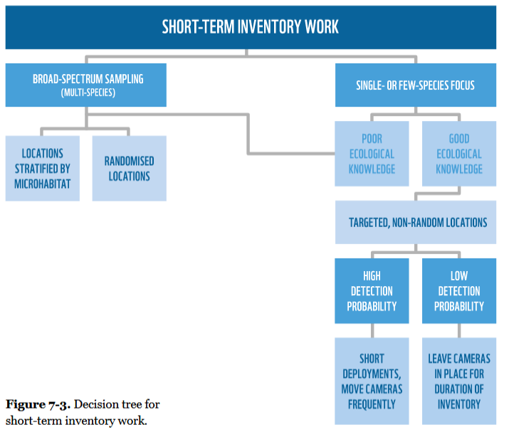

|  |  |  |  |
| --- | --- | --- | --- |
| **Image** | **file_name** | **Caption (if applicable)** | **ref_id** |
|  | figure1_filename.png | figure1_caption | figure1_ref_id |
|  | figure2_filename.png | figure2_caption | figure2_ref_id |
|  | figure3_filename.png | figure4_caption | figure3_ref_id |
|  | figure4_filename.png | figure4_caption | figure4_ref_id |
|  | figure5_filename.png | figure5_caption | figure5_ref_id |
|  | figure6_filename.png | figure6_caption | figure6_ref_id |

## Video

|  |  |  |
| --- | --- | --- |
| **caption** | **URL (no < / > before/after URL** | **ref_id** |
| vid1_caption | vid1_url | vid1_ref_id |
| vid2_caption | vid2_url | vid2_ref_id |
| vid3_caption | vid3_url | vid3_ref_id |
| vid4_caption | vid4_url | vid4_ref_id |
| vid5_caption | vid5_url | vid5_ref_id |
| vid6_caption | vid6_url | vid6_ref_id |

## Analytical tools & resources

|  |  |  |  |  |
| --- | --- | --- | --- | --- |
| **Type** | **Name** | **Note** | **URL** | **ref_id** |
| resource1_type | resource1_name | resource1_note | resource1_url | resource1_ref_id |
| resource2_type | resource2_name | resource2_note | resource2_url | resource2_ref_id |
| resource3_type | resource3_name | resource3_note | resource3_url | resource3_ref_id |
| resource4_type | resource4_name | resource4_note | resource4_url | resource4_ref_id |
| resource5_type | resource5_name | resource5_note | resource5_url | resource5_ref_id |
| resource6_type | resource6_name | resource6_note | resource6_url | resource6_ref_id |
| resource7_type | resource7_name | resource7_note | resource7_url | resource7_ref_id |
| resource8_type | resource8_name | resource8_note | resource8_url | resource8_ref_id |
| resource9_type | resource9_name | resource9_note | resource9_url | resource9_ref_id |
| resource10_type | resource10_name | resource10_note | resource10_url | resource10_ref_id |
| resource11_type | resource11_name | resource11_note | resource11_url | resource11_ref_id |
| resource12_type | resource12_name | resource12_note | resource12_url | resource12_ref_id |
| resource13_type | resource13_name | resource13_note | resource13_url | resource13_ref_id |
| resource14_type | resource14_name | resource14_note | resource14_url | resource14_ref_id |
| resource15_type | resource15_name | resource15_note | resource15_url | resource15_ref_id |

## References / Glossary

|  |  |
| --- | --- |
| **ref_id** | **glossary_keys** |
| Refs | keys_here |

## Notes