<https://courses.lumenlearning.com/wm-biology2/chapter/population-demography/>

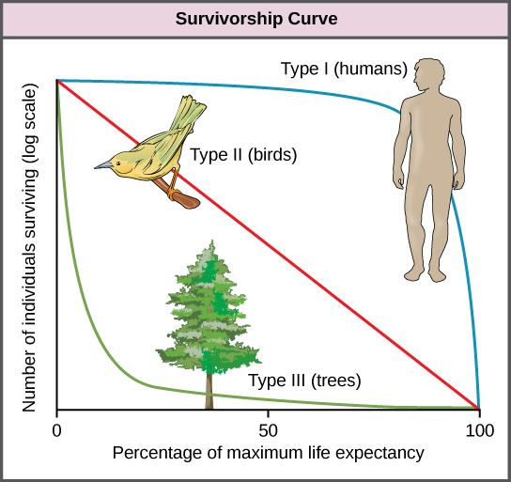

Figure 5. Survivorship curves show the distribution of individuals in a population according to age. Humans and most mammals have a Type I survivorship curve because death primarily occurs in the older years. Birds have a Type II survivorship curve, as death at any age is equally probable. Trees have a Type III survivorship curve because very few survive the younger years, but after a certain age, individuals are much more likely to survive.

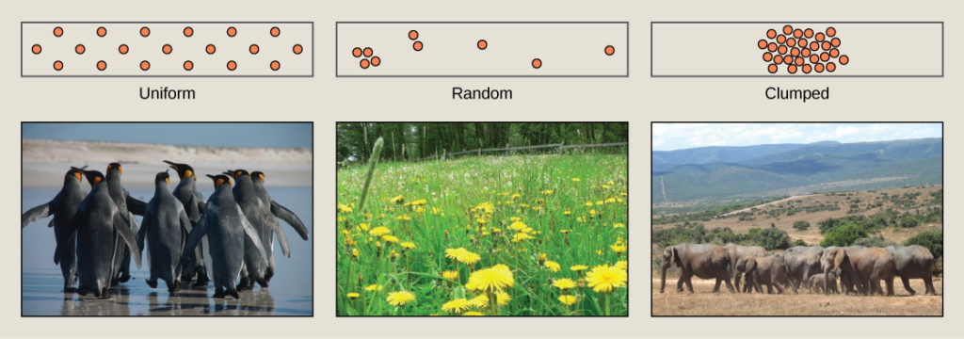

Figure 4. Species may have uniform, random, or clumped distribution. Territorial birds such as penguins tend to have uniform distribution. Plants such as dandelions with wind-dispersed seeds tend to be randomly distributed. Animals such as elephants that travel in groups exhibit clumped distribution. (credit a: modification of work by Ben Tubby; credit b: modification of work by Rosendahl; credit c: modification of work by Rebecca Wood)

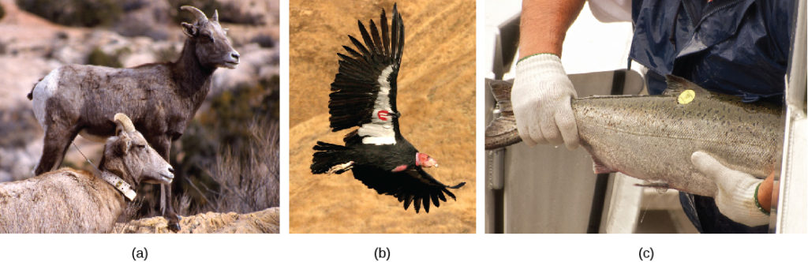

Figure 3. Mark and recapture is used to measure the population size of mobile animals such as (a) bighorn sheep, (b) the California condor, and (c) salmon. (credit a: modification of work by Neal Herbert, NPS; credit b: modification of work by Pacific Southwest Region USFWS; credit c: modification of work by Ingrid Taylar)

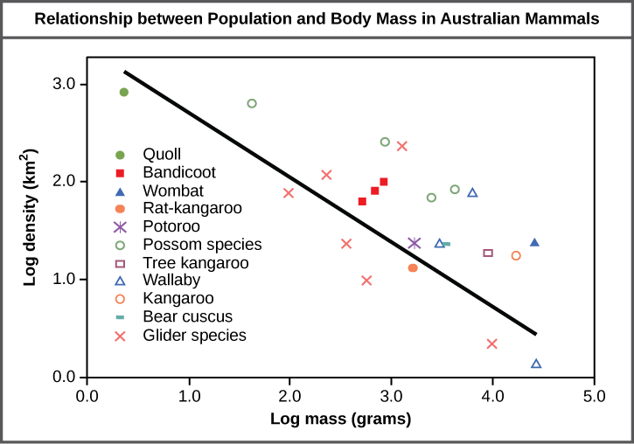

Figure 1. Australian mammals show a typical inverse relationship between population density and body size.