tgpp <- read.csv("~/Desktop/Programming in R/tgpp.csv")

1. What are the names of the columns in this dataset?

* plot year record_id corner scale richness easting northing slope ph yrsslb

head(tgpp)

## plot year record_id corner scale richness easting northing slope ph  
## 1 205 1998 187 NA 100 60 727000 4080000 3 6.9  
## 2 205 1998 188 1 10 36 727000 4080000 3 6.9  
## 3 205 1998 189 2 10 34 727000 4080000 3 6.9  
## 4 205 1998 190 3 10 37 727000 4080000 3 6.9  
## 5 205 1998 191 4 10 33 727000 4080000 3 6.9  
## 6 205 1998 192 1 1 21 727000 4080000 3 6.9  
## yrsslb  
## 1 0.39  
## 2 0.39  
## 3 0.39  
## 4 0.39  
## 5 0.39  
## 6 0.39

2.How many rows and columns does this data file have?

This data set has 11 columns and 4,080 rows.

length(tgpp$plot)

## [1] 4080

1. What kind of object is each data column? Hint: checkout the function sapply().]

sapply(tgpp,class)

## plot year record_id corner scale richness easting   
## "integer" "integer" "integer" "integer" "numeric" "integer" "integer"   
## northing slope ph yrsslb   
## "integer" "integer" "numeric" "numeric"

1. What are the values of the the datafile for rows 1, 5, and 8 at columns 3, 7, and 10?

1,3–> 187 5,7–> 727000 8,10–> 6.9

1. Create a pdf of the relationship between the variables “scale” and “richness”. Scale is the area in square meters of the quadrat in which richness was recorded. Be sure to label your axes clearly, and choose a color you find pleasing for the points. To get a list of available stock colors use the function colors().

plot(tgpp$richness~tgpp$scale, xlab="Scale (m^2)", ylab="Richness",col="Red")

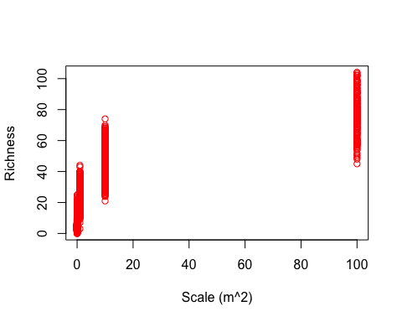

1. What happens to your plot when you set the plot argument log equal to ‘xy’. plot(…, log=‘xy’)

The plot looks much better.

plot(tgpp$richness~tgpp$scale,log='xy', xlab="Scale (m^2)", ylab="Richness",col="Red")

## Warning in xy.coords(x, y, xlabel, ylabel, log): 4 y values <= 0 omitted  
## from logarithmic plot

