**CHAPTER 4 “lab gems”**

* Often have to write code that performs the same task multiple times
  + Disadvantages to duplicating code
    - Makes program large
    - Time consuming
    - May need to be corrected in many places
* Repetition structure: makes computer repeat included code as necessary
  + Includes condition-controlled loops and count-controlled loops
* while loop: while condition is true, do something
  + Two parts:
    - Condition tested for true or false value
    - Statements repeated as long as condition is true
  + In flow chart, line goes back to previous part
  + General format:

while *condition*:

*statements*

* In order for a loop to stop executing, something has to happen inside the loop to make the condition false
* Iteration: one execution of the body of a loop
* while loop is known as a *pretest* loop
  + Tests condition before performing an iteration
    - Will never execute if condition is false to start with
    - Requires performing some steps prior to the loop
* Loops must contain within themselves a way to terminate
  + Something inside a while loop must eventually make the condition false
* Infinite loop: loop that does not have a way of stopping
  + Repeats until program is interrupted
  + Occurs when programmer forgets to include stopping code in the loop
* Count-Controlled loop: iterates a specific number of times
  + Use a for statement to write count-controlled loop
    - Designed to work with sequence of data items
      * Iterates once for each item in the sequence
    - General format:

for *variable* in *[val1, val2, etc]*:

*statements*

* + - Target variable: the variable which is the target of the assignment at the beginning of each iteration
* The range function simplifies the process of writing a for loop
  + range returns an iterable object
    - Iterable: contains a sequence of values that can be iterated over
* range characteristics:
  + One argument: used as ending limit
  + Two arguments: starting value and ending limit
  + Three arguments: third argument is step value
* Purpose of target variable is to reference each item in a sequence as the loop iterates
* Target variable can be used in calculations or tasks in the body of the loop
  + Example: calculate square root of each number in a range
* Sometimes the programmer does not know exactly how many times the loop will execute
* Can receive range inputs from the user, place them in variables, and call the range function in the for clause using these variables
  + Be sure to consider the end cases: range does not include the ending limit
* The range function can be used to generate a sequence with numbers in descending order
  + Make sure starting number is larger than end limit, and step value is negative
  + Example: range (10, 0, -1)
* Programs often need to calculate a total of a series of numbers
  + Typically include two elements:
    - A loop that reads each number in series
    - An *accumulator* variable
  + Known as program that keeps a running total: accumulates total and reads in series
  + At end of loop, accumulator will reference the total
* In many assignment statements, the variable on the left side of the = operator also appears on the right side of the = operator
* Augmented assignment operators: special set of operators designed for this type of job
  + Shorthand operators

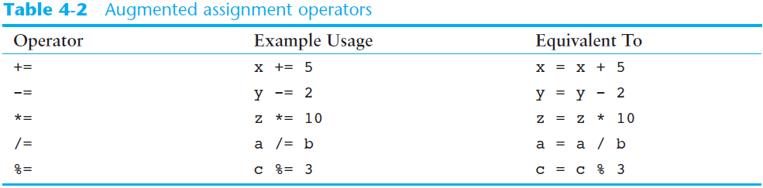

* Sentinel: special value that marks the end of a sequence of items
  + When program reaches a sentinel, it knows that the end of the sequence of items was reached, and the loop terminates
  + Must be distinctive enough so as not to be mistaken for a regular value in the sequence
  + Example: when reading an input file, empty line can be used as a sentinel
* Computer cannot tell the difference between good data and bad data
  + If user provides bad input, program will produce bad output
  + GIGO: garbage in, garbage out
  + It is important to design program such that bad input is never accepted
* Input validation: inspecting input before it is processed by the program
  + If input is invalid, prompt user to enter correct data
  + Commonly accomplished using a while loop which repeats as long as the input is bad
    - If input is bad, display error message and receive another set of data
    - If input is good, continue to process the input
* Nested loop: loop that is contained inside another loop
  + Example: analog clock works like a nested loop
    - Hours hand moves once for every twelve movements of the minutes hand: for each iteration of the “hours,” do twelve iterations of “minutes”
    - Seconds hand moves 60 times for each movement of the minutes hand: for each iteration of “minutes,” do 60 iterations of “seconds”
* Key points about nested loops:
  + Inner loop goes through all of its iterations for each iteration of outer loop
  + Inner loops complete their iterations faster than outer loops
  + Total number of iterations in nested loop: number_iterations_inner x

number_iterations_outer

**Lab Exercise 4**

**Focus**

1. While loops and For loops

2. Count--controlled loops

3. Sentinel controlled loops

**Part A: Building upon an Existing Solution**

For this portion of the lab, **you will reuse the program you wrote in Lab 3A.** Redesign this solution so that some portions of the code are repeated. In lab 3 you validated input to ensure that the user entered inputs within certain values. If the user entered an invalid value, the program terminated. Now you will add a loop such that the user gets three changes to enter a valid value. If the user enters an invalid value more than three times in a row, the program should issue an error message and terminate.

1. Save the program as firstname_lastname_Lab4a.py where you will replace firstname and lastname with your actual first and last name.
2. Test all conditions prior to submitting. If the user enters an invalid value, then the program will issue an error message and terminate immediately. (Do NOT accept further data).

**Part B: Draw Something**

In this portion of the lab you will draw an inverted triangle using loops.

**********

*********

********

*******

******

*****

****

***

**

*

Save this program as firstname_lastname_Lab4b.jpy where you will replace firstname and lastname with your actual first and last name.

**Part B: Draw Something New!**

Write a complete and syntactically correct Python program to solve the following problem:

You are the professor for COSC 1336 at Austin Community College. You want to write a program that will take in the number of grades of the students in your class. Since the students in a class vary from semester to semester, there is no fixed number assigned to the number of students. You will keep track of how many students’ grade you input. You will stop taking input when the student enters a grade of

minus 1 (-1).

Your program will use loops and will accomplish the following:

1. Read in a numeric grade from a student
2. Convert the numeric grade to a letter grade using the grade policies in your syllabus.
3. Keep a running total of the numeric grades entered.
4. Keep a count of the number of grades entered.
5. Issue a message that comments on the letter grade earned. As an example, you may write “You made an F! Obviously you did not study!”
6. At the end of the program calculate a class average unless there were NO grades entered.

🟏All input to the program will be interactive from the keyboard. The output of the program will include the individual grades converted, the message issued to the student, a class average, and the number of grades entered.

🟏Use the IDLE programming environment if you are using Python with IDLE.

🟏Please save your file as firstname_lastname_Lab4c.py where you will replace firstname and lstname with your actual first name and last name. Remember to use the extension .py.

🟏Run and test your program for all conditions. Once you are sure it works you will turn in the items listed in the next section.

All labs will be graded in Blackboard. Once you are done with the lab turn it in to the Lab 4 link.

**For this lab you will turn into Blackboard the following THREE items:**

|  |
| --- |
| 1. The Python *code file* you saved in part A -- cassandra_francis_lab4a.py  2. The Python code file you saved in part B -- cassandra_francis_lab4b.py  3. The Python code file you saved in part C -- cassandra_francis_lab4c.py |