/*
* Project Name: Simple ATM Machine Transaction Java Project to Display the ATM Transaction
* Programmer: Student - Christian Alvarez
* Date: 03-24-2021
*/
package atm.transactions;
/*imports*/
// i :: import array & scanner
import java.util.Date; // i.2 :: import Date
import java.util.Scanner; // i.3 :: import Scanner

public class ATMTransactions {
/*Variables*/
// v :: Declare global Var
public static Double balance = 5000.0;
public static Double withdraw, deposit;
public static int choice = 0;
// v.2 :: Declare user & password global var(s)
public final static String USERNAME = "ChristianA";
public final static String PASSWORD = "07061999";
public static String userName = "";
public static String passWord = "";

/*Classes*/
// c :: Define Classes(c)
// c.1 :: Define Main Class
public static void main(String[] args) {
/*Main*/
// Main :: Call Classes
// Main.2 :: Call printHeadings()
printHeadings();

// Main.3 :: Call checkLogIn()
checkLogIn();

// Main.4 :: Call printATMMainMenu()
printATMMainMenu();

// Main.5 :: Call checkUserChoice()
checkUserChoice();

// Main.6 :: Call performATMOperation()
performATMOperation();

// Main.7 :: Call printFooters()
printFooters();

}

// c.2 :: Define printHeadings()
public static void printHeadings() {
// 1 :: Create Date object
Date date = new Date();

// 2 :: print Header
System.out.println(date); // 2.2 :: print date
System.out.println("******************************************");
System.out.println("*** Welcome to Chase Bank ATM Machine ***"); // 2.3 :: print welcome statement
System.out.println("******************************************\n");
}

// c.3 :: Define checkLogIn()
public static void checkLogIn() {
// 1 :: prompt user for login (-Heading-)
System.out.println("Check Log In: Check User Name and Password");

// 2 :: Create Scanner input
Scanner input = new Scanner(System.in);

// 3 :: prompt user for userName
System.out.print("Please Enter User Name: ");
userName = input.nextLine(); // 3.2 :: read & store in userName

// 4 :: prompt user for passWord
System.out.print("Please Enter Password: ");
passWord = input.nextLine(); // 4.2 :: read & store in passWord

// 5 :: use count to limit time users can login
int count = 0;

// 5.2 :: Use while loop if the user entered wrong login
while ( !(userName.equalsIgnoreCase(USERNAME) && passWord.equals(PASSWORD) ) && count <= 2 ){
// 5.3 :: prompt user for correct login
System.out.println("Your User Name or Password are Wrong. Please Try again");

// 5.4 :: prompt user for UserName
System.out.print("Please Enter User Name: ");
userName = input.nextLine(); // 5.5 read & store in userName

// 5.6 :: prompt user for PassWord
System.out.print("Please Enter Password: ");
passWord = input.nextLine(); // 5.7 :: read & store in passWord

// 5.8 :: +1 to count, meaning no less time user can sign in
count += 1;

// 5.9 :: Check using if statement to see if user has correct Username and Password
// Note: User Name is case-insensitive while Password is Case sensitive
if ( (userName.equalsIgnoreCase(USERNAME) && passWord.equals(PASSWORD)) ){
System.out.println ("\n*** Welcome to Chase ATM Machine ***\n");
}
// 5.10 :: tell user they have no more tries to login
else if (count == 2) {
System.out.println("Sorry, try again in three hours");
System.exit(0);
}
}

}

// c.4 :: Define printATMMainMenu()
public static void printATMMainMenu() {
// 1 :: print Main Menu
System.out.println("\n***********************************************");
System.out.println("******* Automated Teller Machine (ATM) ********");
System.out.println("********----------------------------***********");
System.out.println("********* 1) Choose 1 for Withdraw **********"); // 1.2 :: print option 1
System.out.println("********** 2) Choose 2 for Deposit ************"); // 1.3 :: print option 2
System.out.println("********** 3) Choose 3 for Check Balance ******"); // 1.4 :: print option 3
System.out.println("********** 4) Choose 4 for EXIT **************"); // 1.5 :: print option 4
System.out.println("***********************************************\n");

}

// c.5 :: Define checkUserChoice()
public static void checkUserChoice() {
// 1 :: Create Scanner input
Scanner input = new Scanner(System.in);

// 2 :: Use while loop to check the users choice
while (choice != 1 && choice != 2 && choice != 3 && choice != 4 ) {
// 2.2 :: prompt user for choice
System.out.print("Choose from ATM Menu the Operation you want to perform: ");
choice = input.nextInt(); // 2.3 :: read & store in choice
}
}

// c.6 :: Define performATMOperation()
public static void performATMOperation() {
// 1 :: Use switch case for choice
switch(choice) {
case 1:
performMoneyWithdraw();
break;
case 2:
performMoneyDeposit();
break;
case 3:
performCheckBalance();
break;
case 4:
performExit();
break;
default:
System.out.println("** Invalid Choice. Please choose from ATM Menu**");
break;
}
}

// c.7 :: Define performMoneyWithdraw()
public static void performMoneyWithdraw() {
// 1 :: Create Scanner input
Scanner input = new Scanner(System.in);

// 2 :: prompt user for money withdrawn
System.out.print("Enter money to be withdrawn: $");
withdraw = input.nextDouble(); // 2.2 :: read & store in withdraw

// 3 :: Check using if statemnet to see if there is available balance to Withdraw money
if (balance >= withdraw) {
// 3.2 :: Calculate balance - withdraw
balance = balance - withdraw;

// 3.3 ::
System.out.printf("Please collect your money $%.2f %n", withdraw); // 3.3 ::
System.out.printf("Your Balance is now = $%.2f %n", balance);

}
else {
// 3.4 :: else, no available balance, print ‘Insufficient Balance”
System.out.println("Insufficient Balance");
}
System.out.println(""); // Blank line
}

// c.8 :: Define performMoneyDeposit()
public static void performMoneyDeposit() {
// 1 :: Create Scanner input
Scanner input = new Scanner(System.in);

// 2 :: prompt user for amount deposited
System.out.print("Enter money to be deposited: $");
deposit = input.nextDouble(); // 2.2 :: read & store in deposite

// 3 :: Calculate depostie + balance
balance = balance + deposit;

// 4 :: tell user the transactions was sucessful
System.out.println("Your Money has been successfully depsited");
System.out.printf("Your Balance is now = $%.2f %n", balance); // 4.2 :: print new balance
System.out.println(""); // Blank line
}

// c.9 :: Define performCheckBalance()
public static void performCheckBalance() {
// 1 :: print user Balance
System.out.printf("Your Balance now is = $%.2f %n " , balance);
System.out.println(""); // Blank line

}

// c.10 :: Define performExit()
public static void performExit() {
System.out.println("** You have Exited the ATM Machineprogram **");
System.exit(0);
}

// c. :: Define printFooters()
public static void printFooters() {
// 1 :: print footer
System.out.println("\n********************************************");
System.out.println("*** Thank you for Choosing Chase Bank *******"); // 1.2 :: print thank you statement
System.out.println("***Programmer: Student - Christian Alvarez***"); // 1.3 :: print student name
System.out.println("*********************************************");
}

}

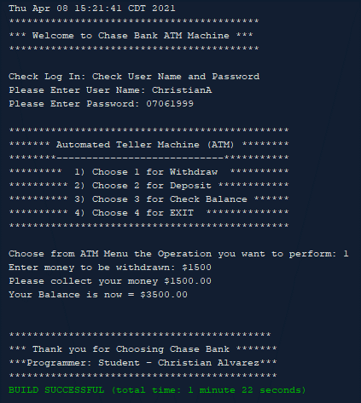
Withdraw
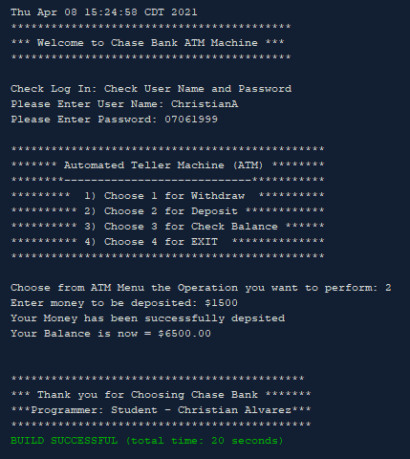
Deposit
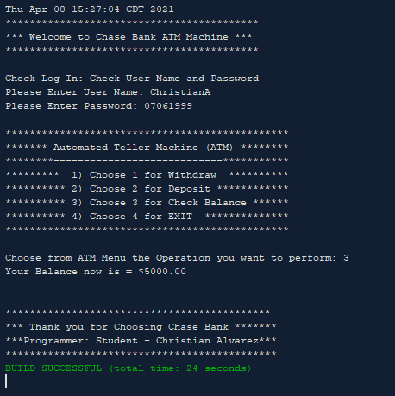
Check Balance
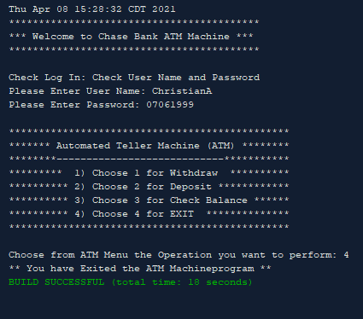
Exit
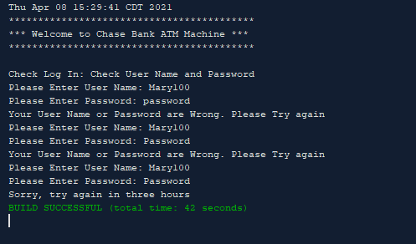
User gave wrong username & password

