**2.1 send start sampling/shut down command(开关采集)**

FF-FE-00-O/F-CSH-CHL

Shut down command:FF-FE-00-00-01-FD 关闭采集

Stop ECG & ACC sampling command:FF-FE-00-01-01-FE 停止采集

Start ECG/ACC sampling command:FF-FE-00-02-02-FF开始采集

FFFE000202FF

**2.2 send set patch clock command (设置时间)**

FF-FE-01-year-month-date-hour-min-ser-Self-CSH-CHL

Self = 0x00: FF-FE-01-11-08-17-0a-10-20-00-CSH-CHL 不返回电池状态

Self = 0x01: FF-FE-01-17-08-18-16-10-50-01-CSH-CHL 返回电池状态

**2.3 Switch patch work mode(工作模式)**

FF-FE-02-mode-CSH-CHL mode 默认为1

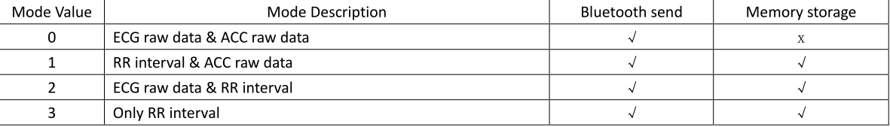

MODE = 0 FF-FE-02-00-02-00

MODE = 1 FF-FE-02-01-02-01

MODE = 2 FF-FE-02-02-02-02

MODE = 3 FF-FE-02-03-02-03

**2.4 send FLASH operation command(发送Flash命令模式)**

FF-FE-03-operation-CSH-CSL

Operation = 1 FF-FE-03-01-02-01 Flash上传数据

Operation = 2 FF-FE-03-02-02-02取消Flash上传

Operation = 3 FF-FE-03-03-02-03 删除所有闪存数据

**2.6 send init PATCH parameters command(发送初始化参数命令)**

FF-FE-05-V1-V2-V3-V4-V5-V6-V7-V8-V9-VA-VB-VC-VD-VF-CSH-CSL

**2.7** send OTA

FF-FE-06-02-03

**2.8 set consumer information into flash command(用户信息设置到Flash)**

**FF-FE-07-XX-XX-XX-XX-XX-XX-XX-XX-XX-XX-XX-XX-XX-XX-XX-CSH-CSL**

**2.9 read consumer information from flash(读取用户信息)**

FF-FE-08-02-05

**2.10 erase consumer information from flash(删除用户信息)**

FF-FE-09-02-06