**FuzzySort Report**

**Kexin Ding**

*Dear TA, I am the only member in my team. And I also finish both two algorithms. Please check the code in fuzzysort_quicksort.py. Thank you!*

**1.Results**

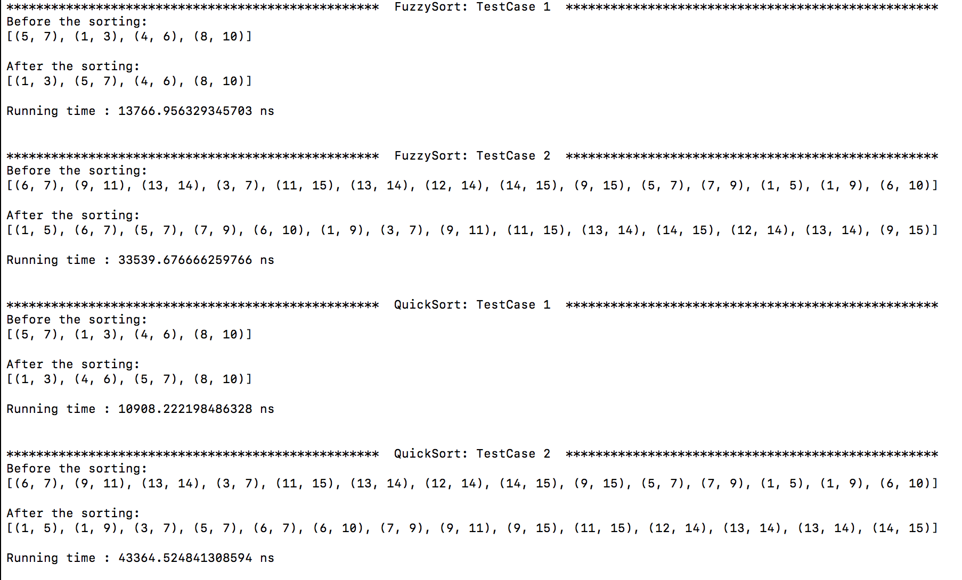

**Some explanation for the result:**

1. Testing two test cases as the requirement.

2. Evaluating running time by time.time() and show it on the nanosecond scale.

3. For the fairness, running each algorithm for 5000 times. Using the average of the running time as the output.

4. Because of using random.randint() in find_overlap(), hence fuzzy-sort will show multiple results in the different running. But each result will satisfy the concept of fuzzy-sort.

**Time Complexity:**

For Fuzzy Sort:

T (n) = 2T (n/2) + ϴ(n)

= 2*2*T(n/4) + 2 * ϴ(n)

= 2*2*2*T(n/8) + 3 * ϴ(n)

…

= $2^{i}T(n/2^{i})$ + i * ϴ(n)

🡺 i = lgn

= n + lgn* ϴ(n)

= ϴ (nlgn)

For QuickSort:

T (n) = 2T (n/2) + ϴ(n)

= 2*2*T(n/4) + 2 * ϴ(n)

= 2*2*2*T(n/8) + 3 * ϴ(n)

…

= $2^{i}T(n/2^{i})$ + i * ϴ(n)

🡺 i = lgn

= n + lgn* ϴ(n)

= ϴ (nlgn)