**Young tableaus(applications of the heap properties)**

**Kexin Ding**

*Please check the integrated code in young.py*

**1.Draw 4×4 tableau containing the elements {9,16,3,2,4,8,5,14,12}**

|  |  |  |  |
| --- | --- | --- | --- |
| 2 | 3 | 5 | 14 |
| 4 | 8 | 9 | 16 |
| 12 | ∞ | ∞ | ∞ |
| ∞ | ∞ | ∞ | ∞ |

**2. Argue that an m×n Young tableau Y is empty if Y[1,1]=∞. Argue that Y is full (contains mn elements) if Y[m,n]<∞.**

If Y[1,1] = ∞, it means all elements in the first row and column are ∞. Y[1,1] is the smallest element in Y. The rest element of Y will be larger than Y[1,1]. If Y[1,1] = ∞, other elements in Y will also equal to ∞ to satisfy the rules of Young tableau. Hence, the Young tableau Y is empty.

If Y[m, n] **<** ∞, it means the last “children” element(the bottom right element) is not ∞. And this bottom right element is the largest element in the Y. Each element is smaller than Y[m, n]. If Y[m, n] is smaller than ∞, each element in Y will smaller than ∞. Hence Y is not empty.

**3. Give an algorithm to implement EXTRACT-MIN.**

**Time complexity:**

T(p) = T(p − 1) + O(1)

= T(p − 2) + O(1) + O(1)

= T(p - (p - 1)) + (p - 1) * O(1)

= T(1) + (p - 1) * O(1)

= p * O(1)

= O(p)

= O(m + n)

**Result:**

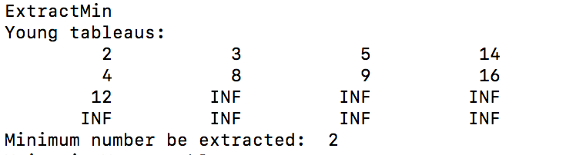

**Code:**

*def Young(Y, i, j, m, n):*

*x = i*

*y = j*

*if i < m and Y[i][j] > Y[i + 1][j]:*

*x = i + 1*

*y = j*

*if j < n and Y[x][y] > Y[i][j + 1]:*

*x = i*

*y = j + 1*

*if x != i or y != j:*

*Y[i][j], Y[x][y] = Y[x][y], Y[i][j]*

*Young(Y, x, y, m, n)*

*def ExtractMin(Y, m, n):*

*tmp = Y[0][0]*

*Y[0][0] = sys.maxsize*

*young(Y, 0, 0, m, n)*

*return tmp*

**4. Show how to insert a new element into a nonfull m×n Young tableau in O(m+n) time**

**Time Complexity:**

The similar algorithm as 3. But an inversing process.

T(p) = T(p − 1) + O(1)

= T(p − 2) + O(1) + O(1)

= T(p - (p - 1)) + (p - 1) * O(1)

= T(1) + (p - 1) * O(1)

= p * O(1)

= O(p)

= O(m + n)

**Result:**

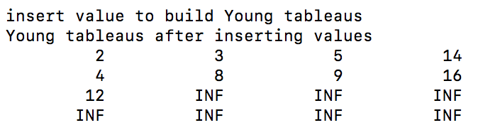

**Code:**

*def Inverse(Y, m, n):*

*i = m*

*j = n*

*if m>0 and Y[m][n] < Y[m-1][n]:*

*i = m - 1*

*j = n*

*if n>0 and Y[i][j] < Y[m][n-1]:*

*i = m*

*j = n - 1*

*if i!=m or j!=n:*

*Y[m][n], Y[i][j] = Y[i][j], Y[m][n]*

*Inverse(Y, i, j)*

*def Insert(Y, m, n, value):*

*if m < 0 and n < 0:*

*return*

*Y[m][n] = value*

*Inverse(Y, m, n)*

**5. Using no other sorting method as a subroutine, show how to use an n×n Young tableau to sort n2 numbers in O(n3) time.**

Inserting is actually an in-order operation. It will maintain the order in its algorithm. For inserting one element, we need to spend O(m + n) = O(n + n) = O(n). For inserting $n^{2}$ elements, we need to spend $n^{2}O(n)$ = O($n^{3}$).

**6. Give an O(m+n)-time algorithm to determine whether a given number is stored in a given m×n Young tableau.**

**Time complexity:**

T(p) = T(p − 1) + O(1)

= T(p − 2) + O(1) + O(1)

= T(p - (p - 1)) + (p - 1) * O(1)

= T(1) + (p - 1) * O(1)

= p * O(1)

= O(p)

= O(m + n)

**Result:**

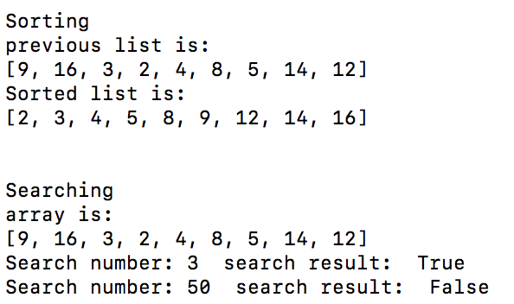

**Code:**

*def YoungSearch(Y, i, j, m, n, value):*

*if Y[i][j] == value:*

*return True*

*x = i*

*y = j*

*if i > 0 and Y[i][j] > value:*

*x = i - 1*

*y = j*

*if j < n and Y[i][j] < value:*

*x = i*

*y = j + 1*

*if x==i and y==j:*

*return False*

*return YoungSearch(Y,x,y,m,n,value)*

*def search(Y, m, n, value):*

*return YoungSearch(Y, m, 0, m, n, value)*