**Coin Changes Report**

**Kexin Ding**

**1. Source Code**

Please check coin_changes.py

**2.Excution Results**

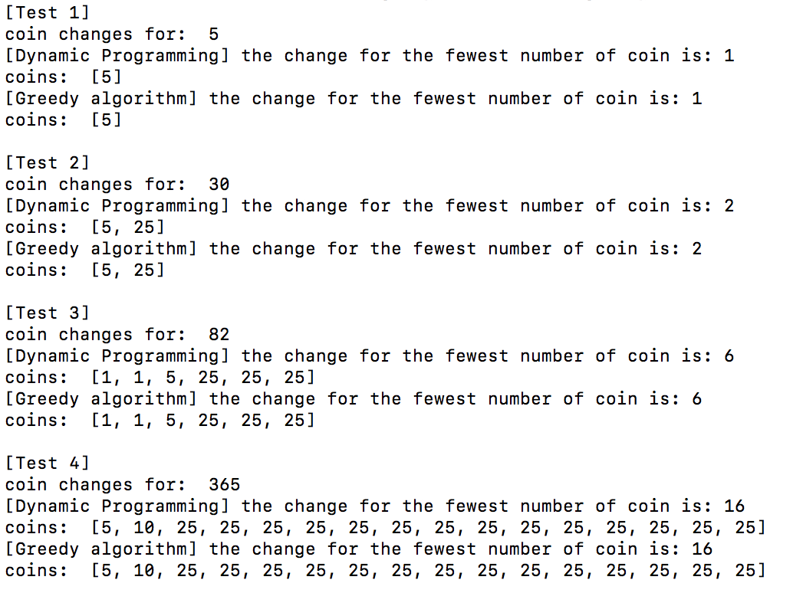

**3. Time Complexity Analysis**

For dynamic programming version, I use the method as the Bottom to Up method. Time complexity: T(n) = O(4n) + O(n) = O(4n) = O(n). 4 is the number of coin types: penny, nickel, dime, quarter.

For the greedy algorithm version, time complexity is T(n) = O(n). Because there is only one for loop.

**4. Answer of c**

a. We assume that we only use the first two denominations $c^{0}$ = 1 and $c^{1}$ = c. At most, we can use (c-1) $c^{0}$* because any value larger than c would be replaced by at least on c. This will reduce the total coin number by c-1. It means the remainder is greater than c and we can use only $c^{0}$ and $c^{1}$. To satisfy the condition of fewer changes, we can use as many $c^{1}$ as we can before use $c^{0}$.

b. We assume that we only use the first two denominations $c^{n-1}$ = 1 and $c^{n}$. At most, we can use (c-1) $c^{n-1}$* because any value larger than $c^{n}$ would be replaced by at least on $c^{n}$. This will reduce the total coin number by c-1. It means the remainder is greater than $c^{n}$ and we can use only $c^{n-1}$ and $c^{n}$. To satisfy the condition of fewer changes, we can use as many $c^{n}$ as we can before use $c^{n-1}$.

c. Consider a and b together, the greedy algorithm applies to all situations of this coin set. Hence greedy algorithm is optimal.