**Day 1 Activites**

A few questions about what goes on in this program are in order before we proceed.

1. How long will it take the timer to roll over?
   1. $\frac{0xFFF cnts}{rollover}* \frac{8 clks}{1 cnt}* \frac{1 us}{8 clks}$ = 0xFFFF *u*s/rollover
2. How long does each timer count last?
   1. $\frac{1 cnt}{1}* \frac{8 clks}{1 cnt}* \frac{1 us}{8 clks}$ = 1 cnt = 1 *u*s

The while(1) loop in main reads in the ir pules in the for loop.

Annotate the picture below to indicate which line of the for loop in the program is executed at which part of the pulse. You should show a total of 6 lines of code (lines 32-34 and lines 36-38).

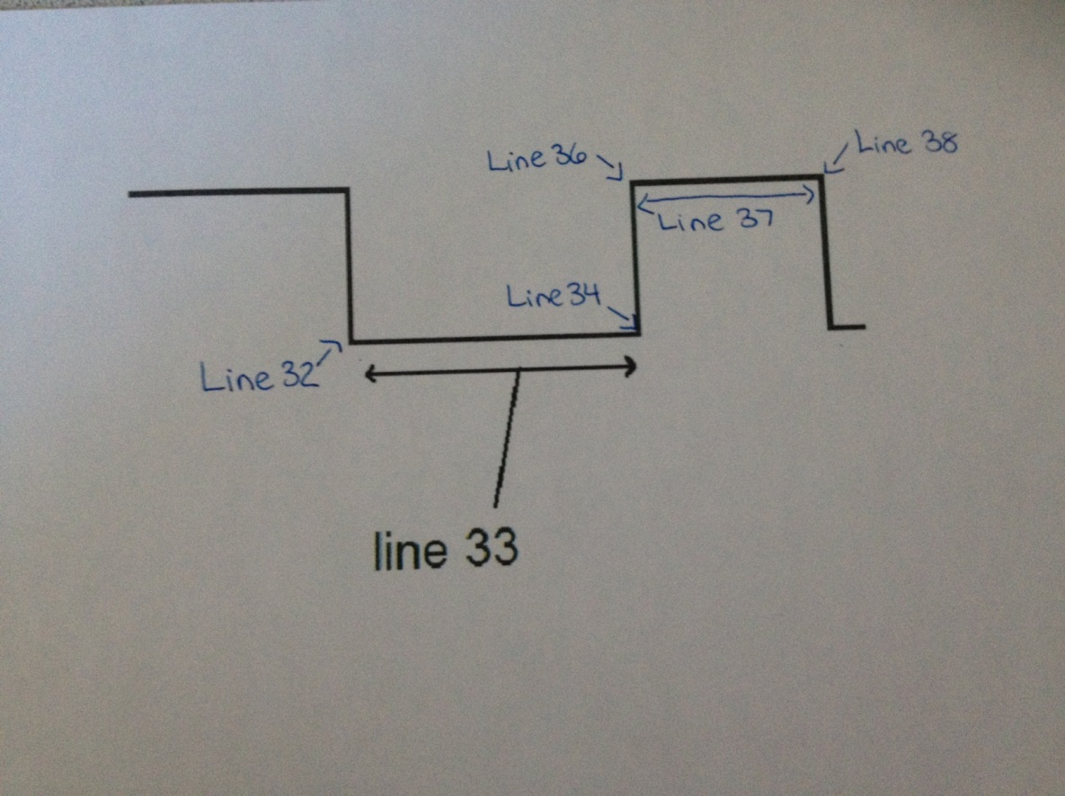

List the lengths of the pulses generated by the remote control in absolute time using the O'scope (3 significant figures) and in timer A counts. Note: "start logic 0 half-pulse" refers to the logic LOW portion of the start pulse, and "data 0 logic 1 half pulse" refers to the second half (which is a logic HIGH) of the pulse representing a zero bit.

|  |  |  |
| --- | --- | --- |
| **Pulse** | **Duration(ms)** | **Timer A Counts** |
| Start logic 0 half-pulse | 9.063 ms | 9063 |
| Start logic 1 half-pulse | 4.453 ms | 4453 |
| Data 1 logic 0 half-pulse | 0.609 ms | 609 |
| Data 1 logic 1 half-pulse | 1.656 ms | 1656 |
| Data 0 logic 0 half-pulse | 0.593 ms | 593 |
| Data 0 logic 1 half-pulse | 0.531 ms | 531 |
| Stop logic 0 half-pulse | 0.625 ms | 625 |
| Stop logic 1 half-pulse | 39.873 ms | 39873 |

Collect and tabulate in Excel 8 samples of timer A counts for each of the following pulse types (in decimal). Compute the average and standard deviation of each pulse type. I would suggest just grabbing it from the CCS variables tab.  
- Data 1, logic 1 half-pulse - Data 0, logic 0 half-pulse - Data 0, logic 1 half-pulse  
Ensure you label the rows and columns of your table so that I will know what the information in each cell means.

|  |  |  |  |
| --- | --- | --- | --- |
|  | Data 1 Logic 1 | Data 0 Logic 0 | Data 0 Logic 1 |
| 1 | 1661 | 538 | 573 |
| 2 | 1668 | 535 | 579 |
| 3 | 1648 | 558 | 579 |
| 4 | 1668 | 534 | 558 |
| 5 | 1690 | 528 | 582 |
| 6 | 1692 | 559 | 577 |
| 7 | 1588 | 590 | 583 |
| 8 | 1692 | 585 | 577 |
| Mean | 1663.375 | 553.375 | 576 |
| Std Dev | 34.463 | 23.868 | 7.910 |

For each pulse type list the range of timer A counts that would correctly classify 99.9999426697% of the pulses. This number has something to do with the [standard deviation](http://en.wikipedia.org/wiki/Standard_deviation#Rules_for_normally_distributed_data) (hint: look at the table in this section).

The count would that would classify 99.9999426697% of the pulses would be two standard deviations.

Data 1 Logic 1 range = (1594.5 to 1732.3)

Data 0 Logic 0 range = (505.6 to 601.1)

Data 0 Logic 1 range = (560.2 to 591.8)

Write the codes (in hex) for several remote control buttons.

|  |  |
| --- | --- |
| **Button** | **Code (note including start and stop bits)** |
| 0 | xC2CC |
| 1 | xC284 |
| 2 | xC244 |
| 3 | xC2C4 |
| Power | xC3D0 |
| VOL + | xC228 |
| VOL - | xC2A8 |
| CH + | xC298 |
| CH - | xC218 |