Name:_______________________________________

Citizen Science: Biogeography, Behavior, Biodiversity and more (migration, phenology, etc.)

Scientific research is in a new era of massive datasets facilitated by new technologies such as genomics, high-resolution satellite imagery, drones, and more. Ecology research now widely uses motion-sensor cameras to capture high-quality images and videos of species that are rare, secretive or otherwise difficult to observe in person. The problem with these giant datasets (e.g., hundreds of thousands of photos in each study) is that they are too extensive for a single graduate student or even small team of researchers to process. Therefore, an increasingly common practice is to implement Citizen Science, whereby volunteers are enlisted to help collect or process data. Today (and in the future) we will be citizen scientists contributing to various mammal-related projects.

Part 1: Urban Wildlife Occurrence (10 pts)

These first few questions will familiarize you with the approach of citizen science, so we will walk through the process together. First, visit https://www.zooniverse.org/projects/pat-lorch/focus-on-wildlife-cleveland-metroparks/classify. You may wish to sign up for an account on Zooniverse, but this is optional. If you are not automatically directed here, click the gray box on the lower right side of the page labeled "Show the project tutorial".

- (2pt) What is the goal of this project?

- (1 pt) How do the researchers prevent errors in their data if I incorrectly classify an image?

Select the Play button on the lower left side of the image to cycle through three images taken in rapid succession. It may help to pause the cycle on Image 2 or 3.
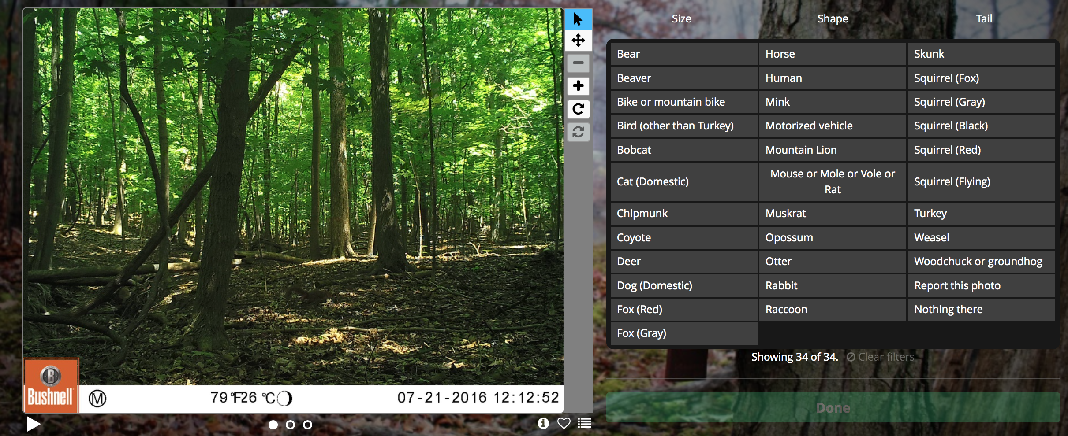

c. (1 pt) Why are there three sets of images per classification?

Choose the animal that best matches the one you saw in the three images. Choose the number of animals you saw, and if applicable, select the best answers for additional questions. Click "Identify". Before you proceed to the next image, make sure there are no other animals in the image (e.g., a deer triggered the camera and a squirrel is in a tree). If there are additional animals, continue as before. When you have identified all the animals in the image, click "Done" and then continue to the subsequent images with "Next".

Continue with the next set of images. You will notice that some sets are taken during the day and others are taken at night.

d. (1 pt) How can you use this temporal information (day vs. night) to help with your identification?

e. (1 pt) Some of the animals in the nighttime images are nearly impossible to identify. What should I do?

If you need help with identification, you can filter the list of potential animals by size, tail shape and length, or body shape.
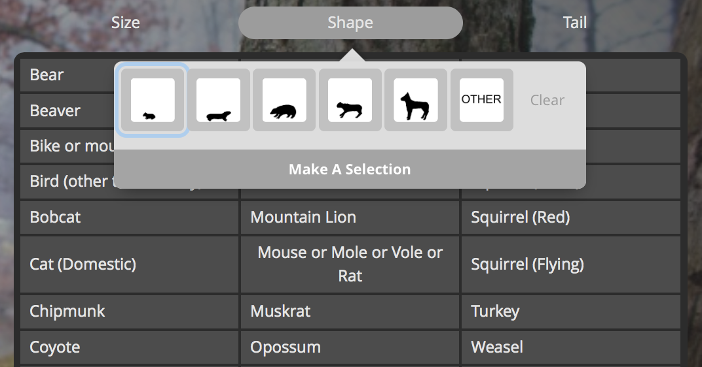

Repeat these steps for 10 total images. Be sure to scan the entire image during all cycles of the image (e.g., one quadrant at a time).

f. (1 pt) What was the most common animal you saw?

g. (1 pt) The cameras are triggered by movement. Why do some of the photos have no animals in them?

h. (2 pts) What is an example of a question that can be asked, or a hypothesis that can be tested, with camera trapping data that cannot be answered in other ways?

Part 2: Citizen Science project of your choice (40 pts)

Select a mammal-based citizen science project from the list on the next page to contribute to. Briefly describe the goal of the project and the tasks required so that your TA is familiar with the project (10 pts). Keep track of the number of photos or videos you analyze (or relevant task). If you are scanning photos, scan at least 100; if you are watching videos, watch at least 25; if you are uploading mammal sightings from your time spent observing in nature, search for at least 3 hours.

Write a 3-paragraph report (30 pts) describing: i) why the project is important, ii) what are the scientific goals, iii) what we can learn about mammalogy from this project (including any fun facts about the species observed!).

Zooniverse / Scistarter.com / Nature's Notebook potential projects

You may select one of the following mammal-based projects. If you would like to participate in a different project, please email Loren for approval first.

Identify animals on camera traps in Cleveland Parks: https://www.zooniverse.org/projects/pat-lorch/focus-on-wildlife-cleveland-metroparks/classify

Document bat behavior at their roosts in Arizona: https://www.zooniverse.org/projects/zooniverse/arizona-batwatch/classify

Help identify mammals that triggered camera trips in Africa: https://www.zooniverse.org/projects/panthera-research/camera-catalogue/classify

(NC only) North Carolina trail cams: http://scistarter.com/project/13783

Chimp and See (document behavior & species): http://scistarter.com/project/12644

Identify animals in Mozambique: http://scistarter.com/project/11189

Squirrel pelage in your neighborhood: http://scistarter.com/project/1393

Digitize museum info with DigiVol: http://scistarter.com/project/683 or Notes From Nature: http://scistarter.com/project/842

Record biodiversity observations with iNaturalist: http://scistarter.com/project/421 or Project Noah: http://scistarter.com/project/338 or Wildlife Watch: http://scistarter.com/project/24 (may not exist anymore)

analyzing canid howls to understand social behavior: http://scistarter.com/project/1033

Document animals in the Serengeti: http://scistarter.com/project/646

If you have pictures of African mammals: http://scistarter.com/project/583

Listen to orca vocalizations: http://scistarter.com/project/286

Observe phenology (seasonal timing) in local mammals with Nature's Notebook: https://usanpn.org/natures_notebook

