**STEADY STATE CONSTANT VELOCITY @ 120 KM/H**

1. **Steering Wheel Angle vs. Lateral Acceleration Gradient**

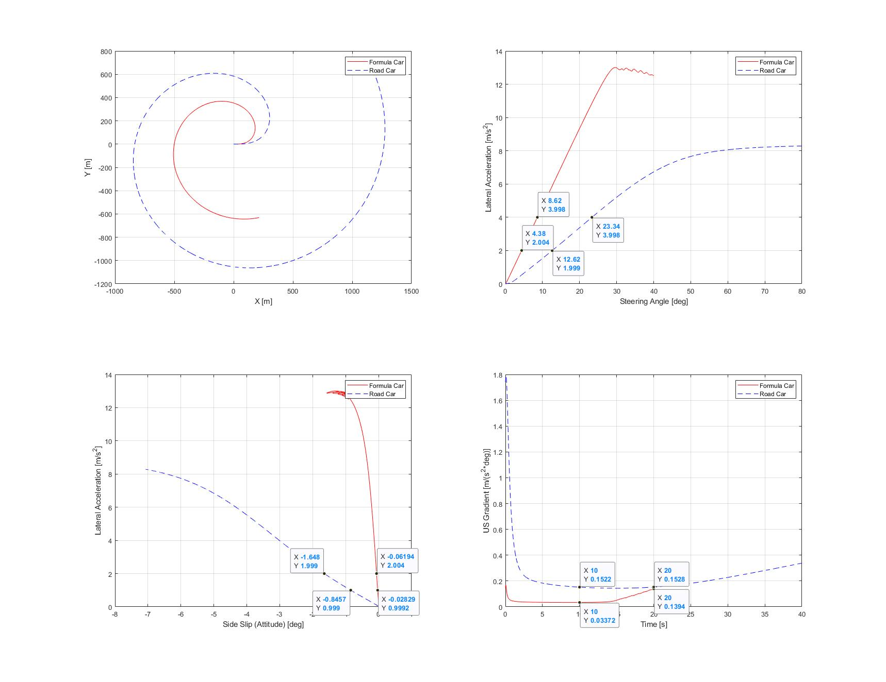

Figure 1 – Plots and Data Tips

* 1. Formula Car
 $$grad_{formula}=\frac{3.998-2.004}{8.62-4.38}=0.470283 \frac{m}{s^{2}*deg}$$

 2. Road Car

$$grad_{road}=\frac{3.998-1.999}{23.34-12.62}=0.186474 \frac{m}{s^{2}*deg}$$

The calculations based on the data provided by the plots in Figure 1 show that the Formula Car has a higher lateral acceleration generation rate per unit of steering wheel input compared to the Road Car.

1. **Understeer Gradient**
   1. @ 10 seconds
      1. Formula Car
 $$K_{US}= 0.03372 \frac{m}{s^{2}*deg}$$

     2. Road Car
 $$K_{US}= 0.1522 \frac{m}{s^{2}*deg}$$

  2. @ 20 seconds
      1. Formula Car
 $$K_{US}= 0.1394 \frac{m}{s^{2}*deg}$$

     2. Road Car

$$K_{US}= 0.1528 \frac{m}{s^{2}*deg}$$

Note that the Formula Car is naturally less understeery compared to the Road Car due to its tyres characteristics and the fact that its centre of gravity is located close to its geometric centre in the x-axis. Its balance though gets more understeery by the 14th second of the simulation when it reaches around 30 degrees of steering angle and -2.5 degrees of front slip angle due to the decreasing rate of its cornering stiffness.

Figure 2 evidences that the tyres start coming off their linear range, increasing their slip angles following the non-linear region. Figure 3 shows that due to the increasingly slip angle in the fronts, the lateral force coefficient starts decreasing, thus reducing the front axle cornering capacity, which happens around 30 degrees of steering angle.

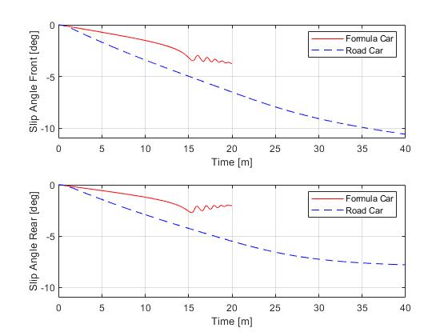

Figure 2 – Slip Angles vs. Time

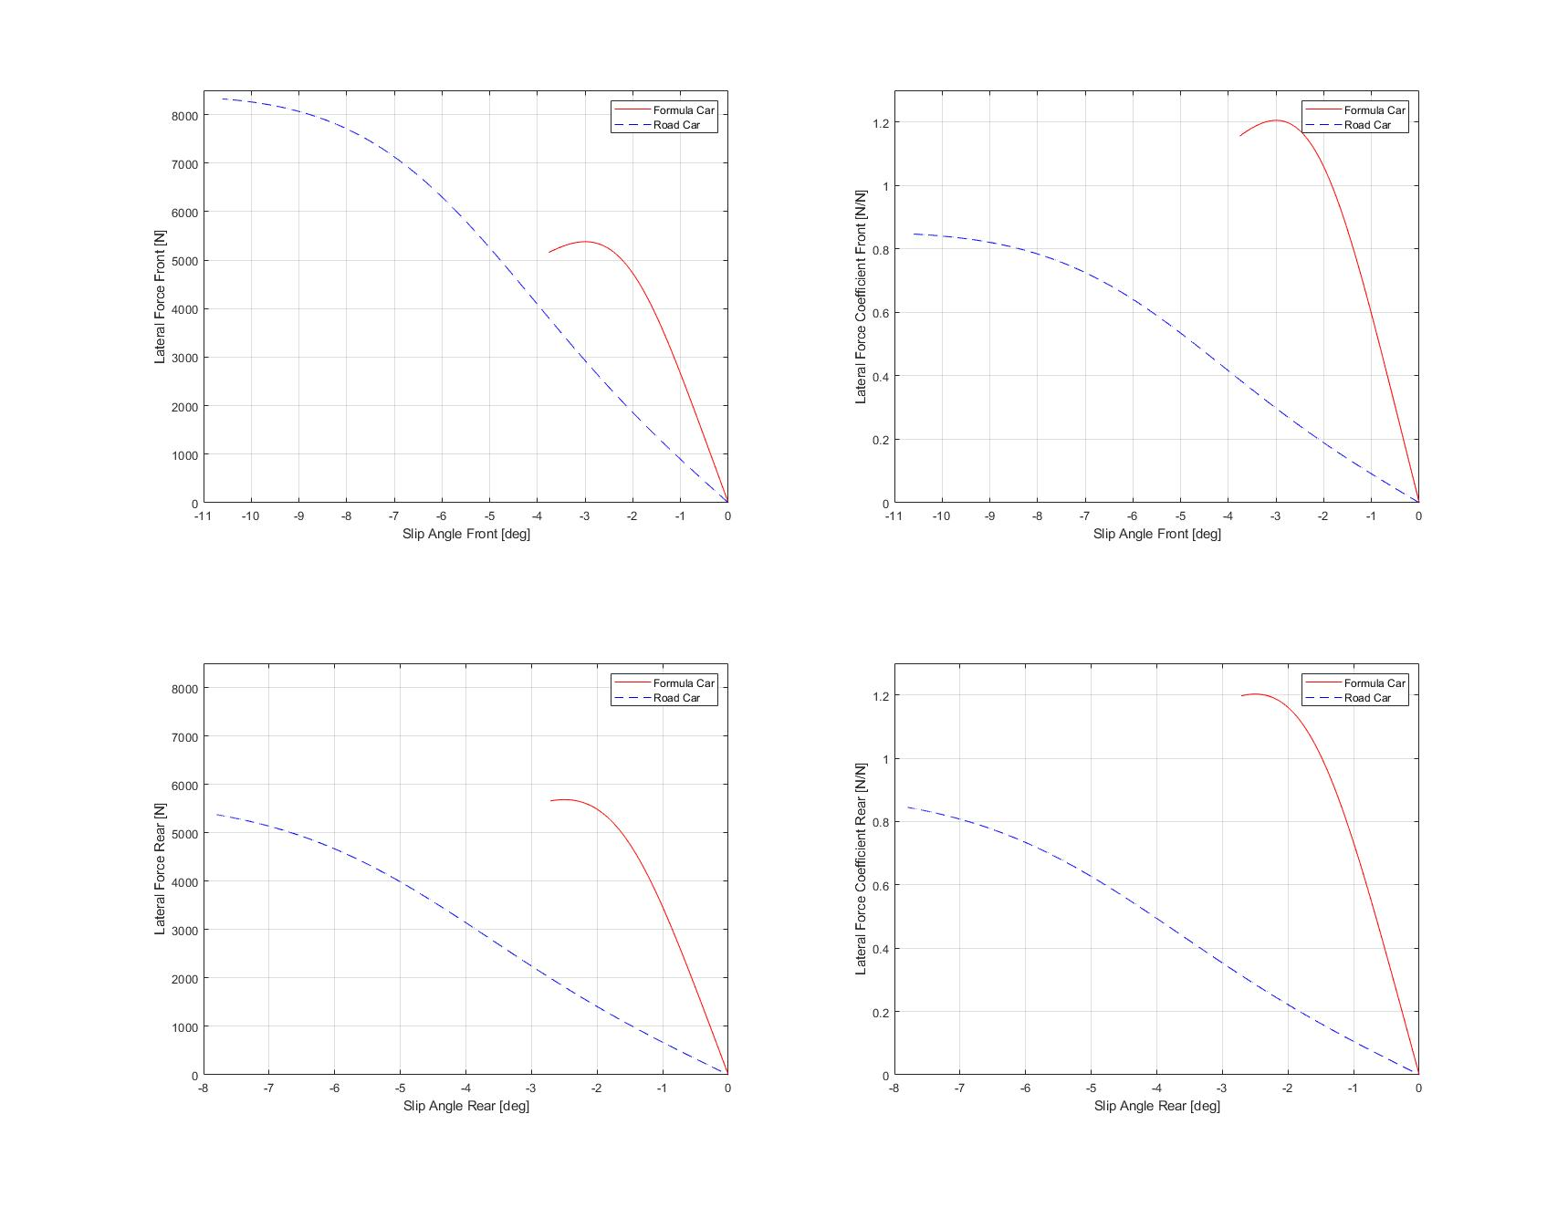

Figure 3 – Cornering Stiffness Plot

1. **Side Slip vs. Lateral Acceleration Gradient**
   1. Formula Car
 $$grad_{formula}=\frac{2.004-0.9992}{-0.06194+0.02829}=-29.8603 \frac{m}{s^{2}*deg}$$

  2. Road Car

$$grad_{road}=\frac{1.999-0.999}{-1.648+0.8457}=-1.24642 \frac{m}{s^{2}*deg}$$

From the data tips illustrated in Figure 1 the above calculations could be made and evidence that for the road car the lateral acceleration gradient per side slip unit is considerably lower, meaning that when compared to the formula car the road car achieves much higher side slips in order to generate higher values of lateral acceleration.

**STEP STEER CONSTANT VELOCITY CORNERNING @ 120 KM/H**

1. **Lateral Acceleration Overshoot**

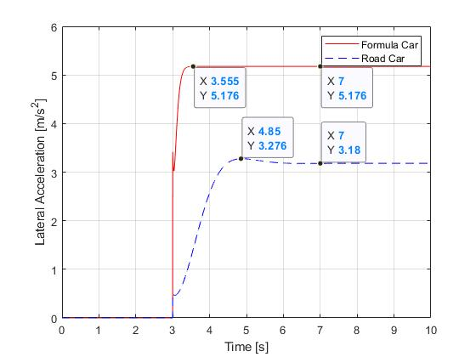

Figure 4 – Lateral Acceleration vs. Time

As can be noticed from Figure 4, there is no overshoot for the Formula Car for a steering angle of 11 degrees at 120 km/h. However, for the Road Car there is an overshoot around 2 seconds after the 18 degrees of steering wheel step input have been applied. The overshoot value is calculated below:

$$overshoot_{road}=\frac{3.276-3.18}{3.18}*100=14.65378\%$$

1. **Yaw Rate Overshoot**

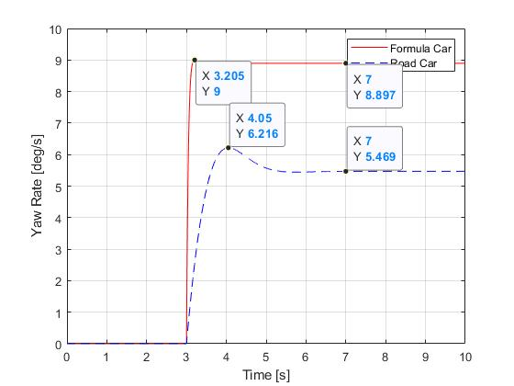

Figure 5 - Yaw Rate vs. Time

Figure 5 illustrates the presence of overshoot in Yaw Rate for both Formula and Road Cars, which is significantly higher for the road car and which value is given below.

$$overshoot_{formula}=\frac{9-8.897}{8.897}*100=1.157694\%$$

$$overshoot_{road}=\frac{6.216-5.469}{5.469}*100=13.6588\%$$

1. **Vehicle with the Higher Response**

Once the yaw rate and lateral acceleration plots have been generate and overshoot analysis done the conclusion is that the Formula Car is more responsive than the road car as it reaches steady-state condition much quicker than the Road Car does. The overshoot for both channels for the Formula Car is also much lower than the Road Car and it is also able to generate greater lateral accelerations and yaw rates.