1. 7DoF Model Screenshots
   1. Sprung Mass:

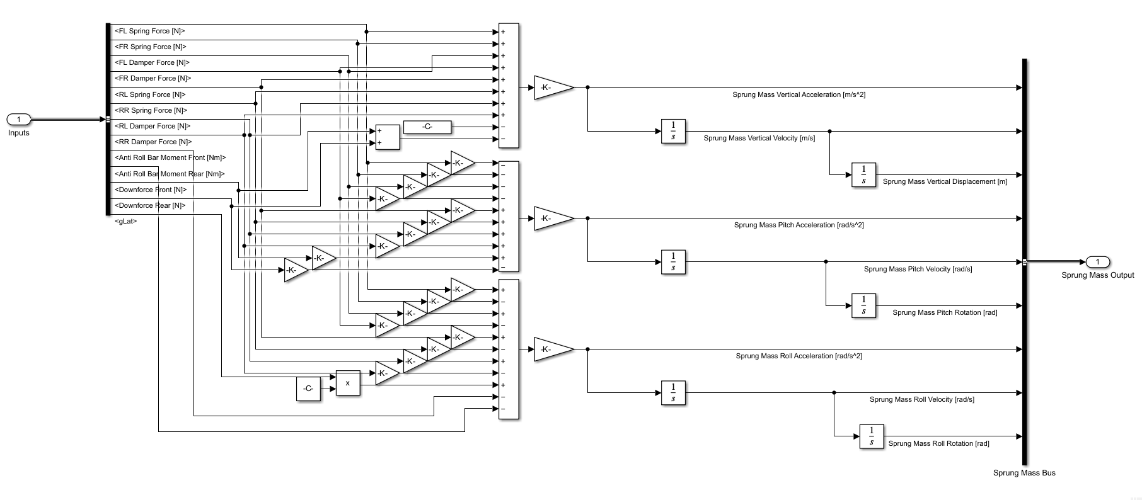

* 1. FL:

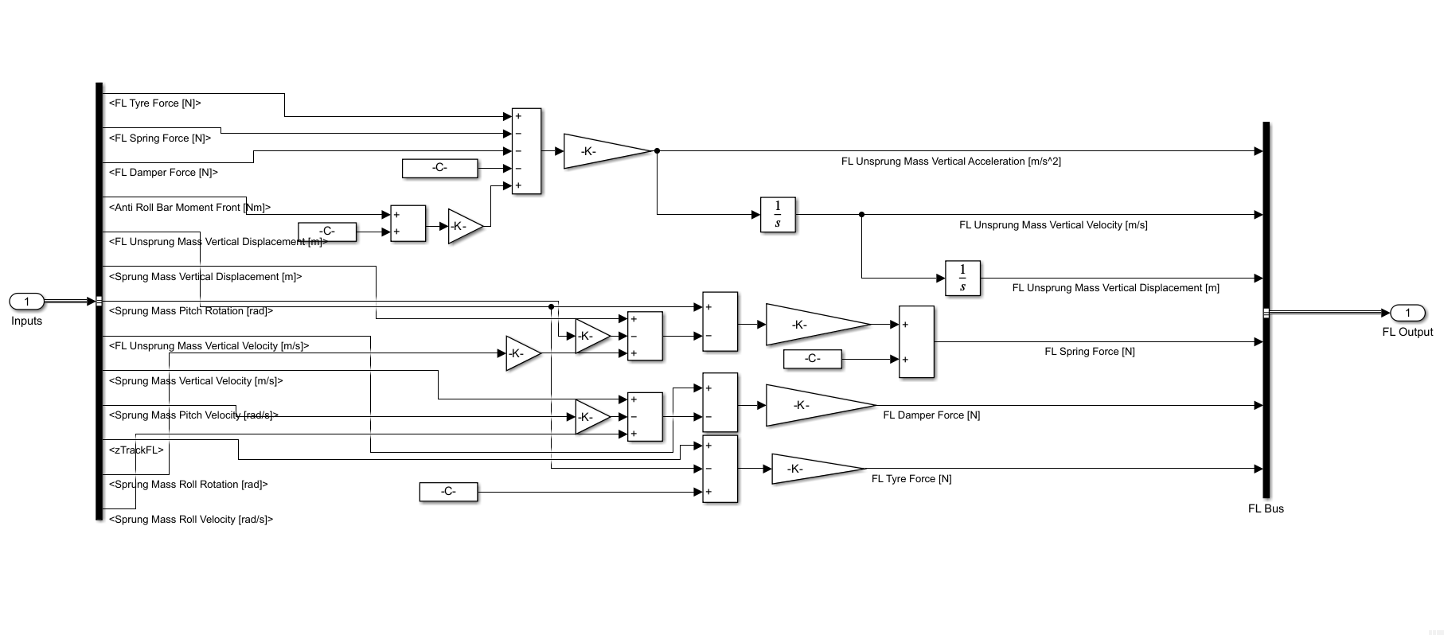

* 1. FR:

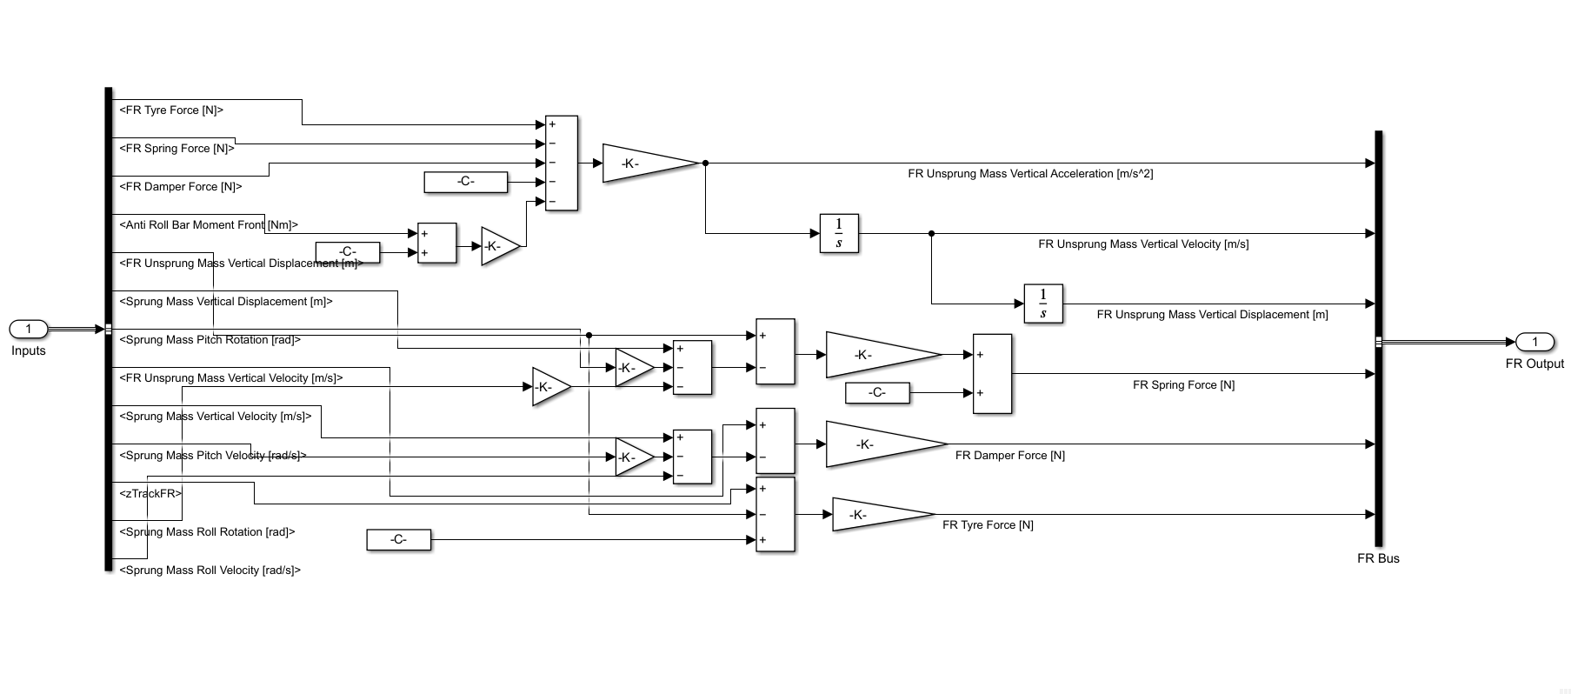

* 1. RL:

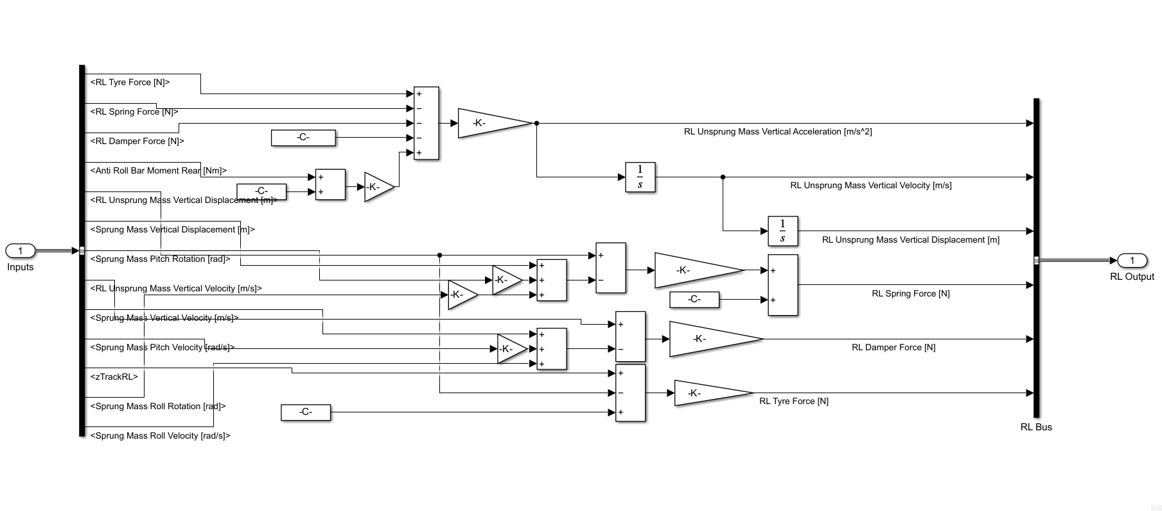

* 1. RR:

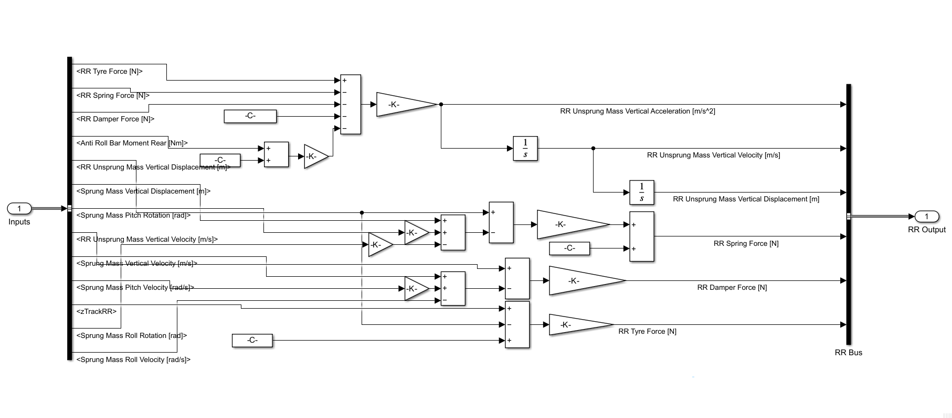

* 1. ARB F & R:

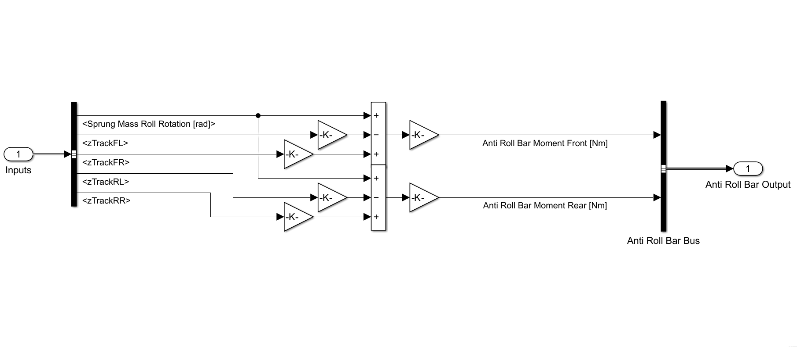

* 1. Aero:

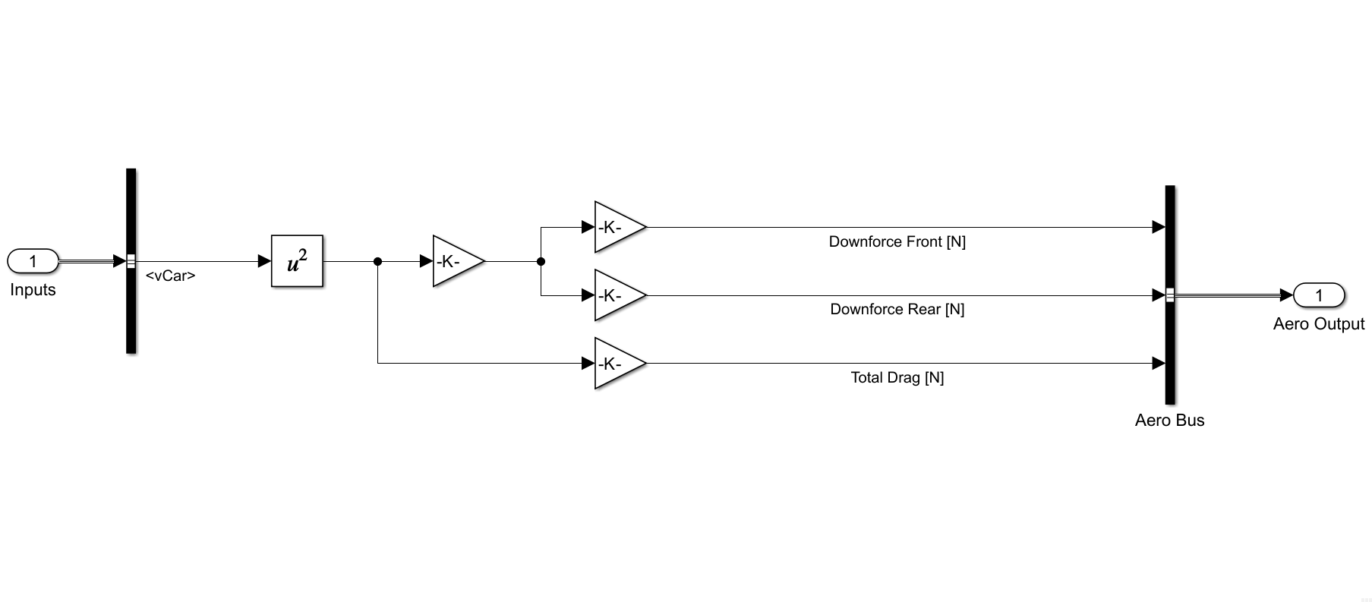

1. Model Verification Steps:
   1. Static Equilibrium:

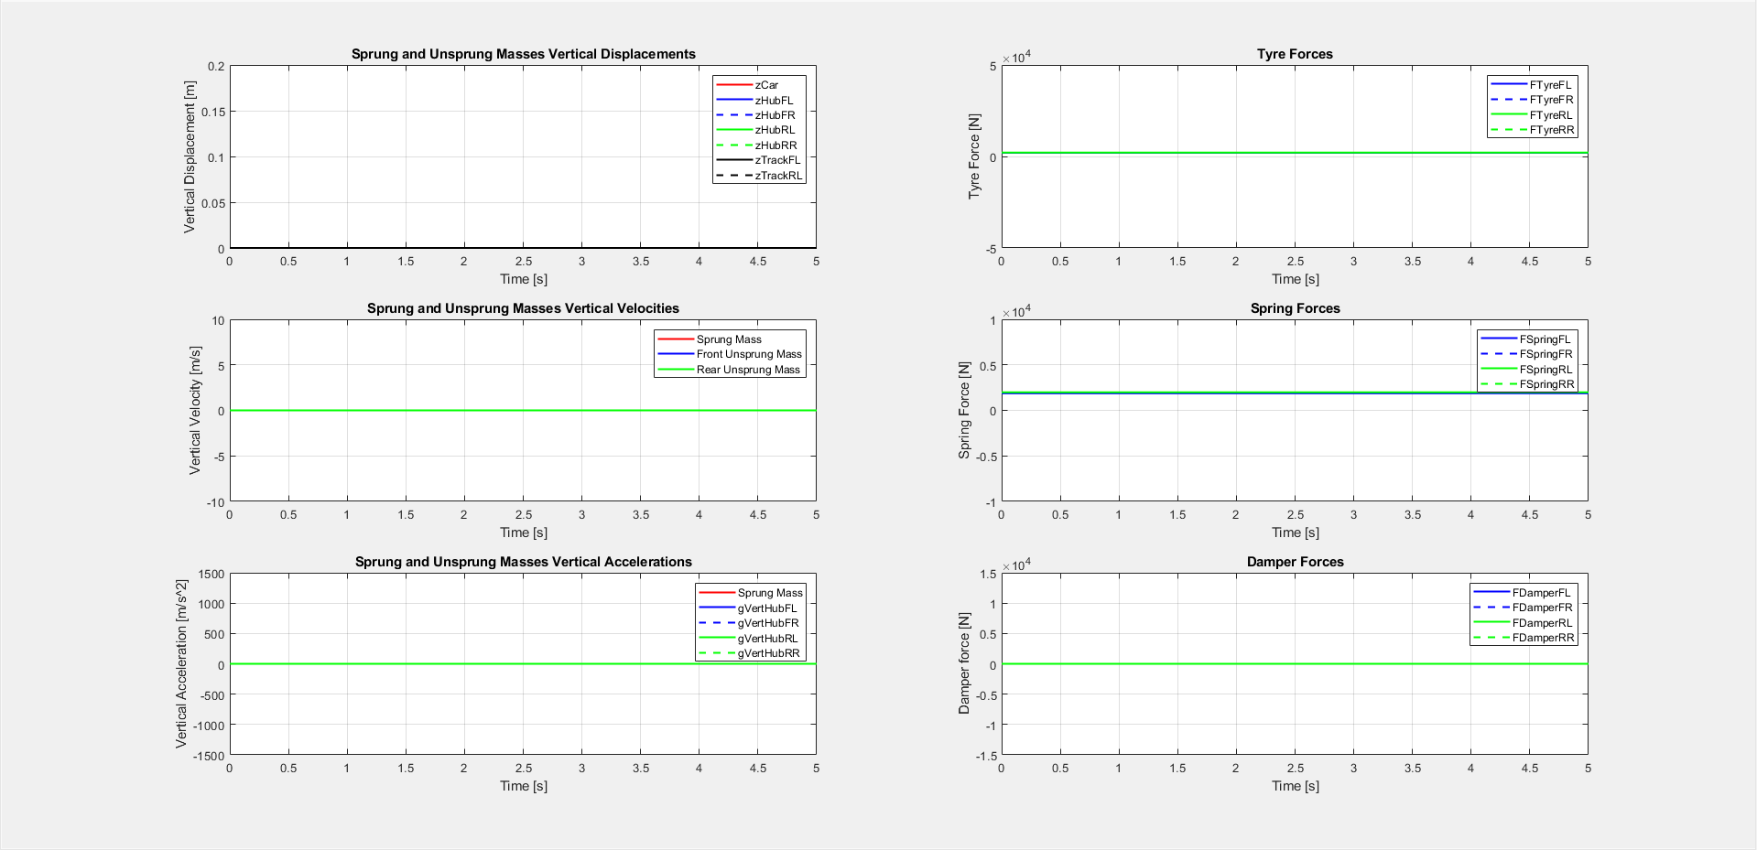

* 1. Aero Forces:

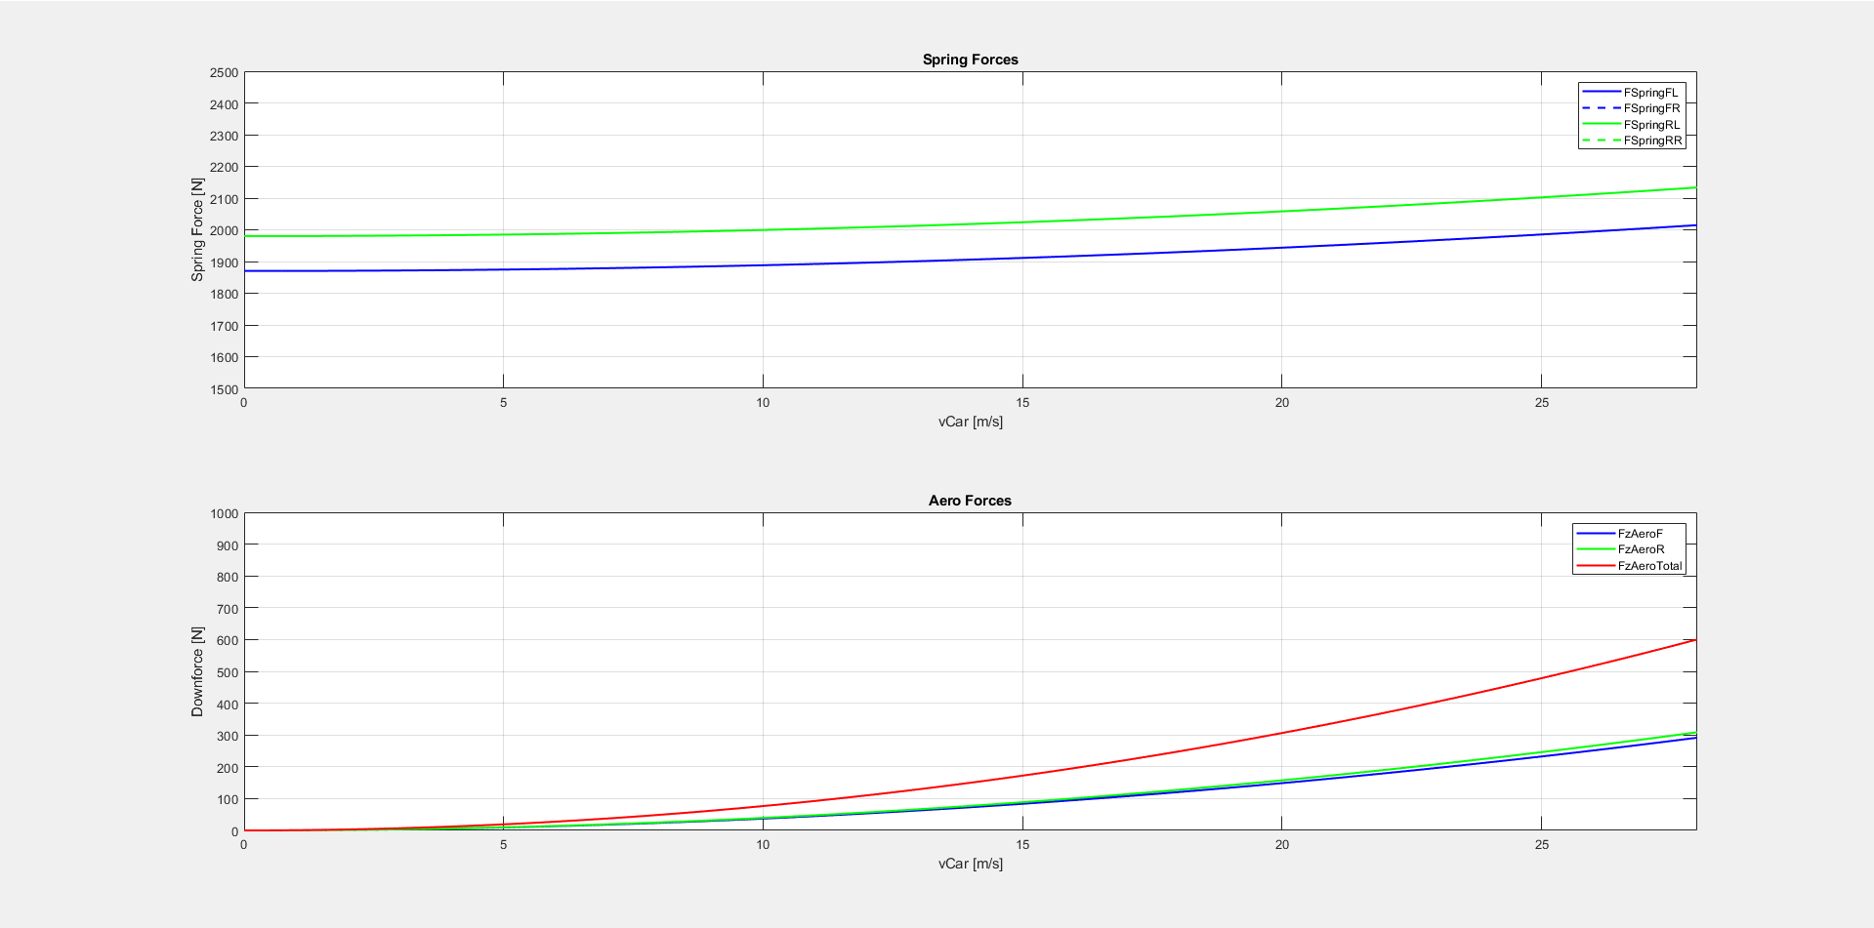

* 1. Lateral Load Transfer

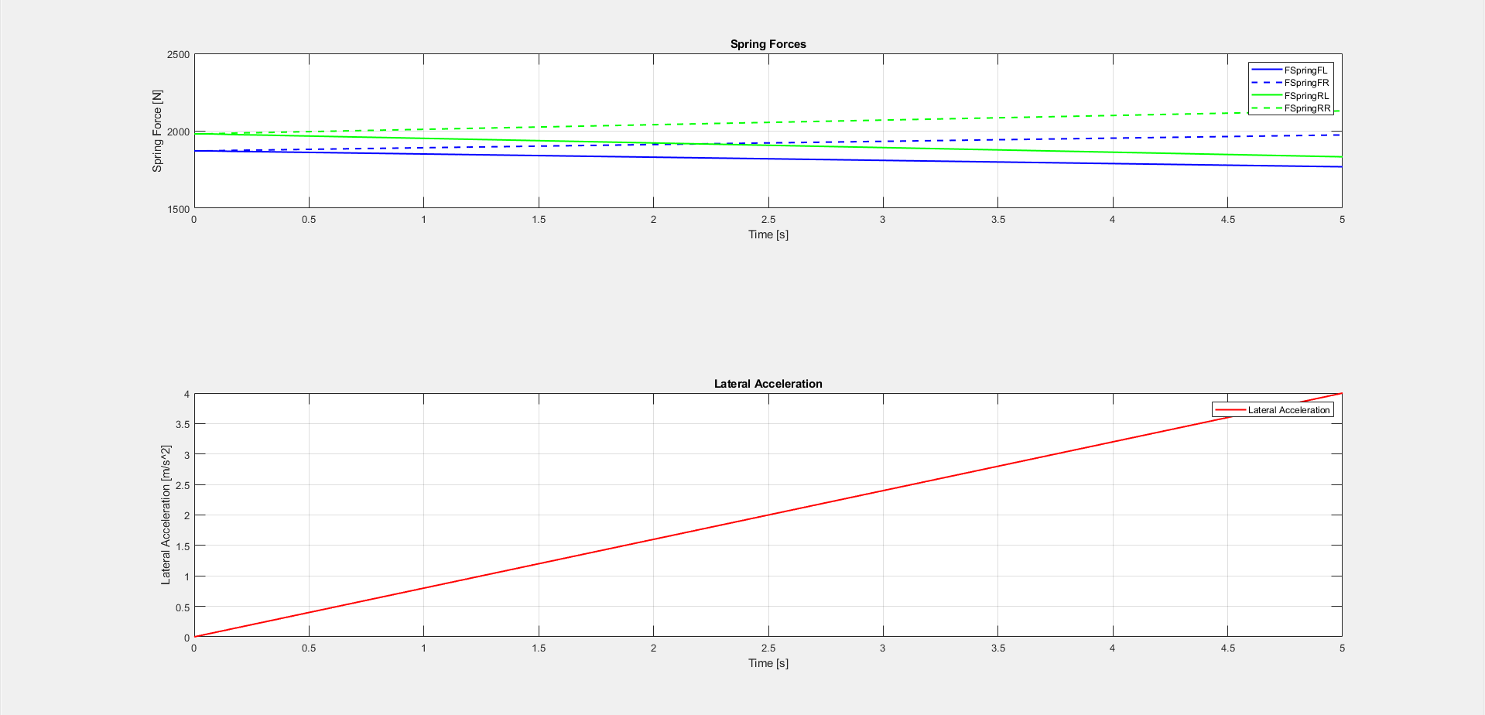

* 1. Wheel Hop Natural Frequencies in Heave

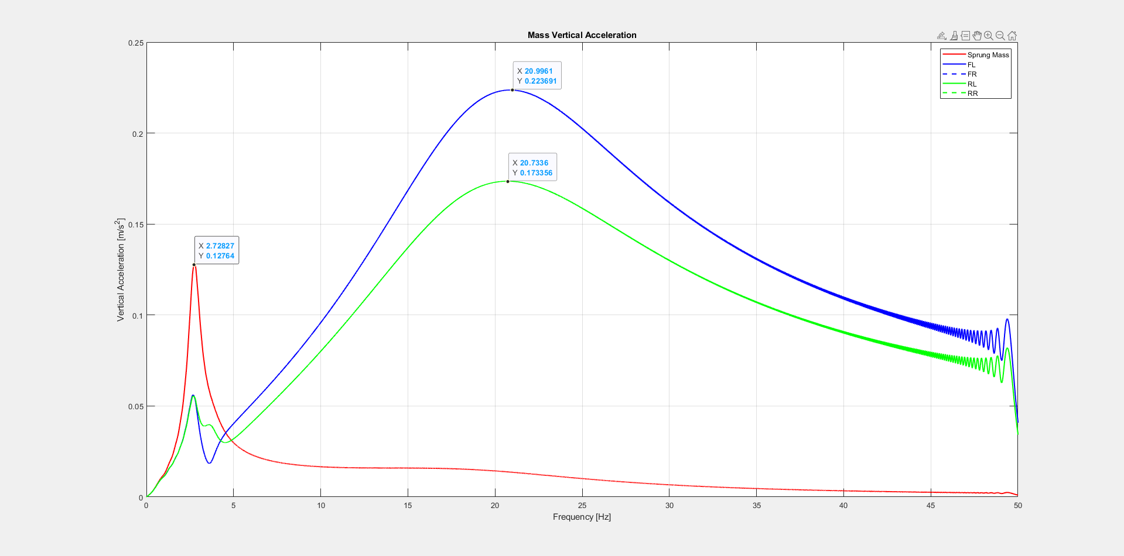

% Ride Frequency Front Left [Hz]

postsim.f_rideFL = (2*pi)^-1*(suspension.k_springFL/(chassis.m_s/2 * (chassis.b / chassis.L)))^(1/2);

% Wheel Hub Frequency Front Left [Hz]

postsim.f_hubFL = (2*pi)^-1*((suspension.k_tyreFL+suspension.k_springFL)/chassis.m_usFL)^(1/2);

% Critical Damping Front Left [Ns/m]

postsim.c_criticalFL = 2*(suspension.k_springFL*(chassis.m_s/2 * (chassis.b / chassis.L)))^(1/2);

% Damping Ratio Front Left [-]

postsim.c_ratioFL = suspension.c_damperFL/postsim.c_criticalFL;

% Ride Frequency Rear Left [Hz]

postsim.f_rideRL = (2*pi)^-1*(suspension.k_springRL/(chassis.m_s/2 * (chassis.a / chassis.L)))^(1/2);

% Wheel Hub Frequency Rear Left [Hz]

postsim.f_hubRL = (2*pi)^-1*((suspension.k_tyreRL+suspension.k_springRL)/chassis.m_usRL)^(1/2);

% Critical Damping Rear Left [Ns/m]

postsim.c_criticalRL = 2*(suspension.k_springRL*(chassis.m_s/2 * (chassis.a / chassis.L)))^(1/2);

% Damping Ratio Rear Left [-]

postsim.c_ratioRL = suspension.c_damperRL/postsim.c_criticalRL;

