1. Front Spring Rate [N/m] @ Front Ride Frequency = 3.00 [Hz}:
   1. f_rideF = (2*pi)^-1*(suspension.k_springF/(chassis.m_s * (chassis.b / chassis.L)))^(1/2);
      1. chassis.m_s = 850 [kg];
      2. chassis.L = 3.5 [m];
      3. chassis.b = 1.7 [m];
      4. f_rideF = 3 [Hz];
      5. **suspension.k_springF = 146,000 [N/m];**
2. Rear Spring Rate [N/m] @ Rear Ride Frequency = 3.60 [Hz}:
   1. f_rideR = (2*pi)^-1*(suspension.k_springR/(chassis.m_s * (chassis.a / chassis.L)))^(1/2);
      1. chassis.m_s = 850 [kg];
      2. chassis.L = 3.5 [m];
      3. chassis.a = 1.8 [m];
      4. f_rideF = 3.60 [Hz];
      5. **suspension.k_springR = 223,000 [N/m];**
3. Front and Rear Springs Pre Loads [N]:
   1. suspension.F0F = chassis.m_s * (chassis.b / chassis.L) * constants.g;
   2. suspension.F0R = chassis.m_s * (chassis.a / chassis.L) * constants.g;
      1. chassis.m_s = 850 [kg];
      2. chassis.L = 3.5 [m];
      3. chassis.b = 1.7 [m];
      4. chassis.a = 1.9 [m]
      5. constants.g = 9.81 [m/s^2];
      6. **suspension.F0F = 4050.1 [N];**
      7. **suspension.F0R = 4288.4 [N];**
4. Front Damping Coefficient [Ns/m] @ Damping Ratio = 0.2 [-]:
   1. c_ratioF = suspension.c_damperF/c_criticalF;
      1. c_criticalF = 2*(suspension.k_springF*(chassis.m_s * (chassis.b / chassis.L)))^(1/2);
      2. suspension.k_springF = 146,000 [N];
      3. chassis.m_s = 850 [N];
      4. chassis.L = 3.5 [m];
      5. chassis.b = 1.7 [m];
      6. c_criticalF = 1552.8 [Ns/m];
      7. **suspension.c_damperF = 3100 [Ns/m];**
5. Rear Damping Coefficient [Ns/m] @ Damping Ratio = 0.2 [-]:
   1. c_ratioR = suspension.c_damperR/c_criticalR;
      1. c_criticalR = 2*(suspension.k_springF*(chassis.m_s * (chassis.a / chassis.L)))^(1/2);
      2. suspension.k_springR = 223,000 [N];
      3. chassis.m_s = 850 [N];
      4. chassis.L = 3.5 [m];
      5. chassis.a = 1.8 [m];
      6. c_criticalR = 1974.7 [Ns/m];
      7. **suspension.c_damperR = 4000 [Ns/m];**
6. Front and Rear Wheel Hub Frequencies [Hz];
   1. f_hubF = (2*pi)^-1*((suspension.k_tyreF+suspension.k_springF)/chassis.m_usF)^(1/2);
      1. suspension.k_tyreF = 400000 [N/m];
      2. suspension.k_springF = 146,000 [N/m];
      3. chassis.m_usF = 30 [kg];
      4. **f_hubF = 21.4712 [Hz];**
   2. f_hubR = (2*pi)^-1*((suspension.k_tyreR+suspension.k_springR)/chassis.m_usR)^(1/2);
      1. suspension.k_tyreR = 400000 [N/m];
      2. suspension.k_springR = 223,000 [N/m];
      3. chassis.m_usR = 35 [kg];
      4. **f_hubR = 21.2339 [Hz];**
7. Heave Natural Frequency [Hz];
   1. **2.73 Hz;**

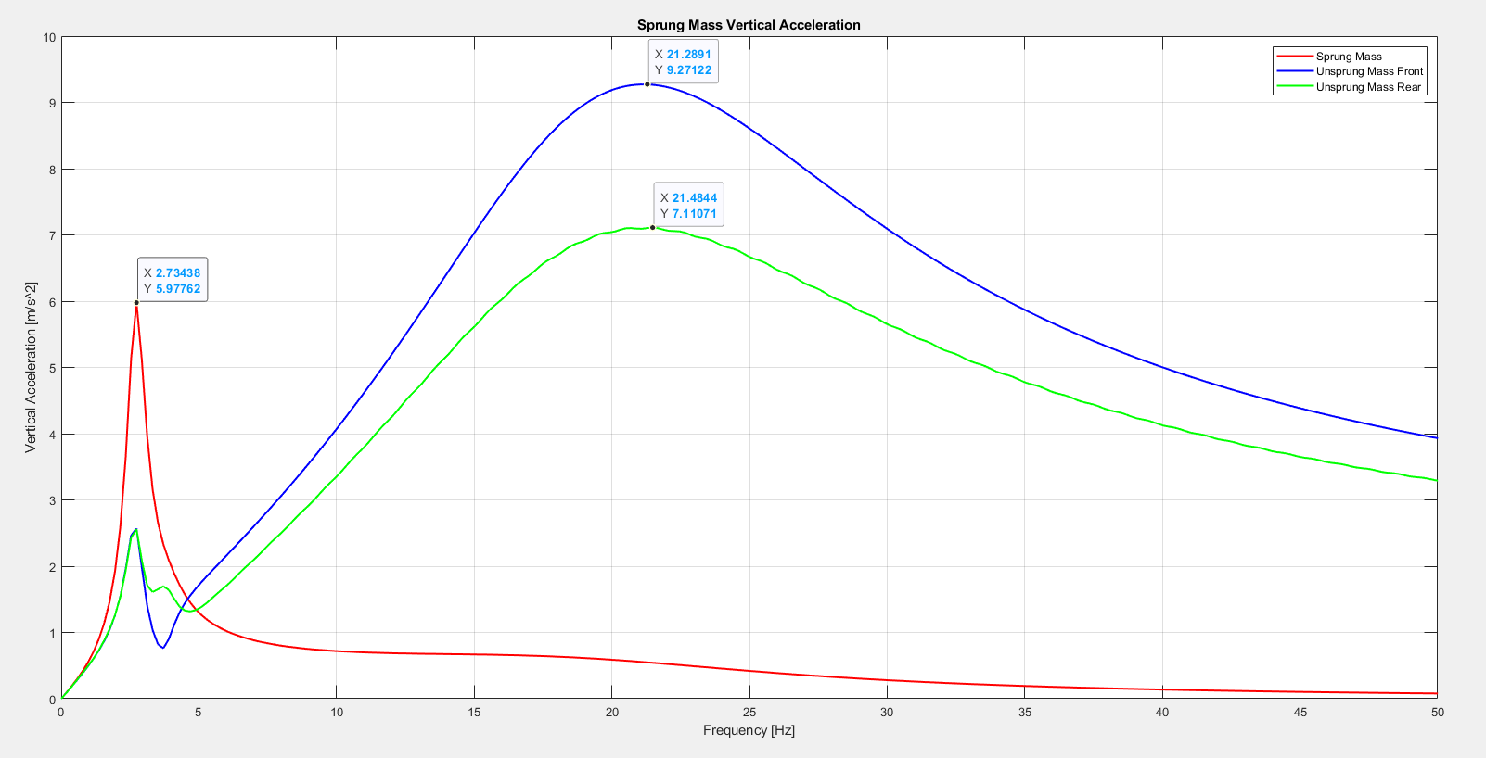

1. Pitch Natural Frequency [Hz];
   1. **3.71 Hz;**

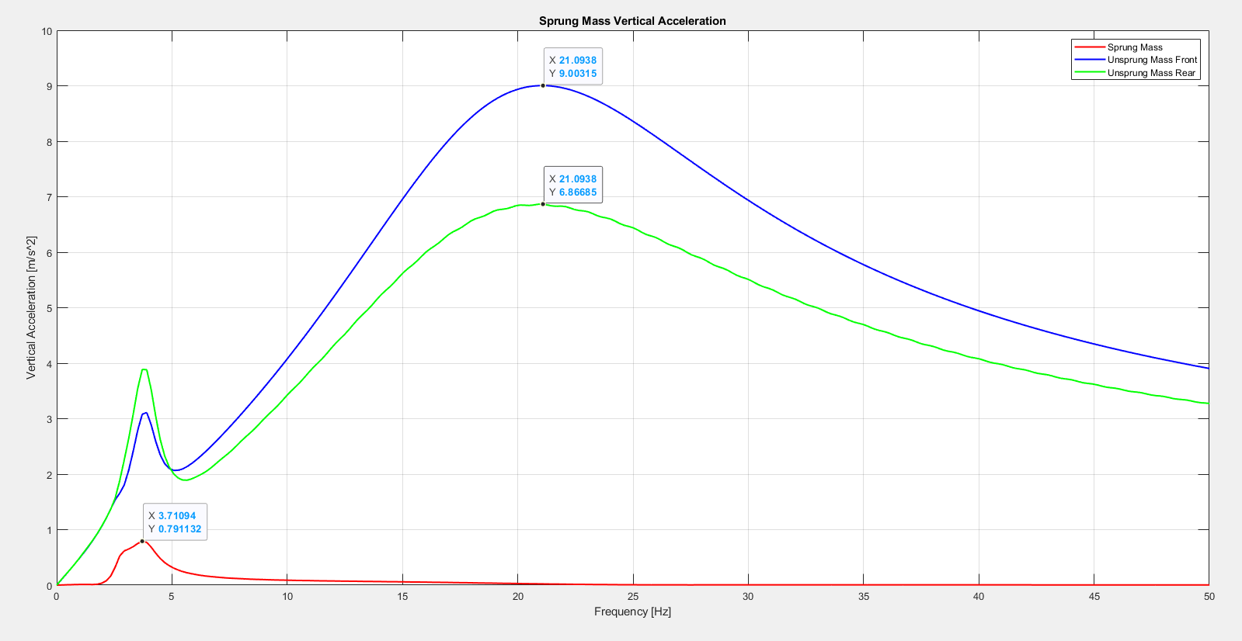

1. Front and Rear Wheel Hub Frequencies [Hz];
   1. Heave:
      1. **Front Wheel Hub Frequency FFT = 21.29 [Hz]**
      2. **Rear Wheel Hub Frequency FFT = 21.48 [Hz]**
      3. **Front Wheel Hub Frequency Calculated = 21.47 [Hz]**
      4. **Rear Wheel Hub Frequency Calculated = 21.23 [Hz]**
   2. Pitch:
      1. **Front Wheel Hub Frequency FFT = 21.09 [Hz]**
      2. **Rear Wheel Hub Frequency FFT = 21.48 [Hz]**
      3. **Front Wheel Hub Frequency Calculated = 21.47 [Hz]**
      4. **Rear Wheel Hub Frequency Calculated = 21.23 [Hz]**