**Braking from 300km/h to 180km/h**

* CAero = 1.00:
  + V_initial = 300 km/h @ 1 s;
  + V_final = 180 km/h @ 3.52 s;
  + Braking_time = 2.52 s;
  + Braking_distance = 167.47 m;
  + Braking_acceleration (AVG) = -13.227 m/s^2;
* CAero = 1.50:
  + V_initial = 300 km/s @ 1 s;
  + V_final = 180 km/h @ 3.38 s;
  + Braking_time = 2.38 s;
  + Braking_distance = 157.99 m;
  + Braking_acceleration (AVG) = -14.006 m/s^2;
* General comments:
  + The vehicle with 50% higher aerodynamics forces is able to brake from 300 km/h to 180 km/h 0.14s quicker than the original vehicle and takes 9.48 m less in distance, which means that the driver can delay its braking point 10 m into the corner.
  + Not a massive difference in terms of braking points, however in extreme circumstances could be enough to enable the driver to overtake under braking.

**Braking from 180 km/h to 100 km/h**

* CAero = 1.00:
  + V_initial = 180 km/h @ 1 s;
  + V_final = 100 km/h @ 3.13 s;
  + Braking_time = 2.13 s;
  + Braking_distance = 82.93 m;
  + Braking_acceleration (AVG) = -10.433 m/s^2;
* CAero = 1.50:
  + V_initial = 180 km/s @ 1 s;
  + V_final = 100 km/h @ 3.06 s;
  + Braking_time = 2.06 s;
  + Braking_distance = 79.92 m;
  + Braking_acceleration (AVG) = -10.787 m/s^2;
* General comments:
  + The vehicle with 50% higher aerodynamics forces is able to brake from 180 km/h to 100 km/h 0.07s quicker than the original vehicle and takes 3.01 m less in distance, which means that the driver can delay its braking point 3 m into the corner.
  + Even less of a difference when compared to the first case which effectively wouldn’t give the driver great advantages over a single manouver.

Figure 1 – Braking from 300 km/h to 180 km/h

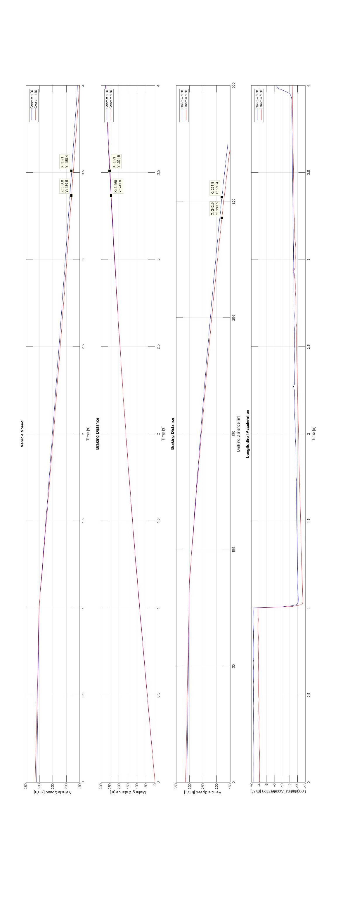

Figure 2 – Braking from 180 km/h to 100 km/h

