Here is a modified version of a group project that I recently completed for my .Net/Visual C# class. In this project, I was in charge of coding the functionality of the GUI. I took it one step further, though, and had improved upon the original design that had been presented to me by two of our group members. Here are the various screen shots, along with explanations, of what this app can do:

1. This is what the user sees once they have opened the app:

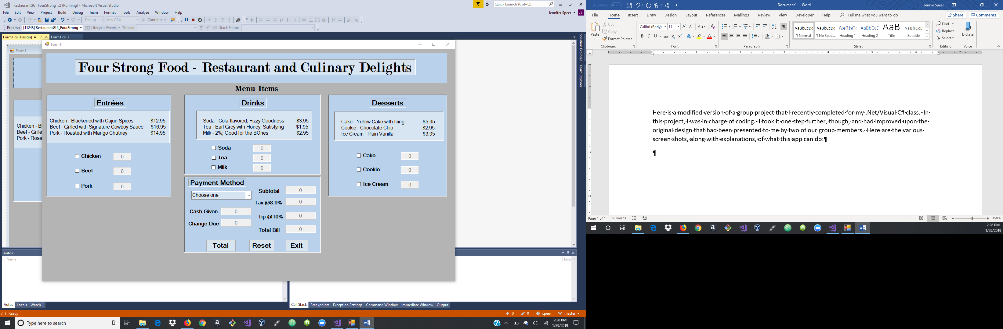

1. Upon making their selections of the various menu choices, and clicking ‘total’, this is what they will see (\*\*notice that I have ‘greyed-out’ where a user cannot enter, unless they have selected that option; the user is also not allowed to modify the subtotal, tax, tip, or total bill):

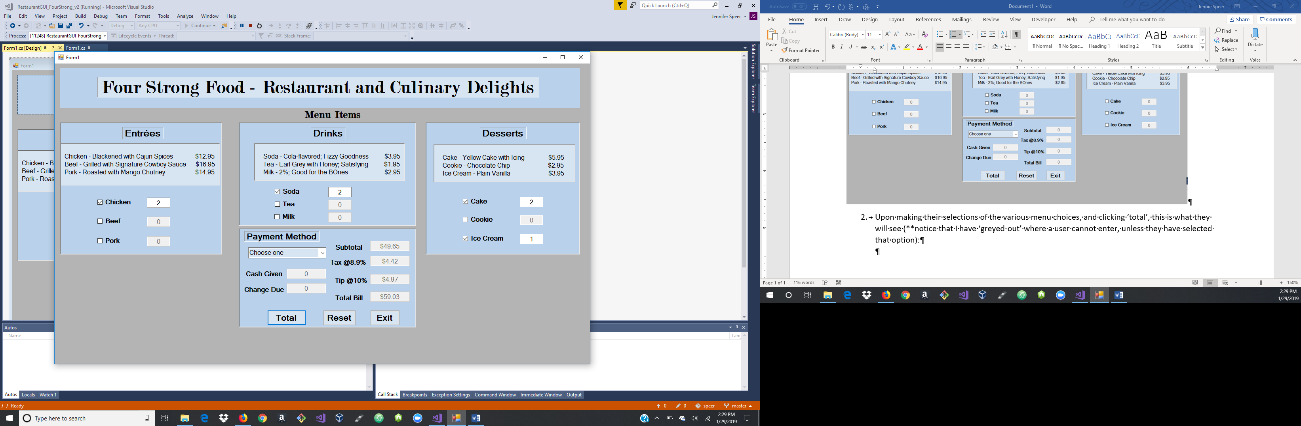

1. There are various types of payment options, but all but cash will not trigger any other functions within this app. As you can see from when ‘cash’ is selected, the user can now enter an amount of ‘cash given’. Once the ‘total’ has been clicked again, it calculates the amount of ‘change due’.

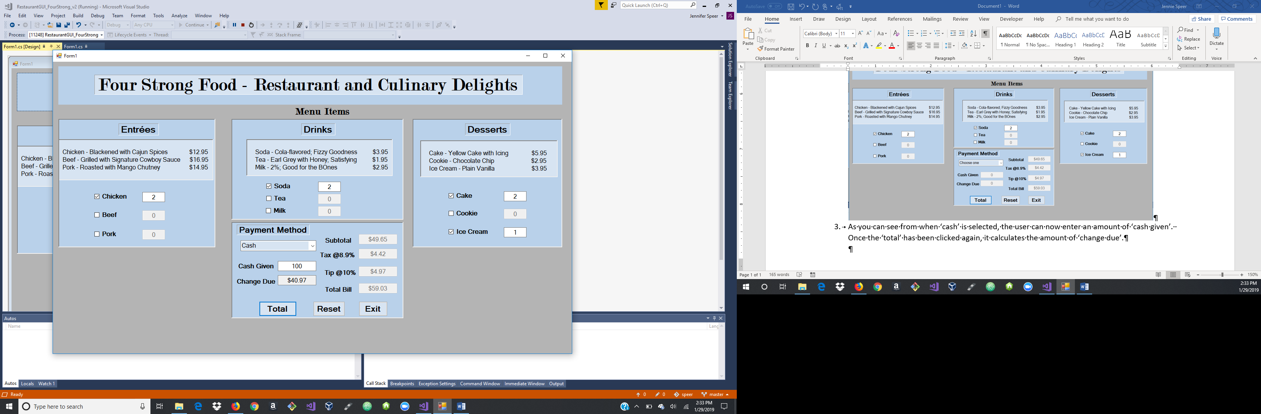

1. Once reset has been clicked, all of the fields have been zeroed out:

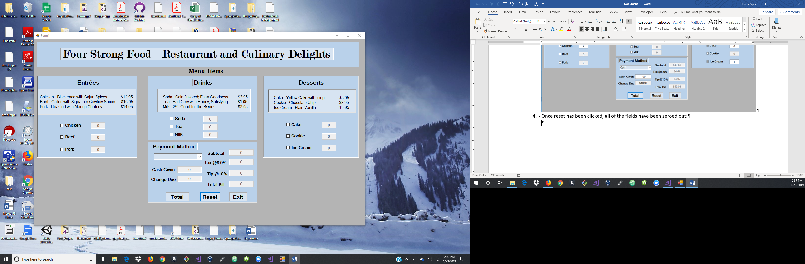

1. This pop-up prompts the user for one last click of their choice of whether or not to ‘exit the system’:

