(referencing In-n-out burger @ <http://www.in-n-out.com/> )

**HOME** page has a top menu bar with navigation options for: HISTORY, FOUNDATION, ? ?

Background image:

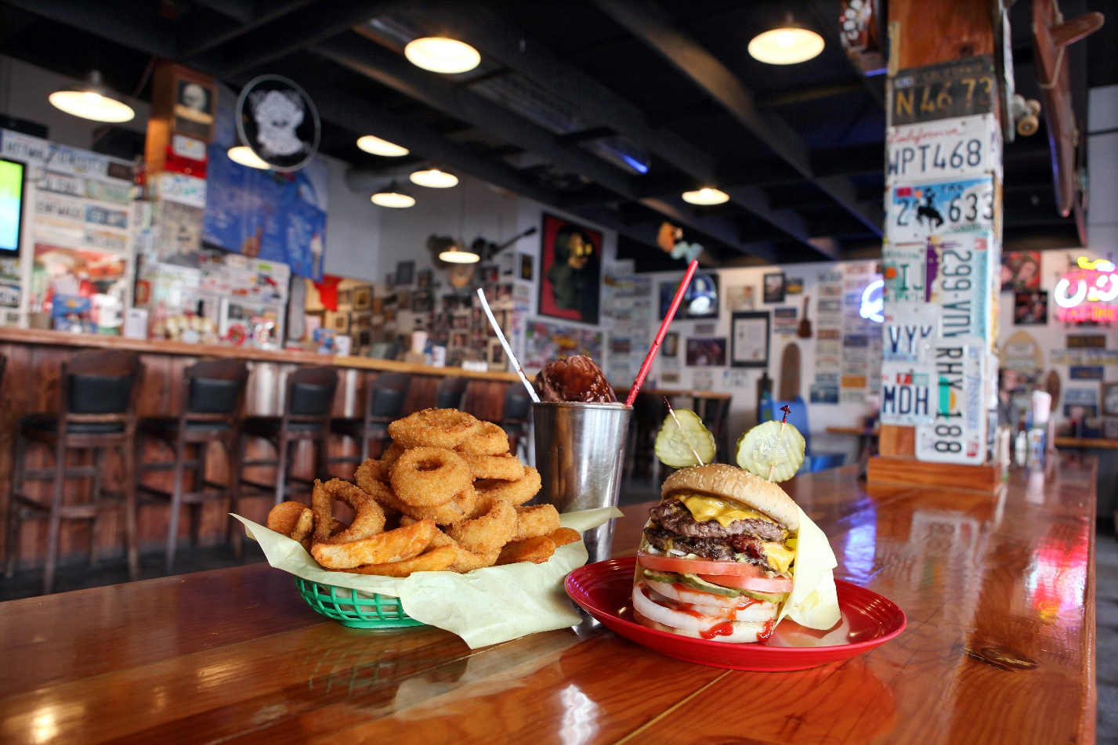

**HISTORY**

Will’s Grill was founded October 22, 1948 (69 years ago).

We are an American regional chain of fast food restaurants with locations primarily in the American Midwest. We were founded in St. Louis, Missouri in 1948 by siblings Will and Alice Grimley. Our chain is currently headquartered in Kansas City, Missouri, and has slowly expanded outside Northern Missouri into the rest of Missouri, as well as into Kansas, Iowa, Illinois and Indiana. The current owner is Lynsi Grimley, the Grimley’s only grandchild.

As our chain has expanded, it has opened several distribution centers in addition to its original St. Louis location. The new facilities, located in Witchita, Kansas; Des Moines, Iowa; Chicago, Illinois, and Indianapolis, Indiana will provide for future expansion into other parts of the country.

We have resisted franchising our operations or going public. One reason is the prospect of quality or customer consistency being compromised by excessively rapid business growth. Our company’s business practices have been noted for employee-centered personnel policies; i.e. paying their employees $11 per hour to start. The Will’s Grill restaurant chain has developed a highly loyal customer base, and has been rated as one of the top fast food restaurants in several customer satisfaction surveys.

**FOUNDATION**: [https://www.slave2nothing.org/](https://www.slave2nothing.org/)

Will’s Grill donates a portion of their sales to the Slave 2 Nothing Foundation to open paths to freedom for those who are enslaved by any person or substance.

**Help us set them free.**

Visit SLAVE2NOTHING.ORG (this is where the hyperlink goes)

<script>

document.write("All content of this website is subject to copyright ©2018");

</script>