BSU RootCrops Research Portal
User Manual
Generated from the local IIS deployment on April 28, 2026.
This manual explains the main screens, roles, and common workflows for daily use of the system.

System Access
- Open the system in a modern browser using the URL provided by the administrator.
- Public users can browse approved public records from Home, Research Library, and Research Assistant.
- Logged-in researchers can submit and manage their own work in My Workspace.
- Administrators can review submissions, import data, manage users, view the masterlist, and audit system logs.

User Roles
- Guest: can browse public approved research and use public search tools.
- Researcher/User: can log in, submit research, track submissions, edit own records, and respond to rejection remarks.
- Administrator: can perform all researcher tasks plus approvals, imports, user management, masterlist maintenance, and log review.

General Navigation
- Use the left sidebar to move between screens.
- Use the bell icon for notifications when available.
- Use Settings to update account details and Logout to end the session.

Feature Guide

1. Login
Use the login screen to access protected researcher and administrator tools.
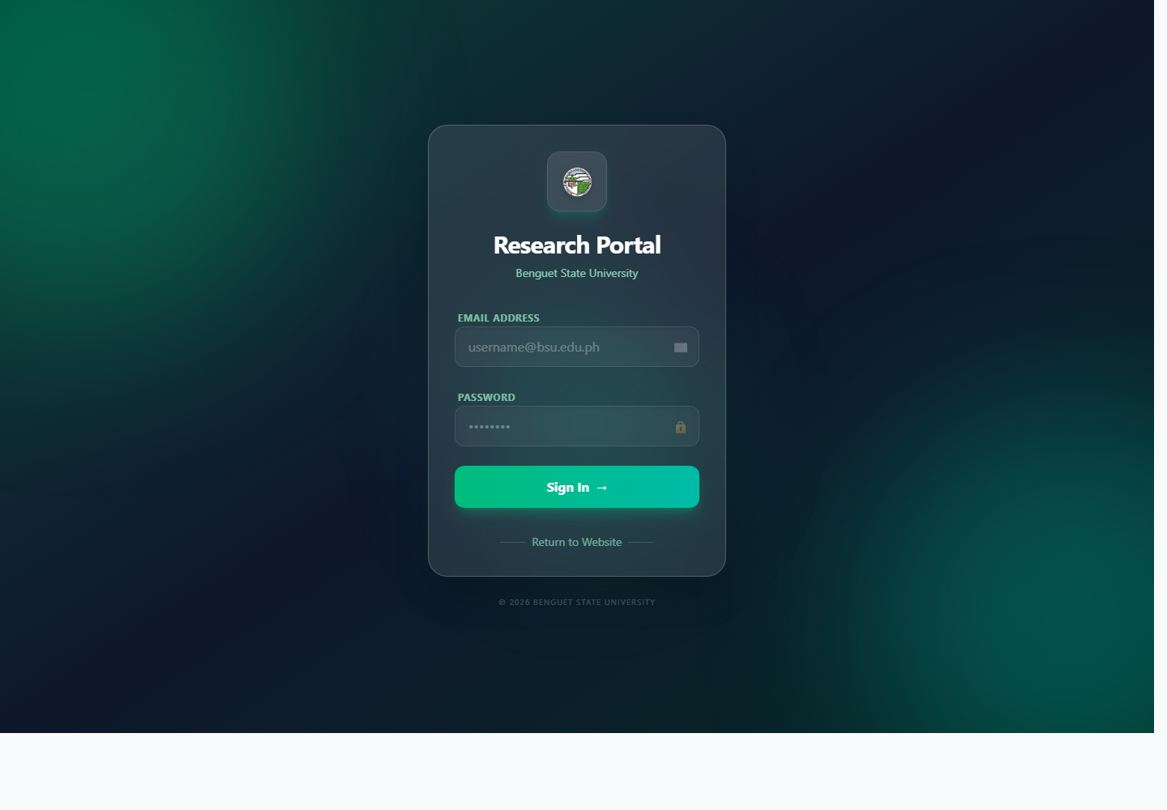
Screenshot: Login

How to use it
- Open the system URL in a browser.
- Enter the email address assigned by the administrator.
- Enter the password and select Sign In.
- If an administrator reset your password, follow the forced password-change prompt before continuing.

Notes
- Use Logout from the left sidebar when using a shared computer.
- If login fails repeatedly, wait for the rate limit to clear or contact an administrator.

2. Home Dashboard
The dashboard gives a quick overview of the research portal, recent system activity, and upcoming deadlines.
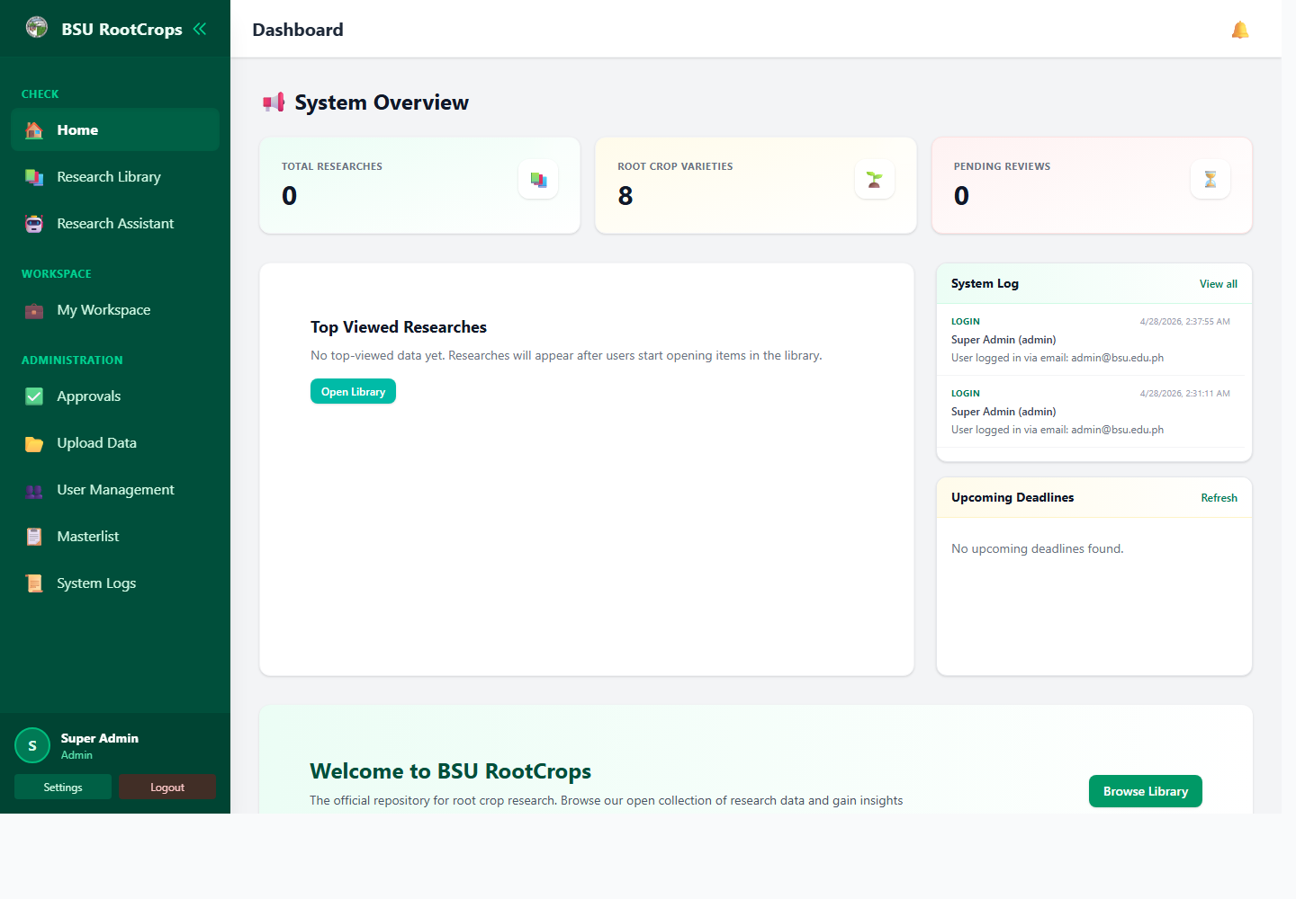
Screenshot: Home Dashboard

How to use it
- Review the summary cards for total researches, root crop varieties, and pending reviews.
- Use Open Library or Browse Library to move directly to the public research collection.
- Administrators can review the System Log widget for recent activity.
- Use the left sidebar to move between feature areas.

Notes
- The sidebar shows extra administration links only when the current account is an administrator.

3. Research Library
The Research Library is the main browsing area for approved research records.
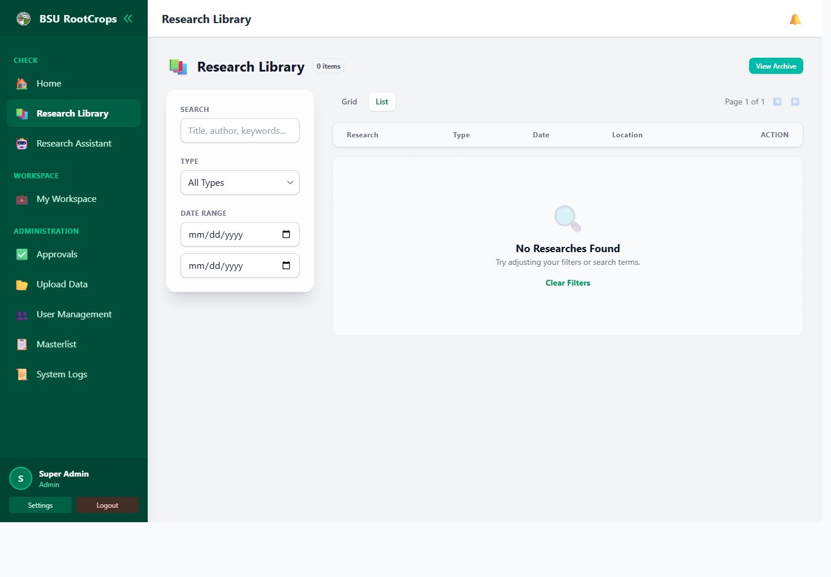
Screenshot: Research Library

How to use it
- Select Research Library from the sidebar.
- Search by title, author, subject, crop, or other metadata.
- Use available filters to narrow the result list.
- Open a record to view details and, when available, open its PDF or external link.

Notes
- Guests can see public approved records. Logged-in users may see additional private approved records depending on system rules.

4. Research Assistant
The assistant helps users search the local research database using natural language questions.
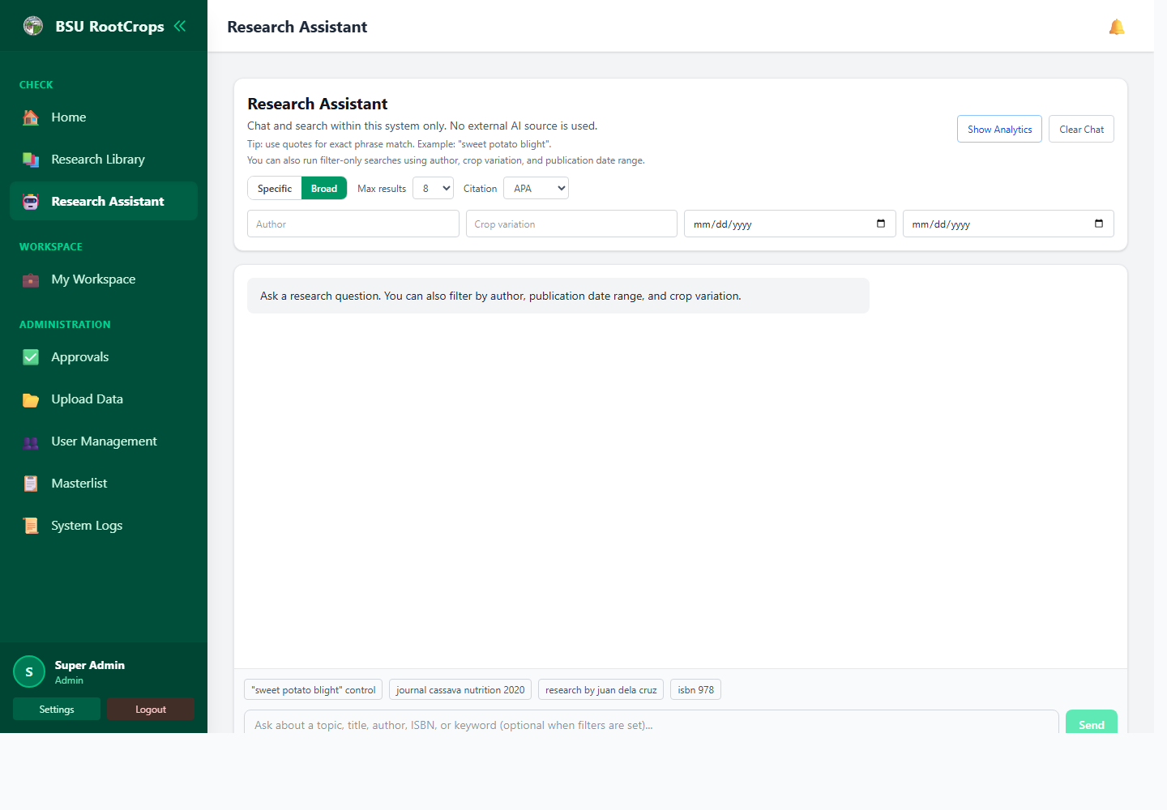
Screenshot: Research Assistant

How to use it
- Open Research Assistant from the sidebar.
- Type a question or research topic in the prompt field.
- Review the ranked results and highlighted matching text.
- Open a result, copy a citation, or submit feedback when available.

Notes
- The assistant searches local records; it is not a replacement for validating final citations and research details.

5. My Workspace
My Workspace is where logged-in users manage their own submissions.
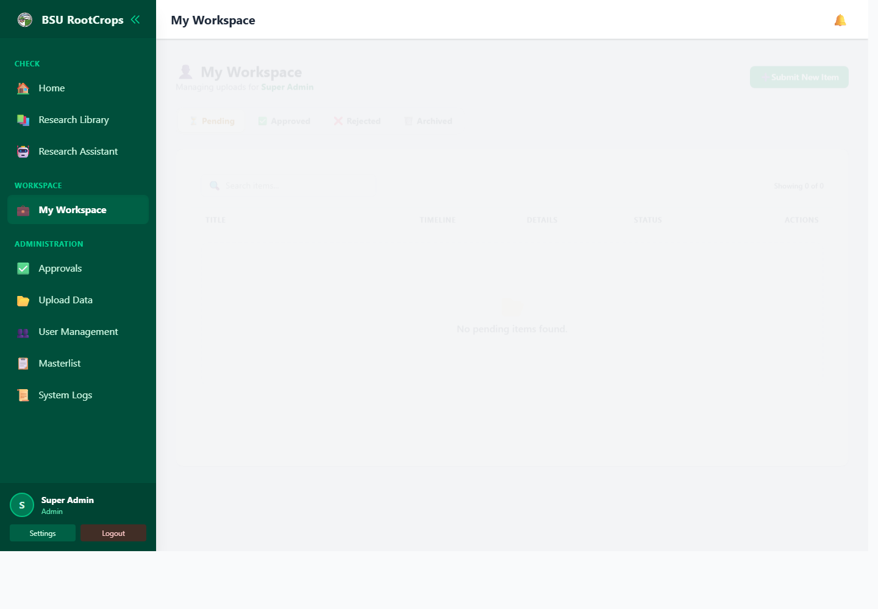
Screenshot: My Workspace

How to use it
- Select My Workspace from the sidebar.
- Create a new submission and fill in the required metadata fields.
- Attach a PDF when available, then submit for review.
- Monitor the status of submissions: pending, approved, rejected, or archived.
- For rejected submissions, edit the record and resubmit after addressing administrator remarks.

Notes
- Only the uploader or an administrator should be able to edit a submitted research item.

6. Approvals and Rejections
Administrators use Approvals to review pending submissions and manage rejected items.
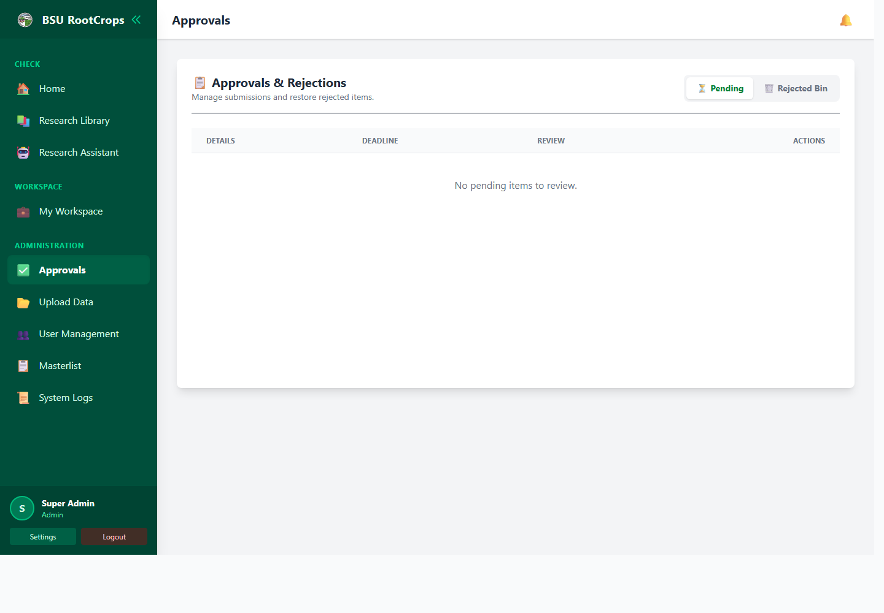
Screenshot: Approvals and Rejections

How to use it
- Open Approvals from the Administration section.
- Review each pending submission and its metadata/PDF before deciding.
- Select Approve to publish a valid submission.
- Select Reject to return the submission with remarks for the uploader.
- Use the Rejected Bin tab to review or restore rejected items when appropriate.

Notes
- Approval makes the research visible according to its access level. Rejection should include clear remarks.

7. Upload Data
Upload Data supports administrator imports for CSV records and bulk PDF matching.
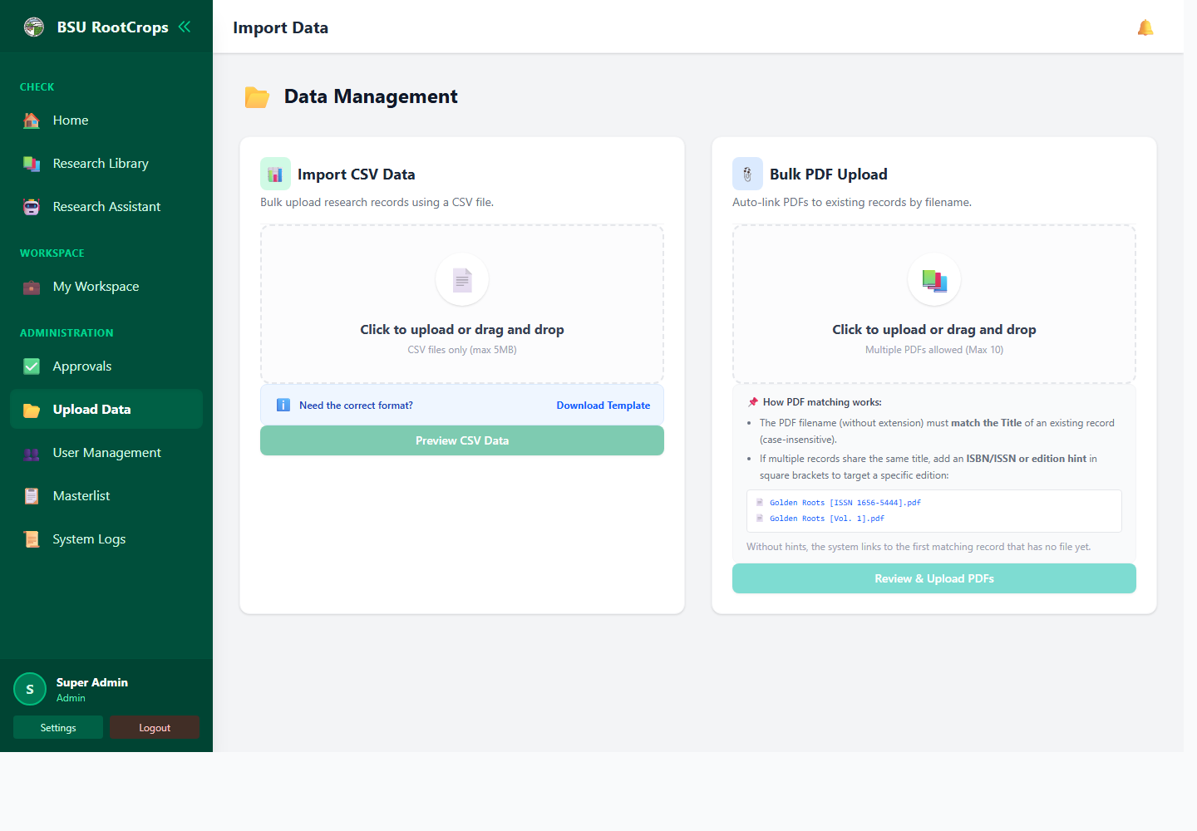
Screenshot: Upload Data

How to use it
- Open Upload Data from the Administration section.
- For CSV import, choose the CSV file and preview rows before committing the import.
- Review duplicate warnings and skipped rows before final upload.
- For bulk PDF upload, choose up to the allowed number of PDF files and preview matches.
- Confirm upload so matched PDFs are encrypted and attached to existing records.

Notes
- Use the official CSV format. Large or malformed files may be rejected.

8. User Management
Administrators use User Management to create accounts, reset passwords, and disable or enable users.
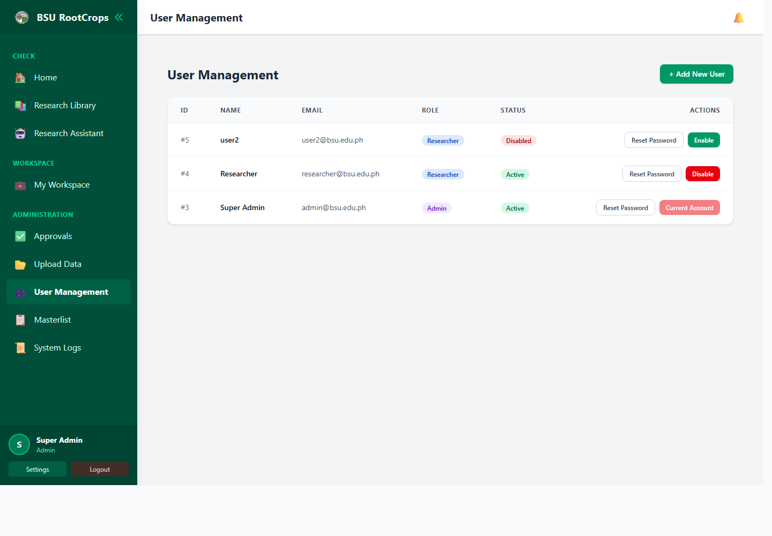
Screenshot: User Management

How to use it
- Open User Management from the Administration section.
- Create a user by entering name, email, password, and role.
- Use Reset Password when a user can no longer access the system.
- Disable an account to prevent further login without deleting its historical activity.

Notes
- After a password reset, the user should change the temporary password at next login.
- Keep at least one enabled administrator account.

9. Masterlist
The Masterlist is the administrator view of all research records across statuses.
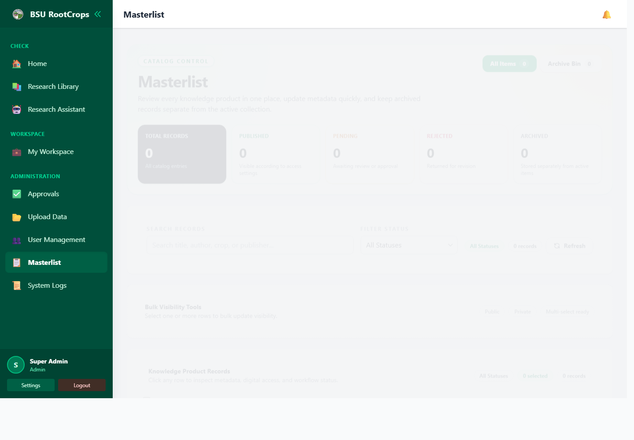
Screenshot: Masterlist

How to use it
- Open Masterlist from the Administration section.
- Search, filter, and inspect records across approved, pending, rejected, and archived states.
- Open a record to check metadata, PDF status, comments, and visibility.
- Edit metadata or visibility when corrections are needed.
- Archive records that should no longer appear in active lists.

Notes
- Use bulk visibility changes carefully because they can affect many records at once.

10. System Logs
System Logs help administrators audit important actions such as login, imports, approvals, and user changes.
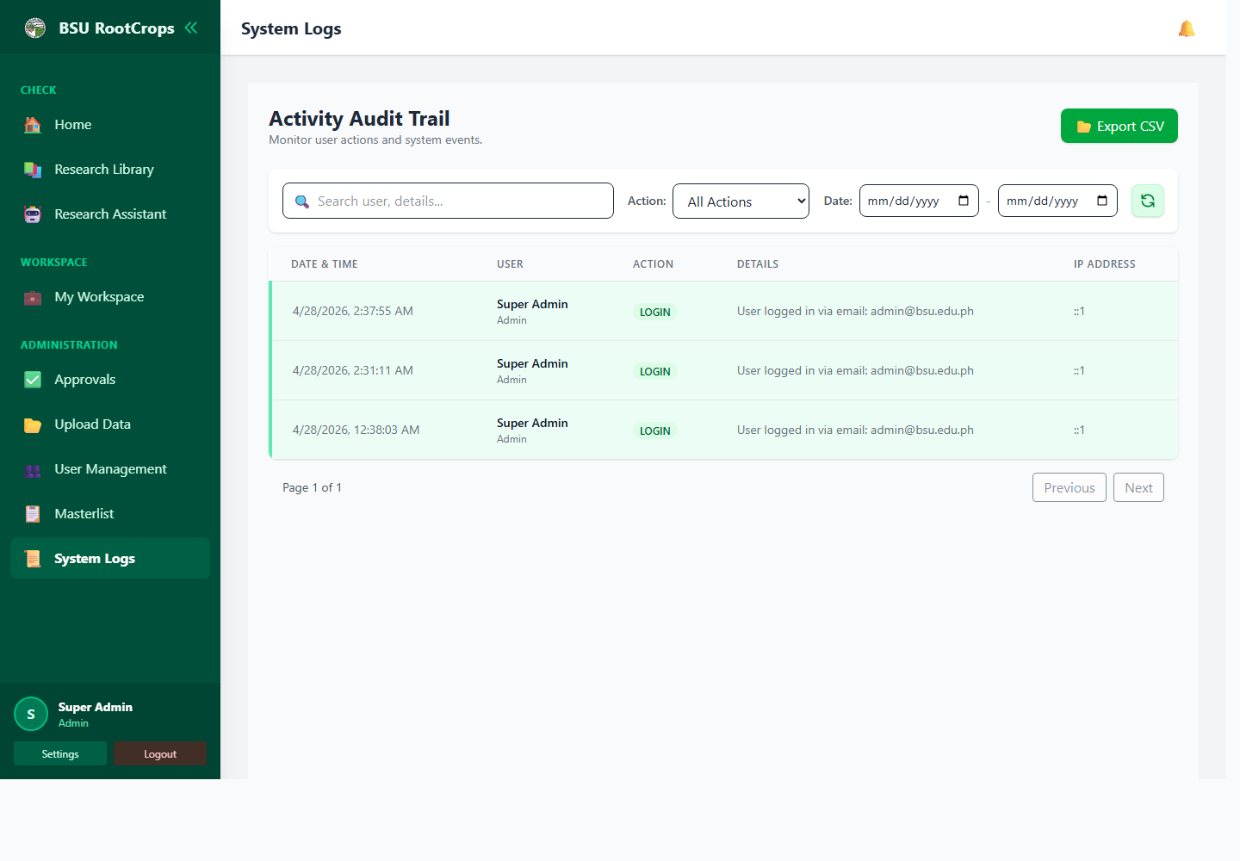
Screenshot: System Logs

How to use it
- Open System Logs from the Administration section.
- Filter by action, keyword, or date range.
- Review user, role, action details, IP address, and timestamp.
- Export logs when a copy is needed for reporting or investigation.

Notes
- Logs should be reviewed when investigating suspicious behavior or accidental changes.

11. Settings
Settings lets the current user update profile information and change their password.
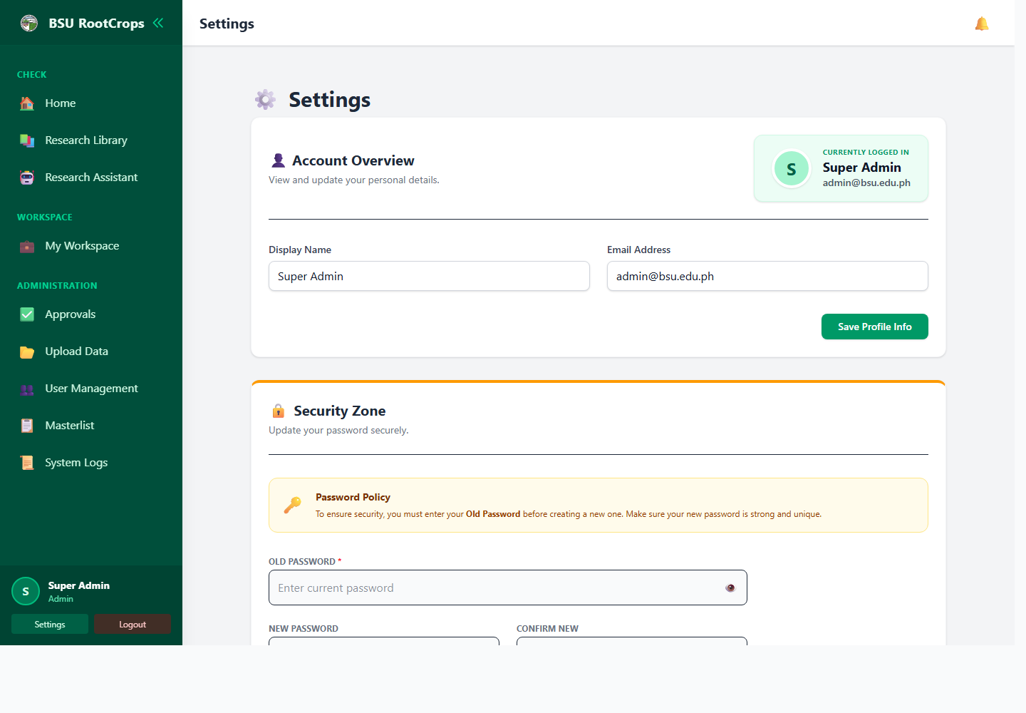
Screenshot: Settings

How to use it
- Open Settings from the bottom of the sidebar.
- Update display name or email address, then save profile changes.
- To change password, enter the current password and the new password twice.
- Use a strong password and sign out when finished on a shared device.

Notes
- Password changes require the current password to prevent unauthorized changes from an unattended session.

Daily Operating Checklist
- Use administrator accounts only for administrator work.
- Review pending submissions regularly.
- Check System Logs when unexpected changes occur.
- Back up the database and encrypted uploaded files before major maintenance.
- Keep deployment secrets, encryption keys, and database backups outside public web folders.

