BSU RootCrops Research Portal
Complete User Manual
Separate guide for public users, researchers, and administrators in one manual.
Includes step-by-step how-to pages, screenshots, table of contents, and page numbering.
Updated: April 28, 2026

Table of Contents
This manual uses an automatic Word table of contents with page numbers.
Table of contents will update automatically in Microsoft Word. If page numbers are not visible, right-click here and choose Update Field.

Manual Map
Section | Best for | Main purpose
Part 1 - Everyone | Guests, researchers, admins | Login, homepage, library, assistant, and account password.
Part 2 - Researcher/User | Researchers and staff submitters | Add, edit, track, archive, and resubmit research items.
Part 3 - Administrator | Admins only | Approve submissions, import records, manage users, masterlist, and logs.
Part 4 - Help | Everyone | Common problems and simple data entry tips.

Part 1 - Everyone
These pages are for guests, researchers, and admins. Some records or actions may require login depending on your account role.

Roles and Access
Role | Can access | Cannot access
Guest | Homepage, Research Library, Research Assistant, public records. | My Workspace and admin pages.
Researcher/User | Homepage, Library, Assistant, My Workspace, Settings. | Admin approval, import, user management, masterlist, logs.
Admin | All public, researcher, and admin features. | No restriction except normal account/session security.

How to Log In
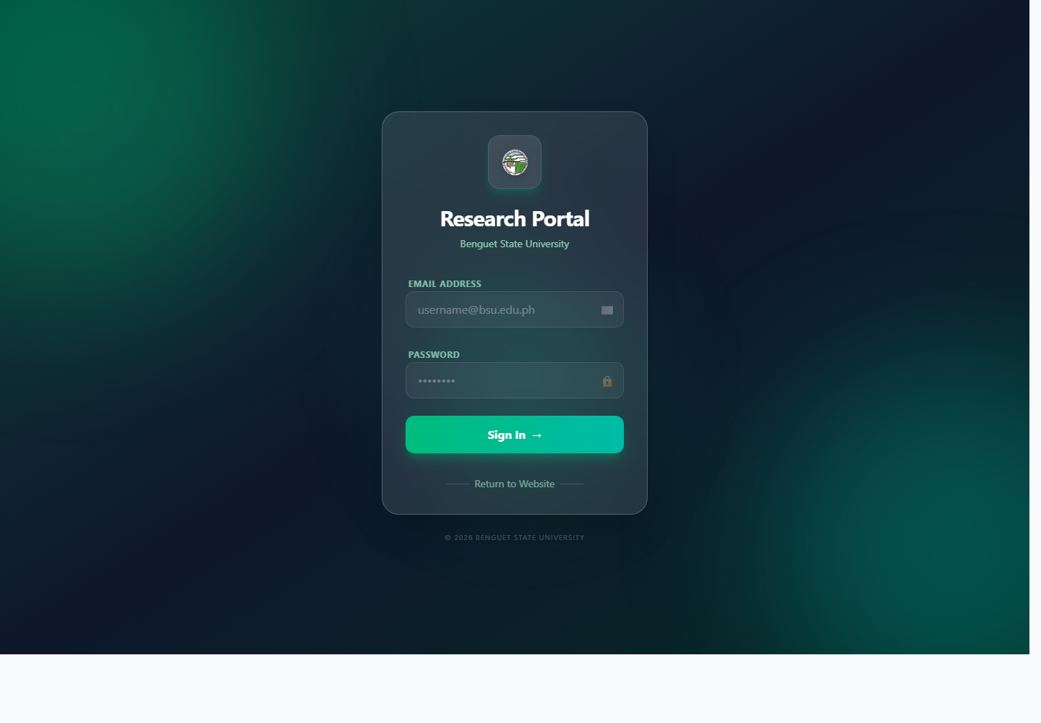
Screenshot: Login screen
1. Open the system in your browser.
2. Click Login Area if you are on the public homepage.
3. Type your email address.
4. Type your password.
5. Click Sign In.
6. Wait for the dashboard to open.
- If you enter the wrong password too many times, wait for the lockout to end before trying again.
- If you forgot your password, ask an admin to reset it.

How to Use the Homepage
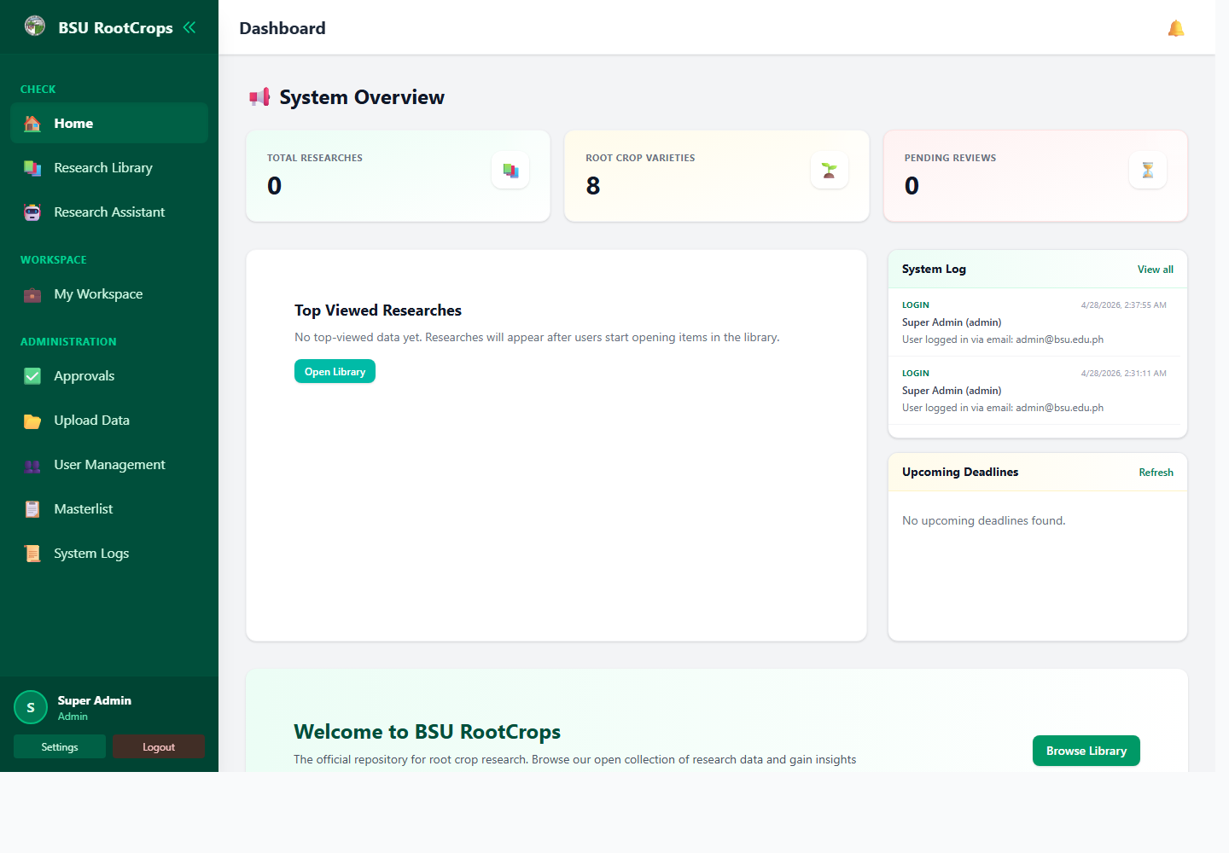
Screenshot: Home dashboard
1. Open Home from the sidebar.
2. Review the cards and summary sections.
3. Click Browse Library to go to the research collection.
4. If you are logged in, check notifications in the top-right area.
5. Admins can also use homepage cards to jump to logs, approvals, or related admin views.

How to Search in the Research Library
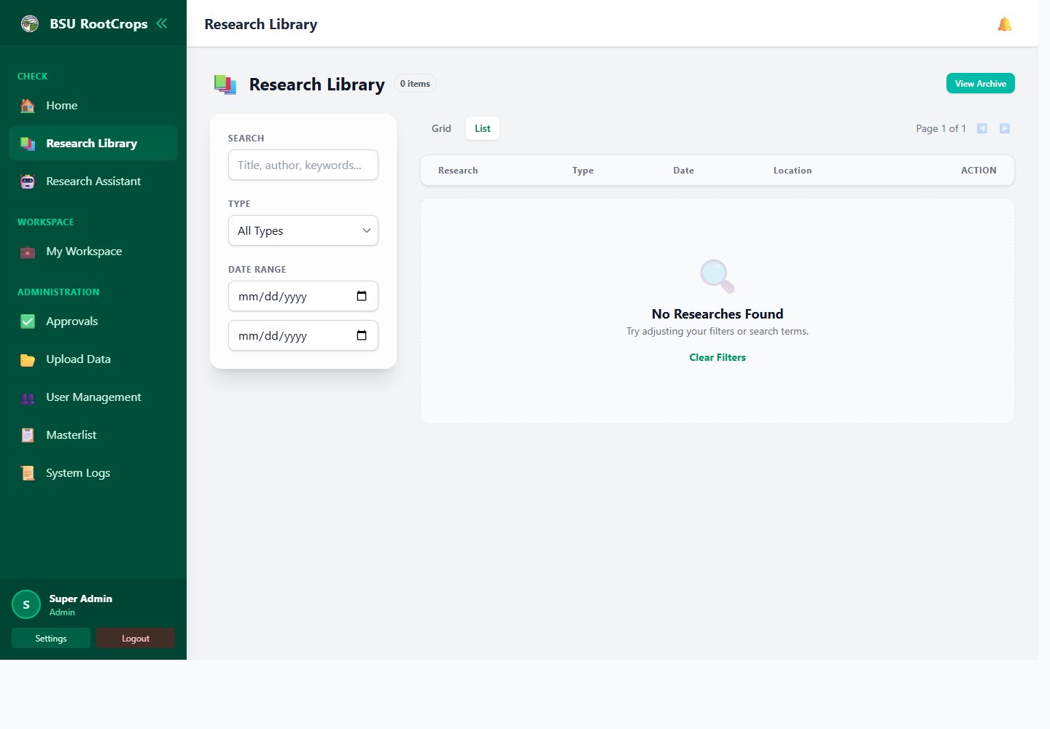
Screenshot: Research Library
1. Open Research Library.
2. Type a title, author, crop, publisher, keyword, or ISBN/ISSN in the search box.
3. Use filters when you need a more specific result.
4. Choose Grid or List view.
5. Click a record to open the details.
6. Open the PDF or external link if available.

How to Use the Research Assistant
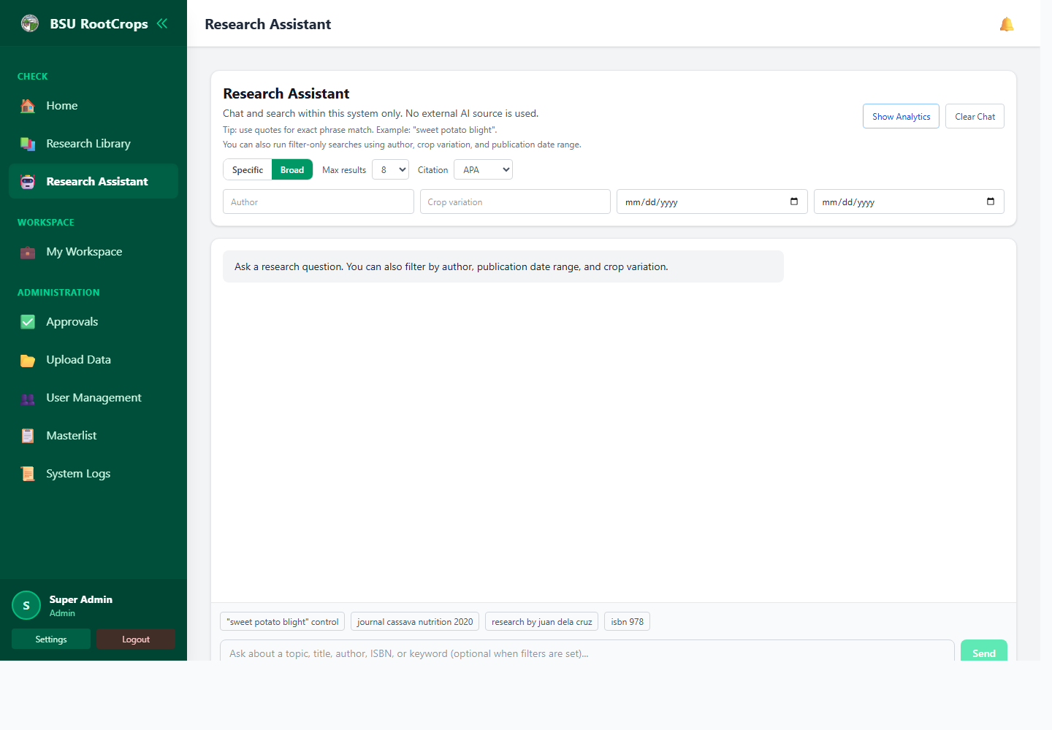
Screenshot: Research Assistant
1. Open Research Assistant.
2. Type a topic, question, title, author, ISBN, or keyword.
3. Use Specific for stricter results or Broad for related results.
4. Optional: add author, crop variation, or date filters.
5. Choose how many results to show.
6. Click Send.
7. Open a result, open the PDF, or copy a citation if available.
Tip: Use quotation marks for exact phrases, for example "sweet potato blight".

How to Change Your Password
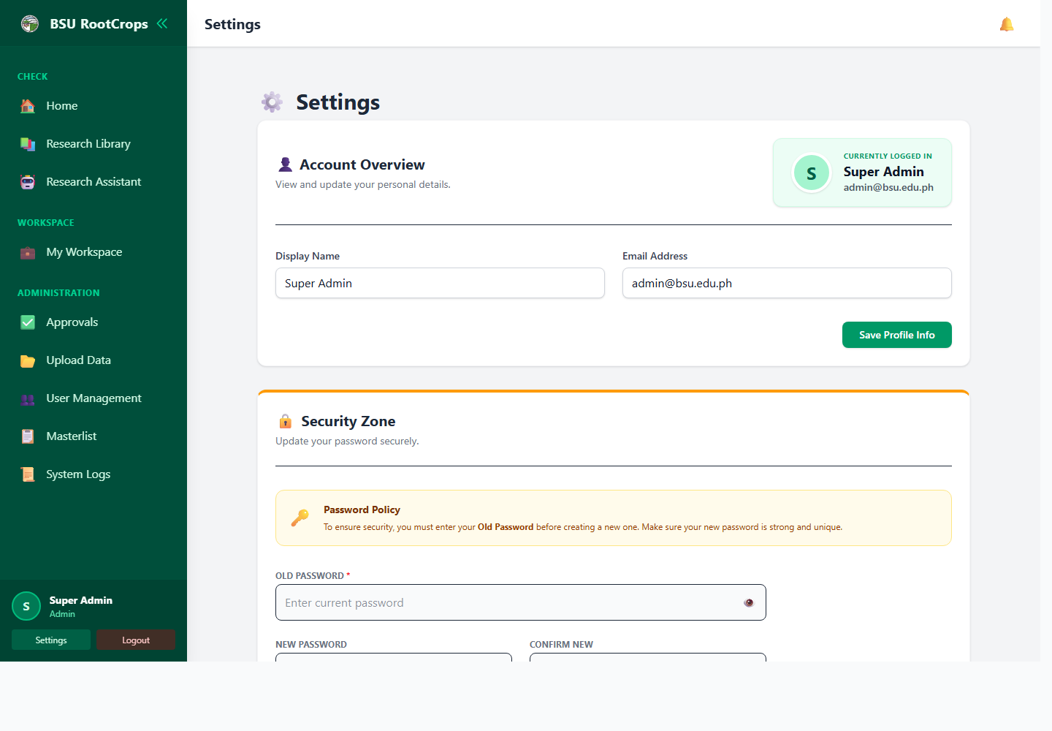
Screenshot: Settings
1. Log in to your account.
2. Open Settings from the sidebar or user area.
3. Go to the Security Zone section.
4. Type your Old Password.
5. Type your New Password.
6. Type the same new password again in Confirm New.
7. Click Change Password.
8. If the system logs you out after changing password, log in again using the new password.
- Use a password that is not shared with other accounts.
- Do not write the password inside the system notes or records.
- If an admin reset your password, change it immediately after login.

Part 2 - Researcher/User Guide
This section is for users who submit and manage research items in My Workspace.

My Workspace Overview
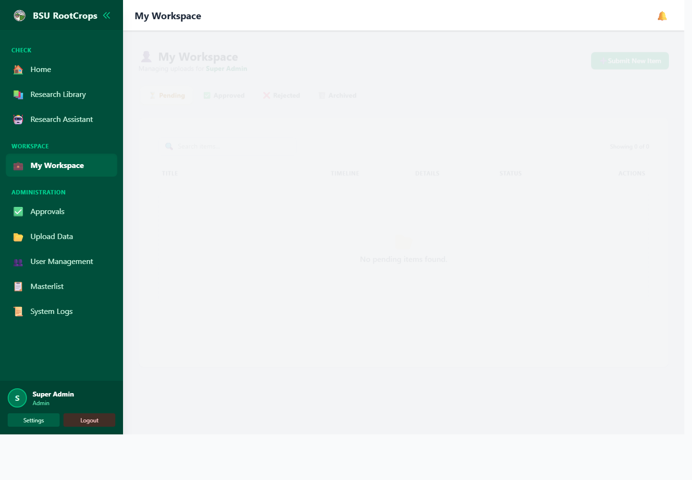
Screenshot: My Workspace
Tab | Meaning | What you can do
Pending | Submitted item waiting for admin review. | Open feedback, edit details, archive, or wait for approval.
Approved | Accepted item published in the library. | View the item and attached PDF if available.
Rejected | Item returned by admin for correction. | Read feedback, fix the item, and resubmit.
Archived | Item hidden from active workspace list. | Restore it when needed.

How to Add a Research Item
Use this when you want to submit a new research paper, book, journal, IEC material, thesis, or similar knowledge product.
1. Log in as a researcher/user or admin.
2. Open My Workspace.
3. Click Submit New Item.
4. Select at least one Type.
5. Fill in Title / Name of Product.
6. Fill in Author(s).
7. Fill optional fields if the information is available.
8. Attach a PDF, JPG, JPEG, or PNG if you have a file copy.
9. Click Submit Item.
10. Check the Pending tab to confirm that the item was submitted.
Field | Required? | Simple instruction
Type | Yes | Select one or more: Research Paper, Book, Journal, IEC Material, or Thesis.
Crop Variation | No | Choose the crop or variety, such as Sweet Potato, Cassava, Taro, Potato, or Others.
Title / Name of Product | Yes | Enter the full official title. Avoid short unclear titles.
Author(s) | Yes | Enter all author names. Separate multiple authors with commas or semicolons.
Publication Date | No | Enter when the material was published.
Date Started | No | Use for ongoing work or tracked submissions. Leave blank if not applicable.
Deadline | No | Use when there is a due date or revision deadline.
Publisher / Producer | No | Enter the school, office, agency, journal, or producer.
Edition | No | Enter edition, volume, issue, or version. Example: Vol. 1.
Physical Description | No | Enter page count or format. Example: 35 pages, PDF.
ISBN / ISSN | No | Enter the identifier exactly as written on the material.
Subject(s) / Keywords | No | Enter useful search words such as crop, disease, method, topic, or place.
Shelf Location | No | Enter the physical shelf or location code if there is a hard copy.
Condition | No | Choose New, Good, Fair, Poor, or Damaged. Default is Good.
External Link | No | Paste a full URL if the item has an online source.
Upload File | No | Attach PDF, JPG, JPEG, or PNG.

Example: Complete Research Item Entry
Field | Example
Type | Research Paper
Crop Variation | Sweet Potato
Title / Name of Product | Sweet Potato Production and Pest Management in Benguet
Author(s) | Juan Dela Cruz, Maria Santos
Publication Date | 2026-04-28
Publisher / Producer | Benguet State University
Physical Description | 35 pages, PDF
Subjects / Keywords | sweet potato, pest management, production, Benguet
Shelf Location | Research Shelf A-1
Condition | Good

How to Edit a Submitted Item
1. Open My Workspace.
2. Go to the tab where the item appears, usually Pending or Rejected.
3. Find the item in the table.
4. Click the edit button.
5. Change the needed details.
6. Upload a new file only if you want to replace the old file.
7. Click Update Item.

How to Read Feedback and Resubmit
1. Open My Workspace.
2. Go to the Rejected tab.
3. Click Feedback to read admin comments.
4. Click Full Edit if metadata or file must be changed.
5. Click Resubmit if the existing details are already correct.
6. Write Resubmission Remarks explaining what was fixed.
7. Click Confirm Resubmit or Update Item.
Good resubmission remark example: Re-uploaded the complete PDF and corrected the author name.

How to Archive or Restore Your Item
1. Open My Workspace.
2. Find the item.
3. Click Archive to hide it from the active list.
4. Open the Archived tab when you need it again.
5. Click Restore to return it to the active list.
Archive is not the same as permanent deletion. It only separates the item from your active workspace view.

Part 3 - Administrator Guide
This section is for admin accounts only. These actions affect other users and the public catalog, so review carefully before confirming changes.

Admin Daily Checklist
- Check the homepage for pending submissions and recent activity.
- Review pending items in Approvals.
- Approve correct items or reject with clear remarks.
- Import CSV records only after checking the preview.
- Use Masterlist for metadata fixes, visibility changes, and archive control.
- Review System Logs when investigating user activity.

How to Approve a Research Item
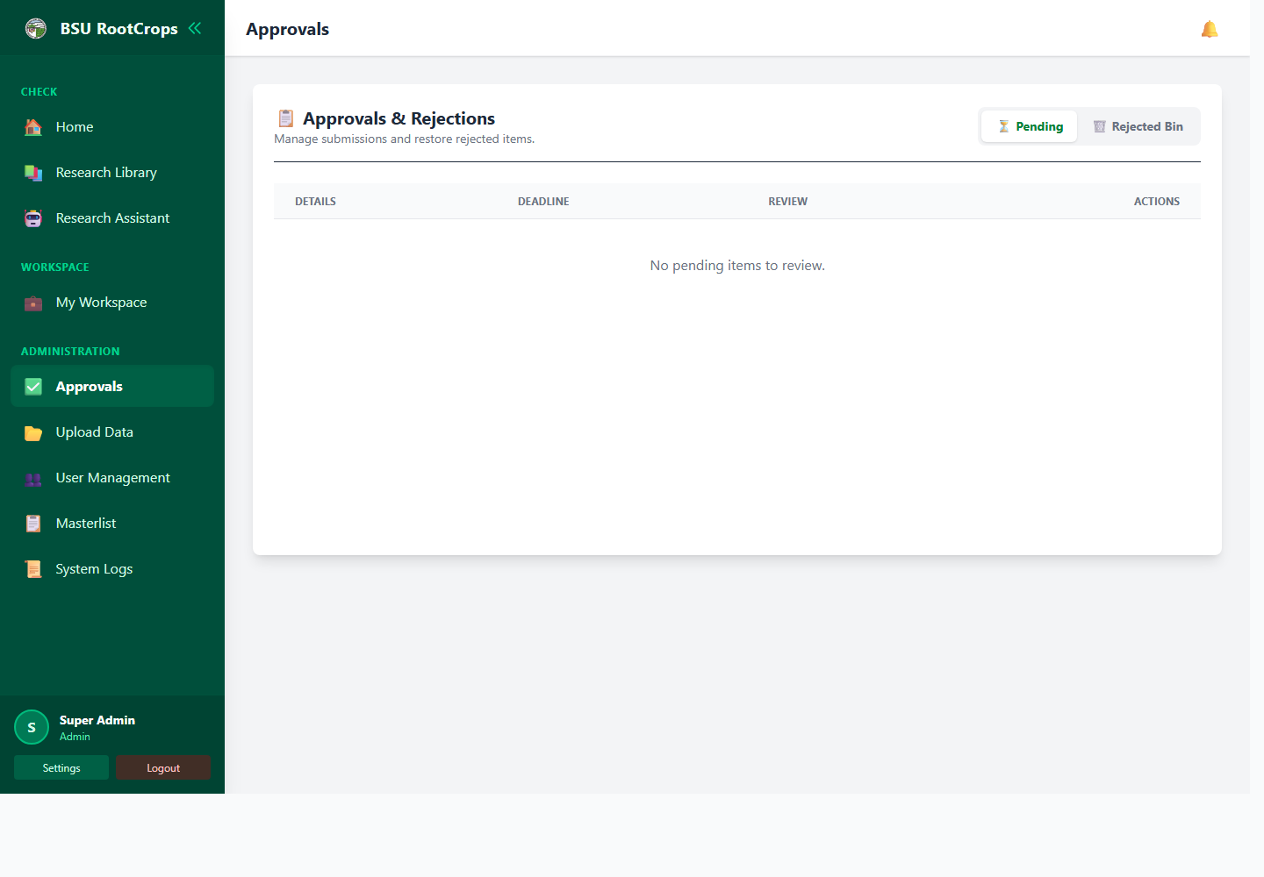
Screenshot: Approvals
1. Open Approvals.
2. Go to the Pending tab.
3. Click the item to inspect details and attached file.
4. Open Comments if you need to discuss with the submitter.
5. Click Approve when the item is correct.
6. Confirm the action.
7. The item becomes available according to its visibility/access setting.

How to Reject a Research Item
1. Open Approvals.
2. Go to Pending.
3. Inspect the item details and file.
4. Click Reject.
5. Enter a clear reason in Remarks / Reason.
6. Confirm the rejection.
7. The submitter can read the feedback and resubmit after correction.
- Good remark: Please upload the complete PDF and correct the publication date.
- Good remark: Add missing author name and shelf location before resubmitting.
- Avoid unclear remarks such as "wrong" or "fix this".

How to Import CSV Data
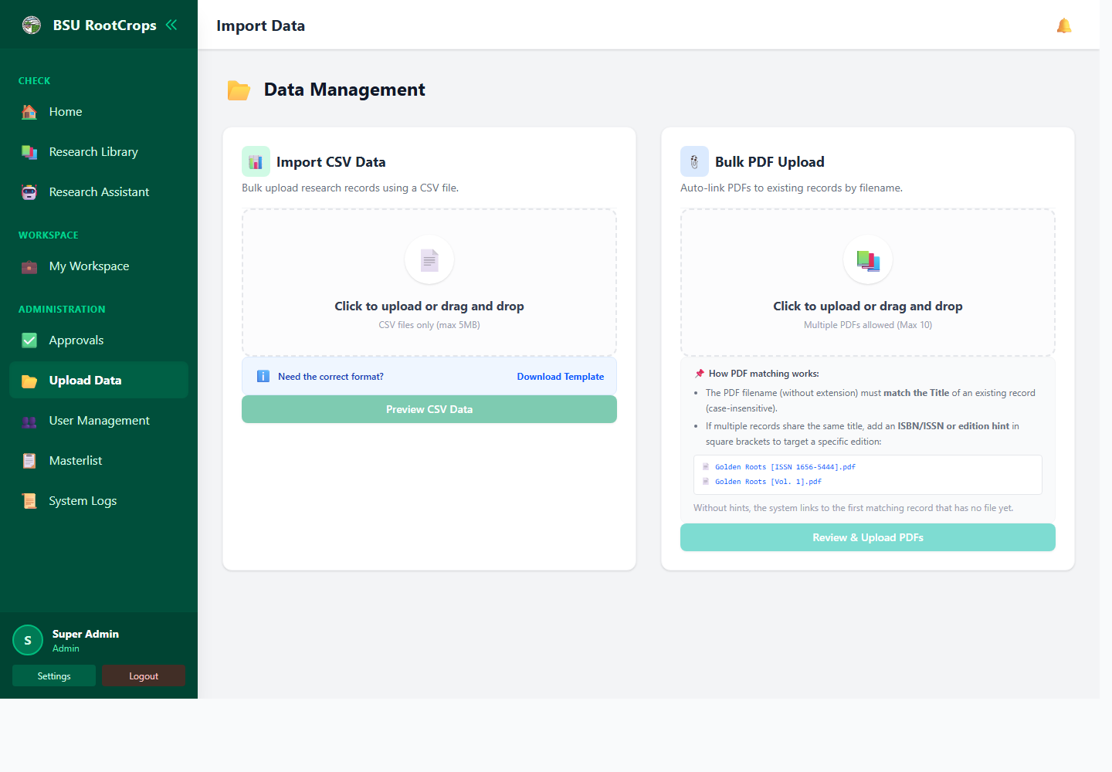
Screenshot: Import Data
1. Open Import Data.
2. Download the template if preparing a new CSV.
3. Fill the CSV columns: Title, Author, Type, Date, Edition, Publisher, Pages, ISBN/ISSN, Subjects, Location, Condition, and Crop.
4. Upload or drag the CSV file.
5. Review the preview table.
6. Double-click a cell to edit it before import.
7. Remove rows that should not be imported.
8. Check duplicate status.
9. Click Confirm & Import.

How to Upload and Link PDFs in Bulk
1. Make sure the catalog records already exist before uploading PDFs.
2. Name each PDF using the matching record title when possible.
3. Open Import Data.
4. Upload up to 10 PDF files.
5. Click Review & Upload PDFs.
6. Check how each file matches a record.
7. Remove files with No Matching Record.
8. Click Upload & Link.
If multiple records have the same title, add an ISBN/ISSN or edition hint in square brackets. Example: Golden Roots [ISSN 1656-5444].pdf

How to Add a User Account
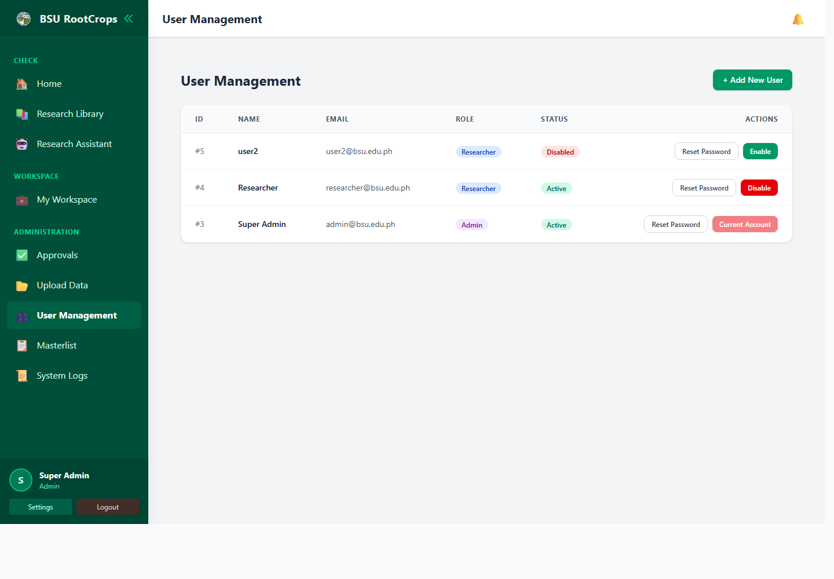
Screenshot: User Management
1. Open User Management.
2. Click Add New User.
3. Enter the user full name.
4. Enter the email address.
5. Enter an initial password.
6. Choose the role: Researcher or Admin.
7. Click Create Account.
8. Tell the user to log in and change the password.

How to Reset a User Password
1. Open User Management.
2. Find the user account.
3. Click Reset Password.
4. Enter a strong temporary password that follows the password rules.
5. Click Reset Password.
6. Tell the user to log in and change the temporary password in Settings.

How to Disable or Enable a User
1. Open User Management.
2. Find the user account.
3. Click Disable to block login for that account.
4. Click Enable to allow the account to log in again.
Use Disable when a user should temporarily lose access without deleting their account history.

How to Manage Records in Masterlist
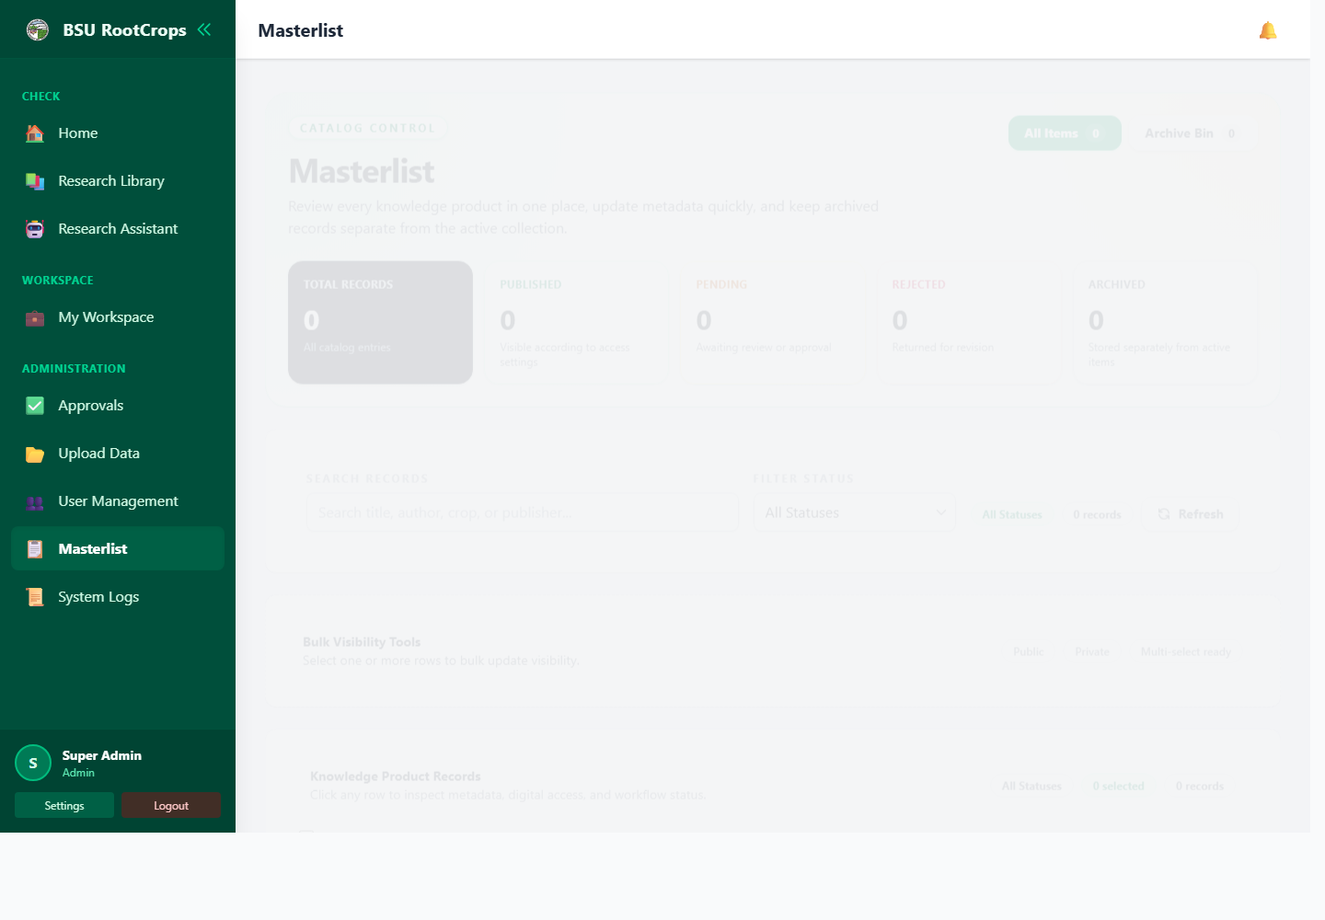
Screenshot: Masterlist
1. Open Masterlist.
2. Search by title, author, crop, or publisher.
3. Filter by All, Published, Pending, Rejected, or Archived.
4. Click a row to inspect metadata, file access, and status.
5. Click Edit to correct metadata or replace a file.
6. Select rows and apply Public or Private visibility in bulk.
7. Open Archive Bin to restore or permanently delete archived records.

How to View and Export System Logs
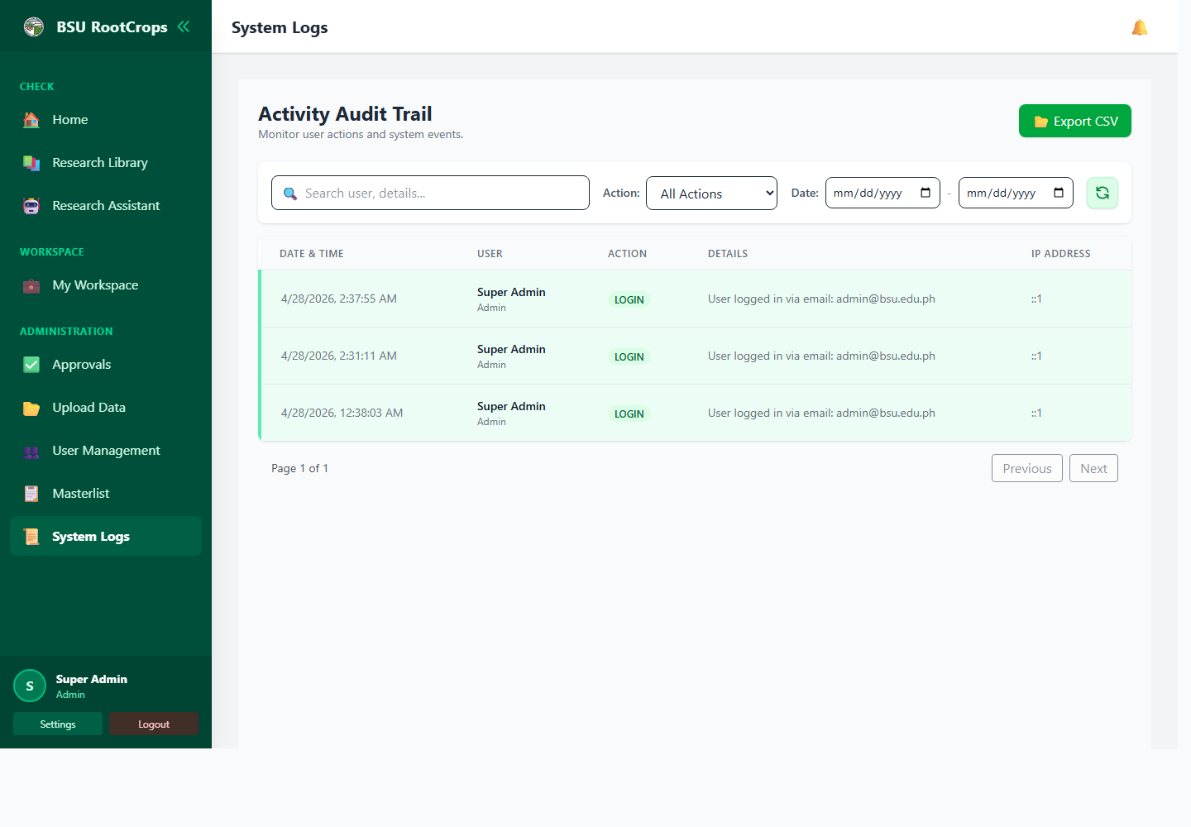
Screenshot: System Logs
1. Open System Logs.
2. Use Search to find a user or detail text.
3. Filter by action such as LOGIN, APPROVE_RESEARCH, REJECT_RESEARCH, or ARCHIVE_RESEARCH.
4. Use the date range to narrow the period.
5. Click refresh/reset to clear filters.
6. Click Export CSV when you need an audit/report copy.

Part 4 - Help and Best Practices

Common Problems
Problem | What to check
Cannot log in | Check email and password. If locked out, wait. If forgotten, ask admin for password reset.
Submit button does not work | Type, Title, and Author(s) are required. External Link must be a valid full URL if filled.
File upload rejected | My Workspace accepts PDF/JPG/JPEG/PNG. CSV import accepts CSV. Bulk PDF upload accepts PDF.
Item not visible in Library | It may still be pending, rejected, archived, or private. Admin should check Approvals or Masterlist.
CSV rows skipped | Rows may be duplicates or missing Title/Author. Review the preview table before importing.
PDF did not link | Filename may not match a title, or the record already has a file. Add ISBN/ISSN or edition hint.
Cannot open admin page | Only admin accounts can open Approvals, Import Data, User Management, Masterlist, and System Logs.

Data Entry Tips
- Use the official title exactly as written on the material.
- Spell author names consistently across records.
- Use helpful keywords in Subjects so searches work better.
- Fill shelf location when there is a physical copy.
- Attach a PDF whenever a digital copy is available.
- Write clear admin feedback and resubmission remarks.

Security Reminders
- Do not share your login password.
- Change temporary passwords immediately.
- Log out when using a shared computer.
- Admins should only give Admin role to trusted staff.
- Avoid uploading backup files or private system files into the public web folder.

