BSU RootCrops Research Portal
Simple User Manual
A simple guide for users and administrators, from the homepage to every main feature of the system.
Updated: April 28, 2026

Quick Start
Use this page when you only need the basic path.
Task | Go to | Simple steps
Browse research | Research Library | Search or filter, then click a record to view details or PDF.
Ask a question | Research Assistant | Type a topic, author, ISBN, or keyword, then click Send.
Submit new item | My Workspace | Click Submit New Item, fill the form, attach a file if available, then click Submit Item.
Review submissions | Approvals | Admin opens pending items, comments, approves, rejects, or restores.
Import many records | Import Data | Admin uploads CSV, reviews the preview, edits if needed, and confirms import.
Manage catalog | Masterlist | Admin searches, edits, changes visibility, archives, restores, or deletes.
Manage users | User Management | Admin creates users, resets passwords, disables, or enables accounts.
Update own account | Settings | Change display name, email, or password.

User Roles
- Guest: can open Homepage, Research Library, and Research Assistant. Guest access may only show public records.
- Researcher: can submit and manage their own items in My Workspace.
- Admin: can use all researcher features plus Approvals, Import Data, User Management, Masterlist, and System Logs.
Use the left sidebar to move around. On a phone or small screen, open the menu from the top-left button.

1. Login
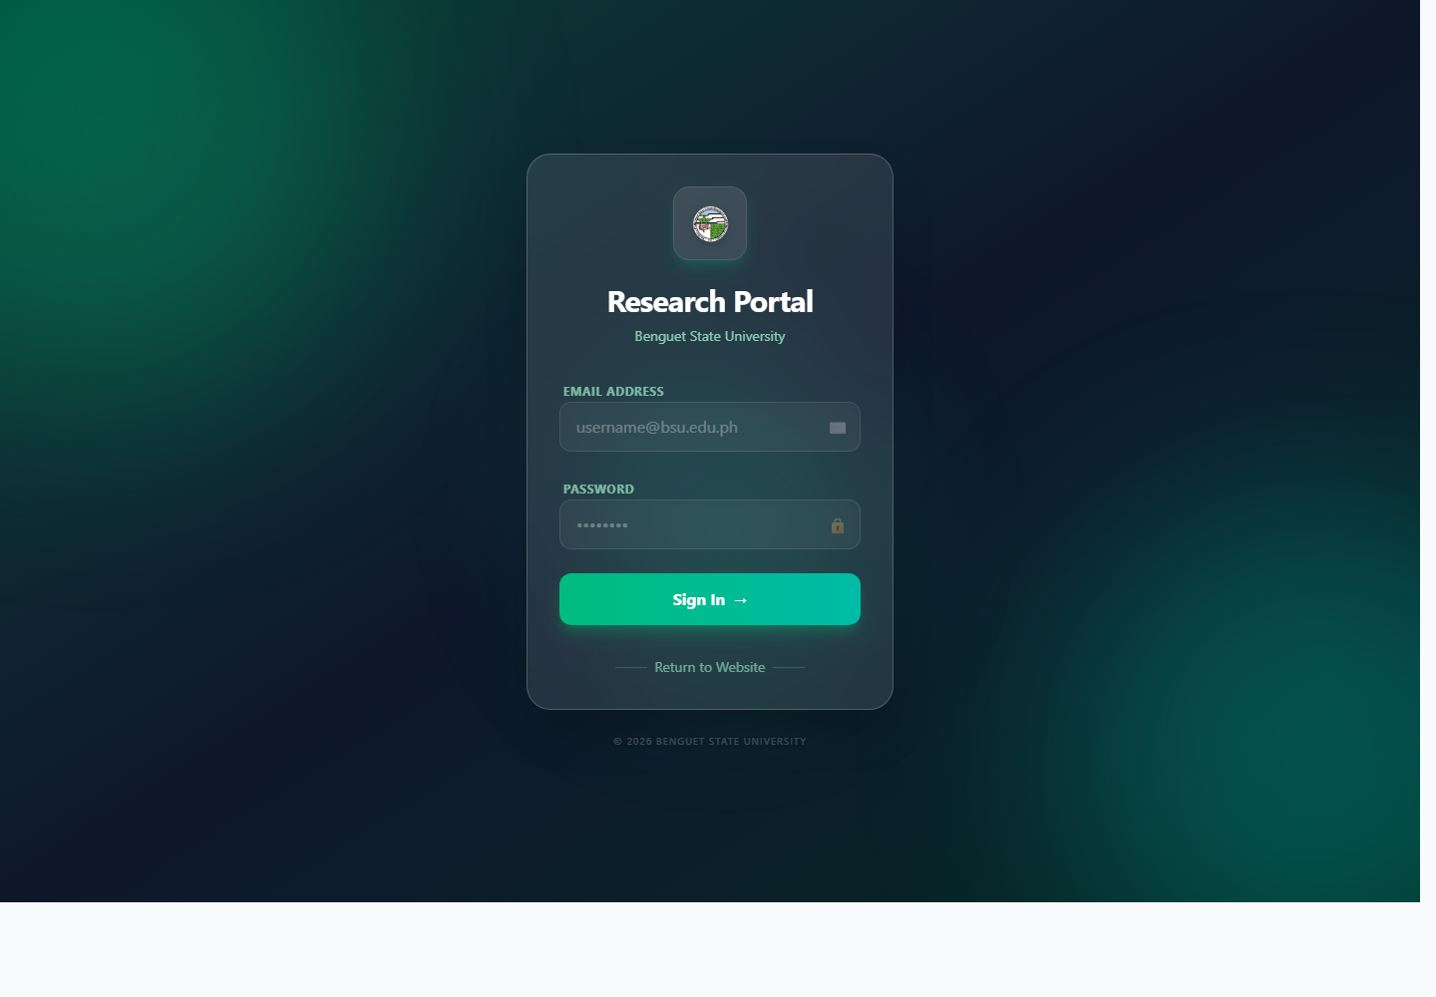
Screenshot: Login screen
1. Open the system in the browser.
2. Click Login Area if you are on the public page.
3. Enter your email address.
4. Enter your password.
5. Click Sign In.
6. If the system asks you to change password, open Settings and create a new password.
If login fails, check spelling and password. After too many failed attempts, wait a short time before trying again.

2. Homepage / Dashboard
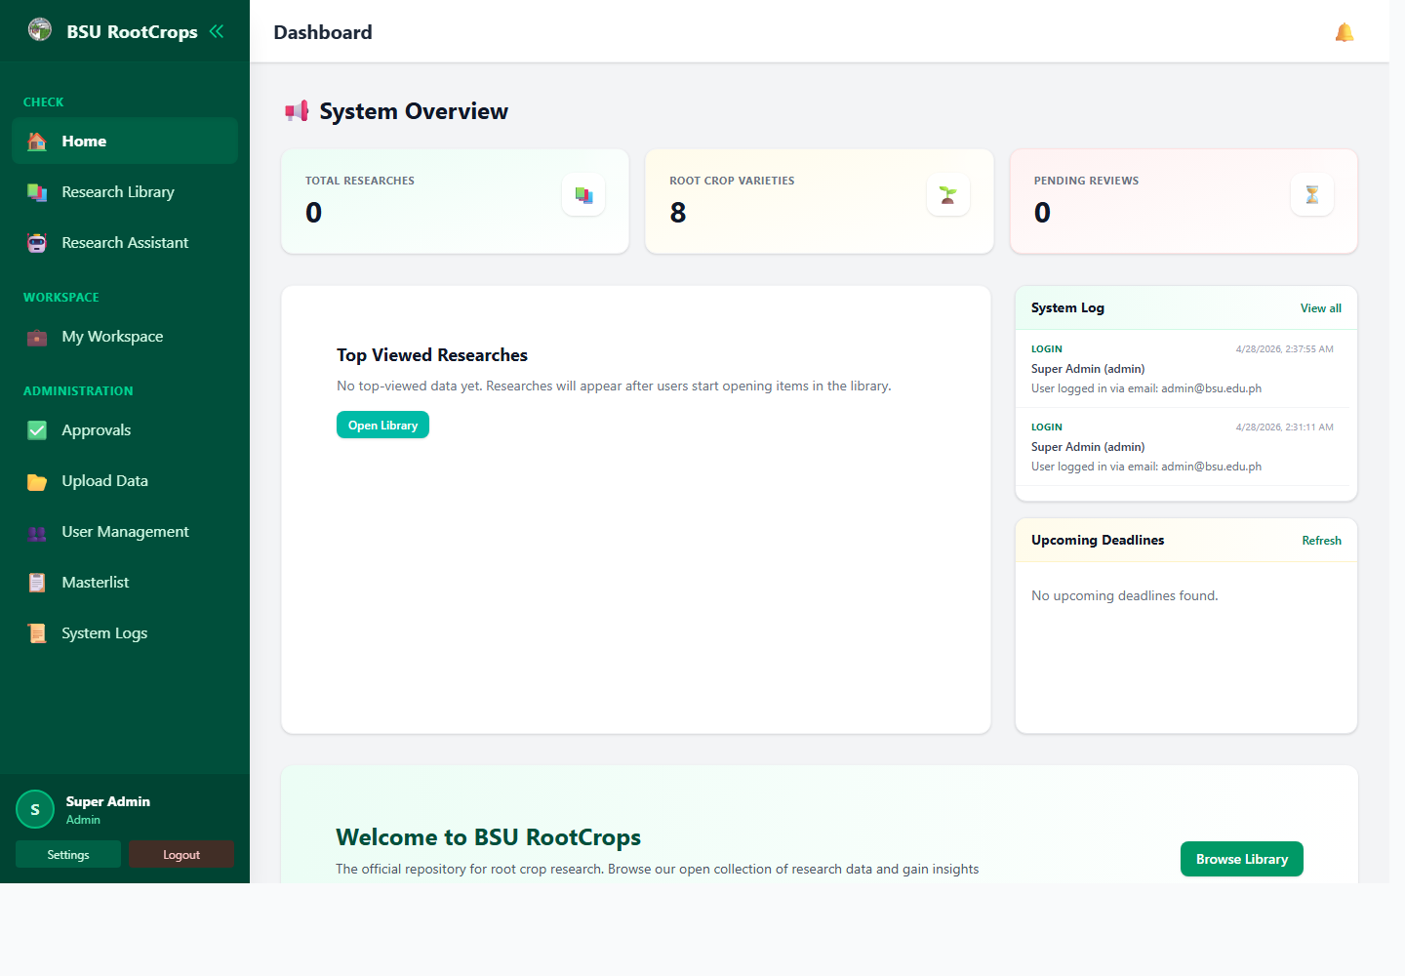
Screenshot: Home dashboard
The Homepage is the first working area after opening the system.
- Researchers see their own research overview.
- Admins see system totals, recent logs, top viewed records, and upcoming deadlines.
- Click a dashboard card or button to open the related page.
- Use Browse Library to go directly to published records.

3. Research Library
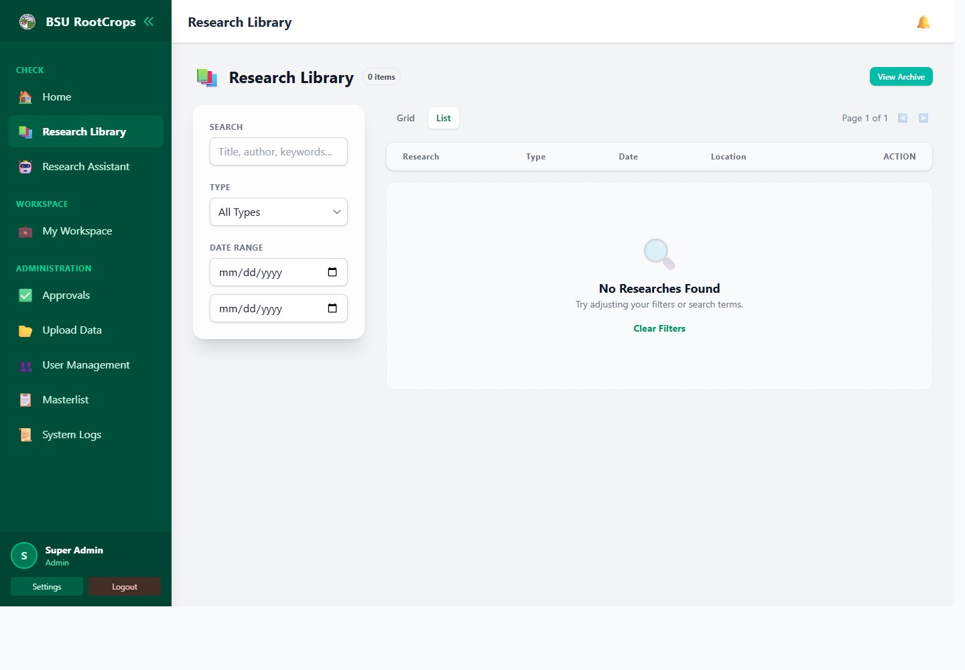
Screenshot: Research Library
1. Open Research Library from the sidebar.
2. Search by title, author, crop, keyword, publisher, or ISBN/ISSN.
3. Use filters such as type and date range if needed.
4. Switch between Grid and List view.
5. Click a record to open its details.
6. Open the PDF or external link if one is available.
Admin note: admins may also view archived records or archive/restore records when those actions are shown.

4. Research Assistant
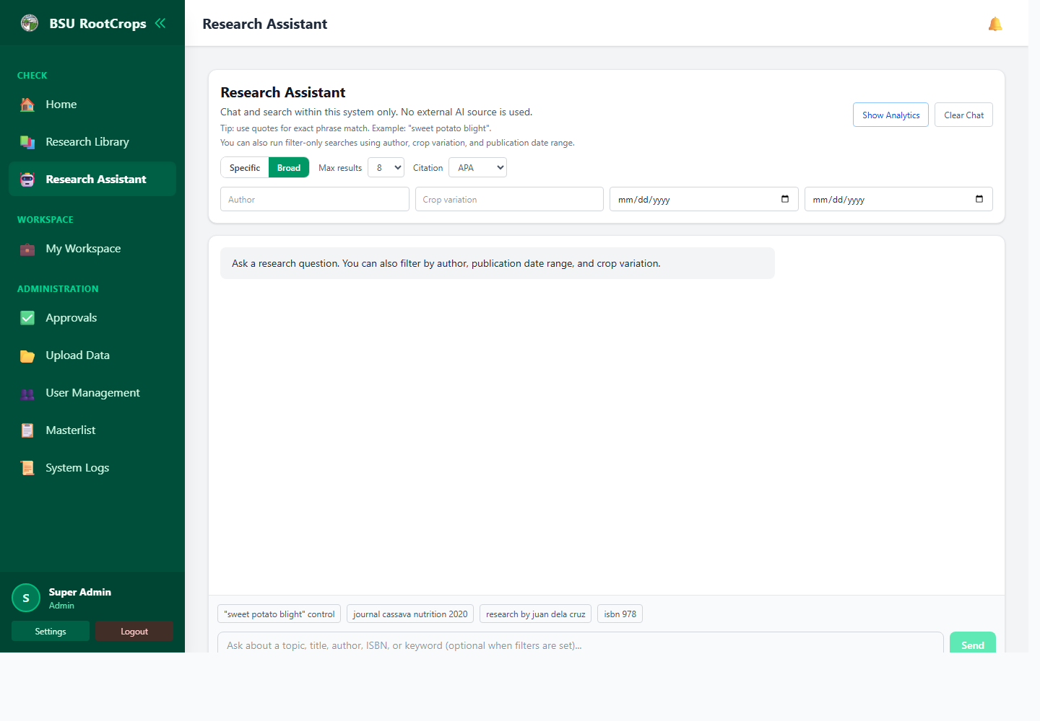
Screenshot: Research Assistant
The Research Assistant searches inside this system only. It does not search the internet.
1. Type a topic, question, title, author, ISBN, or keyword.
2. Choose Specific for stricter matches or Broad for related results.
3. Optional: fill author, crop variation, or publication date filters.
4. Choose the maximum number of results.
5. Click Send.
6. Open a result, open its PDF, or copy a citation when available.
Tip: use quotation marks for exact phrases, for example "sweet potato blight".

5. My Workspace
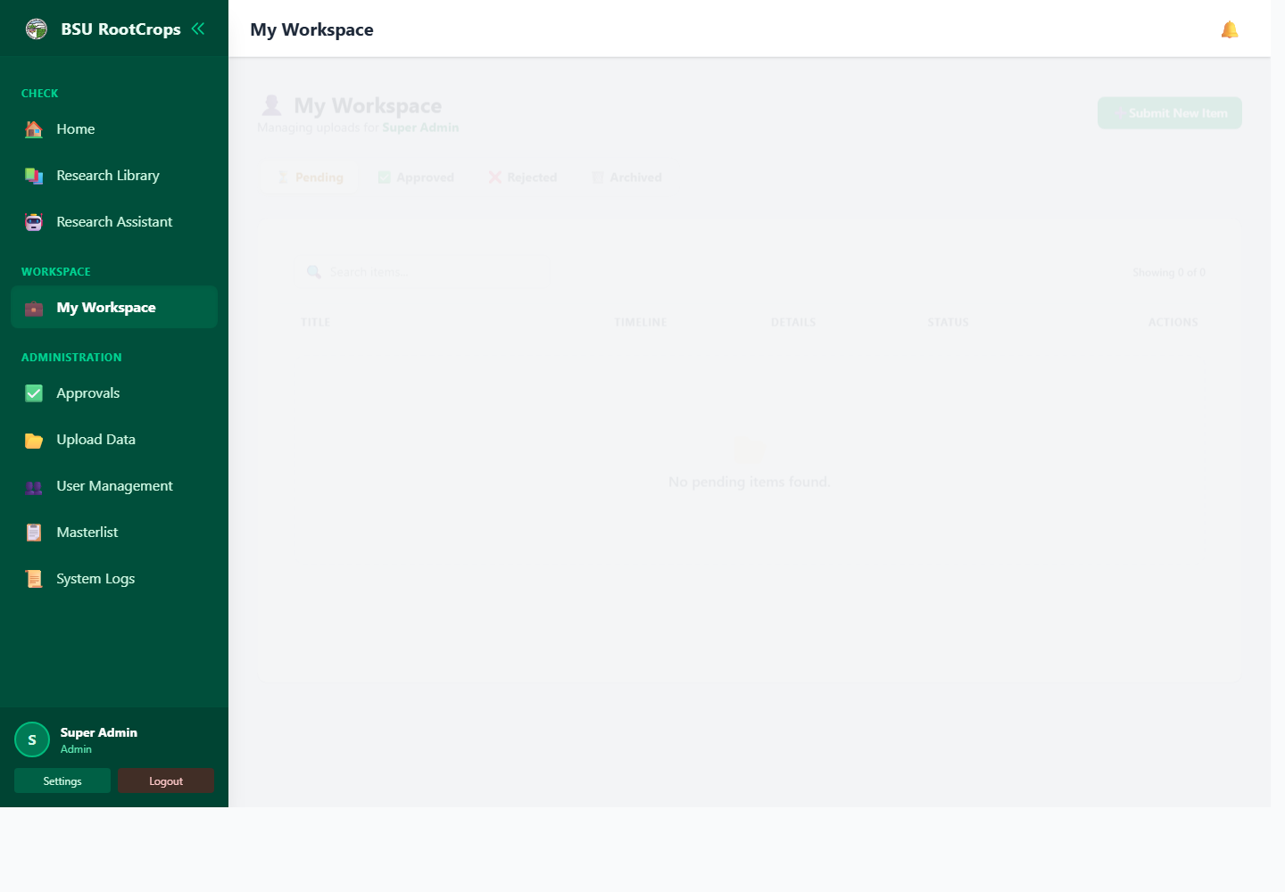
Screenshot: My Workspace
My Workspace is where logged-in users submit, edit, track, and resubmit their own knowledge products.

Workspace Tabs
Tab | Meaning | What to do
Pending | Waiting for admin review. | Open feedback, edit details, archive, or wait for review.
Approved | Accepted and published. | View the item and PDF if available.
Rejected | Returned for correction. | Read feedback, fix the item, and resubmit.
Archived | Hidden from the active workspace list. | Restore it when needed.

Submit a New Item
1. Open My Workspace.
2. Click Submit New Item.
3. Select at least one Type.
4. Fill Title / Name of Product.
5. Fill Author(s).
6. Add crop, dates, publisher, subjects, shelf location, condition, external link, and file if available.
7. Click Submit Item.
8. Check the Pending tab after submitting.

How to Fill In the My Workspace Form
Field | Required? | What to enter
Type | Yes | Select one or more: Research Paper, Book, Journal, IEC Material, or Thesis.
Crop Variation | No | Choose the crop or variety, such as Sweet Potato, Cassava, Taro, Potato, or Others.
Title / Name of Product | Yes | Enter the full official title. Avoid unclear short titles.
Author(s) | Yes | Enter all author names. Separate multiple names with commas or semicolons.
Publication Date | No | Enter the date the material was published.
Date Started | No | Use for ongoing work or tracked submissions. Leave blank if not applicable.
Deadline | No | Use when the item has a due date or revision deadline.
Publisher / Producer | No | Enter the school, office, agency, journal, or producer name.
Edition | No | Enter edition, volume, or issue, such as 2nd Edition, Vol. 1, or Issue No. 5.
Physical Description | No | Enter page count or format, such as 120 pages, 16 leaves, PDF, or brochure.
ISBN / ISSN | No | Enter the identifier exactly as written on the material.
Subject(s) / Keywords | No | Enter search words, topics, crops, methods, diseases, or places. Use commas.
Shelf Location | No | Enter the physical shelf/location code, such as Shelf 6B or Thesis Section.
Condition | No | Choose New, Good, Fair, Poor, or Damaged. Default is Good.
External Link | No | Paste the full URL if the item has an online source.
Upload File | No | Attach PDF, JPG, JPEG, or PNG. On edit, upload only if replacing the file.
Resubmission Remarks | Only rejected items | Explain what was corrected after admin feedback.

Example Entry
Field | Example
Type | Research Paper
Crop Variation | Sweet Potato
Title / Name of Product | Sweet Potato Production and Pest Management in Benguet
Author(s) | Juan Dela Cruz, Maria Santos
Publisher / Producer | Benguet State University
Physical Description | 35 pages, PDF
Subjects / Keywords | sweet potato, pest management, production, Benguet
Shelf Location | Research Shelf A-1
Condition | Good

Edit, Feedback, and Resubmit
1. Open the correct tab and click the edit button on the row.
2. Update the needed fields, then click Update Item.
3. Click Feedback to read or reply to admin comments.
4. For rejected items, read the remarks before editing.
5. Use Full Edit when metadata or file must change.
6. Use Resubmit when the metadata is correct and you only need to explain what was fixed.
7. Write clear remarks, for example: Re-uploaded missing pages and corrected the title.
Archive only hides the item from the active workspace list. Open Archived to restore it.

6. Approvals
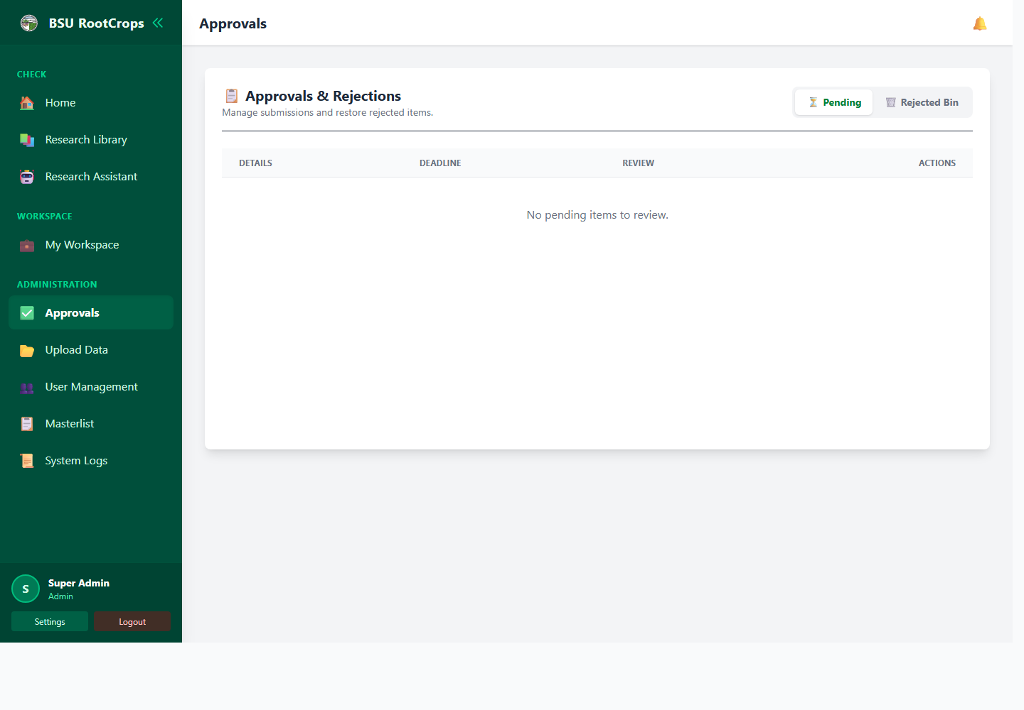
Screenshot: Approvals
Approvals is for admins reviewing submitted items.
1. Open Approvals.
2. Use Pending to see items waiting for review.
3. Click an item to inspect details.
4. Use Comments to ask questions or leave review notes.
5. Click Approve when the item is ready.
6. Click Reject when corrections are needed. Always enter a clear reason.
7. Use Rejected Bin to restore rejected items or permanently delete them when necessary.
8. Use the deadline action when a pending item needs a new due date.
- Good rejection remark: Please correct the author name and upload the complete PDF.
- Good rejection remark: Add publication date and shelf location before resubmitting.
- Avoid vague remarks like "wrong" or "fix this".

7. Import Data
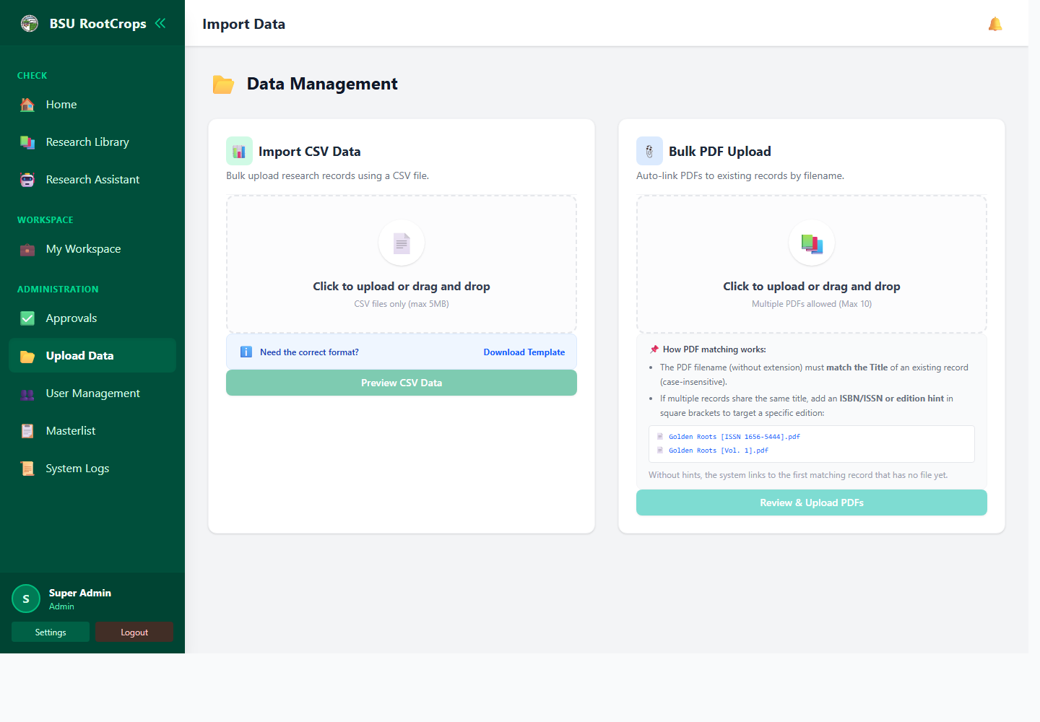
Screenshot: Import Data
Import Data is for admins adding many records or linking many PDFs.

Import CSV Records
1. Open Import Data.
2. Download the template when preparing a new CSV.
3. Fill the expected columns: Title, Author, Type, Date, Edition, Publisher, Pages, ISBN/ISSN, Subjects, Location, Condition, and Crop.
4. Upload or drag the CSV file.
5. Review the preview table.
6. Double-click a cell to edit it before importing.
7. Remove rows that should not be imported.
8. Check duplicate status.
9. Click Confirm & Import when correct.

Bulk PDF Upload
1. Prepare PDF files after matching records already exist.
2. Use the record title as the PDF filename when possible.
3. Upload up to 10 PDFs at a time.
4. Click Review & Upload PDFs.
5. Check each match result.
6. Remove files with No Matching Record if needed.
7. Click Upload & Link.
If several records share one title, add a hint in square brackets, for example: Golden Roots [ISSN 1656-5444].pdf

8. User Management
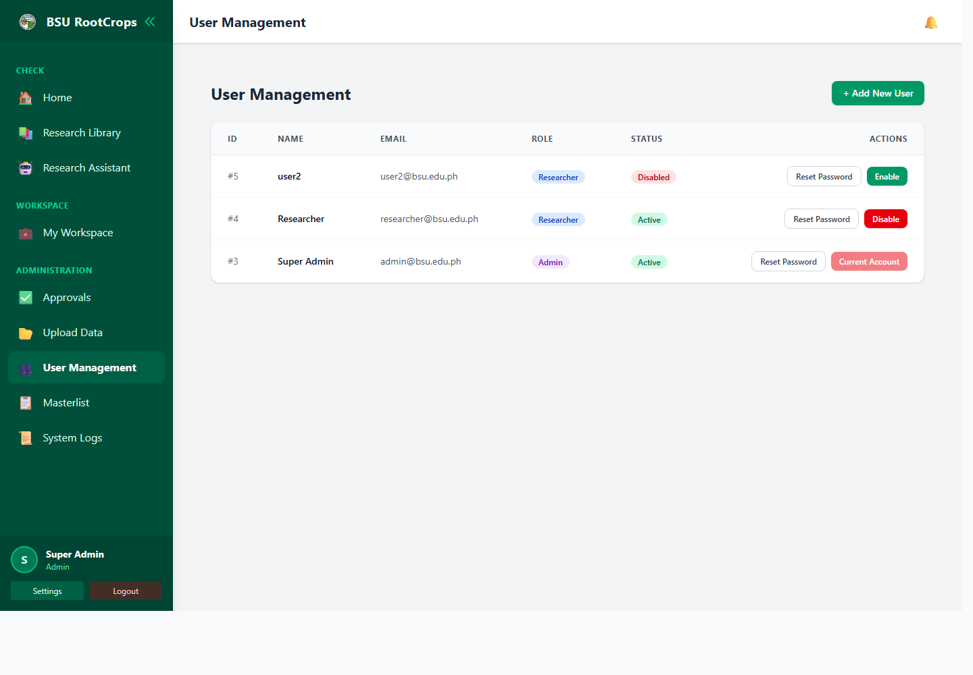
Screenshot: User Management
1. Open User Management.
2. Click Add New User.
3. Fill Full Name, Email Address, Initial Password, and Role.
4. Choose Admin only for trusted staff.
5. Choose Researcher for normal submitters.
6. Click Create Account.
7. Use Disable to block login without deleting the account.
8. Use Enable to allow login again.
9. Use Reset Password when a user forgets a password.
Use strong temporary passwords and tell users to change them after login.

9. Masterlist
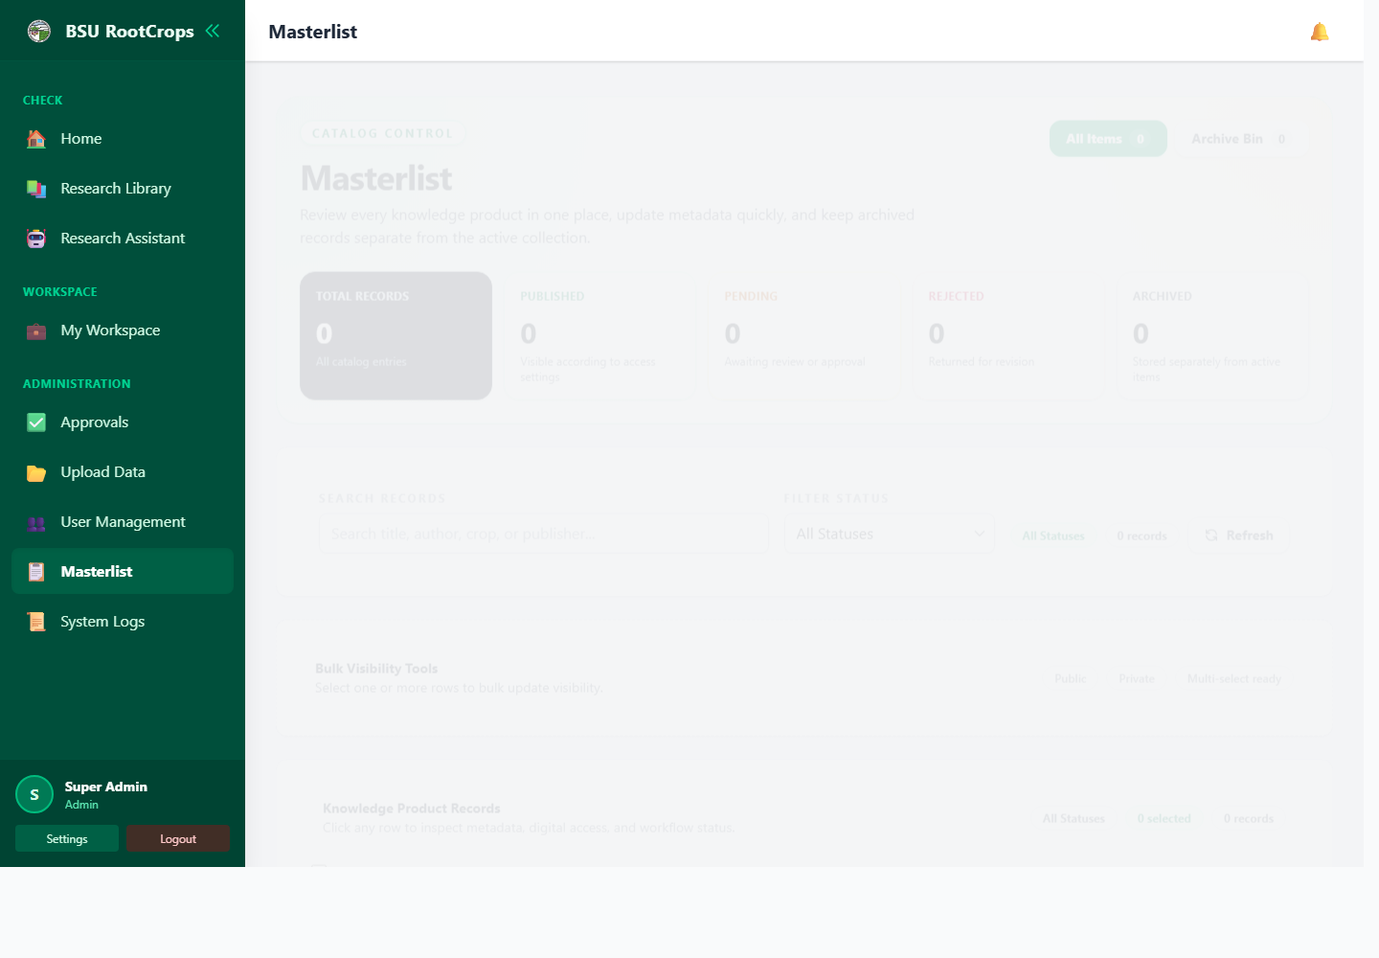
Screenshot: Masterlist
Masterlist is the admin control page for all knowledge product records.
1. Open Masterlist.
2. Search by title, author, crop, or publisher.
3. Filter by All, Published, Pending, Rejected, or Archived.
4. Click a row to inspect metadata, file access, and status.
5. Use Edit to correct metadata or replace a file.
6. Select rows to change visibility in bulk.
7. Use Public when guests may view the item.
8. Use Private when login is required.
9. Open Archive Bin to restore or permanently delete archived records.
The edit form is similar to My Workspace. Admins also see Visibility, which controls public/private access.

10. System Logs
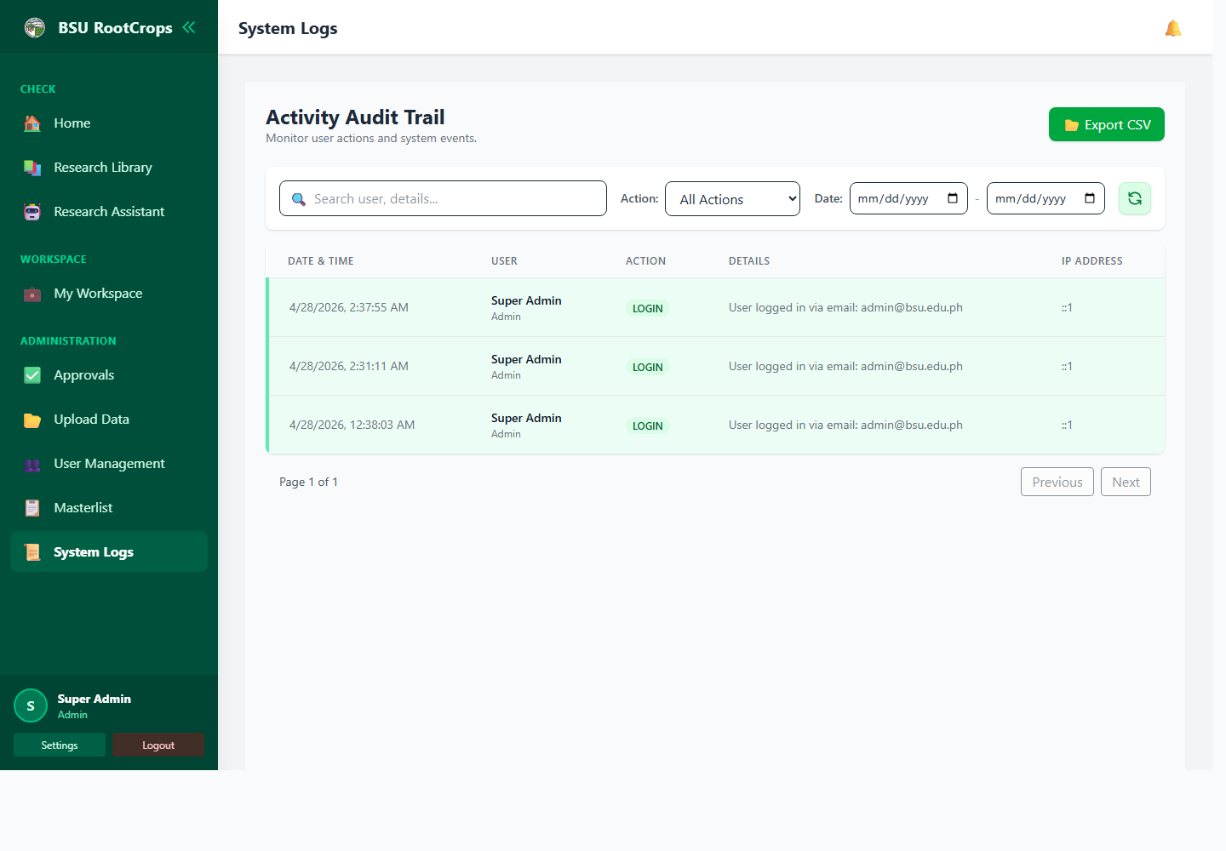
Screenshot: System Logs
System Logs help admins review activity inside the portal.
1. Open System Logs.
2. Search by user name or details.
3. Filter by action, such as login, import, approve, reject, or archive.
4. Use date range for a specific period.
5. Click refresh/reset to clear filters.
6. Click Export CSV for an audit or report copy.

11. Settings
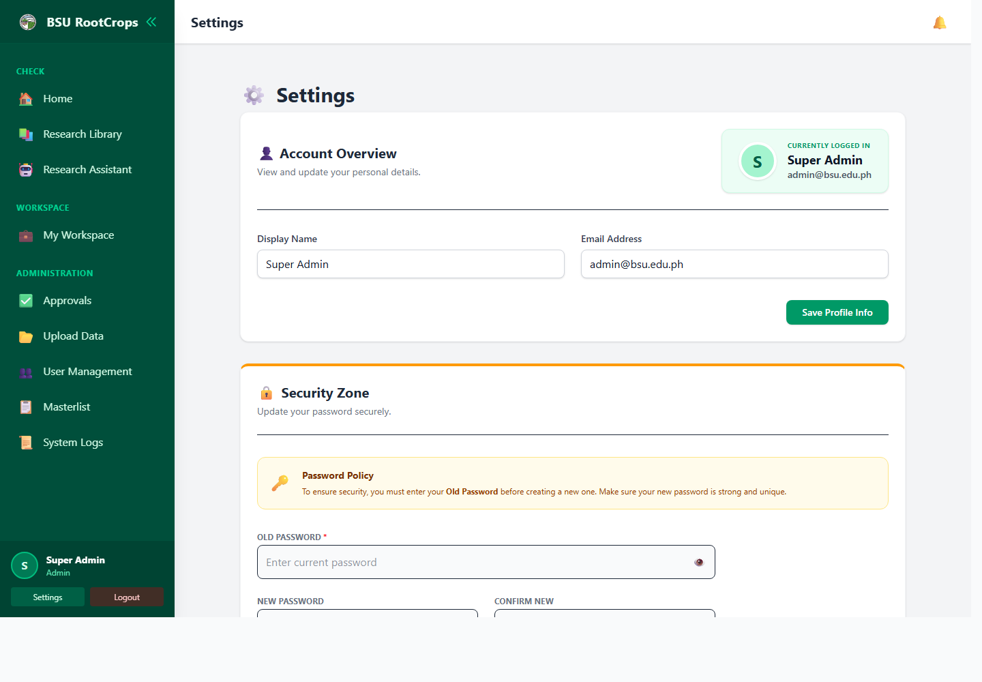
Screenshot: Settings
Settings is where users manage their own profile and password.
1. Open Settings.
2. To update profile, edit Display Name or Email Address, then click Save Profile Info.
3. To change password, enter Old Password, New Password, and Confirm New.
4. Click Change Password.
5. If password change is required, create a new password before continuing.

Daily Workflow

Researcher Workflow
1. Log in.
2. Check notifications and My Workspace.
3. Submit new items.
4. Track Pending, Approved, Rejected, and Archived tabs.
5. Read feedback on rejected items.
6. Correct and resubmit rejected items with remarks.
7. Use Library and Assistant to find approved records.

Admin Workflow
1. Log in.
2. Check dashboard totals, logs, and deadlines.
3. Review pending submissions in Approvals.
4. Approve correct items or reject with clear remarks.
5. Import CSV records and link PDFs when adding large batches.
6. Use Masterlist to fix metadata, visibility, and archive status.
7. Manage user accounts.
8. Export logs when audit records are needed.

Common Problems
Problem | What to check
Cannot log in | Check email and password. Wait if locked out. Ask admin for password reset if needed.
Submit button does not work | Type, Title, and Author(s) must be filled. External Link must be a valid URL if provided.
File rejected | Use PDF/JPG/JPEG/PNG in My Workspace, CSV for CSV import, and PDF for bulk PDF upload.
Item not visible in Library | It may be pending, rejected, archived, or private. Admin should check Approvals or Masterlist.
CSV rows skipped | Rows may be duplicates or missing Title/Author. Review preview before confirming.
PDF did not link | Filename may not match a title, or the record already has a file. Add ISBN/ISSN or edition hint.
Cannot open admin page | Only admin accounts can open Approvals, Import Data, User Management, Masterlist, and System Logs.

Simple Data Entry Tips
- Use the official title exactly as written.
- Spell author names consistently.
- Use helpful keywords in Subjects.
- Fill shelf location when there is a physical copy.
- Attach a PDF whenever available.
- Write clear feedback and resubmission remarks.

