Constraint Layout

Create a new project named “My Constraint Layout”

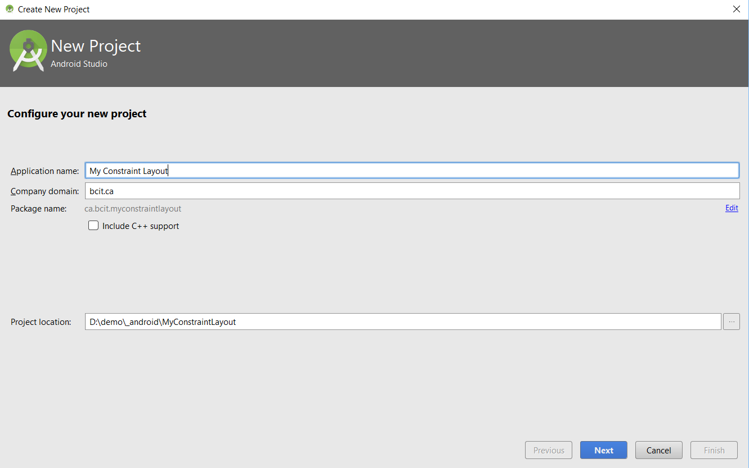

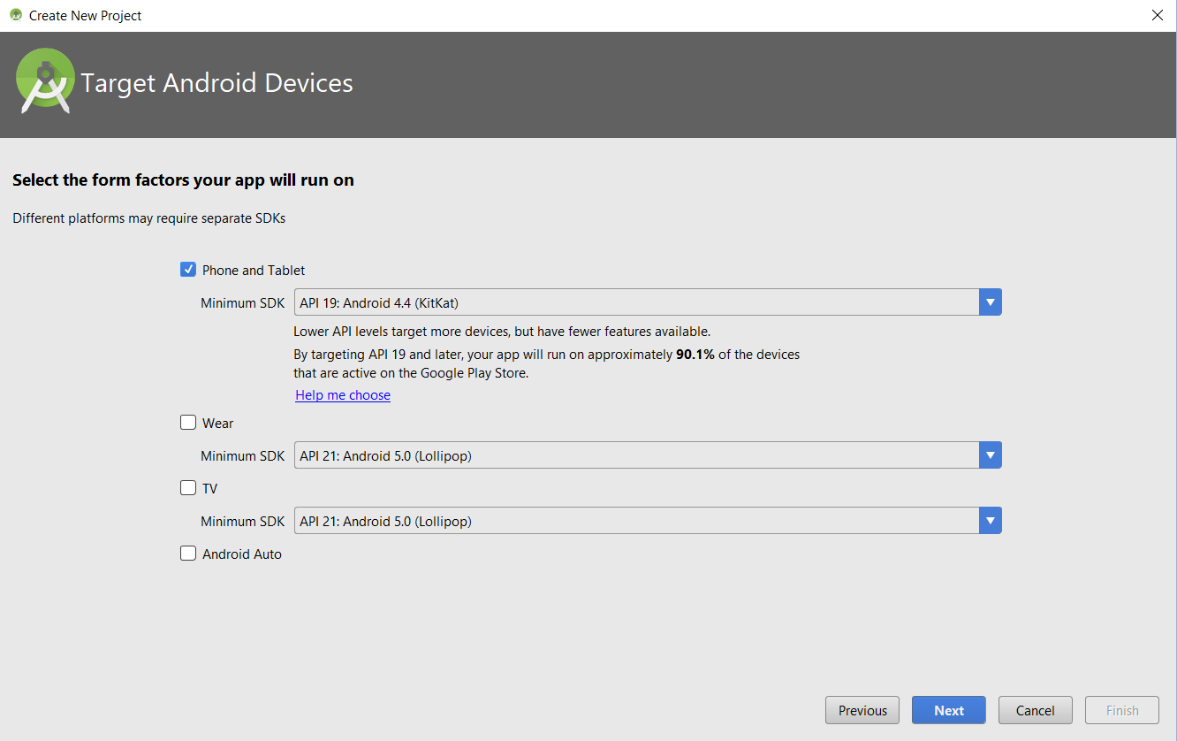

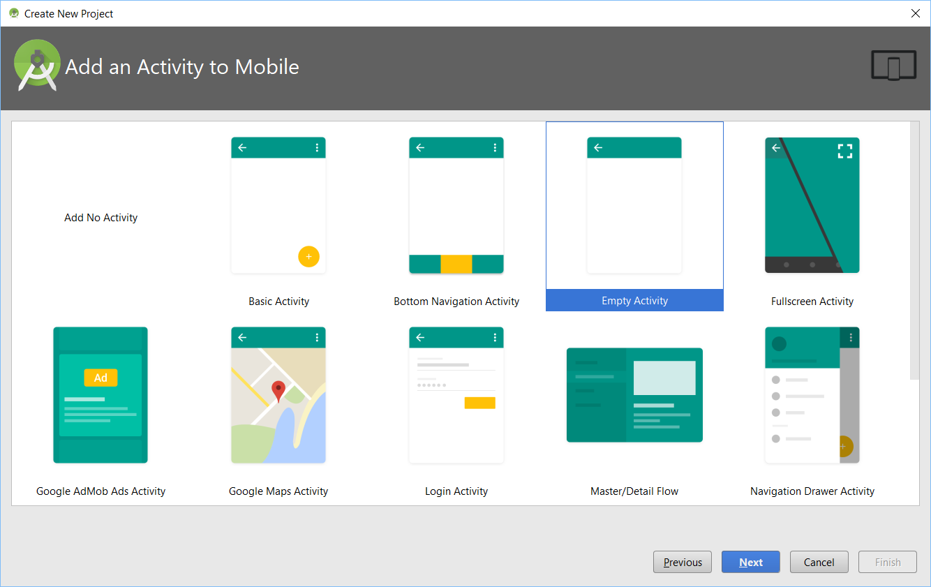

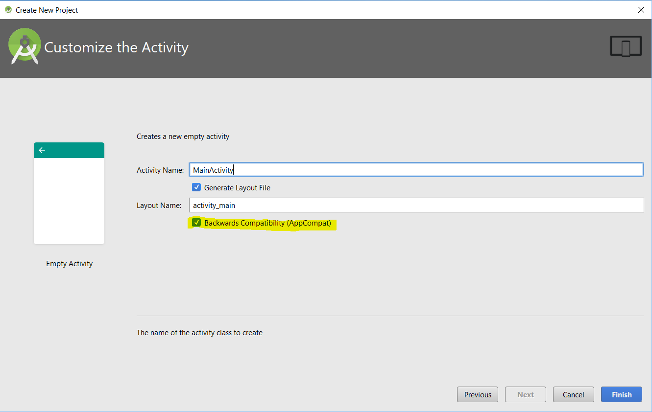

File >> Project Structure

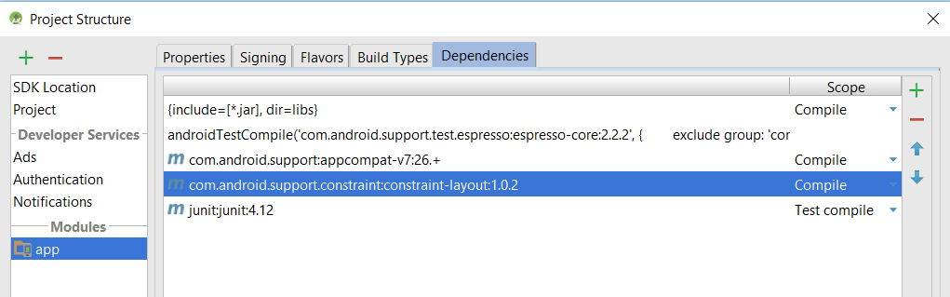

Add these string resources:

<string name="to_label">To:</string>

<string name="email_hint">Enter email address</string>

<string name="subject_hint">Subject</string>

<string name="message_hine">Message</string>

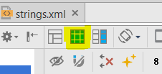<string name="send_button">Send</string>

### Constraints

Switch to design view.

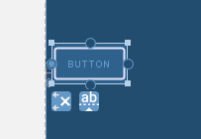Click on “Blueprint” toolbar to only show blueprint view:

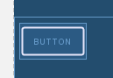Drag a button into the design view.

Attach a left constraint to the left edge of screen.

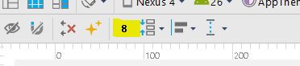Attach a vertical constraint to top edge of window.

Default Margin size can be changed here:

You can also change the margins here:

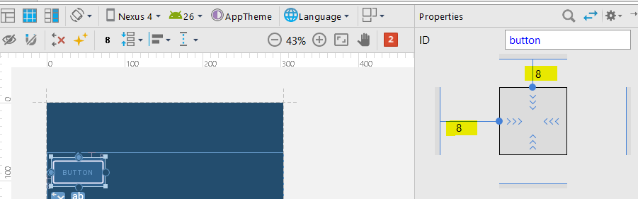

The button XML now looks like this:

<Button

android:id="@+id/button"

android:layout_width="wrap_content"

android:layout_height="wrap_content"

android:text="Button"

android:layout_marginLeft="24dp"

app:layout_constraintLeft_toLeftOf="parent"

app:layout_constraintTop_toTopOf="parent"

android:layout_marginTop="24dp" />

**Center button**

Add two contraints to opposite sides of the control.

**Move button left and right**

This is done by changing the *bias*.

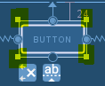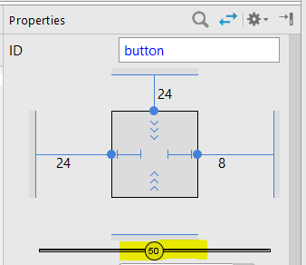

**Changing the control size:**

1. Resize control by dragging size handles
2. As big as contents:

Set layout_width & layout_height to be wrap_content

1. Match the view constraints by setting width and/or height to 0dp.

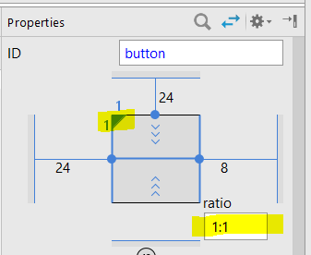layout_width="0dp"

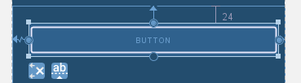

1. Match the views constraints.

Change width or height to 0dp then click here. This will display the ratios input field

**Adding more controls**

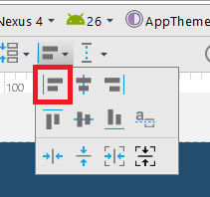Drag a second button to the blueprint.

Draw a constraint from top of second button to bottom of first button.

To align left edges, selct both buttons and select “Align Left Edges”

This creates a constraint from left edge of second button to left edge of first button:

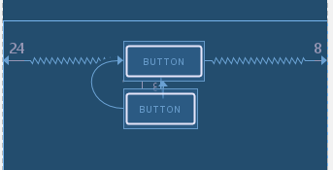

Infer constraints:

Add controls in the places you want them to be then click on infer constraints. A good guess is make by the IDE and appropriate constraints are added.

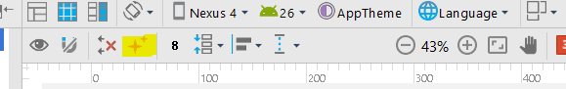

Setup UI so it looks like this:

