Build Interactive Apps

We will build an app that looks like this:

User selects a continent from the spinner (drop-down-list) then clicks button. Countries in the continent then get displayed.

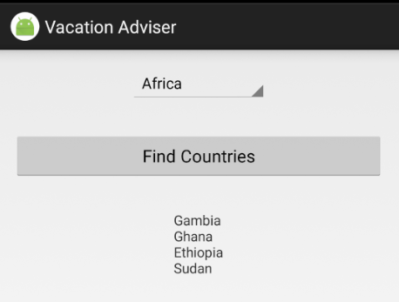

Create a new project named “Vacation Adviser”.

Choose “Empty Activity”.

On the “Customize the Activity” dialog, uncheck “Backwards Compatibility (AppCompat).

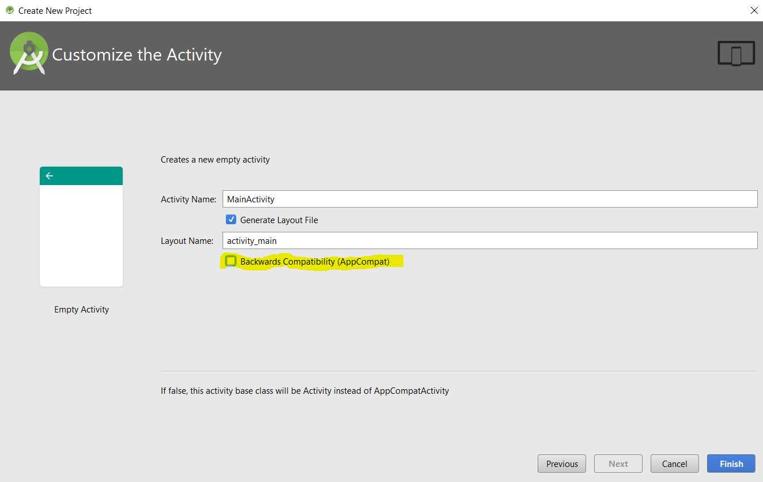

Add the following to strings.xml:

<string name="find_country">Find Countries</string>

<string name="countries">No continent selected</string>

<string-array name="continents">

<item>Asia</item>

<item>Africa</item>

<item>Australia</item>

<item>Europe</item>

<item>North America</item>

<item>South America</item>

</string-array>

Change the layout XML to LinearLayout

Add orientation of LinearLayout to vertical: *android:orientation="vertical"*

Replace controls in the layout with the following:

<Spinner

android:id="@+id/continent"

android:layout_width="wrap_content"

android:layout_height="wrap_content"

android:layout_gravity="center"

android:layout_margin="16dp"

android:layout_marginTop="40dp"

android:entries="@array/continents" />

<Button

android:id="@+id/button"

android:layout_width="match_parent"

android:layout_height="wrap_content"

android:layout_margin="16dp"

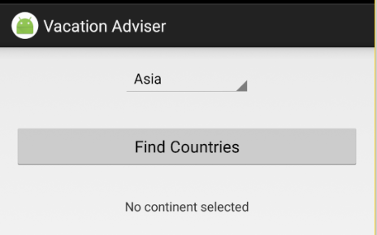 android:gravity="center"

android:text="@string/find_country" />

<TextView

android:id="@+id/country"

android:layout_width="wrap_content"

android:layout_height="wrap_content"

android:layout_gravity="center"

android:layout_margin="16dp"

android:text="@string/countries" />

Run the app:

Clicking on the button does nothing.

Let us add a class that provides data about Countries in Continents. Add a Java class named *ContinentExpert* with following code:

public class ContinentExpert {

List<String> getCountries(String continent) {

List<String> countries = new ArrayList<>();

switch (continent) {

case "Africa":

countries.add("Gambia");countries.add("Ghana");

countries.add("Ethiopia");countries.add("Sudan");

break;

case "North America":

countries.add("Mexico");countries.add("Canada");

countries.add("USA");

break;

case "South America":

countries.add("Brazil");countries.add("Ecuador");

countries.add("Chile");countries.add("Peru");

break;

case "Asia":

countries.add("China");countries.add("Japan");

countries.add("Korea");countries.add("India");

break;

case "Australia":

countries.add("Australia");

break;

case "Europe":

countries.add("UK");

countries.add("Germany");countries.add("France");

countries.add("Sweeden");countries.add("Greece");

countries.add("Portugal");countries.add("Spain");

countries.add("Italy");

break;

}

return countries;

}

}

Add the following to the *Button* control:

android:onClick="onClickFindCountry"

Add this instance variable to the Activity class.

private ContinentExpert expert = new ContinentExpert();

Add following event handler method to the Activity file:

public void onClickFindCountry(View v) {

TextView country = (TextView) findViewById(R.id.country);

Spinner continents = (Spinner) findViewById(R.id.continent);

String continent = String.valueOf(continents.getSelectedItem());

List<String> countryList = expert.getCountries(continent);

StringBuilder formattedCountries = new StringBuilder();

for (String item : countryList) {

formattedCountries.append(item).append('\n');

}

country.setText(formattedCountries);

}

Run the application.

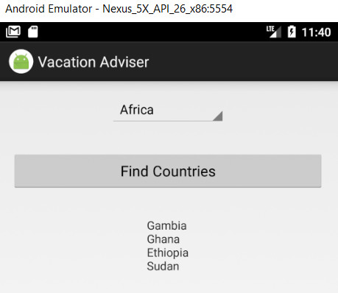

The application works as expected.