# **GAME TWO – TOMB RAIDER: THE DARK RENAISSANCE – CHARACTER SKILLS**

# BASIC SKILLS FOR LARA AND KURTIS:

* **LADDERS** – Characters can climb onto or off the ladder. On ladder, they can either climb up or down or jump backwards.

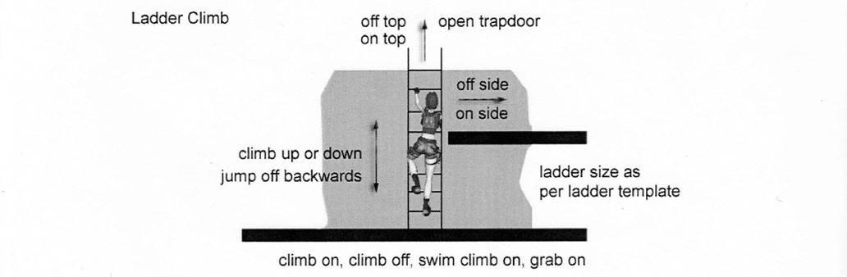  
To be decided: if Lara can get off the ladder earlier (and go left/right like TRAOD).

* **DRAINPIPES** – Characters can climb onto or off the drainpipe. On drainpipe, they can either climb up or down or jump backwards. On top, characters can grab ledges.

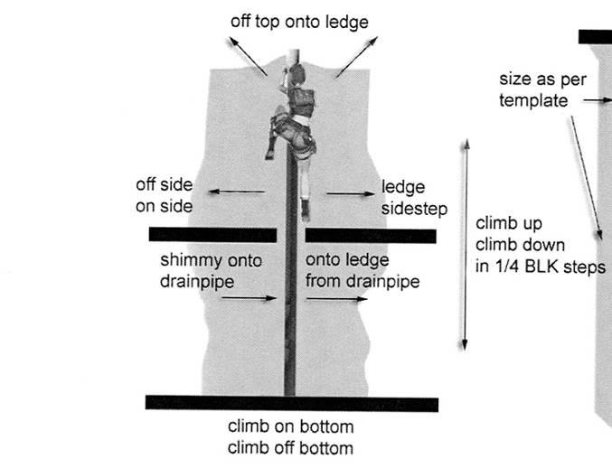  
To be decided: if Lara can go from pipe to shimmy earlier, not only on top.

* **PIPES/CABLES** – Characters can jump and grab a cable. On pipe, they can either swing forward or backwards. They can reverse 180degree. They can lift legs to crawl position, to avoid obstacles. While crawling, they can move forward or backwards.

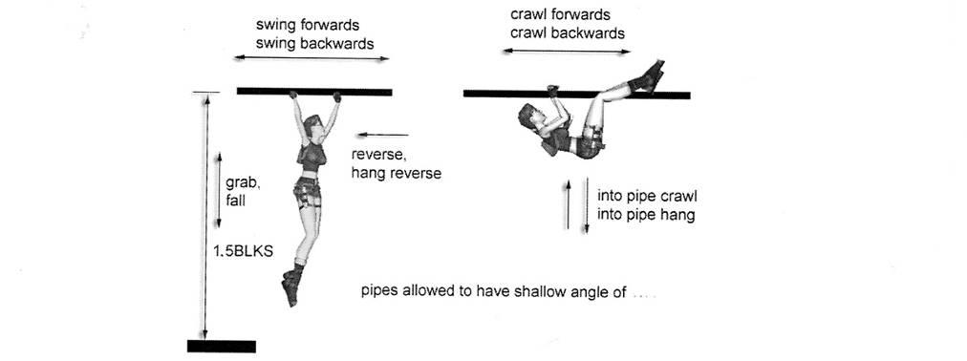

* **WALL CLIMBING** – Characters can climb onto a climbable wall surface. From there, they can either move in a classic way or 45degree into any direction. They can also climb on 45degree backwards slope. While there, they can either move up or down. On top, she can either move into regular wall climbing, or into monkeyswing.

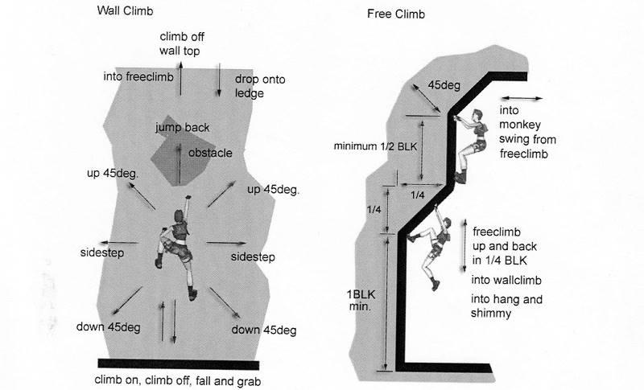  
To be decided: if Lara can go from freeclimb to shimmy on slopes.

* **MONKEYSWING** – Characters can jump and grab onto a monkey swing surface. Apart from classic movement, they can now reverse 180degree or turn into wall climbing.

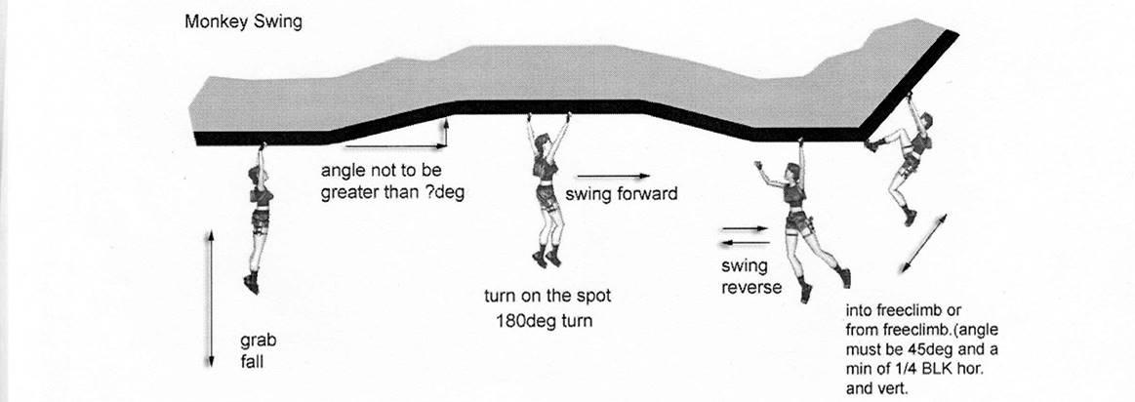

* **CLIMB THROUGH WINDOW/BANISTER** – Characters can climb through windows and banisters that are 2-click high. If there is floor on the other side, they will go into stance. If there is no floor, they will go into fall animation.

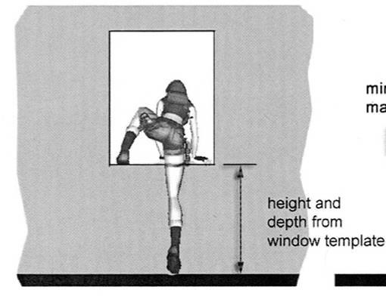

* **SPRINT** – Characters can sprint just like in classic games. While sprinting they can either roll or make a big jump. While rolling, characters can go into crawl. While jumping, characters can either land freely or grab ledge. Characters can jump over 4square wide holes.

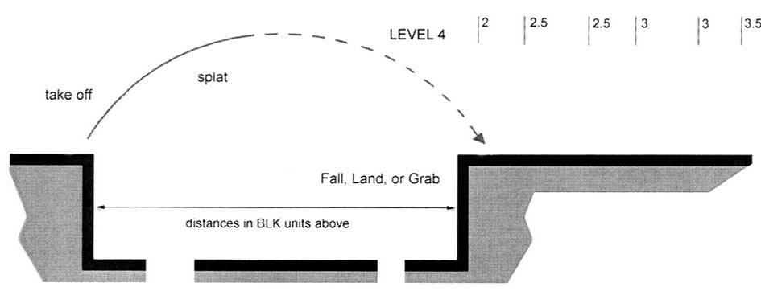

# KURTIS SKILLS:

* **CHIRUGAI** – Kurtis can draw Chirugai and use it as a weapon. When taken, Kurtis goes into aiming mode. He can then throw weapon. After that, he can steer weapon for a limited time to attack more enemies. While using Chirugai, his mana meter decreases. After either time or mana runs out, he catches Chirugai. Then he can use it again if he has mana, or holster.

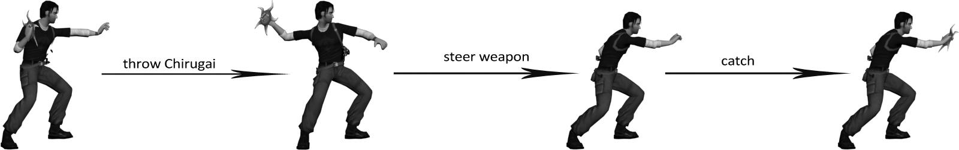

IDEA: Maybe we could implement this behaviour as a custom vehicle using plugins?

* **DOUBLE JUMP** – if you press jump again while jumping, Kurtis will perform double jump. Then he can either grab ledge or land freely. Double jump allows jumping higher, making it possible to reach 6clic or 8click high ledges(TBD).

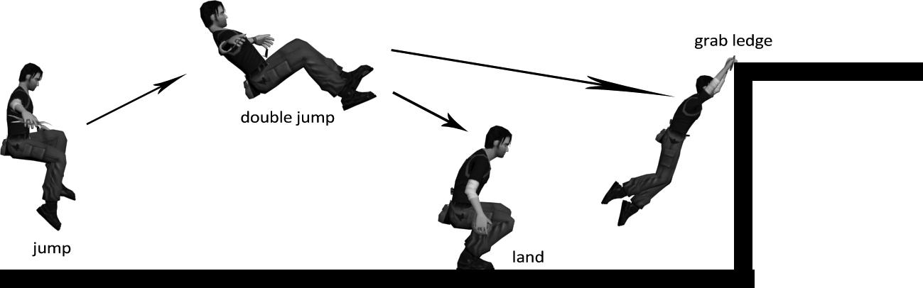

* **PSYCHIC SHIELD** – Kurtis can use a psychic shield that will protect him from any damage. It works like a weapon. When selected, Kurtis will go into protection mode. While in this mode, he cannot be attacked, but he also cannot move.

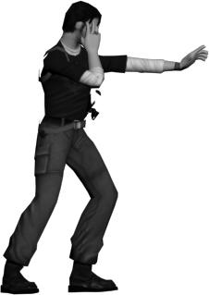

* **DRAIN POWER** – Kurtis can drain health from enemies and turn it into HP/MP. It is used like a weapon. When selected and drawn, Kurtis will go into aim mode. Then, when clicked action, he can drain power from selected enemy. While draining power he is unable to move and is vulnerable to any attack. TBD: if enemies’ health increase Kurtis’ HP or MP.

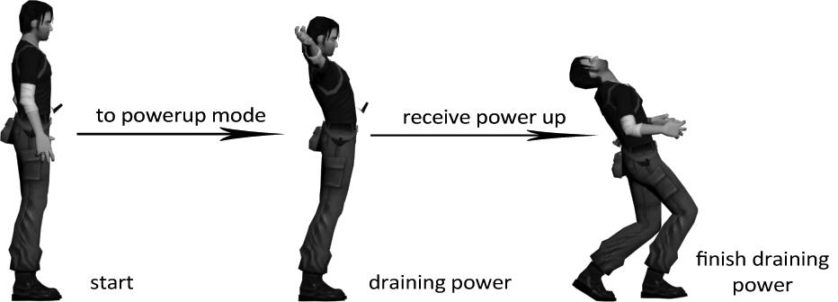

* **Farsight** – Kurtis can use his psychic ability to come out of his body. When using this method he can see places that can’t be reached in a normal way. Once selected in the inventory screen, Kurtis will go into farsight mode. While in this mode, player can move camera freely for a limited period of time (or to a specified distance). After time runs out, or the camera is too far from Kurtis, the camera will jump back to Kurtis.

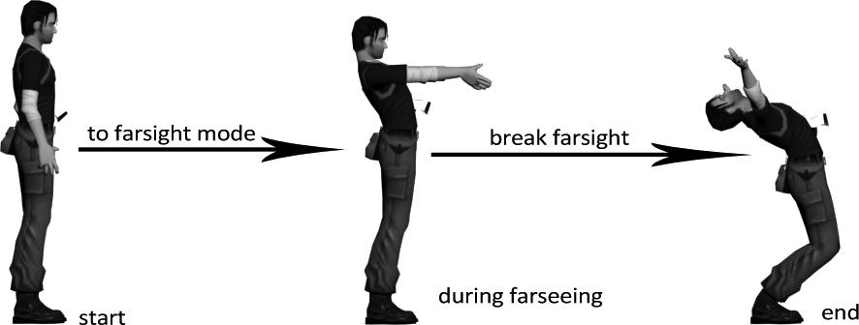

IDEA: Farsight ability could also be achieved using plugins and custom vehicle. Alternative option is to make it trigger cutscenes when used in correct places (a bit like puzzles).  
EXAMPLE: <https://www.youtube.com/watch?v=vgVpGpVCckE>

# POSSIBLE SKILLS FOR KURTIS AND LARA (TO BE DECIDED):

* **Hand-to-hand combat** – is it actually needed? Lara has her trusty dual pistols now, while Kurtis can always use Boran X. Both weapons have unlimited ammo.
* **Stealth** – should we implement stealth mechanics? If yes, how could we use it in our levels? Our GAME TWO consists of tombs and ancients places only and characters have weapons all the time. There is no need for stealth mechanics.
* **Throwing grenades (LARA ONLY)** – we could use GRENADE_LAUNCHER slot. Instead of a full launcher though, Lara would throw grenades over arm just like flares.