This publication, including all photographs, illustrations and software, is protected under international copyright laws, with all rights reserved. Neither this manual, nor any of the material contained herein, may be reproduced without the express written consent of the manufacturer.
The information in this document is subject to change without notice. The manufacturer makes no representations or warranties with respect to the contents hereof and specifically disclaims any implied warranties of merchantability or fitness for any particular purpose. Further, the manufacturer reserves the right to revise this publication and to make changes from time to time in the content hereof without obligation of the manufacturer to notify any person of such revision or changes.

Trademarks
IBM, VGA, and PS/2 are registered trademarks of International Business Machines.
Intel, Pentium, Pentium-II, Pentium-III, MMX, and Celeron are registered trademarks of Intel Corporation.
Microsoft, MS-DOS and Windows 95/98/NT/2000 are registered trademarks of Microsoft Corporation.
PC-cillin and ChipAwayVirus are trademarks of Trend Micro Inc.
AMI is a trademark of American Megatrends Inc.
A3D is a registered trademark of Aureal Inc.
SuperVoice is a registered trademark of Pacific Image Communications Inc.
MediaRing Talk is a registered trademark of MediaRing Inc.
3Deep is a registered trademark of E-Color Inc.
Other names used in this publication may be trademarks and are acknowledged.

Copyright © 2001
All Rights Reserved
M755 Series, V7.1B
S63T/April 2001
Notice:
- Please avoid to do “Clear CMOS” and “reFlash BIOS” operations simultaneously.
- If the user needs to do the above operations simultaneously, the user must to reprogram the LAN ID, and its procedure is as follows:
- You may find the LAN ID on the motherboard at least.
- You may find the programming utility (EE.ZIP) on our Web site – http://www.pcchips.com.tw/bios.html or on the Driver CD disc (\LAN\SiS900\Utility\).
- Please follow the “README.TXT” (After unzipping EE.ZIP or under the directory \LAN\SiS900\Utility\) instruction to reprogram your LAN ID.

Table of Contents

Chapter 1: Introduction 1
Key Features 2
Package Contents 5
Static Electricity Precautions 6
Pre-Installation Inspection 6
Chapter 2: Mainboard Installation 7
Mainboard Components 8
Install A CPU 9
Install Memory 10
Setting Jumper Switches 11
Install the Mainboard 13
Install the Extension Brackets 14
Optional Extension Brackets 18
Install Other Devices 20
Expansion Slots 22
Chapter 3: BIOS Setup Utility 25
Introduction 25
Running the Setup Utility 26
Standard CMOS Setup Page 27
Advanced Setup Page 28
Power Management Setup Page 30
PCI / Plug and Play Setup Page 32
Load Optimal Settings 33
Load Best Performance Settings 33
Features Setup Page 34
CPU PnP Setup Page 36
Hardware Monitor Page 37
Change Password 37
Exit 38
Chapter 4: Software & Applications 39
Introduction 39
Installing Support Software 39
Installing Under Windows 98 41

Chapter 1

Introduction

This mainboard has a Socket 370, which uses either an Intel PPGA/FCPGA Celeron or FCPGA Pentium III processor.

This mainboard supports front-side bus speeds of 66MHz, 100MHz or 133MHz.

This mainboard uses the GFXcel chipset which provides CPU Plug & Play through firmware, integrates a 128-bit AGP Graphics Accelerator and has an embedded 10BaseT/100BaseTX Network Interface. The mainboard has a built-in AC97 Codec and provides an AMR slot to support Audio and Modem application. In addition, the mainboard has a full set of I/O Ports including a keyboard port, a parallel port, a serial port and a VGA port. And optional two USB ports, a PS/2 mouse port, a Infrared port can be added using the ATX Form card, two extra USB ports can be added using the optional Extended USB Module that connects to the mainboard.

This mainboard has all the features you need to develop a powerful multimedia workstation that is network ready. The board is Baby-AT size and has power connectors for AT/ATX power supply.

Key Features
The key features of this mainboard include:

Socket-370 Processor Support
- Supports PPGA/FCPGA Celeron and FCPGA Pentium III CPUs
- Supports 66MHz, 100MHz or 133MHz FSB

All processors are automatically configured using firmware and a synchronous/asynchronous Host/DRAM Clock Scheme.

Memory Support
- Two DIMM slots for 168-pin SDRAM memory modules
- Support for 66MHz, 100MHz, & 133MHz memory bus
- Maximum installed memory is 2 x 512MB = 1 GB

Expansion Slots
- Two 32-bit PCI slots
- AMR slot for a special audio/modem riser card

Onboard IDE channels
- Primary and Secondary PCI IDE channels
- Support for PIO (programmable input/output) modes
- Support for Multiword DMA modes
- Support for Bus Mastering and Ultra DMA 33/66 modes

Power Supply and Power Management
- AT/ATX power supply connector
- ACPI and previous PMU support, suspend switch, keyboard power on/off
- Supports Wake on Modem, Wake on LAN and Wake on Alarm

Built-in Graphics System
- Onboard 128-bit 2D/3D 100MHz Host interface AGP Graphics Accelerator Complies with AGP V2.0
- Shared memory architecture allows a maximum of 64 MB main memory to act as frame buffer
- Supports high resolutions up to 1920x1200 16M colors, up to 2048x2048 Texture size and Virtual screen up to 4096x4096
- Supports hardware DVD Accelerator

AC97 Codec
- Compliant AC97 2.1 specification
- Supports 18-bit ADC (Analog Digital Converter) and DAC (Digital Analog Converter) as well as 18-bit stereo full-duplex codec

Onboard I/O Ports
- Provides PC99 Color Connectors for easy peripheral device connections
- Floppy disk drive connector with 1Mb/s transfer rate
- One serial port with 16550-compatible fast UART
- One parallel port with ECP and EPP support
- Optional ATX form card provides two USB ports, a mini-DIN port for a PS/2 mouse and one mini-DIN port for infrared
- Optional extended USB module provides extra two USB ports

Built-in Ethernet LAN
- 10BaseT/100BaseTX Ethernet LAN
- LAN controller integrates Fast Ethernet MAC and PHY compliant with IEEE802.3u 100BASE-TX, 10BASE-T and ANSI X3.263 TP-PMD standards
- Compliant with ACPI 1.0 and the Network Device Class Power Management 1.0
- High Performance provided by 100Mbps clock generator and data recovery circuit for 100Mbps receiver

Onboard Flash ROM
- Automatic CPU and board configuration
- Supports Plug and Play configuration of peripheral devices and expansion cards
- Built-in virus protection using Trend’s ChipAwayVirus provides boot process virus protection.

Bundled Software
- PC-Cillin2000 provides automatic virus protection under DOS, Windows 95/98/NT/2000
- SuperVoice is data, fax and voice communication software
- MediaRing Talk provides PC to PC or PC to Phone internet phone communication
- 3Deep delivers the precise imagery and displays accurate color in your monitor
- WinDVD2000 is a DVD playback application (optional)

Dimensions
- Baby-AT form factor (22cm x 22cm)

Package Contents
Attention: This mainboard series includes four different models. They are M755LMR (LAN/Modem Ready), M755LR (LAN Ready), M755MR (Modem Ready) and M755 (without LAN & Modem).
Please contact your local supplier for your purchase model.
Each model will support different specification, list as below:
Model | Specification
M755LMR | Onboard LAN header (LAN1), LAN extension bracket and an AMR v.90 56K Fax/Modem card
M755LR | Onboard LAN header (LAN1) and LAN extension bracket
M755MR | Support an AMR v.90 56K Fax/Modem card
M755 | ---

Your mainboard package ships with the following items:
- The mainboard
- This User’s Guide
- 1 UDMA/66 IDE cable
- Floppy disk drive cable
- Audio ports and Game/MIDI port extension bracket
- Serial/Parallel ports extension bracket
- VGA extension bracket
- Support software on CD-ROM disk

Optional Accessories
You can purchase the following optional accessories for this mainboard.
- ATX Form card for 2 USB ports, an IR port and a PS/2 port
- Extended USB module

Static Electricity Precautions
Components on this mainboard can be damaged by static electricity. Take the following precautions when unpacking the mainboard and installing it in a system.
- Keep the mainboard and other components in their original static-proof packaging until you are ready to install them.
- During installation, wear a grounded wrist strap if possible. If you don’t have a wrist strap, discharge static electricity by touching the bare metal of the system chassis.
- Handle the mainboard carefully by the edges. Avoid touching the components unless it is absolutely necessary. During installation put the mainboard on top of the static-protection packaging it came in with the component side facing up.

Pre-Installation Inspection
- Inspect the mainboard for damage to the components and connectors on the board.
- If you suspect that the mainboard has been damaged, do not connect power to the system. Contact your mainboard vendor and report the damage.

Chapter 2

Mainboard Installation

To install this mainboard in a system, follow the procedures in this chapter:

- Identify the mainboard components
- Install a CPU
- Install one or more system memory modules
- Verify that any jumpers or switches are set correctly
- Install the mainboard in a system chassis (case)
- Connect any extension brackets or cables to the mainboard connector headers
- Install any other devices and make the appropriate connections to the mainboard connector headers.

Note:
- Before installing this mainboard, make sure jumper JP3 is set to Normal, the default setting. See this chapter for information on locating JP3 and the setting options.
- Never connect power to the system during installation. Doing so may damage the mainboard.

Mainboard Components
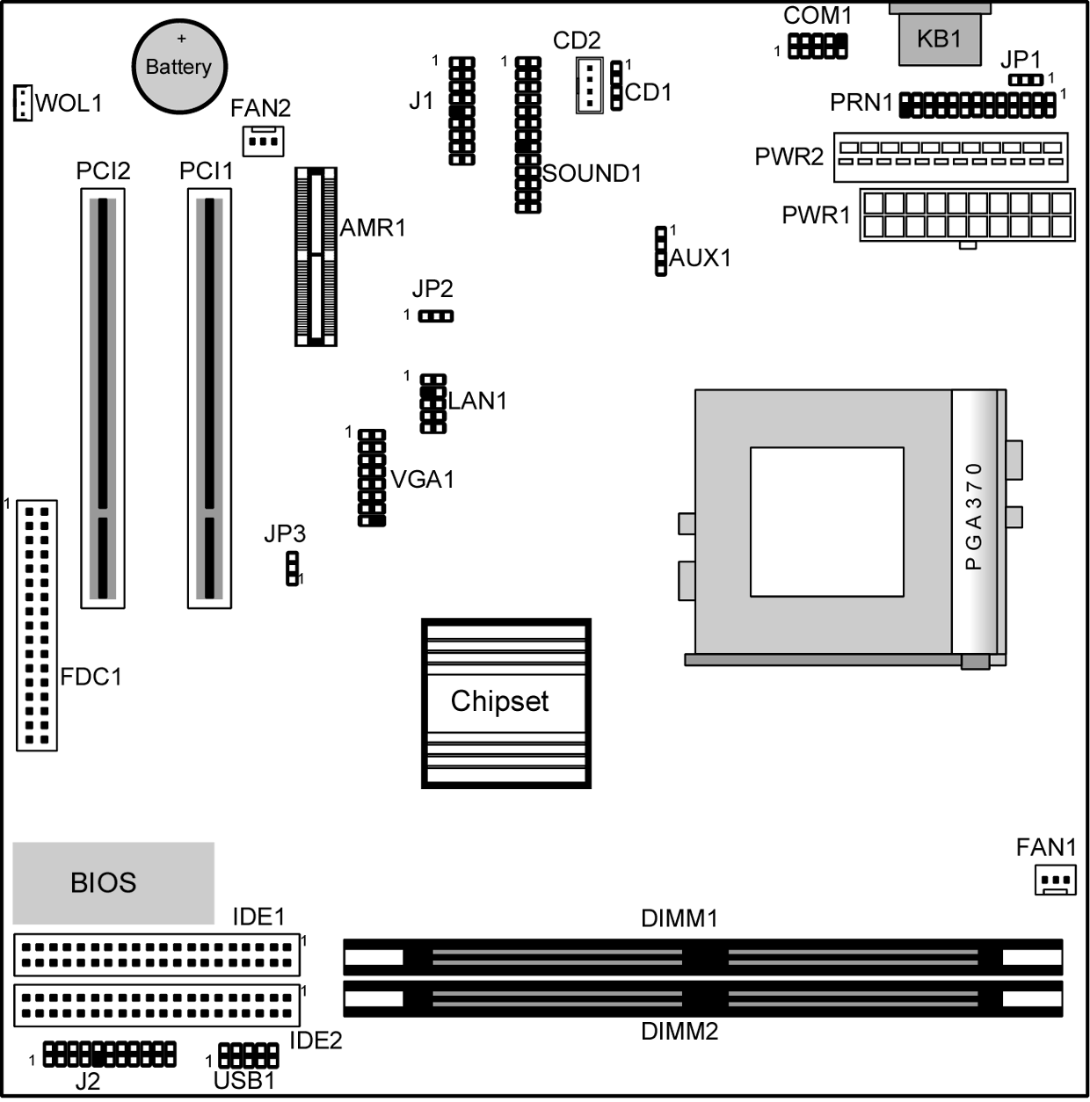
Use the diagram below to identify the major components on the mainboard.

Note: Any jumpers on your mainboard that do not appear in this illustration are for testing only.

Install A CPU
This mainboard has a Socket 370 which supports PPGA/FCPGA Celeron and FCPGA Pentium III processors.

To ensure reliability, ensure that your processor has a heatsink/cooling fan assembly.

Do not try to install a Socket 7 processor in the Socket-370. A Socket 7 processor such as the Pentium-MMX, or the AMD K5/K6 does not fit in the Socket 370.

The following list notes the processors that are currently supported by this mainboard.

PPGA/FCPGA Celeron: 300~700 MHz, FSB: 66 MHz
FCPGA Pentium III “Coppermine”: 500~1130MHz, FSB: 100MHz, 133MHz

Installing a Socket-370 Processor
A processor installs into the ZIF (Zero Insertion Force) Socket-370 on the mainboard.

- Locate the Socket-370 and FAN1. Pull the locking lever out slightly from the socket and raise it to the upright position.
Socket-370
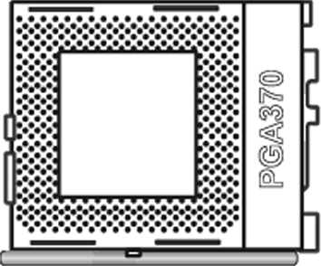
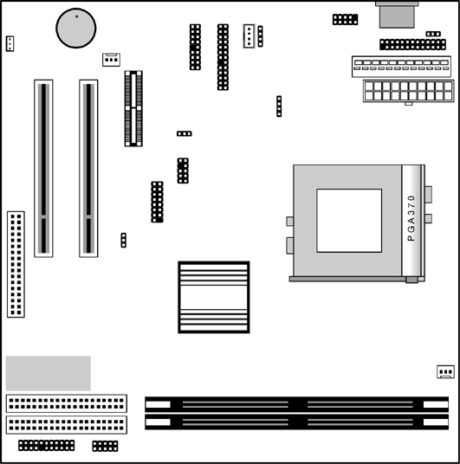

Pin-1 Corner

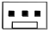
FAN1

- On the processor, identify the Pin-1 corner by its beveled edge.
- On the Socket-370, identify the Pin-1 corner. The Pin-1 corner is at the end of the locking lever when it is locked.
- Match the Pin-1 corners and insert the processor into the socket. No force is required and the processor should drop into place freely.
- Swing the locking lever down and hook it under the catch on the side of the socket. This secures the CPU in the socket.
- All processors should be installed with a combination heatsink/cooling fan, connect the cable from the fan to the CPU fan power connector FAN1.

Install Memory
The mainboard has two DIMM sockets for system memory modules. You must install at least one memory module in order to use the mainboard. You must install the first memory module in the DIMM1 socket to provide shared memory to the onboard VGA display circuitry.

DIMM2

DIMM1

For this mainboard, you must use 168-pin, 3.3V unbuffered SDRAM memory modules. If the installed CPU uses a 100 MHz system bus, you must use PC100/PC133 memory. If the installed CPU uses a 66 MHz system bus, you must use PC66/PC100 memory. You can install any size memory module from 16MB to 512MB, so the maximum memory size is 2 x 512MB = 1 GB.

The edge connectors on the memory modules have cut outs, which coincide with spacers in the DIMM sockets so that memory modules can only be installed in the correct orientation.

To install a module, push the retaining latches at either end of the socket outwards. Position the memory module correctly and insert it into the DIMM socket. Press the module down into the socket so that the retaining latches rotate up and secure the module in place by fitting into notches on the edge of the module.

Setting Jumper Switches
Jumpers are sets of pins which can be connected together with jumper caps. The jumper caps change the way the mainboard operates by changing the electronic circuits on the mainboard. If a jumper cap connects two pins, we say the pins are SHORT. If a jumper cap is removed from two pins, the pins are OPEN.
JP1
1

JP3

JP2
1
1

Jumper JP1: Keyboard Power On Selector
If you enable the keyboard power on feature, you can use hot keys on your keyboard as a power on/off switch for the system.
Note: The system must provide 1A on the +5VSB (+5V Standby) signal before using the Keyboard Power On function.
Function | Jumper Setting
Disable Keyboard Power On | Short Pins 1-2
Enable Keyboard Power On | Short Pins 2-3

Jumper JP2: Wake On LAN Selector
This controls the LAN Wake Up feature where the system will wake up in response to a signal over a LAN it is connected to.
Note: The system must provide 1A on the +5VSB (+5V Standby) signal in order for this feature to work.
Function | Jumper Setting
Disable | Short Pins 1-2
Enable | Short Pins 2-3

Jumper JP3: Clear CMOS Memory
Use this jumper to clear the contents of the CMOS memory. You may need to clear the CMOS memory if the settings in the Setup Utility are incorrect and prevent your mainboard from operating. To clear the CMOS memory, disconnect all the power cables from the mainboard and then move the jumper cap into the CLEAR setting for a few seconds.
Function | Jumper Setting
Clear CMOS Memory | Short Pins 1-2
Normal Operation | Short Pins 2-3

Install the Mainboard
Install the mainboard in a system chassis (case). The board is a Baby-AT size mainboard with a set of I/O ports. You can install this mainboard in any AT case. Ensure that your case has an I/O cover plate that matches the ports on this mainboard.

Install the mainboard in a case. Follow the instructions provided by the case manufacturer using the hardware and internal mounting points on the chassis.

FAN2

J2

PWR1
PWR2

Connect the power connector from the power supply to the PWR2/PWR1 AT/ATX Power connector on the mainboard. If there is a cooling fan installed in the system chassis, connect the cable from the cooling fan to the FAN2 fan power connector on the mainboard. Connect the case switches and indicator LEDs to the J2 switch and LED connector header. See the illustration below for a guide to the J2 connector pin assignments.
Power LED
Pins 2-4-6
Speaker
Pins 1-3-5-7
Keylock
Pins 8-10
2
1
Reset Switch
Pins 17-18
Power Button/Suspend
Switch Pins 21-22

+2
21
22
21
+2
21
+2
21
HDD LED
Pins 15-16
Suspend LED
Pins 19-20

Install the Extension Brackets
The extension brackets are used to connect features on the mainboard to external connectors that can be attached to the system chassis. Follow the steps below to install the extension brackets.

Note: All the ribbon cables used on the extension brackets have a red stripe on the Pin-1 side of the cable.

Audio Ports and Game/MIDI Port Extension Bracket
This bracket provides three audio jacks for stereo line in, stereo line out and microphone. In addition it has a 15-pin D-connector which can be used by either a joystick or a MIDI device.
If you are using a four channel speaker system, channel one and two are output through the Stereo Line-out, and the rear speaker channels three and four are output through Stereo Line-in.
SOUND1-
Audio Header
1

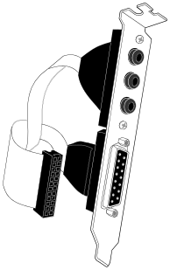
Audio Ports & Game/MIDI Extension Bracket
Stereo Line-in /Rear speaker channels 3-4
Microphone
Stereo Line-out /Speaker channels 1-2
Game/MIDI

- On the mainboard, locate the SOUND1 audio header for this bracket.
- Plug the cable from the bracket into the audio header.
- In the system chassis, remove a blanking plate from one of the expansion slots and install the extension bracket in the slot. Use the screw that held the blanking plate in place to secure the extension bracket.

Serial/Parallel Ports Extension Bracket
This bracket has one serial port - COM1 (9-pins) and one parallel port –PRN1 (25pins). On this mainboard, the second serial port is reserved for the Fax/Modem so you can only connect one of the serial ports to the manboard header COM1.

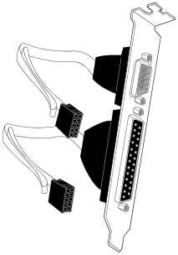
Serial Port
COM1
Parallel Port
LPT1
Serial/Parallel Ports
Extension Bracket
1
1
PRN1
COM1

- On the mainboard, locate the headers COM1 and PRN1 for this bracket.
- Plug the serial cable into COM1 and the parallel cable into PRN1.
- In the system chassis, remove a blanking plate from one of the expansion slots and install the extension bracket in the slot. Use the screw that held the blanking plate in place to secure the extension bracket.

VGA Extension Bracket
The VGA extension bracket has a 15-pin connector for an external monitor cable.
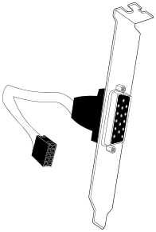
VGA1 Header
1
VGA Extension Bracket

- On the mainboard, locate the VGA1 header for this bracket.
- Plug the cable from the bracket into the header.
- In the system chassis, remove a blanking plate from one of the expansion slots and install the extension bracket in the slot. Use the screw that held the blanking plate in place to secure the extension bracket.

LAN Adapter Extension Bracket
This bracket supports an RJ45 network connector and connects to the built in LAN header on the mainboard.


1
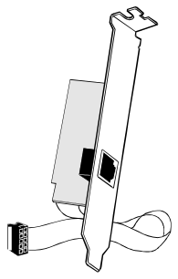

LAN Header

LAN Extension Bracket

- On the mainboard, locate the LAN header for this bracket.
- Plug the cable from the bracket into the LAN header.
- In the system chassis, remove a blanking plate from one of the expansion slots and install the extension bracket in the slot. Use the screw that held the blanking plate in place to secure the extension bracket.

Optional Extension Brackets
For this mainboard, you can also obtain an ATX form card and a USB module extension bracket. Install them by following the steps below.

ATX Form Card
This ATX Form Card provides a mini-DIN port for infrared, one mini-DIN port for a PS/2 mouse. In addition it has two USB (Universal Serial Bus) ports.
1
J1-ATX Header

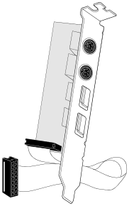
Infrared Port
USB Ports
ATX Form Card
PS/2 Mouse
Port

- On the mainboard, locate the J1 ATX header for this bracket.
- Plug the cable from the bracket into the ATX header.
- In the system chassis, remove a blanking plate from one of the expansion slots and install the extension bracket in the slot. Use the screw that held the blanking plate in place to secure the extension bracket.

Extended USB Module
This module bracket has two USB ports for more USB devices.

USB1 Header

GND
UV+
UV-
NC
VCC

VCC
NC
UV-
UV+
GND

- Locate the USB1 header on the mainboard.
- Plug the bracket cable onto the header.
- In the system chassis, remove a slot cover from one of the expansion slots and install the extension bracket in the opening. Use the screw that held the slot cover in place to secure the extension bracket to the chassis.

Install Other Devices
Install and connect any other devices in the system following the steps below.
1

FDC1

IDE2
1
1
IDE1

Floppy Disk Drive
The mainboard ships with a floppy disk drive cable that can support one or two drives. Drives can be 3.5” or 5.25” wide, with capacities of 360K, 720K, 1.2MB, 1.44MB, or 2.88MB.

Install your drives and connect power from the system power supply. Use the cable provided to connect the drives to the floppy disk drive header FDC1.

IDE Devices
IDE devices include hard disk drives, high-density diskette drives, and CD-ROM or DVD-ROM drives, among others.

The mainboard ships with an IDE cable that can support one or two IDE devices. If you connect two devices to a single cable, you must configure one of the drives as Master and one of the drives as Slave. The documentation of the IDE device will tell you how to configure the device as a Master or Slave device. The Master device connects to the end of the cable.

Install the device(s) and connect power from the system power supply. Use the cable provided to connect the device(s) to the Primary IDE channel connector IDE1 on the mainboard.

If you want to install more IDE devices, you can purchase a second IDE cable and connect one or two devices to the Secondary IDE channel connector IDE2 on the mainboard. If you have two devices on the cable, one must be Master and one must be Slave.

Internal Sound Connections
If you have installed a CD-ROM drive or DVD-ROM drive, you can connect the drive audio cable to the onboard sound system.
On the mainboard, locate the two 4-pin connectors CD1 and CD2. There are two kinds of connector because different brands of CD-ROM drive have different kinds of audio cable connectors. Connect the cable to the appropriate connector.

CD1
CD2
1

1 L
2 GND
3 GND
4 R
AUX1

Aux-In Connection
If you have installed a secondary CD-ROM drive or DVD-ROM drive, you can connect the drive audio cable to the onboard sound system.
On the mainboard, locate the 4-pin Aux-In header AUX1. Connect the cable to the connector.

Expansion Slots
This mainboard has two 32-bit PCI expansion slots and one AMR slot.
WOL connector
SB5V
GND
Signal

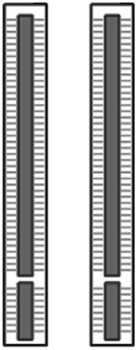

PCI2
PCI1
AMR1

Follow the steps below to install a PCI/AMR expansion card.

- Locate the AMR or PCI slots on the mainboard.
- Remove the slot cover for the expansion slot from the system chassis.
- Insert the expansion card edge connector into the slot and press it firmly down into it so that it is fully inserted.
- Secure the expansion card bracket to the system chassis using the screw that held the slot cover in place.

AMR Slot
The AMR (Audio Modem Riser) slot is an industry standard slot that allows for the installation of a special audio/modem riser card. Different territories have different regulations regarding the specifications of a modem card. You can purchase an AMR card that is approved in your area and install it directly into the AMR slot.

Wake On LAN (WOL)
If you are using an ATX power supply, you can configure your system so that it powers down by software and can be resumed by alarms. If you have installed a LAN adapter expansion card, connect the card to the Wake On LAN connector WOL1. This allows incoming traffic to resume the system from a software power down. You need to enable this feature in the system setup utility.

Chapter 3

BIOS Setup Utility

Introduction
The BIOS Setup Utility records settings and information about your computer such as the date and time, the kind of hardware installed, and various configuration settings. Your computer uses this information to initialize all the components when booting up and functions as the basis for coordination between system components.

If the Setup Utility configuration is incorrect, it may cause the system to malfunction. It can even stop your computer from booting properly. If this happens, you can use the clear CMOS jumper to clear the CMOS memory used to store the configuration information, or you can hold down the Page Up key while you reboot your computer. Holding down the Page Up key also clears the setup information.

You can run the setup utility and manually make changes to the configuration. You might need to do this to configure some of the hardware that you install on or connect to the mainboard, such as the CPU, system memory, disk drives, etc.

Running the Setup Utility
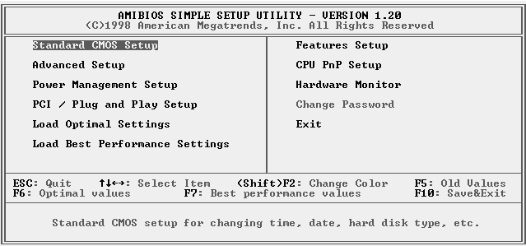
Each time your computer starts, before the operating system loads, a message appears on the screen that prompts you to “Hit <DEL> if you want to run SETUP”. When you see this message, press the Delete key and the Main menu page of the Setup Utility appears on your monitor.

You can use the cursor arrow keys to highlight any of the options on the main menu page. Press Enter to select the highlighted option. To leave the setup utility, press the Escape key. To cycle through the Setup Utility’s optional color schemes hold down the Shift key and press F2.
Some of the options on the main menu page lead to tables of items with installed values. In these pages, use the cursor arrow keys to highlight the items, and then use the PgUp and PgDn keys to cycle through the alternate values for each of the items. Other options on the main menu page lead to dialog boxes which require you to answer Yes or No by hitting the Y or N keys.
If you have already made changes to the setup utility, press F10 to save those changes and exit the utility. Press F5 to reset the changes to the original values. Press F6 to install the setup utility with a set of default values. Press F7 to install the setup utility with a set of high-performance values.

Standard CMOS Setup Page
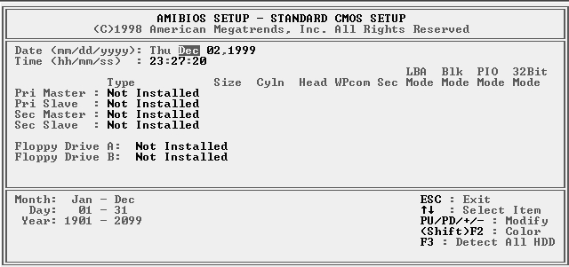
Use this page to set basic information such as the date and time, the IDE devices, and the diskette drives. If you press the F3 key, the system will automatically detect and configure the hard disks on the IDE channels.

Date & Time | Use these items to set the system date and time
Pri Master  Pri Slave  Sec Master  Sec Slave | Use these items to configure devices connected to the Primary and Secondary IDE channels. To configure an IDE hard disk drive, choose Auto. If the Auto setting fails to find a hard disk drive, set it to User, and then fill in the hard disk characteristics (Size, Cyls, etc.) manually. If you have a CD-ROM drive, select the setting CDROM. If you have an ATAPI device with removable media (e.g. a ZIP drive or an LS-120) select Floptical.
Floppy Drive A  Floppy Drive B | Use these items to set the size and capacity of the floppy diskette drive(s) installed in the system.

Advanced Setup Page
Use this page to set more advanced information about your system. Take some care with this page. Making changes can affect the operation of your computer.
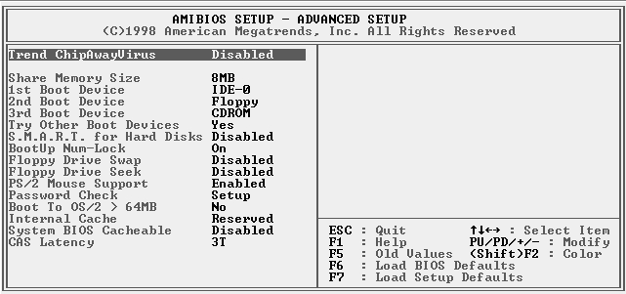

Trend ChipAway Virus | This mainboard has built-in virus protection in the firmware. Use this item to enable or disable the built-in virus protection.
Frame Buffer Cache Control | This item appears when a Frame Buffer Cache card is installed in the ADIMM socket. The default setting, Auto, automatically sets the display memory size. The Manual setting uses the next item to manually set display memory size.
Share Memory Size | This item lets you allocate a portion of the main memory for use by the onboard VGA display.
1st Boot Device  2nd Boot Device  3rd Boot Device | Use these items to determine the device order the computer uses to look for an operating system to load at start-up time.
Try Other Boot Device | If you enable this item, the system will also search for other boot devices if it fails to find an operating system from the first two locations.
S.M.A.R.T. for Hard Disks | Enable this item if any IDE hard disks support the S.M.A.R.T. (Self-Monitoring, Analysis and Reporting Technology) feature.
BootUp Num-Lock | This items determines if the Num Lock key is active or inactive at system start-up time.
Floppy Drive Swap | If you have two diskette drives installed and you enable this item, drive A becomes drive B and drive B becomes drive A.
Floppy Drive Seek | If you enable this item, your system will check all floppy disk drives at start up. Disable this item unless you are using an old 360KB drive.
PS/2 Mouse Support | If this item is set to Enabled, the onboard PS/2 Mouse port will work. Setting this to Disable turns off the port.
Password Check | If you have entered a password for the system, use this item to determine if the password is required to enter the Setup Utility (Setup) or required both at start-up and to enter the Setup Utility (Always).
Boot to OS/2 > 64MB | Enable this item if you are booting the OS/2 operating system and you have more than 64MB of system memory installed.
Internal Cache | Leave this item enabled since all the processors that can be installed on this board have internal cache memory.
System BIOS Cacheable | If you enable this item, a segment of the system BIOS will be cached to main memory for faster execution.
CAS Latency | This item determines the operation of the SDRAM memory CAS (column address strobe). We recommend that you leave this item at the default value. The 2T setting requires faster memory that specifically supports this mode.

Power Management Setup Page
This page sets some of the parameters for system power management operation.

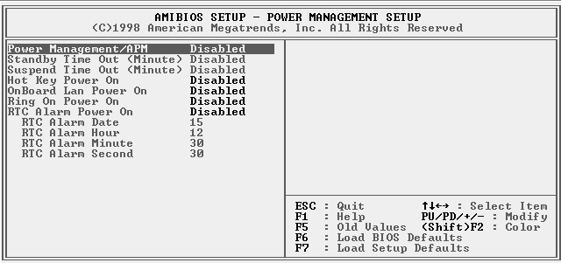

Power Management/APM | Use this item to enable or disable a power management scheme. If you enable power management, you can use the items below to set the power management operation. Both APM and ACPI are supported.
Standby Time Out (Minute) | This sets the timeout for Standby mode in minutes. If the time selected passes without any system activity, the computer will enter power-saving Standby mode.
Suspend Time Out (Minute) | This sets the timeout for Suspend mode in minutes. If the time selected passes without any system activity, the computer will enter power-saving Suspend mode.
Hot Key Power On | If you enable this item, you can turn the system on by pressing hot keys (Ctrl+Alt+BackSpace) on the keyboard. You must connect an ATX power supply and enable the jumper in order to use this feature.
OnBoard Lan Power On | The system can be turned off with a software command. If you enable this item, the system can automatically resume if there is traffic on the network adapter. You must use an ATX power supply in order to use this feature.
Ring On Power On | The system can be turned off with a software command. If you enable this item, the system can automatically resume if there is an incoming call on the Fax/Modem. You must use an ATX power supply in order to use this feature.
RTC Alarm Power On | The system can be turned off with a software command. If you enable this item, the system can automatically resume at a fixed time based on the system’s RTC (realtime clock). Use the items below this one to set the date and time of the wake-up alarm. You must use an ATX power supply in order to use this feature.

PCI / Plug and Play Setup Page
This page sets some of the parameters for devices installed on the PCI bus and devices that use the system plug and play capability.

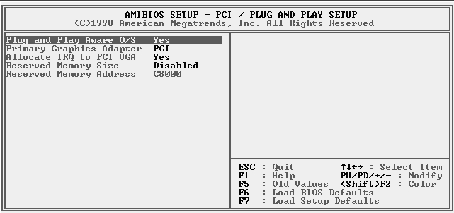

Plug and Play Aware O/S | Enable this item if you are using an O/S that supports Plug and Play such as Windows 95 or 98.
Primary Graphics Adapter | This item indicates if the primary graphics adapter uses the PCI or the AGP bus. The default PCI setting still lets the onboard display work and allows the use of a second display card installed in a PCI slot.
Allocate IRQ to PCI VGA | If this item is enabled, an IRQ will be assigned to the PCI VGA graphics system. You set this value to No to free up an IRQ.
Reserved Memory Size | This item lets you reserve a block of memory for any device that requires it.
Reserved Memory Address | This item lets you set the address for any block of memory that has been reserved.

Load Optimal Settings
If you select this item and press Enter a dialog box appears. If you press Y, and then Enter, the Setup Utility loads a set of fail-safe default values. These default values are not very demanding and they should allow your system to function with most kinds of hardware and memory chips.

Load Best Performance Settings
If you select this item and press Enter a dialog box appears. If you press Y, and then Enter, the Setup Utility loads a set of best-performance default values. These default are quite demanding and your system might not function properly if you are using slower memory chips or other low-performance components.

Features Setup Page
This page sets some of the parameters for peripheral devices connected to the system.

AMIBIOS SETUP – Features SETUP
(C) 2000 American Megatrends, Inc. All Rights Reserved
OnBoard FDC Enabled
OnBoard Serial PortA 3F8h/COM1
OnBoard IR Port Disabled
OnBoard Parallel Port 378h
Parallel Port Mode Normal
Parallel Port IRQ 7
Parallel Port DMA N/A
OnBoard Game Port Auto
OnBoard MIDI Port 300h
MIDI Port IRQ 10
OnBoard PCI IDE Both
Ultra DMA Support Disabled
OnChip Audio Enabled
OnChip Modem Enabled
OnBoard LAN Enabled
USB Function Enabled
USB Function for DOS Disabled
ESC : Quit ↑↓←→ : Select Item
F1 : Help PU/PD/+/- : Modify
F5 : Old Values (Shift)F2 : Color
F6 : Load Optimal values
F7 : Load Best performance values

OnBoard FDC | Use this item to enable or disable the onboard floppy disk drive interface.
OnBoard Serial PortA | Use this item to enable or disable the onboard COM1 serial port, and to assign a port address
OnBoard IR Port | Use this item to define the protocol for an infrared port if you have installed an optional IR port. The choices are IrDA and ASKIR.
Onboard Parallel Port | Use this item to enable or disable the onboard LPT1 parallel port, and to assign a port address. The Auto setting will detect and available address.
Parallel Port Mode | Use this item to set the parallel port mode. You can select SPP (Standard Parallel Port), ECP (Extended Capabilities Port), EPP (Enhanced Parallel Port), or ECP + EPP.
Parallel Port IRQ | Use this item to assign either IRQ 5 or 7 to the parallel port.
Parallel Port DMA | Use this item to assign a DMA channel to the parallel port. The options are 0, 1 and 3.
OnBoard Game Port | Use this item to enable or disable the onboard Game port.
OnBoard MIDI Port | Use this item to enable or disable the onboard MIDI port, and to assign a port address.
MIDI Port IRQ | Use this item to assign an IRQ to the MIDI port.
Onboard PCI IDE | Use this item to enable or disable either or both of the onboard Primary and Secondary IDE channels.
Ultra DMA Support | Use this item to set Ultra DMA support for IDE devices on the Primary or Secondary IDE channels. You must enable this or UDMA devices will not work at their intended speed.
OnChip Audio/ Modem | Use these items to enable or disable the onboard audio/modem chip.
OnBoard LAN | This item enables or disables the onboard network interface.
USB Function | Enable this item if you plan to use the USB ports on this mainboard.
USB Function for DOS | Enable this item if you plan to use the USB ports on this mainboard in a DOS environment.

CPU PnP Setup Page
This page lets you manually configure the mainboard for the CPU. The system will automatically detect the kind of CPU that you have installed and make the appropriate adjustments to the items on this page.
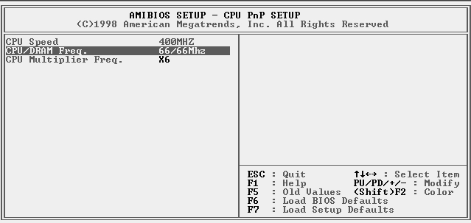
Note: If you manually set the wrong speed and the system won’t run properly, press the Page Up key while the system is booting and a default setting will replace the incorrect CPU setting.

CPU Speed | The item displays the internal clock speed of the CPU, based on the next two items.
CPU/SDRAM Frequency | Use this item to sets the external clock frequency for the CPU and the memory bus frequency. The options include combinations of 66 and 100MHz. Set the CPU clock based on the requirements of the CPU installed on the board. Select the memory frequency based on the speed of the memory installed on the board.
CPU Multiple Freq. | Use this item to set a multiplier for the CPU external frequency. The multiplier times the external CPU frequency sets the internal clock speed of the CPU, e.g. 100 MHz (external clock or “FSB”) x 4.5 (muliplier) = 450 MHz (internal clock speed of the installed CPU).

Hardware Monitor Page
This page sets some of the parameters for the hardware monitoring function of this mainboard.

AMIBIOS SETUP – HARDWARE Monitor
©1998 American Megatrends, Inc. All Rights Reserved
--- Hardware Monitor ---
Socket 370 30°C/86°F
Fan#1 Speed
Fan#2 Speed
Vcore 2.000 V
+1.800V 1.800 V
Vcc3 3.300 V
Vcc 5.000 V
+12V 12.000 V
SB5V 5.000 V
ESC : Quit ↑↓←→ : Select Item
F1 : Help PU/PD/+/- : Modify
F5 : Old Values (Shift)F2 : Color
F6 : Load Optimal values
F7 : Load Best performance values

Socket 370 | This item display CPU temperature measurement. The system will alert you if a safe temperature is exceeded.
FAN#1, 2 Speed & Voltage Measurements | These items indicate cooling fan speeds in RPM and the various system voltage measurements. If the values deviate beyond certain limits, the hardware monitoring feature will alert you with a warning.

Change Password
If you highlight this item and press Enter, a dialog box appears which lets you enter a Supervisor password. You can enter no more than six letters or numbers. Press Enter after you have typed in the password. A second dialog box asks you to retype the password for confirmation. Press Enter after you have retyped it correctly. The password is then required to access the Setup Utility or for that and at start-up, depending on the setting of the Password Check item in Advanced Setup.

Change or Remove the Password
Highlight this item, press Enter and type in the current password. At the next dialog box, type in the new password, or just press Enter to disable password protection.

Exit
Highlight this item and press Enter to save the changes that you have made in the Setup Utility configuration and exit the program. When the Save and Exit dialog box appears, press Y to save and exit, or press N to exit without saving.

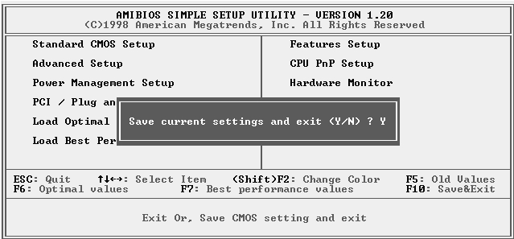

Chapter 4

Software & Applications

Introduction
The support software CD-ROM that is included in the mainboard package contains all the drivers and utility programs needed to properly run our products. Below you can find a brief description of each software program, and the location for your mainboard version. More information on some programs is available in a README file, located in the same directory as the software.
If the operating system used in your system is Windows 98, it will automatically install all the drivers and utilities for your board. See the Auto-Installing under Windows 98 section.

Installing Support Software
The software on the support CD-ROM is for Windows 95/NT/2000 and Windows 98. The installation procedure differs depending on which Operating System you have, but the automatic installation is now for Win98 only.

Installing Under Windows 95/NT/2000
To install support software for Windows 95/NT/2000 follow this general procedure:
- Insert the support CD-ROM disc in the CD-ROM drive.
(The system might get an error message from the PnP function. Don’t care the message. You don’t really need that file to install the drivers)
- Use My Computer or Windows Explorer to look at the directory structure. You must use the Open command in the right-button menu. Double-clicking on the drive icon will result in an error message because the disc’s AutoRun feature doesn’t work in Windows 95/NT/2000.
- Execute the EXE file name given in the description below.

Note: The correct path name for each software driver is provided, where D: identifies the CD-ROM drive letter – modify if necessary.

Bus Master IDE Driver
The IDE Bus Master Drivers allows the system to properly manage the IDE channels on the mainboard. You only need to install an IDE driver if you are running Windows 95. Use the default Windows driver on the Windows CD-ROM disc.

Display Drivers and Software
Find the Display drivers and software here:
- D:\VGA\SiS630\

Audio Driver
The Audio driver allows the system to use the onboard audio circuitry. Find the driver and audio application here:
- D:\SOUND\Driver\SiS\

Network Adapter Driver
Find the network interface driver here:
- D:\LAN\SiS900

AMR Modem Drivers and Software
Find the fax/modem drivers and software here:
- D:\Modem\Driver\AMR\PCtel\
- D:\Modem\SuperVoice\ [Telecom management software]
- D:\Modem\MediaRingTalk\

USB Driver
The USB Driver allows the system to recognize the USB ports on the mainboard. You need to install this driver if you are running Windows 95. Windows 95 OSR2 does not require this driver.
This driver is available for:
- Win95 – D:\USB\EUSBSUPP\USBSUPP.EXE
- Win95 (Chinese) – D:\USB\CUSBSUPP\CUSBSUPP.EXE

3Deep Software
Find the software here:
- D:\3Deep\3Deep 3.3\Setup.EXE

BIOS Update Utility
The BIOS Update utility allows you to update the BIOS file on the mainboard to a newer version. You can download the latest version of the BIOS setup available for your mainboard from the website.
- D:\UTILITY\AMINFxxx.EXE

PC-Cillin Software
The PC-cillin software program provides anti-virus protection for your system.
Find this program here:
- D:\PC-CILLIN\

Installing Under Windows 98
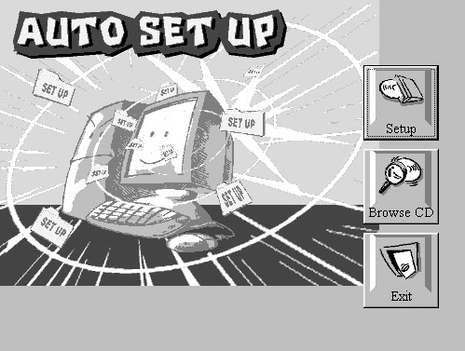
The support software CD-ROM disc loads automatically under Windows 98. When you insert the CD-ROM disc in the system CD-ROM drive the Autorun feature will automatically bring up the install screen. The screen has three buttons on it, Setup, Browse CD and Exit. See the following screen illustration.
When you click on the Setup button the software installation program will run and you can select what kind of installation you want to do, as explained later in this section.
The Browse CD button is the standard Windows command that allows you to examine the contents of the disc using the Windows 98 file browsing interface.
The Exit button closes the Auto Setup window. To run the program again, reinsert the CD-ROM disc in the drive or click on AutoRun in the context sensitive menu for the CD-ROM drive icon in a file browser window.

Installing Software with Auto Setup
To install support software for the system board follow this procedure:
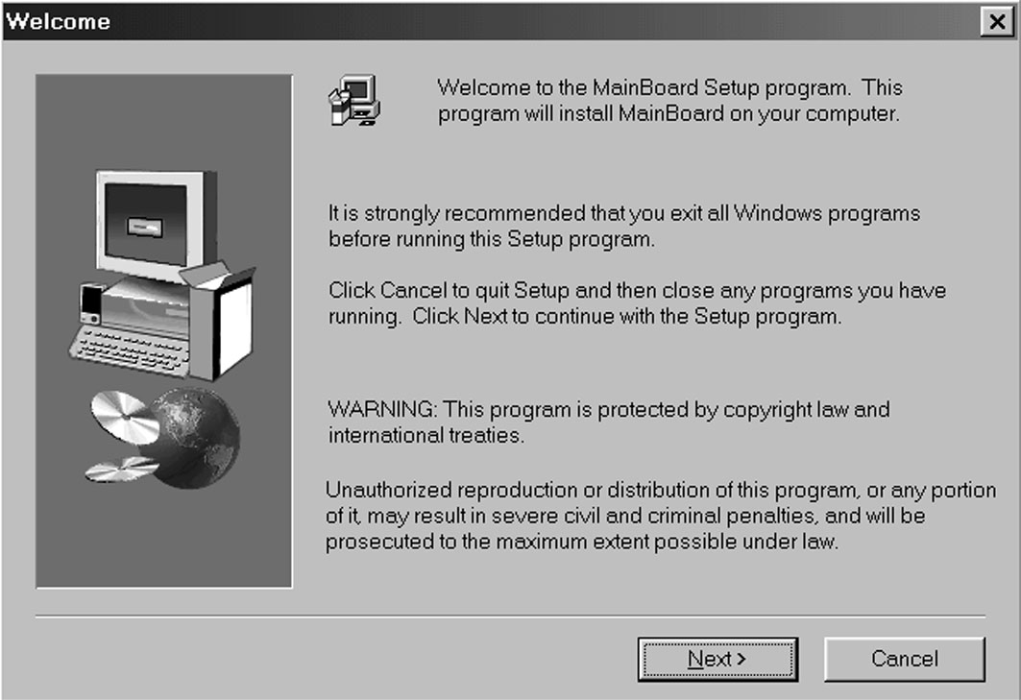
- Click on the Setup button. The install program will load and display the following screen. Click the Next button.
- Select the items that you want to setup by clicking on it (the default options are recommended). Click the Next button to proceed.
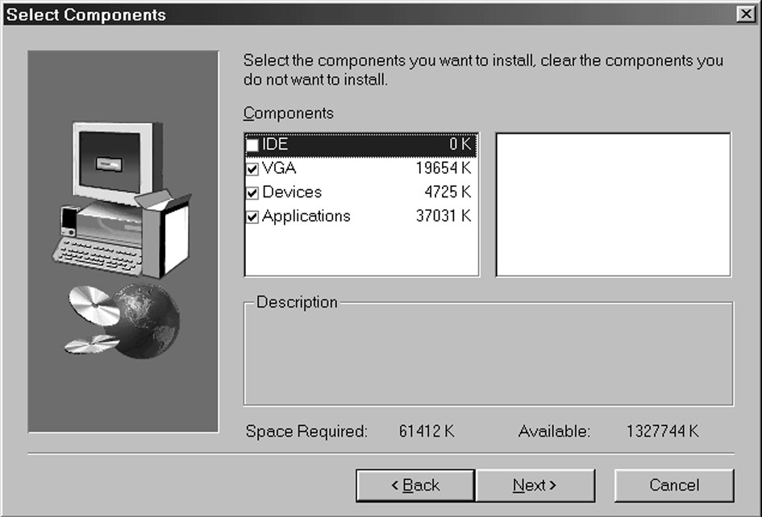
- The support software will automatically install.

Once any of the installation procedures start, software is automatically installed in sequence. You will need to follow the onscreen instructions, confirm commands and allow the computer to restart as few times as is needed to complete installing whatever software you selected to install. When the process is finished, all the support software will be installed and working.

There are some utilities that you have to manually install if you need, check to the above section.

