This publication, photographs, illustrations and software are under the protection of international copyright laws and all rights reserved. It does not allow any reproduction of this manual, content and any materials contained herein without the written consent of the authentic manufacturer.
The information in this manual is subject to change without notice. The manufacturer does neither represent nor warrant the contents hereof; and specifically disclaims any implied warranties of merchantability or fitness for any particular purpose. Furthermore, the manufacturer reserves the right to revise and change this publication from time to time, without the obligation of notifying any person of such revision or changes.

Trademarks
IBM, VGA, and PS/2 are registered trademarks of International Business Machines.
Intel, Pentium, Pentium-II, Pentium-III, Pentium-IV, MMX, Celeron and Tualatin are registered trademarks of Intel Corporation.
Microsoft, MS-DOS and Windows 95/98/NT/2000 are registered trademarks of Microsoft Corporation.
Sound Blaster is a trademark of Creative Technology Ltd.
PC-cillin is a trademark of Trend Micro Inc.
AMI is a trademark of American Megatrends Inc.
A3D is a registered trademark of Aureal Inc.
SuperVoice is a registered trademark of Pacific Image Communications Inc.
MediaRing Talk is a registered trademark of MediaRing Inc.
3Deep is a registered trademark of E-Color Inc.
Other names used in this publication may be trademarks and are acknowledged.

Copyright © 2001
All Rights Reserved
M758+ Series, V5.1
S63X/November 2001
Notice:
- Please avoid operating “Clear CMOS” and “reFlash BIOS” simultaneously.
- If users need to proceed the above operations simultaneously, they must reprogram the LAN ID and follow this procedure as bellow:
- You can at least find the LAN ID on the motherboard.
- You can find the programming utility (EE.ZIP) on our Web site – http://www.pcchips.com.tw/bios.html or on the Driver CD disc (\LAN\SiS900\Utility\).
- Please follow the “README.TXT” (After unzipping EE.ZIP or under the directory \LAN\SiS900\Utility\) instruction to reprogram your LAN ID.

- Owing to Microsoft’s certifying schedule is various to every
supplier, we might have some drivers not certified yet by
Microsoft. Therefore, it might happen under Windows XP that a dialogue box (shown as below) pop out warning you this
software has not passed Windows Logo testing to verify its
compatibility with Windows XP. Please rest assured that our
RD department has already tested and verified these drivers.
Just click the “Continue Anyway” button and go ahead the
installation.
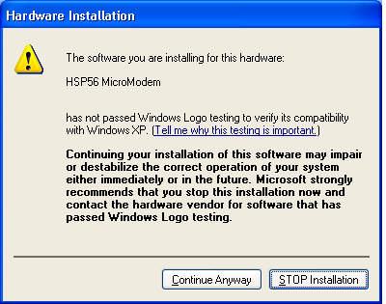
Table of Contents

Chapter 1: Introduction 1
Key Features 2
Package Contents 5
Static Electricity Precautions 6
Pre-Installation Inspection 6
Chapter 2: Mainboard Installation 7
Mainboard Components 8
I/O Ports 8
Install A CPU 9
Install Memory 11
Setting Jumper Switches 12
Install the Mainboard 14
Install the Extension Brackets 15
Optional Extension Brackets 16
Install Other Devices 17
Expansion Slots 19
Audio System Applications 19
Chapter 3: BIOS Setup Utility 23
Introduction 23
Running the Setup Utility 24
Standard CMOS Setup Page 25
Advanced Setup Page 26
Power Management Setup Page 28
PCI / Plug and Play Setup Page 30
Load Optimal Settings 31
Load Best Performance Settings 31
Features Setup Page 32
CPU PnP Setup Page 34
Hardware Monitor Page 35
Change Password 35
Exit 36
Chapter 4: Software & Applications 37
Introduction 37
Installing Support Software 37
Installing under Windows 98 39

Chapter 1

Introduction

This mainboard has a Socket-370 processor socket for Intel FCPGA Celeron, FCPGA Pentium III or Tualatin/Tualatin Celeron processors. You can install any one of these processors
on this mainboard.

This mainboard supports front-side bus speeds of 66MHz, 100MHz or 133MHz.

This mainboard has the GFXcel chipset which provides CPU Plug & Play through firmware, integrates a 128-bit AGP Graphics Accelerator and has an embedded 10BaseT/100BaseTX Network Interface. This mainboard has a built-in PCI 3D 5.1 Sound System and a V.90 Fax/Modem DAA module shipped with this mainboard. In addition, this mainboard has a full set of ATX I/O Ports including PS/2 keyboard and mouse ports, two USB ports, a parallel port, a serial port and a VGA port. Two extra USB ports can be availed with the Extended USB Module connected to this mainboard.

This mainboard has all the features you need to develop a powerful multimedia workstation of network ready and built-in communications. This board is Micro-ATX size and has power connector for an ATX power supply.

Key Features
The key features of this mainboard include:

Socket-370 Processor Support
- Supports FCPGA Celeron, FCPGA Pentium III and Tualatin/Tualatin Celeron CPUs
- Supports 66MHz, 100MHz or 133MHz Front-Side Bus
All processors are automatically configured using firmware and a synchronous/asynchronous Host/DRAM Clock Scheme.
Note: 1. Socket-370 doesn’t support PPGA Celeron CPU. PPGA
Celeron processor can’t be installed in Socket-370.
2. Please refer to Page 9 and 10 for more detailed
description about Tualatin/Tualatin Celeron CPU.

Memory Support
- Two DIMM slots for 168-pin SDRAM memory modules
- Support for 66MHz, 100MHz, & 133MHz memory bus
- Maximum installed memory is 2 x 512MB = 1 GB

Expansion Slots
- Three 32-bit PCI slots

Onboard IDE channels
- Primary and Secondary PCI IDE channels
- Support for PIO (programmable input/output) modes
- Support for Multiword DMA modes
- Support for Bus Mastering and Ultra DMA 33/66/100 modes (the Ultra DMA 100 mode is optional, please refer to Page 9,10)

Power Supply and Power Management
- ATX power supply connector
- ACPI and previous PMU support, suspend switch, keyboard power on/off
- Supports Wake on Modem, Wake on LAN and Wake on Alarm

Built-in Graphics System
- Onboard 128-bit 2D/3D 100MHz Host interface AGP Graphics Accelerator Complies with AGP V2.0
- Shared memory architecture allows a maximum of 64 MB main memory to act as frame buffer
- Supports high resolutions up to 1920x1200 16M colors, up to 2048x2048 Texture size and Virtual screen up to 4096x4096
- Supports hardware DVD Accelerator

Sound System
- Complies with the PC98 audio specification
- 16-bit CODEC for full-duplex playback and recording
- HRTF 3D professional audio supports both Direct Sound 3D® and A3D®-compatible interfaces
- Supports Front Left/Right, Rear Left/Right Surround and Center/Subwoofer (Low-Frequency Effects) 6 channel audio-out.
- Driver support for MS-DOS, Microsoft Windows 95/98/2000/NT 4.0
- Built-in 32ohm earphone buffer and 3D surround sound
- Provides MPU-401 Game/MIDI port and legacy Sound Blaster 16 support
- Downloadable Wave-table Synthesizer supports Direct Music®
- Stereo Mixer supports analog mixing from CD-Audio and Line In

Onboard I/O Ports
- Provides PC99 Color Connectors for easy peripheral device connections
- Floppy disk drive connector with 1Mb/s transfer rate
- One serial port with 16550-compatible fast UART
- One parallel port with ECP and EPP support
- Four USB ports (two for optional) and two PS/2 ports for keyboard and mouse
- One infrared port connector for optional module

Built-in Ethernet LAN
- 10BaseT/100BaseTX Ethernet LAN
- LAN controller integrates Fast Ethernet MAC and PHY compliant with IEEE802.3u 100BASE-TX, 10BASE-T and ANSI X3.263 TP-PMD standards
- Compliant with ACPI 1.0 and the Network Device Class Power Management 1.0
- High Performance provided by 100Mbps clock generator and data recovery circuit for 100Mbps receiver

Fax/Modem DAA Module
- 56 Kbps Fax/Modem DAA module
- Supports V.90, V.34, V.32bis, V.32, V.22bis, V.22
- Supports Auto Fallback and MNP 5, V.42bis data compression with 115,200-compatible Virtual UART
- Requires 16MB RAM and Microsoft Windows 95/98/NT

Onboard Flash ROM
- Automatic CPU and board configuration
- Supports Plug and Play configuration of peripheral devices and expansion cards

Bundled Software
- PC-Cillin2000 provides automatic virus protection under DOS, Windows 95/98/NT/2000
- SuperVoice is data, fax and voice communication software
- MediaRing Talk provides PC to PC or PC to Phone internet phone communication
- 3Deep delivers the precise imagery and displays accurate color in your monitor
- WinDVD2000 is a DVD playback application (optional)
- Recovery Genius 21st V5.0 provides the function to recover, reserve and transfer hard disk data.
- CD Ghost is the software stimulating a real CD-ROM to perform equivalent function.
- Language Genius 21st is the software to provides learning tools of language and singing.

Dimensions
- Micro-ATX form factor (24.4cm x 19cm)

Package Contents
Attention: This mainboard series have six different models, M758LMR+ (LAN/Modem Ready), M758LR+ (LAN Ready), M758LRT+(LAN Ready, support Tualatin CPU), M758T+(support Tualatin CPU), M758MR+ (Modem Ready) and M758+ (without LAN & Modem). Please contact your local supplier for your purchased model.
Each model will support different specification listed as below:
Model | Specification
M758LMR+ | Onboard LAN (RJ45) connector and a Fax/Modem DAA module
M758LR+ | Onboard LAN (RJ45) connector
M758LRT+ | Onboard LAN (RJ45) connector
M758MR+ | Support a Fax/Modem DAA module
M758+ | ---
M758T+ | ---

Your mainboard package ships with the following items:
- The mainboard
- This User’s Guide
- 1 UDMA/66 IDE cable
- Floppy disk drive cable
- Support software on CD-ROM disk
- I/O pannel

Optional Accessories
You can purchase the following optional accessories for this mainboard.
- Extended USB module

Static Electricity Precautions
Static electricity could damage components on this mainboard. Take the following precautions while unpacking this mainboard and installing it in a system.
- Don’t take this mainboard and components out of their original static-proof package until you are ready to install them.
- While installing, please wear a grounded wrist strap if possible. If you don’t have a wrist strap, discharge static electricity by touching the bare metal of the system chassis.
- Carefully hold this mainboard by its edges. Do not touch those components unless it is absolutely necessary. Put this mainboard on the top of static-protection package with component side facing up while installing.

Pre-Installation Inspection
- Inspect this mainboard whether there are any damages to components and connectors on the board.
- If you suspect this mainboard has been damaged, do not connect power to the system. Contact your mainboard vendor about those damages.

Chapter 2

Mainboard Installation

To install this mainboard in a system, please follow these instructions in this chapter:

- Identify the mainboard components
- Install a CPU
- Install one or more system memory modules
- Make sure all jumpers and switches are set correctly
- Install this mainboard in a system chassis (case)
- Connect any extension brackets or cables to connecting headers on the mainboard
- Install other devices and make the appropriate connections to the mainboard connecting headers.

Note:
- Before installing this mainboard, make sure the jumper JP7 is set to Normal setting. See this chapter for information about locating jumper JP7 and the setting options.
- Never connect power to the system while installing; otherwise, it may damage the mainboard.

Mainboard Components
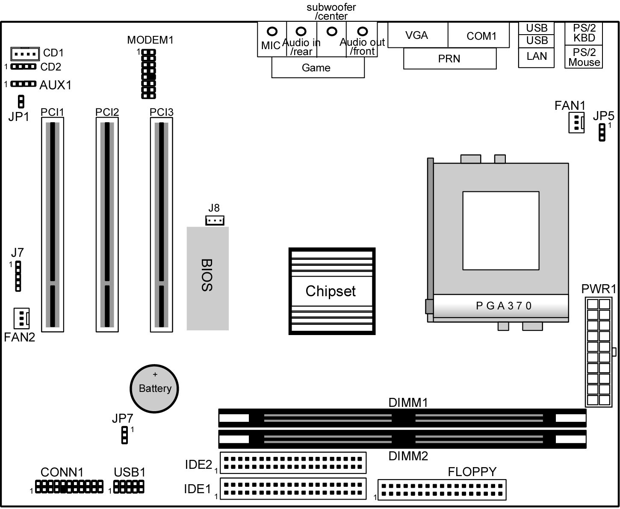
This diagram helps you identify major components on this mainboard.
Note: Any jumpers on your mainboard that do not appear in this illustration are for testing only.

I/O Ports
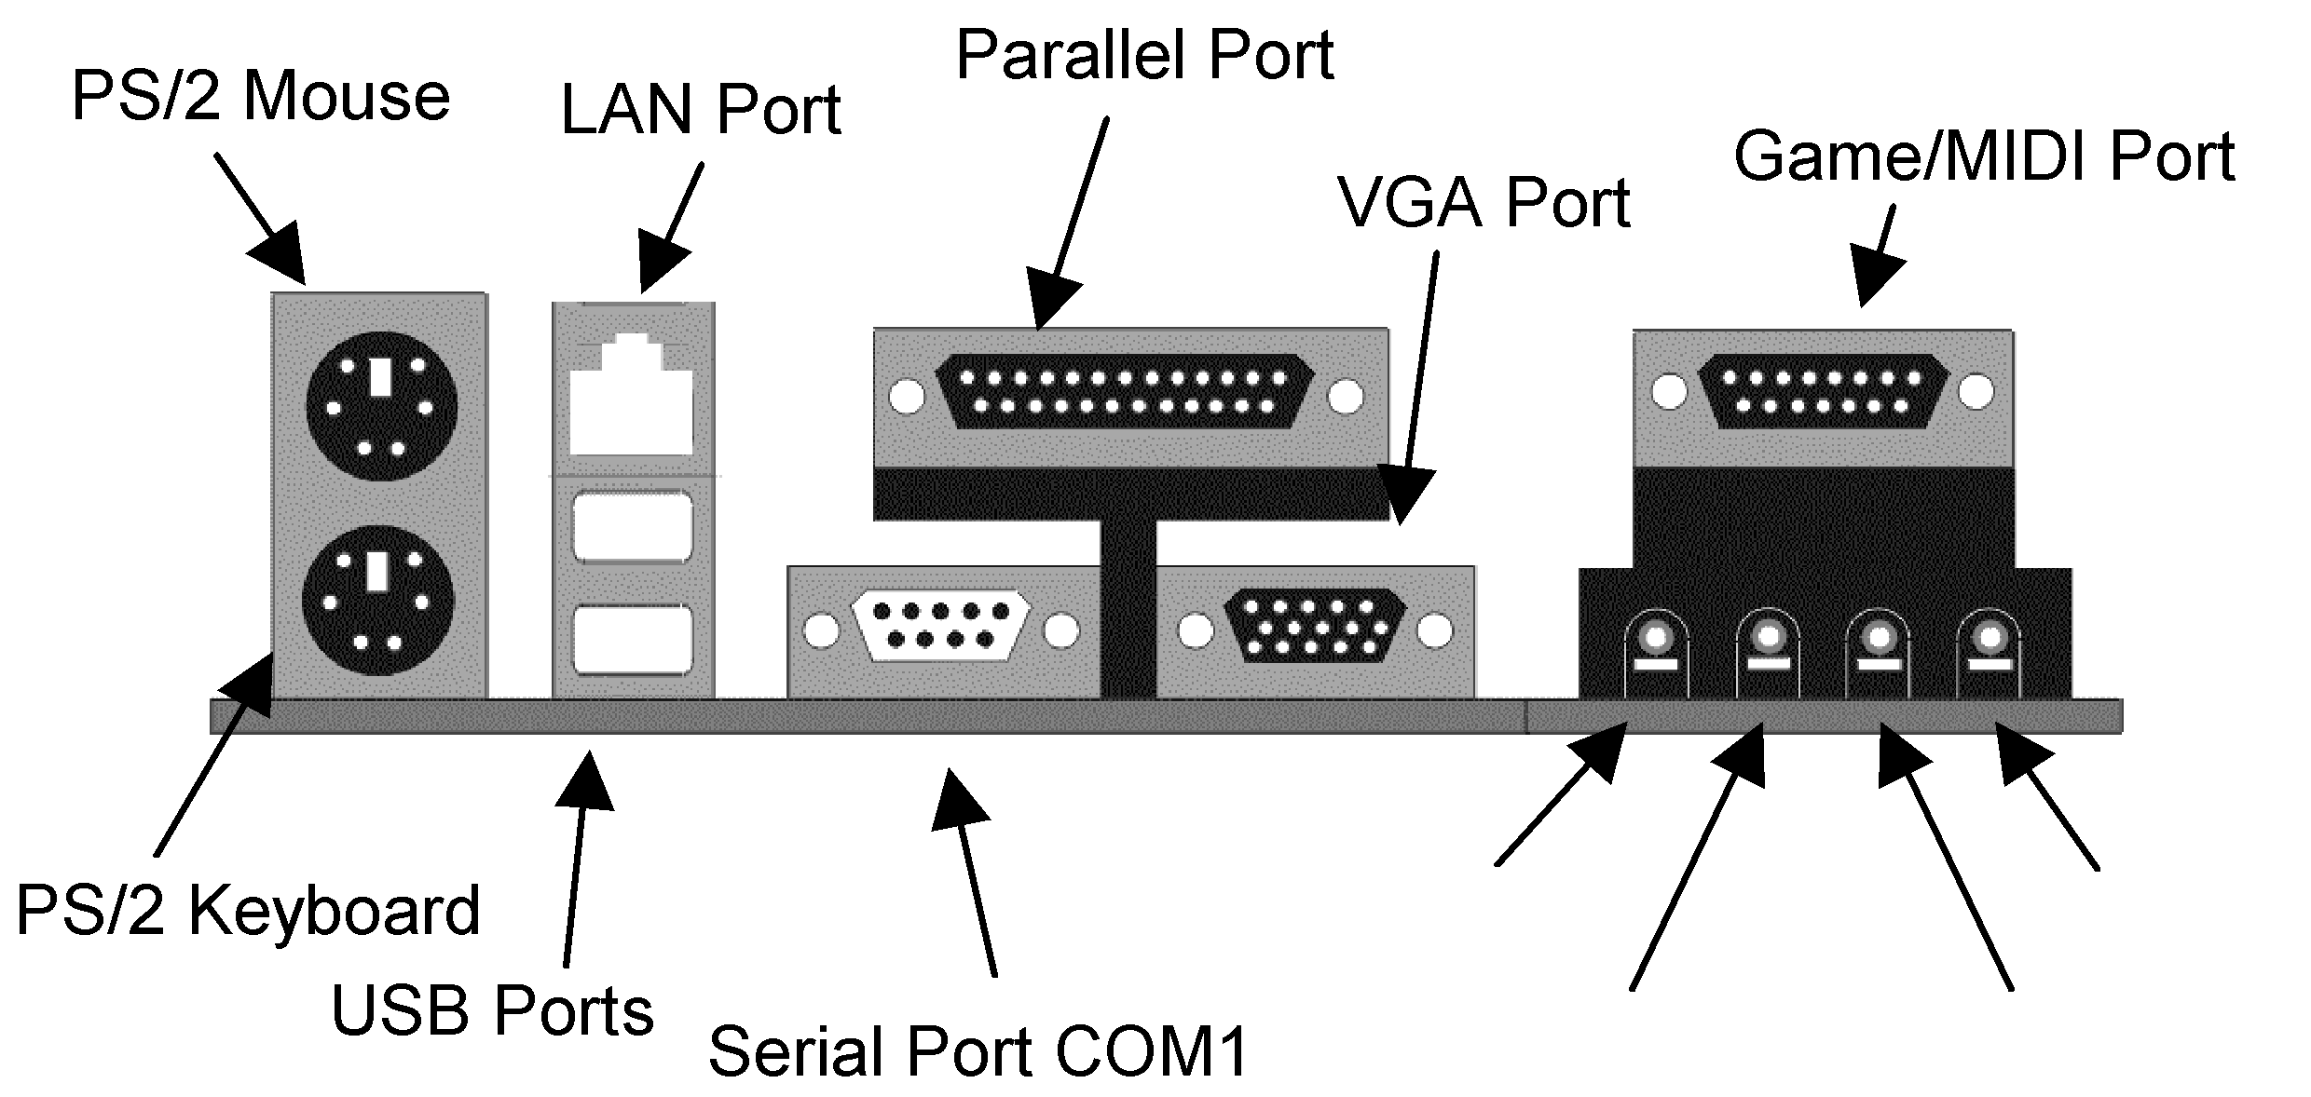
This illustration shown below is a side view of the built-in I/O ports on this mainboard.
Audio out
Subwoofer
/Center
Audio in
Microphone
(See page 19 for detail information)

I/O Pannel
An I/O panel is shipped with this mainboard. Before installing this mainboard, it is necessary to remove the original I/O panel and install our I/O panel to the system case as follows.
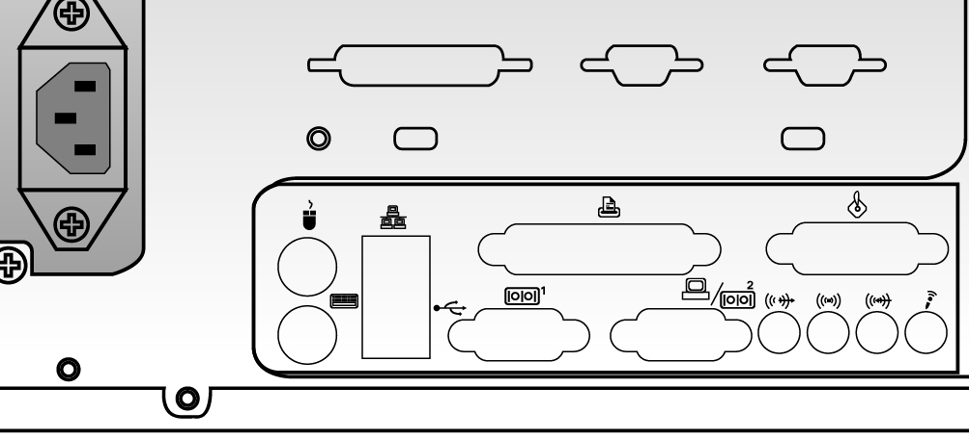
I/O panel
A back view of the system case

Install A CPU
This mainboard has a Socket 370 supporting FCPGA Celeron, FCPGA Pentium III and Tualatin/Tualatin Celeron processors.
Do not support PPGA Celeron processor.

To ensure reliability, ensure that your processor has a heatsink/cooling fan assembly.

Do not try to install a Socket 7 processor in the Socket-370. A Socket 7 processor such as the Pentium-MMX, or the AMD K5/K6 does not fit in the Socket 370. Do not try to install PPGA Celeron processor in Socket-370.

The following list notes the processors that are currently supported by this mainboard.

FCPGA Celeron: 300~966 MHz, FSB: 66 MHz
FCPGA Pentium III: 500~1130MHz, FSB: 100MHz, 133MHz
Tualatin/Tualatin Celeron: up to 1.2GHz, FSB: 100MHz(only
for model M758LRT+ and M758T+)

The “T” in the model name indicates this mainboard supporting Tualatin CPU. You can also tell the difference by one RED IDE connector and two “T” labels beside the socket.

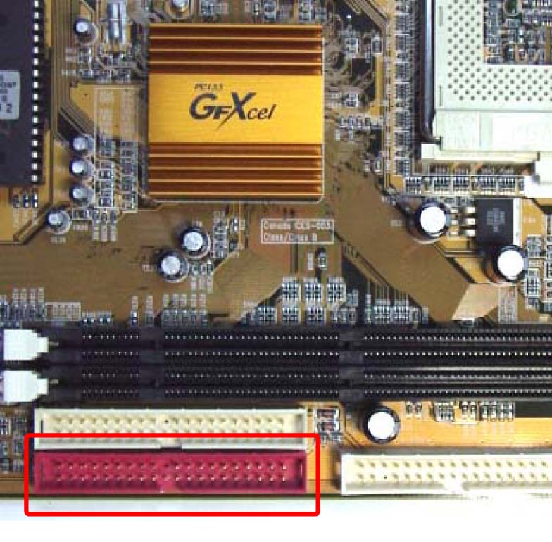
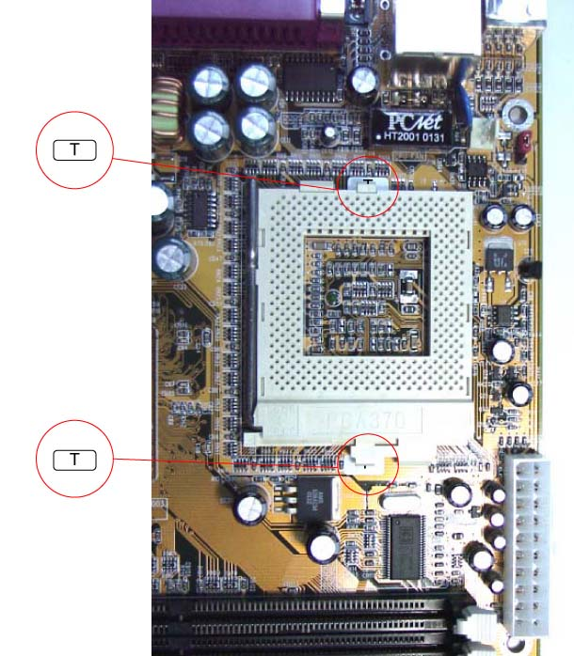
Two “T” labels beside the socket indicate Tualatin

One RED IDE connector

Installing a Socket-370 Processor
Install a processor into the ZIF (Zero Insertion Force) Socket-370 on the mainboard.

- Locate the Socket-370 and FAN1. Pull the locking lever out slightly from the socket and raise it to the upright position.
FAN1
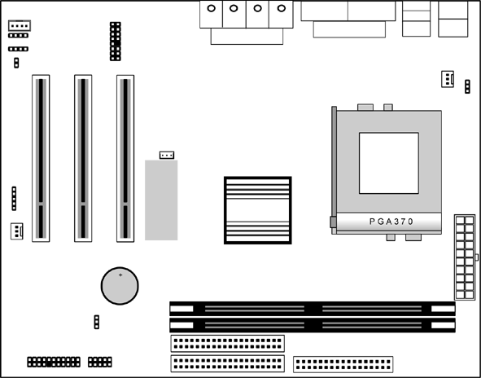

Pin-1 Corner
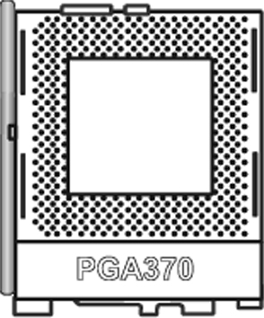

Socket-370

- Identify the Pin-1 corner of the processor by its beveled edge.
- Identify the Pin-1 corner on the Socket-370. The Pin-1 corner is at the top of the locking lever when it is locked.
- Insert the processor into the socket matching the Pin-1 corner. The processor should drop into place freely without force.
- Push locking lever down and hook it under the catch on the side of socket. This secures the CPU in the socket.
- All processors should be installed together with a heatsink /cooling fan, connecting the cable from the fan to the CPU fan power connector FAN1.

Install Memory
This mainboard has two DIMM sockets for system memory modules. You must install at least one memory module in order to work out this mainboard. You must install the first memory module in the DIMM1 socket to give shared memory to the onboard VGA display circuitry.

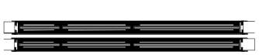
DIMM1
DIMM2

For this mainboard, you must use 168-pin, 3.3V unbuffered SDRAM memory modules. If the installed CPU uses a 100MHz system bus, you must use PC100 or PC133 memory; if a 66MHz system bus, you must use PC66 memory. You can install any size memory module from 16 MB to 512MB, so the maximum memory size is 2 x 512MB = 1GB.
Edge connectors on the memory modules have cut outs coinciding with spacers in the DIMM sockets that memory modules can only be installed in the correct orientation.
To install a module, push the retaining latches at either end of the socket outwards. Position the memory module correctly and insert it into the DIMM socket. Press the module down into the socket so that the retaining latches rotate up and secure the module in place by fitting into notches on the edge of the module.

Setting Jumper Switches
Jumpers are sets of pins connected together with caps. Jumper caps change the way of mainboard’s operation by changing the electronic circuits on the mainboard. If a jumper cap connects two pins, we say those pins are SHORT; if the cap is removed, they are OPEN.

JP5
1
JP1

JP7
1

Jumper JP1: Enable/Disable Fax/Modem
This 2-pin jumper enables or disables the onboard Fax/Modem connector.
Function | Jumper Setting
Disable Onboard Modem | Short Pins 1-2
Enable Onboard Modem | Open Pins 1-2

Jumper JP5: Keyboard Power On Selector
If you enable the keyboard power on feature, you can use hot keys on your keyboard as a power on/off switch for the system.
Note: The system must provide 1A on the +5VSB (+5V Standby) signal before using the Keyboard Power On function.
Function | Jumper Setting
Disable Keyboard Power On | Short Pins 1-2
Enable Keyboard Power On | Short Pins 2-3

Jumper JP7: Clear CMOS Memory
This jumper can clear the contents of the CMOS memory. You may need to clear the CMOS memory if the settings in the Setup Utility are incorrect and prevent your mainboard from operating. To clear the CMOS memory, disconnect all the power cables from the mainboard and then move the jumper cap into the CLEAR setting for a few seconds.
Function | Jumper Setting
Normal Operation | Short Pins 1-2
Clear CMOS Memory | Short Pins 2-3

Install the Mainboard
Install this mainboard in a system chassis (case). This board is a Micro-ATX size mainboard with a twin-tier of I/O ports. You can install this mainboard in any ATX case. Make sure your case has an I/O cover plate that matches the ports on this mainboard.
Install this mainboard in a case. Follow these instructions of the case manufacturer to use the hardware and internal mounting points on the chassis.


1
PWR1

J7-IR Port
Header


FAN2
CONN1

Connect the power connector from the power supply to the PWR1 ATX Power connector on the mainboard. If there is a cooling fan installed in the system chassis, connect the cable from the cooling fan to the FAN2 fan power connector on the mainboard; if an infrared port installed in the system chassis, connect the cable from the infrared port to the J7 IR port header. Connect the case switches and indicator LEDs to the CONN1 switch and LED connector header. This illustration below gives you a guide of the header’s pin assignment.
Power LED
Pins 2-4-6
Speaker
Pins 1-3-5-7
Keylock
Pins 8-10
HDD LED
Pins 15-16
2
1
Reset Switch
Pins 17-18
Power Button/Suspend
Switch Pins 21-22

22
21

Install the Extension Brackets
The extension brackets connect features of this mainboard to external connectors attached to the system chassis. Follow these step below to install extension brackets.

Note: All ribbon cables used on the extension brackets have a red stripe on the Pin-1 side of the cable.

Fax/Modem Module
The Fax/Modem DAA module plugs directly into the mainboard in aligned with an expansion slot opening in the system chassis. When you remove the slot cover from the system chassis, you can access the LINE and TEL RJ11 connectors on the metal edge of the Fax/Modem DAA module.
Modem Header

2 MCLK
4 FRA-SY
6 SCLK
8 RIN-WAK
12 SDO
14 SDI
16 RST
GND 1
GND 3
GND 5
AUX 3V 7
HOOK 9
RIN 11
AUX 5V 13
MUTE 15

- Locate the modem header on this mainboard.
- Plug the Fax/Modem DAA module into the modem header.
- Remove the modem header slot cover.
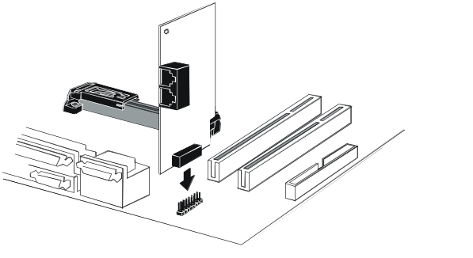
Modem DAA Module
Modem Header
Line & Tel
RJ11 Sockets

Optional Extension Brackets
You also have a USB module extension bracket for this mainboard. Install it by following these steps below.

Extended USB Module
This module bracket has two USB ports for more USB devices.

1
USB1 Header

- Locate the USB1 header on this mainboard.
- Plug the bracket cable onto the header.
- In the system chassis, remove a slot cover from one of the expansion slots and install the extension bracket into that emptied slot. Secure this extension bracket to the chassis with a screw.

Install Other Devices
Follow these steps below to install and connect other devices in the system.

IDE1
1
1
IDE2
FLOPPY
1

Floppy Disk Drive
The mainboard ships with a floppy disk drive cable that can support one or two drives. Drives can be 3.5” or 5.25” wide, with capacities of 360K, 720K, 1.2MB, 1.44MB, or 2.88MB.
Install your drives and connect power from the system power supply. Use the enclosed cable to connect the drives to the floppy disk drive header FLOPPY.

IDE Devices
IDE devices include hard disk drives, high-density diskette drives, and CD-ROM or DVD-ROM drives, among others.
The mainboard ships with an IDE cable that can support one or two IDE devices. If you connect two devices to one single cable, you must configure one of the drives as Master and the other as Slave. The documentation of the IDE device will tell you how to configure the device as a Master or Slave device. The Master device connects to the end of the cable.
Install the device(s) and connect power from the system power supply. Use the enclosed cable to connect the device(s) to the Primary IDE channel connector IDE1 on the mainboard.
If you want to install more IDE devices, you can purchase a second IDE cable and connect one or two devices to the Secondary IDE channel connector IDE2 on the mainboard. If you have two devices on the cable, one must be Master and another must be Slave.

Internal Sound Connections
If you have installed a CD-ROM drive or DVD-ROM drive, you can connect the drive audio cable to the onboard sound system.
On the mainboard, locate the two 4-pin connectors CD1 and CD2. There are two kinds of connectors because different brands of CD-ROM drive have different audio cable connectors. Connect the cable to the appropriate connector.
CD1

1
CD2
AUX1

GND 1
AUXR 2
AUXL 3
GND 4

Aux-In Connection
If you have installed a secondary CD-ROM drive or DVD-ROM drive, you can connect the drive audio cable to the onboard sound system. On the mainboard, locate the 4-pin Aux-In header AUX1, connect the cable to the connector.

Expansion Slots
This mainboard has three 32-bit PCI expansion slots.
PCI1/2/3

J8-
WOL connector

Follow these steps below to install a PCI expansion card.

- Locate the PCI slots on the mainboard.
- Remove the expansion slot cover from the system chassis.
- Insert the expansion card edge connector into the slot and press it firmly down into until fully inserted.
- Secure the expansion card bracket to the system chassis with a screw.

Wake On LAN (WOL)
If you are using an ATX power supply you can configure your system so that it powers down by software and can be resumed by alarms. If you have installed a LAN adapter expansion card, connect the card to the Wake On LAN connector J8. This allows incoming traffic to resume the system from a software power down. You need to enable this feature in the system setup utility.

Audio System Applications
There are three configurations of 2-channel speaker-out, 4-channel speaker-out and 6-channel speaker-out for the onboard audio system applications. You have to connect the speakers and the microphone to the correct phone-jack as follows.

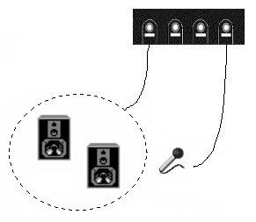
1. 2-Channel Speaker-out System
Speakers
Audio Out
Reserved
Audio In
Microphone
Sound jacks

2. 4-Channel Speaker-out System
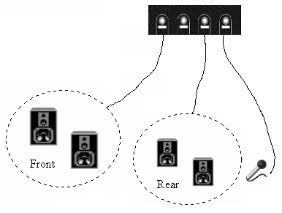
Front
Reserved
Rear
Microphone
Sound jacks
channel
channel
3. 6-Channel Speaker-out System
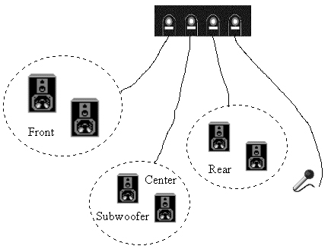
Front
Subwoofer
/Center
Rear
Microphone

Sound jacks
channel
channel

Chapter 3

BIOS Setup Utility

Introduction
The BIOS Setup Utility records settings and information of your computer, such as date and time, the type of hardware installed, and various configuration settings. Your computer applies those information to initialize all the components when booting up and basic functions of coordination between system components.

If the Setup Utility configuration is incorrect, it may cause the system to malfunction. It can even stop your computer booting properly. If it happens, you can use the clear CMOS jumper to clear the CMOS memory which has stored the configuration information; or you can hold down the Page Up key while rebooting your computer. Holding down the Page Up key also clears the setup information.

You can run the setup utility and manually change the configuration. You might need to do this to configure some hardware installed in or connected to the mainboard, such as the CPU, system memory, disk drives, etc.

Running the Setup Utility
Every time you start your computer, a message appears on the screen before the operating system loading that prompts you to “Hit <DEL>if you want to run SETUP”. Whenever you see this message, press the Delete key, and the Main menu page of the Setup Utility appears on your monitor.

AMIBIOS SIMPLE SETUP UTILITY – VERSION 1.21.06
(C) 2000 American Megatrends, Inc. All Rights Reserved
Standard CMOS Setup  Advanced Setup  Power Management Setup  PCI / Plug and Play Setup  Load Optimal Settings  Load Best Performance Settings | Features Setup  CPU PnP Setup  Hardware Monitor  Change Password  Exit
Esc : Quit ↑ ↓ ← →: Select Item (Shift)F2 : Change Color F5 : Old Values
F6 : Optimal values F7 : Best performance values F10 : Save&Exit
Standards COMOS setup for changing time, date, hard disk type, etc.

You can use cursor arrow keys to highlight anyone of options on the main menu page. Press Enter to select the highlighted option. Press the Escape key to leave the setup utility. Hold down the Shift key and press F2 to cycle through the Setup Utility’s optional color schemes.
Some options on the main menu page lead to tables of items with installed values that you can use cursor arrow keys to highlight one item, and press PgUp and PgDn keys to cycle through alternative values of that item. The other options on the main menu page lead to dialog boxes that require your answer Yes or No by hitting the Y or N keys.
If you have already changed the setup utility, press F10 to save those changes and exit the utility. Press F5 to reset the changes to the original values. Press F6 to install the setup utility with a set of default values. Press F7 to install the setup utility with a set of high-performance values.

Standard CMOS Setup Page
Use this page to set basic information such as the date and time, the IDE devices, and the diskette drives. If you press the F3 key, the system will automatically detect and configure the hard disks on the IDE channels.
AMIBIOS SETUP – STANDARD CMOS SETUP
(C) 2000 American Megatrends, Inc. All Rights Reserved
Date (mm/dd/yy) : Wed Oct.24, 2001
Time (hh/mm/ss) : 15:33:21
LBA Blk PIO 32Bit
Type Size Cyln Head WPcom Sec Mode Mode Mode Mode
Pri Master : Not Installed
Pri Slave : Not Installed
Sec Master : Not Installed
Sec Slave : Not Installed
Floppy Drive A : Not Installed
Floppy Drive B : Not Installed
Month : Jan – Dec ESC : Exit
Day : 01 – 31 ↑↓ : Select Item
Year : 1901 – 2099 PU/PD/+/- : Modify
(Shift)F2 : Color
F3 : Detect All HDD

Date & Time | Use these items to set the system date and time
Pri Master  Pri Slave  Sec Master  Sec Slave | Use these items to configure devices connected to the Primary and Secondary IDE channels. To configure an IDE hard disk drive, choose Auto. If the Auto setting fails to find a hard disk drive, set it to User, and then fill in the hard disk characteristics (Size, Cyls, etc.) manually. If you have a CD-ROM drive, select the setting CDROM. If you have an ATAPI device with removable media (e.g. a ZIP drive or an LS-120) select Floptical.
Floppy Drive A  Floppy Drive B | Use these items to set the size and capacity of the floppy diskette drive(s) installed in the system.

Advanced Setup Page
This page sets up more advanced information about your system. Be careful to set up this page, for any changes can affect the operation of your computer.

AMIBIOS SETUP – ADVANCED SETUP
(C) 2000 American Megatrends, Inc. All Rights Reserved
Frame Buffer Cache Control720 KB3 1/2
Share Memory Size 16 MB
Display Type Reserved
1st Boot Device IDE-0
2nd Boot Device Floppy
3rd Boot Device CDROM
Try Other Boot Devices Yes
S.M.A.R.T. for Hard Disks Disabled
BootUp Num-Lock On
Floppy Drive Swap Disabled
Floppy Drive Seek Disabled
PS/2 Mouse Support Enabled
Password Check Setup
Boot To OS/2 > 64MB No
Internal Cache WriteBack
System BIOS Cacheable Disabled
CAS Latency 3T
ESC : Quit ↑↓←→ : Select Item
F1 : Help PU/PD/+/- : Modify
F5 : Old Values (Shift)F2 : Color
F6 : Load BIOS Defaults
F7 : Load Setup Defaults

Frame Buffer Cache Control | This item appears when a Frame Buffer Cache card is installed in the ADIMM socket. The default setting, Auto, automatically sets the display memory size. The Manual setting uses the next item to manually set display memory size.
Share Memory Size | This item lets you allocate a portion of the main memory for use by the onboard VGA display.
Display Type | This item provides some options of display type, H/W, CRT1 only, CRT1+LCD/S and CRT1+LCD.
1st Boot Device  2nd Boot Device  3rd Boot Device | Use these items to determine the device order the computer uses to look for an operating system to load at start-up time.
Try Other Boot Device | If you enable this item, the system will also search for other boot devices if it fails to find an operating system from the first two locations.
S.M.A.R.T. for Hard Disks | Enable this item if any IDE hard disks support the S.M.A.R.T. (Self-Monitoring, Analysis and Reporting Technology) feature.
BootUp Num-Lock | This items determines if the Num Lock key is active or inactive at system start-up time.
Floppy Drive Swap | If you have two diskette drives installed and you enable this item, drive A becomes drive B and drive B becomes drive A.
Floppy Drive Seek | If you enable this item, your system will check all floppy disk drives at start up. Disable this item unless you are using an old 360KB drive.
PS/2 Mouse Support | If this item is set to Enabled, the onboard PS/2 Mouse port will work. Setting this to Disable turns off the port.
Password Check | If you have entered a password for the system, use this item to determine if the password is required to enter the Setup Utility (Setup) or required both at start-up and to enter the Setup Utility (Always).
Boot to OS/2 > 64MB | Enable this item if you are booting the OS/2 operating system and you have more than 64MB of system memory installed.
Internal Cache | Leave this item enabled since all the processors that can be installed on this board have internal cache memory.
System BIOS Cacheable | If you enable this item, a segment of the system BIOS will be cached to main memory for faster execution.
CAS Latency | This item determines the operation of the SDRAM memory CAS (column address strobe). We recommend that you leave this item at the default value. The 2T setting requires faster memory that specifically supports this mode.

Power Management Setup Page
This page sets up some parameters for system power management operation.

AMIBIOS SETUP – POWER MANAGEMENT SETUP
(C) 2000 American Megatrends, Inc. All Rights Reserved
Power Management/APM APM/ACPI
Standby Time Out(Minute) Disabled
Suspend Time Out(Minute) Disabled
Hot Key Power On Disabled
OnBoard LAN Power On Disabled
Ring On Power On Disabled
RTC Alarm Power On Disabled
RTC Alarm Date 15
RTC Alarm Hour 12
RTC Alarm Minute 30
RTC Alarm Second 30
ESC : Quit ↑↓←→ : Select Item
F1 : Help PU/PD/+/- : Modify
F5 : Old Values (Shift)F2 : Color
F6 : Load BIOS Defaults
F7 : Load Setup Defaults

Power Management/APM | Use this item to enable or disable a power management scheme. If you enable power management, you can use the items below to set the power management operation. Both APM and ACPI are supported.
Standby Time Out (Minute) | This sets the timeout for Standby mode in minutes. If the time selected passes without any system activity, the computer will enter power-saving Standby mode.
Suspend Time Out (Minute) | This sets the timeout for Suspend mode in minutes. If the time selected passes without any system activity, the computer will enter power-saving Suspend mode.
Hot Key Power On | If you enable this item, you can turn the system on by pressing hot keys (Ctrl+Alt+BackSpace) on the keyboard. You must connect an ATX power supply and enable the jumper in order to use this feature.
OnBoard Lan Power On | The system can be turned off with a software command. If you enable this item, the system can automatically resume if there is traffic on the network adapter. You must use an ATX power supply in order to use this feature.
Ring On Power On | The system can be turned off with a software command. If you enable this item, the system can automatically resume if there is an incoming call on the Fax/Modem. You must use an ATX power supply in order to use this feature.
RTC Alarm Power On | The system can be turned off with a software command. If you enable this item, the system can automatically resume at a fixed time based on the system’s RTC (realtime clock). Use the items below this one to set the date and time of the wake-up alarm. You must use an ATX power supply in order to use this feature.

PCI / Plug and Play Setup Page
This page sets up some parameters for those devices installed on the PCI bus and utilizing the system plug and play capability.

AMIBIOS SETUP – PCI / PLUG AND PLAY SETUP
(C) 2000 American Megatrends, Inc. All Rights Reserved
Plug and Play Aware O/S Yes
Primary Graphics Adapter PCI
Allocate IRQ for PCI VGA Yes
Reserved Memory Size Disabled
Reserved Memory Address C8000
ESC : Quit ↑↓←→ : Select Item
F1 : Help PU/PD/+/- : Modify
F5 : Old Values (Shift)F2 : Color
F6 : Load BIOS Defaults
F7 : Load Setup Defaults

Plug and Play Aware O/S | Enable this item if you are using an O/S that supports Plug and Play such as Windows 95 or 98.
Primary Graphics Adapter | This item indicates if the primary graphics adapter uses the PCI or AGP bus. The default PCI setting still lets the onboard display work and allows the use of a second display card installed in a PCI slot.
Allocate IRQ to PCI VGA | If this item is enabled, an IRQ will be assigned to the PCI VGA graphics system. You set this value to No to free up an IRQ.
Reserved Memory Size | This item lets you reserve a block of memory for any device that requires it.
Reserved Memory Address | This item lets you set the address for any block of memory that has been reserved.

Load Optimal Settings
If you select this item and press Enter a dialog box appears. If you press Y, and then Enter, the Setup Utility loads a set of fail-safe default values. These default values are not very demanding and they should allow your system to function with most kinds of hardware and memory chips.
Note: It is highly recommended that users enter this option to load optimal values for accessing the best performance.

Load Best Performance Settings
If you select this item and press Enter a dialog box appears. If you press Y, and then Enter, the Setup Utility loads a set of best-performance default values. These default are quite demanding and your system might not function properly if you are using slower memory chips or other low-performance components.

Features Setup Page
This page sets up some parameters for peripheral devices connected to the system.

AMIBIOS SETUP – FEATURES SETUP
(C) 2000 American Megatrends, Inc. All Rights Reserved
OnBoard FDC Enabled
OnBoard Serial PortA 3F8h/COM1
OnBoard IR Port Disabled
OnBoard Parallel Port 378h
Parallel Port Mode EPP+ECP
Parallel Port IRQ 7
Parallel Port DMA 3
OnBoard PCI IDE Both
Ultra DMA Support Disabled
OnBoard Sound Enabled
OnBoard LAN Enabled
USB Function Enabled
USB Function For DOS Disabled
ESC : Quit ↑↓←→ : Select Item
F1 : Help PU/PD/+/- : Modify
F5 : Old Values (Shift)F2 : Color
F6 : Load BIOS Defaults
F7 : Load Setup Defaults

OnBoard FDC | Use this item to enable or disable the onboard floppy disk drive interface.
OnBoard Serial PortA | Use this item to enable or disable the onboard COM1 serial port, and to assign a port address
OnBoard IR Port | Use this item to define the protocol for an infrared port if you have installed an optional IR port. The choices are IrDA and ASKIR.
Onboard Parallel Port | Use this item to enable or disable the onboard LPT1 parallel port, and to assign a port address. The Auto setting will detect and available address.
Parallel Port Mode | Use this item to set the parallel port mode. You can select SPP (Standard Parallel Port), ECP (Extended Capabilities Port), EPP (Enhanced Parallel Port), or ECP + EPP.
Parallel Port IRQ | Use this item to assign either IRQ 5 or 7 to the parallel port.
Parallel Port DMA | Use this item to assign a DMA channel to the parallel port. The options are 0, 1 and 3.
Onboard PCI IDE | Use this item to enable or disable either or both of the onboard Primary and Secondary IDE channels.
Ultra DMA Support | Use this item to set Ultra DMA support for IDE devices on the Primary or Secondary IDE channels. You must enable this or UDMA devices will not work at their intended speed.
OnBoard Sound | This item enables or disables the onboard audio chip.
OnBoard LAN | This item enables or disables the onboard network interface.
USB Function | Enable this item if you plan to use the USB ports on this mainboard.
USB Function for DOS | Enable this item if you plan to use the USB ports on this mainboard in a DOS environment.

CPU PnP Setup Page
This page helps you manually configure the CPU of this mainboard. The system will automatically detect the type of installed CPU and make appropriate adjustments to all items on this page.
Note: If you manually set up wrong speed that the system doesn’t run properly, press the Page Up key while the system is booting and a default setting will replace the incorrect CPU setting.

AMIBIOS SETUP – CPU PnP SETUP
©2000 American Megatrends, Inc. All Rights Reserved
CPU Speed 200 MHz
CPU/DRAM Freq. Reserved
CPU Multiplier Freq. X3
ESC : Quit ↑↓←→ : Select Item
F1 : Help PU/PD/+/- : Modify
F5 : Old Values (Shift)F2 : Color
F6 : Load Optimal values
F7 : Load Best performance values

CPU Speed | The item displays the internal clock speed of the CPU, based on the next two items.
CPU/DRAM Frequency | Use this item to sets the external clock frequency for the CPU and the memory bus frequency. The options include combinations of 66 and 100MHz. Set the CPU clock based on the requirements of the CPU installed on the board. Select the memory frequency based on the speed of the memory installed on the board.
CPU Multiplier Frequency | Use this item to set a multiplier for the CPU external frequency. The multiplier times the external CPU frequency sets the internal clock speed of the CPU, e.g. 100 MHz (external clock or “FSB”) x 4.5 (muliplier) = 450 MHz (internal clock speed of the installed CPU).

Hardware Monitor Page
This page sets up some parameters for the hardware monitoring function of this mainboard.

AMIBIOS SETUP – HARDWARE MONITOR
(C) 2000 American Megatrends, Inc. All Rights Reserved
*** Hardware Monitor ***
CPU Temperature 55°C/131°F SYSTEM Temperature 39°C/102°F Fan#1 Speed 0 RPM
Fan#2 Speed 0 RPM
Vcore 1.616 V
+1.800V 2.496 V
Vcc3 6.784 V
Vcc 4.972 V
+12V 11.968 V
SB5V 5.053 V
ESC : Quit ↑↓←→ : Select Item
F1 : Help PU/PD/+/- : Modify
F5 : Old Values (Shift)F2 : Color
F6 : Load BIOS Defaults
F7 : Load Setup Defaults

CPU, System Temperature | These items display CPU and the system temperature measurement. The system will alert you if a safe temperature is exceeded.
FAN#1, 2 Speed & Voltage Measurements | These items indicate cooling fan speeds in RPM and the various system voltage measurements. If the values deviate beyond certain limits, the hardware monitoring feature will alert you with a warning.

Change Password
If you highlight this item and press Enter, a dialog box appears which lets you enter a Supervisor password. You can enter no more than six letters or numbers. Press Enter after you have typed in the password. A second dialog box asks you to retype the password for confirmation. Press Enter after you have retyped it correctly. The password is then required to access the Setup Utility or for that and at start-up, depending on the setting of the Password Check item in Advanced Setup.

Change or Remove the Password
Highlight this item, press Enter and type in the current password. At the next dialog box, type in the new password, or just press Enter to disable password protection.

Exit
Highlight this item and press Enter to save the changes that you have made in the Setup Utility configuration and exit the program. When the Save and Exit dialog box appears, press Y to save and exit, or press N to exit without saving.

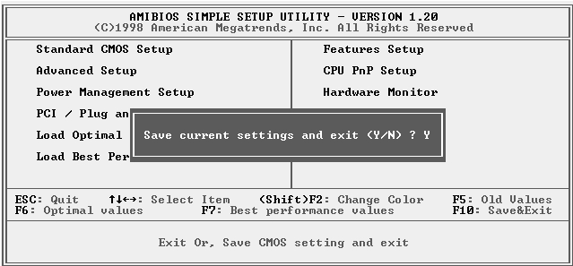

Chapter 4

Software & Applications

Introduction
The support software CD-ROM attached to this mainboard package contains all necessary drivers and utility programs for properly running our products. You can find out a brief description of each software program and location for your mainboard version as below. More information on some programs is available in a README file located in the same directory as the software.
If the operating system of your system is Windows 98, it will automatically install all drivers and utilities for your board. See the Installing under Windows 98 section.

Installing Support Software
The software on this support CD-ROM is for Windows 95/NT/2000 and Windows 98. The installation procedure differs depending on which Operating System you have, but the automatic installation is now for Win98/WinME/Win2000.

Installing under Windows 95/NT
To install support software for Windows 95/NT follow this general procedure:
- Insert the support CD-ROM disc in the CD-ROM drive.
(The system might get an error message from the PnP function. Don’t care the message. You don’t really need that file to install the drivers)
- Use My Computer or Windows Explorer to look at the directory structure. You must use the Open command in the right-button menu. Double-clicking on the drive icon will result in an error message because the disc’s AutoRun feature doesn’t work in Windows 95/NT.
- Execute the EXE file name given in the description below.

Note: The correct path name for each software driver is provided, where D: identifies the CD-ROM drive letter – modify if necessary.

Bus Master IDE Driver
The IDE Bus Master Drivers allows the system properly to manage the IDE channels on the mainboard. You only need to install an IDE driver if you are running Windows 95. Use the default driver on the Windows CD-ROM disc.

Display Drivers and Software
Find the Display drivers and software here:
- D:\VGA\SiS\

Audio Driver
The Audio driver allows the system to use the onboard audio circuitry. Find the driver and audio application here:
- D:\SOUND\Driver\C-Media\

Fax/Modem Drivers and Software
Find the fax/modem drivers and software here:
- D:\Modem\Driver\PCI\
- D:\Modem\SuperVoice\ [Telecom management software]
- D:\Modem\MediaRingTalk\

Network Adapter Driver
Find the network interface driver here:
- D:\LAN\SiS900

USB Driver
The USB Driver allows the system to recognize the USB ports on the mainboard. You need to install this driver if you are running Windows 95. Windows 95 OSR2 does not require this driver.
This driver is available for:
- Win95 – D:\USB\EUSBSUPP\USBSUPP.EXE
- Win95 (Chinese) – D:\USB\CUSBSUPP\CUSBSUPP.EXE

3Deep Software
Find the software here:
- D:\3Deep\3Deep 3.3\Setup.EXE

BIOS Update Utility
The BIOS Update utility allows you to update the BIOS file on the mainboard to a newer version. You can download the latest version of the BIOS setup available for your mainboard from the website.
- D:\UTILITY\AMINFxxx.EXE

PC-Cillin Software
The PC-cillin software program provides anti-virus protection for your system.
Find this program here:
- D:\PC-CILLIN\

Installing under Windows 98
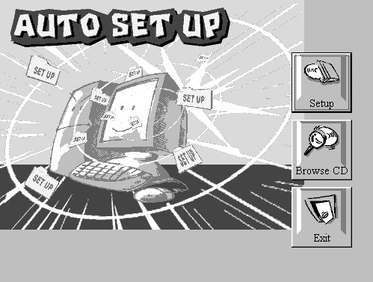
The support software CD-ROM disc loads automatically under Windows 98. When you insert the CD-ROM disc in the system CD-ROM drive the Autorun feature will automatically bring up the install screen. The screen has three buttons on it, Setup, Browse CD and Exit. See the following screen illustration.
When you click on the Setup button the software installation program will run and you can select what kind of installation you want to do, as explained later in this section.
The Browse CD button is the standard Windows command that allows you to examine the contents of the disc using the Windows 98 file browsing interface.
The Exit button closes the Auto Setup window. To run the program again, reinsert the CD-ROM disc in the drive or click on AutoRun in the context sensitive menu for the CD-ROM drive icon in a file browser window.

Installing Software with Auto Setup
To install support software for the system board follow this procedure:
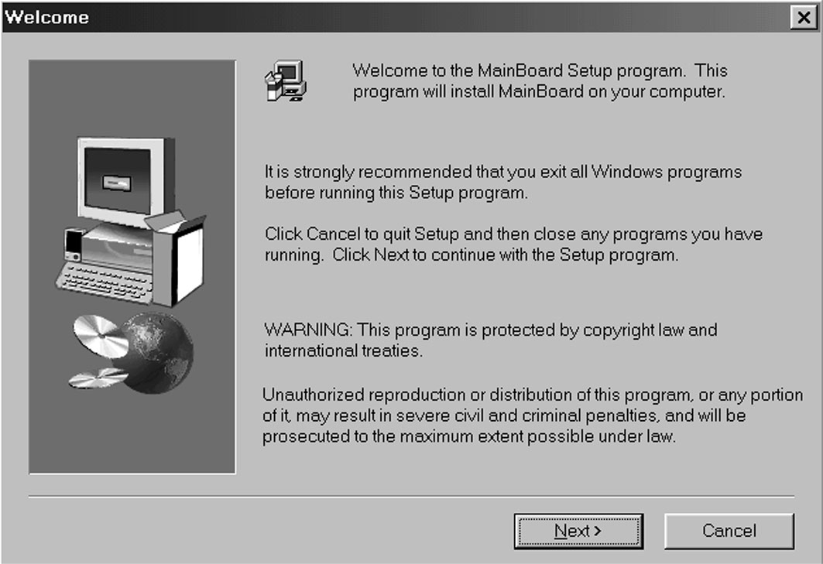
- Click on the Setup button. The install program will load and display the following screen. Click the Next button.
- Select the items that you want to setup by clicking on it (the default options are recommended). Click the Next button to proceed.
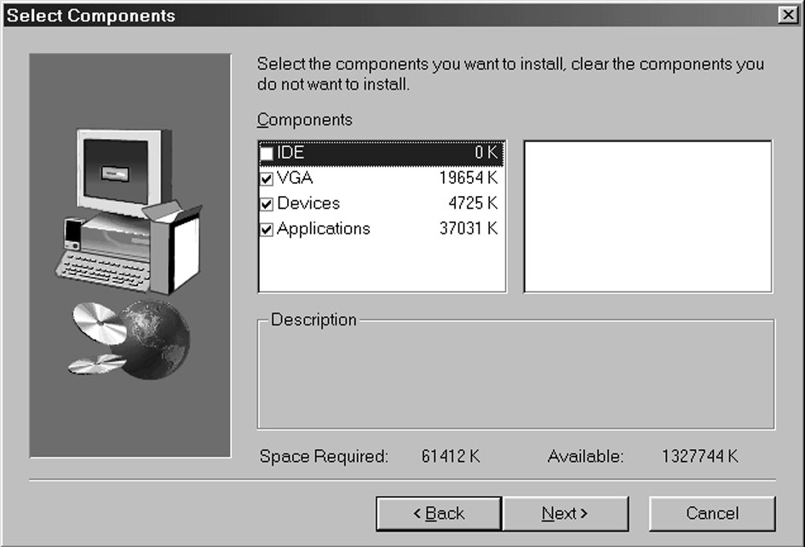
- The support software will automatically install.

Once any of the installation procedures start, software is automatically installed in sequence. You will need to follow the onscreen instructions, confirm commands and allow the computer to restart as few times as is needed to complete installing whatever software you selected to install. When the process is finished, all the support software will be installed and working.

There are some utilities that you have to manually install if you need, check to the above section.

