**Ce face alicatia?**

Aplicatia va avea:

* Prima fereastra ce permite crearea si intrarea unui cont;
* A doua fereastra este un meniu catre celelalte fereste
* A treia fereastra este o liste de cumparaturi individuala fiecarui user;
* A patra este convertor din Ron 🡪 Euro, Celsius 🡪 Fahrenheit si Kg 🡪 Pounds;
* A cincea este un joc de X si 0.

**Cod fereastra 1:**

|  |  |
| --- | --- |
| namespace Tema_aplicatie  {  public partial class Form1 : Form  {  public Form1()  {  InitializeComponent();  }  private void singup_Click(object sender, EventArgs e)  {  int i = 0;  while (i <= 100)  {  progressBar2.Value=i++;  }  StreamReader streamReader = new StreamReader(path: "date.txt");  string line;  bool ok = false;  while ((line = streamReader.ReadLine()) != null)  {  string[] cuvinte = line.Split(' ');  if (cuvinte[0] == user.Text)  {  ok = true;  }  }  streamReader.Close();  if (ok == false)  {  StreamWriter str = new StreamWriter("date.txt", true);  str.WriteLine("{0} {1}", user.Text, pass.Text);  user.Clear();  pass.Clear();  str.Close();  progressBar2.SetState(1);  }else  {  progressBar2.SetState(2);  MessageBox.Show("Username existent");  } } | private void button1_Click(object sender, EventArgs e)  {  progressBar1.SetState(1);  int i = 0;  while (i <= 100)  {  progressBar1.Value = i++;  }  StreamReader streamReader = new StreamReader(path: "date.txt");  string line;  bool ok = false;  while ((line = streamReader.ReadLine()) != null)  {  string[] cuvinte = line.Split(' ');  if (cuvinte[0] == user.Text & cuvinte[1] == pass.Text)  {  Form2 secondForm = new Form2(user.Text);  secondForm.Show();  ok = true;  this.Hide();  }  }  if (ok == false)  {  progressBar1.SetState(2);  MessageBox.Show("Parola gresita");  }  streamReader.Close();  }  } |

public static class ModifyProgressBarColor

{

[DllImport("user32.dll", CharSet = CharSet.Auto, SetLastError = false)]

static extern IntPtr SendMessage(IntPtr hWnd, uint Msg, IntPtr w, IntPtr l);

public static void SetState(this ProgressBar pBar, int state)

{

SendMessage(pBar.Handle, 1040, (IntPtr)state, IntPtr.Zero);

}}

**Imagini functionalitate fereastra 1**

|  |  |
| --- | --- |
|  |  |
|  | |

**Cod fereastra 2:**

namespace Tema_aplicatie

{

public partial class Form2 : Form

{

private string user;

public Form2(string user)

{

InitializeComponent();

this.user = user;

}

private void button1_Click(object sender, EventArgs e)

{

LCump listaCumparaturi = new LCump(user);

listaCumparaturi.Show();

this.Hide();

}

private void button2_Click(object sender, EventArgs e)

{

Convertor convertor = new Convertor(user);

convertor.Show();

this.Hide();

}

private void button4_Click(object sender, EventArgs e)

{

Environment.Exit(1);

}

private void button5_Click(object sender, EventArgs e)

{

Xand0 xand0 = new Xand0(user);

xand0.Show();

this.Hide();

}}}

**Imagini functionalitate fereastra 2**

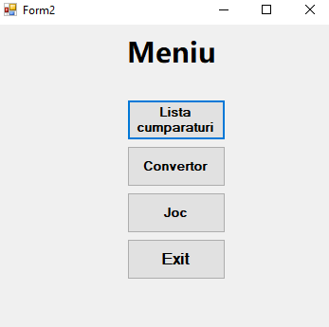

**Cod fereastra 3:**

namespace Tema_aplicatie

{

public partial class LCump : Form

{

private string user;

private string path;

public LCump(string user)

{

this.user = user;

this.path = user + "ListaCump.txt";

InitializeComponent();

StreamWriter str = new StreamWriter(path, true);

str.Close();

}

private void LCump_Load(object sender, EventArgs e)

{

StreamReader streamReader = new StreamReader(path);

string line;

while ((line = streamReader.ReadLine()) != null)

{

listaCumpar.Items.Add(line);

}

streamReader.Close();

}

private void adauga_Click(object sender, EventArgs e)

{

listaCumpar.Items.Add(lucruNou.Text);

lucruNou.Clear();

}

private void Sterge_Click(object sender, EventArgs e)

{

listaCumpar.Items.RemoveAt(listaCumpar.SelectedIndex);

}

private void Exit_Click(object sender, EventArgs e)

{

File.WriteAllText(path, String.Empty);

StreamWriter str = new StreamWriter(path, true);

foreach(string item in listaCumpar.Items)

{

str.WriteLine(item);

}

str.Close();

Form2 form2 = new Form2(user);

form2.Show();

this.Hide();

}

}

}

**Imagini functionalitate fereastra 3**

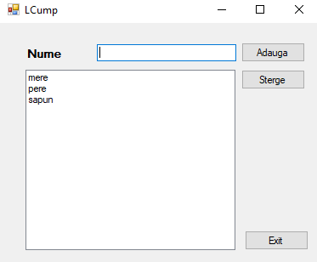

**Cod fereastra 4:**

namespace Tema_aplicatie

{

public partial class Convertor : Form

{

private string user;

public Convertor(string user)

{

InitializeComponent();

this.user = user;

}

private void button1_Click(object sender, EventArgs e)

{

double suma = Convert.ToDouble(detinTB.Text);

if (ron.Checked)

{

convLabel.Text =suma/4.84 + " EURO";

}

if(euro.Checked)

{

convLabel.Text = suma * 4.84 + " RON";

}

}

private void grdButt_Click(object sender, EventArgs e)

{

double grade = Convert.ToDouble(detinTB.Text);

if (celsius.Checked)

{

conGrd.Text = grade *9/5 +32 + " F";

}

if (Far.Checked)

{

conGrd.Text = (grade -32)*5/9 + " C";

}

}

private void button2_Click(object sender, EventArgs e)

{

double grade = Convert.ToDouble(masaTB.Text);

if (kg.Checked)

{

masaLb.Text = grade * 2.20 + " Pounds";

}

if (pounds.Checked)

{

masaLb.Text = grade/2.20 + " Kg";

}

}

private void button3_Click(object sender, EventArgs e)

{

Form2 form2 = new Form2(user);

form2.Show();

this.Hide();

} }}

**Imagini functionalitate fereastra 4**

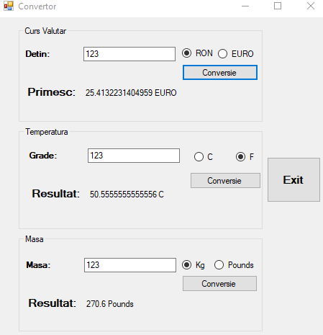

**Cod fereastra 5:**

namespace Tema_aplicatie

{

public partial class Xand0 : Form

{

private bool turn = true;

private int turnCount = 0;

private string user;

public Xand0(string user)

{

InitializeComponent();

this.user = user;

}

private void button1_Click(object sender, EventArgs e)

{

if (turn == true)

{

button1.Text = "X";

}

else button1.Text = "0";

turn = !turn;

turnCount++;

button1.Enabled = false;

check();

}

public void check()

{

bool winner = false;

if ((button1.Text == button2.Text) && (button2.Text == button3.Text) && (button1.Text != ""))

winner = true;

if ((button4.Text == button5.Text) && (button5.Text == button6.Text) && (button4.Text != ""))

winner = true;

if ((button7.Text == button8.Text) && (button8.Text == button9.Text) && (button7.Text != ""))

winner = true;

if ((button1.Text == button4.Text) && (button4.Text == button7.Text) && (button1.Text != ""))

winner = true;

if ((button2.Text == button5.Text) && (button2.Text == button8.Text) && (button2.Text != ""))

winner = true;

if ((button3.Text == button6.Text) && (button6.Text == button9.Text) && (button3.Text != ""))

winner = true;

if ((button1.Text == button5.Text) && (button5.Text == button9.Text) && (button1.Text != ""))

winner = true;

if ((button3.Text == button5.Text) && (button5.Text == button7.Text) && (button3.Text != ""))

winner = true;

if (winner)

{

MessageBox.Show("Castigatorul este " + (turn ? "0" : "X"));

reset();

}else if (turnCount == 9)

{

MessageBox.Show("Egalitate");

reset();

}

}

public void reset()

{

foreach(Control b in Controls.OfType<Button>())

{

b.Enabled = true;

b.Text = "";

}

Reset.Text = "Reset";

button10.Text = "Exit";

turn = true;

turnCount = 0;

}

private void Reset_Click(object sender, EventArgs e)

{

reset();

}

private void button10_Click(object sender, EventArgs e)

{

Form2 form2 = new Form2(user);

form2.Show();

this.Hide();

}

private void button2_Click(object sender, EventArgs e)

{

if (turn == true)

{

button2.Text = "X";

}

else button2.Text = "0";

turn = !turn;

turnCount++;

button2.Enabled = false;

check();

}

private void button3_Click(object sender, EventArgs e)

{

if (turn == true)

{

button3.Text = "X";

}

else button3.Text = "0";

turn = !turn;

turnCount++;

button3.Enabled = false;

check();

}

private void button4_Click(object sender, EventArgs e)

{

if (turn == true)

{

button4.Text = "X";

}

else button4.Text = "0";

turn = !turn;

turnCount++;

button4.Enabled = false;

check();

}

private void button5_Click(object sender, EventArgs e)

{

if (turn == true)

{

button5.Text = "X";

}

else button5.Text = "0";

turn = !turn;

turnCount++;

button5.Enabled = false;

check();

}

private void button6_Click(object sender, EventArgs e)

{

if (turn == true)

{

button6.Text = "X";

}

else button6.Text = "0";

turn = !turn;

turnCount++;

button6.Enabled = false;

check();

}

private void button7_Click(object sender, EventArgs e)

{

if (turn == true)

{

button7.Text = "X";

}

else button7.Text = "0";

turn = !turn;

turnCount++;

button7.Enabled = false;

check();

}

private void button8_Click(object sender, EventArgs e)

{

if (turn == true)

{

button8.Text = "X";

}

else button8.Text = "0";

turn = !turn;

turnCount++;

button8.Enabled = false;

check();

}

private void button9_Click(object sender, EventArgs e)

{

if (turn == true)

{

button9.Text = "X";

}

else button9.Text = "0";

turn = !turn;

turnCount++;

button9.Enabled = false;

check();

}

private void Xand0_Load(object sender, EventArgs e)

{

}

}

}

**Imagini functionalitate fereastra 5**

|  |  |
| --- | --- |
|  |  |
|  | |