CS401
Blurbs Assignment
14706335
Eric Cassells

I have a github with some of the files I used etc for this project.
https://github.com/Castro-711/MachineLearning

For this assignment alot of my time was spent researching ways to implement machine learning algorithms in R and using java to format the files into a csv document.

While formatting the files, I then decided to do some calculations on the data that I could later use to produce some graphs.

I calculated the number of words from each file. Each file is an article written by a student on a topic that interests them relating to machine learning.

I also calculated the number of characters in the source url / text of each article.

As at this stage my plan was to do a simple linear regression modle to see if there was a predictable relationship between the lenght of the source and the word count of the article.

The reason I opted for this approach was because the data I got from my k-means clustering effort just did not seem to fit. Albeit I was not 100% confident of what I was to expect and if I had implemented it right.
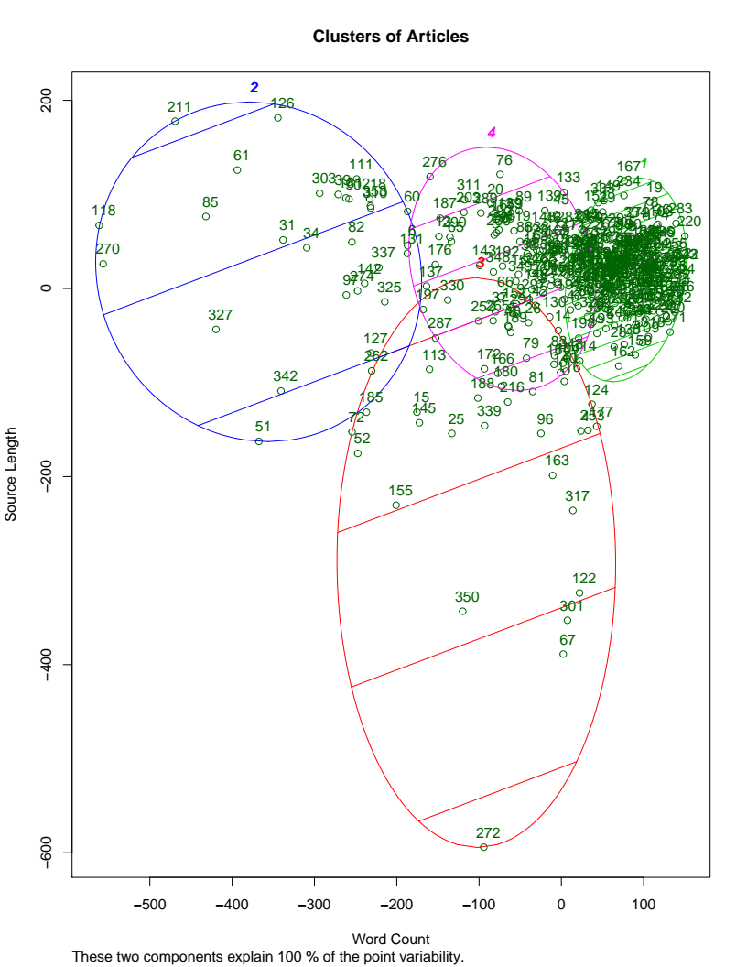

I used the elbow method to calculate the optimal number of clusters.

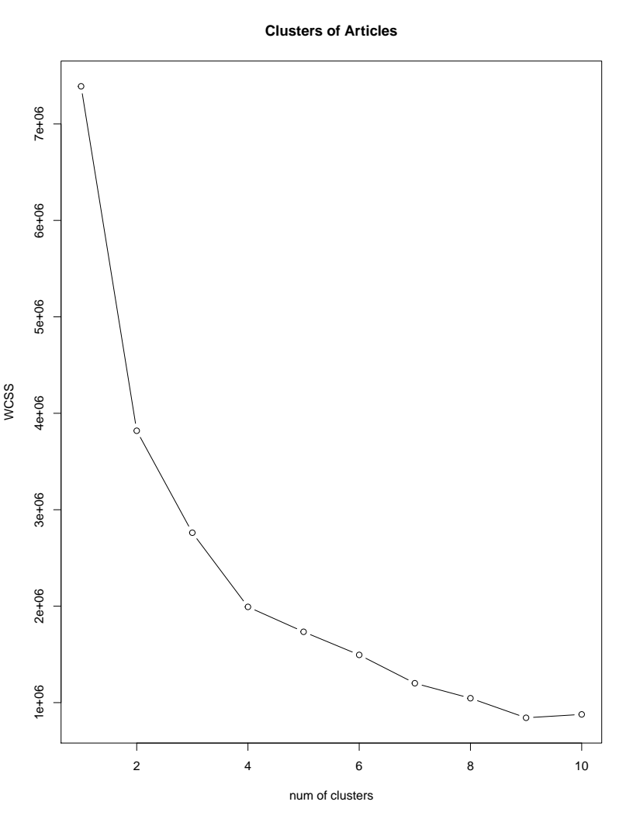

I then applied the simple linear regression model to see if the from the test set it could learn based on the source length to make a decent prediction on the word count of the given article. I understand this is not maybe the best metrics for analysis but I still found the results quite interesting.

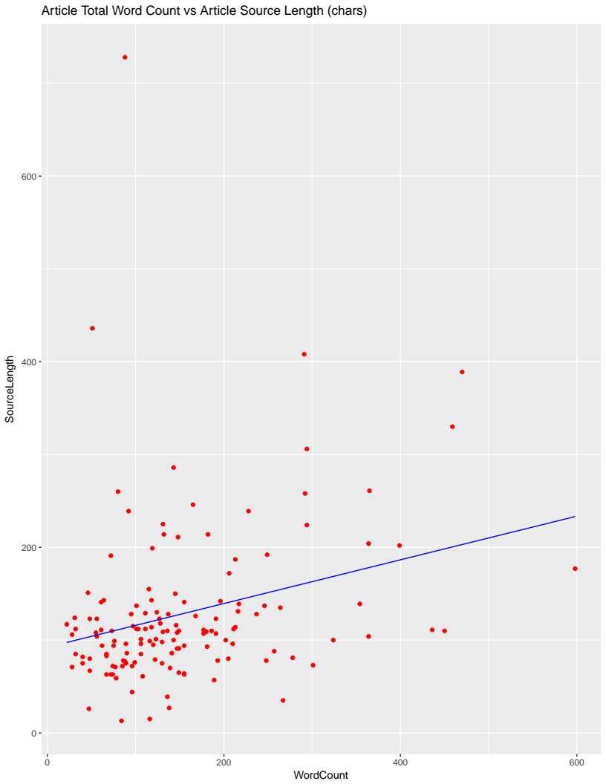
Above is the training set plot. With the linear regression line in blue. There doesn’t seem to be much correlation but there is definitely some. It is clear from the linear regression line that as the source length increases so too does the word count in the article. (Bear in mind the source would only count as one word in most articles as they were mainly links)

Then I plotted the final graph containing the test data.

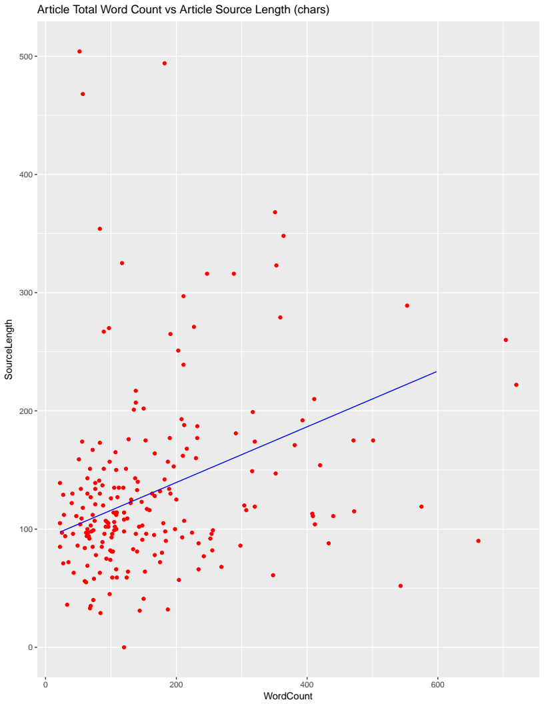
The linear regression line here is still the same as the one from the training set but it looks way more prominent as the bounds of the word count have been widened in this graph.

So it is clear that there is some relationship between the the source length and the number of words the student that chose that source wrote.

